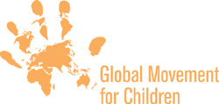
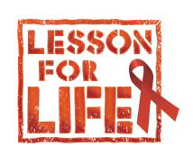
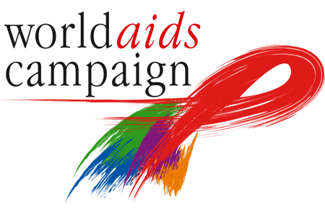

10 MILLION CHILDREN JOIN GIANT HIV/AIDS LESSON

Over 10 million children from 60 countries worldwide will join a giant simultaneous lesson on HIV/AIDS this World AIDS Day, 1 December.

Tens of thousands of schools and youth groups in countries from Azerbaijan to Zimbabwe will participate in the Lesson for Life, learning about HIV/AIDS and mobilising children and their communities to work together to change the destiny of children affected by HIV and AIDS.

Organised by the Global Movement for Children and the World AIDS Campaign, the Lesson for Life will involve some children urging their governments to take as much action on HIV/AIDS as children themselves are taking.

‘In the Lesson for Life, children from across the world will be tackling the HIV/AIDS crisis head on,’ said Miquel De Paladella, from the Global Movement for Children. ‘Our leaders must sit up and take notice of these children - their innovation and energy puts our governments to shame.’

In Zambia, children have been visiting ministers and will speak at a launch event to demand free treatment for their friends living with AIDS, in Vietnam children will quiz ministers in a live Q and A session and in France children from across Paris will meet for a giant lesson in UNESCO’s general assembly.

Children are missing from global awareness, budgets, and action on HIV/AIDS, and do not have the services, care, support, and knowledge that they need.

- Fewer than 5 percent of HIV-positive children have access to treatment.
- Less than 10 percent of children who have lost parents to AIDS get public support or care.

This July, G8 leaders made a commitment to AIDS treatment for all by 2010. But the funding commitments from these donors fall drastically short of what is needed to achieve this target. The $3.7bn pledged in September to the Global Fund to fight AIDS, TB and Malaria is only half of the $7bn that is needed, and is not enough to start any new programmes in 2006 and 2007. Children in particular remain dangerously under-served. As long as they continue to be overlooked, the number of children infected, killed, orphaned and left vulnerable due to AIDS will continue to rise.

‘Empty promises cost lives,’ continued Miquel De Paladella. ‘Every year that governments fail to meet their commitments is another year that the millions of children affected by HIV/AIDS are without the care, support and treatment that are their need and their right.’

International contact:
Kate Norgrove, knorgrove@gmfc.org, +44 7813 164 160, +44 207 012 6860
For national contacts please see table below.

Notes to Editors

1. Broadcast quality footage showing three compelling TV adverts on HIV/AIDS prevention and the orphan crisis are available on PAL and NTSC from knorgrove@gmfc.org +44 20 7012 6860 or +44 7813 164 160.

2. The Global Movement for Children (GMC) is the world-wide movement of organisations and people - including children - uniting efforts to build a world fit for children. The Lesson for Life is an activity initiated by CARE, ENDA, the Latin American and Caribbean Caucus, NetAid, Oxfam, PLAN, Save the Children, UNICEF and World Vision in support of the GMC and as part of the World AIDS Campaign. See www.gmfc.org/hivaids.

3. The following is a small sample of Lesson for Life launch activities happening around the world. For a full list of countries involved see the website here: http://www.gmfc.org/index.php/gmc6/content/view/full/642.

COUNTRY | ACTIVITIES | CONTACT
Bangladesh | 120,000 children and adults will take part in the Lesson for Life across Bangladesh. A launch will be held in Dhaka, attended by local celebrities and politicians. | Raphael Palma or Saidur Rahman,  +880 2 88135557  raphael_palma@wvi.org
Ecuador | An exhibition on children and HIV/AIDS will be launched on 1 December in Quito with a debate on access to treatment, and will then travel to 19 towns. | Julieta Sarzosa  5932 250144  Julieta_sarzosa@wvi.org
France | A lesson with 800 children from across Paris will be held in the general assembly of UNESCO’s headquarters. | Kate Norgrove  +44 7813 164 160  knorgrove@gmfc.org
Ghana | The Vice-President of Ghana launched the month-long Lesson for Life campaign in Ghana recently, which will culminate in a ‘national durbar’ on 1 December. | Esperanza Ampah  Eperanza_ampah@wvi.org  +233-21-226643
Kenya | 160,000 children will be involved in the Lesson in Kenya, including many schools in Nairobi. | Kenneth Ambetsa  +254 445 0256 or 7  kaacr@kaacr.com
Kosovo | Kids from ‘peace clubs’ across the country will take part in the Lesson for Life, and health department representatives will answer questions from children involved. | Rita Llulla  +377 44 349 359  rita_llulla@wvi.org
Malawi | Every secondary school including schools for children with disabilities is holding a Lesson for Life this year, and councillors and local chiefs have been invited to attend. | Kennedy Warren  +265 9287352  kwarren@unicef.org
Mali | A massive lesson of 1,000 children attended by the Minister of Education will take place on 2 December in Bamako. | Daouda Coulibaly  +223 237 20 15  Daouda_coulibaly@wvi.org
Mongolia | 250,000 children will take part in the Lesson for Life in Mongolia. | Mr Ider  + 97611312185 ext 118  idungerdorj@unicef.org
Senegal | One million children will take part in the Lesson across the country, in schools as well as on street corners and in Coranic Schools. The first lady will launch the campaign. | Siléye Gorbal Sy,  +221 6431354;  coalept@yahoo.fr  Cheikh Amadou Bamba Diaw, bambadiaw@yahoo.fr
Somalia | A march calling for support to children affected by AIDS and raising awareness will be held in three towns in Somalia. | Annastacia Olembo  +254-20-4441529  annastacia_olembo@wvi.org
UK | 400+ secondary schools in the UK will be taking part in the Lesson for Life. A survey of children’s knowledge of HIV will be published and launch will be held at a school in London. | Anna Ridout  +44 1908 841 020  anna.ridout@wordvision.org.uk
Vietnam | A Q and A session between children and government ministers will take place in front of a live audience in Hanoi on 3 and 4 December. | Nguyen Thi Xuan Huong  (84-4)- 8220661/Ext.23  Huong.nguyenthixuan@plan-international.org
Zambia | Children living with HIV/AIDS will speak at an event in Lusaka on 2 December, attended by the Minister for Children and Sport, demanding better access to medicines for children affected. | Gertrude Chanda  +260 122 1958  Bernard Kawimde  +260 9780 6080  Gertrude_chanda@wvi.org

