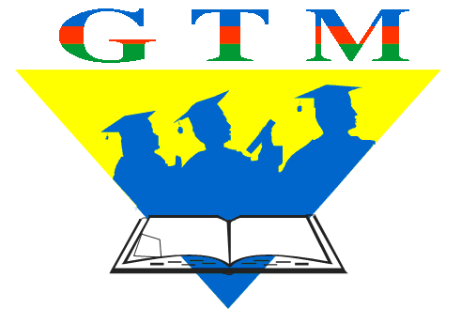

Educational Center for Youth

PR # 050-1
Baku, 12.01.2006

Educational Center for Youth
realizes the new stage of
“Children Rights School” Project

As it is known, beginning from September 2005 Educational Center for Youth (ECY) through the financial support of US Embassy has begun the realization of “Children Rights School” Project in Fizuli region. The main aim of implementing program is to increase the role of children in the development of civil society in regions, to contribute the protection and propagation of children rights, to provide necessary condition for the development of children social growth and to help their formation as a democratic citizen.
Toward the realization of the mentioned goals, “Children Rights School” was established as an initial component of the Project in Fizuli region. Through the established School, the group of volunteer trainers for the children rights has been organised in 23 villages of Fizuli region and they have been given special trainings. At the present as an initial stage of the Project group of volunteer trainers hold seminars and meetings for the rights of children in 23 villages of Fizuli region including educational actions by the participation of the children. It is necessary to note that, in educational meetings information on the basis of children rights, local and international legislation acts, the protection mechanisms of children rights, the appeal regularities for broken right to courts are also provided.
Additionally, the library was created within the “Children Rights School” in this initial stage. The access process of local as well as foreign literatures on children rights to the library still continues.
It is also necessary to inform that “Children Rights School” by the experts of Educational Center for Youth gives free legal advices for children rights in appointed times.

For additional information:
Vusal Quliyev – project coordinator
(+994 12) 433 80 59
(+994 50) 336 95 76
office@ecy-az.org
vusal@ecy-az.org

