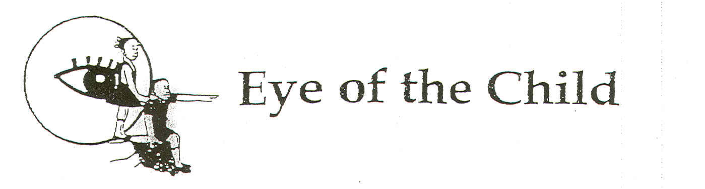

Box 31571 Blantyre 3, Tell 09511311, 09222790 Email eyeofthechild@malawi.net
Physical address feed the children Malawi Magalasi Road

10th October 2006 page 1/5

OPEN LETTER TO MADONNA

Dear Madonna,

SUBJECT: CHILD ADOPTION IN MALAWI

As the World and Malawians have taken interest in your visit to Malawi, we, at Eye of the Child wish to extend our warm welcome and openly express our excitement with the news of your mission to initiate programmes which will support some of the many suffering and children with special interest needs in Country.

The stories of our children particularly those in special needs of support (orphans) can not be adequately explained through this open letter which we have written after failing to contact you or your agent directly. However, we strongly trust your source of information as it has used to motivate your interest on the plight of a Malawian Children. We also trust that you have been briefed by the Ministers responsible.

In case you have never held anything about our organization, Eye of the Child is legally registered national organization which has the legal mandate to compliment Government efforts towards the promotion and protection of Child Rights in the Country. Among the many activities, the organization provides advice and information on issues related to good practices on children, Care, Protection and Justice in Malawi.

Reading and listing through the media coverage on your visit to Malawi that includes Reuter reports, we have obtained some information that you desire to adopt one of the many orphans in the Country. Since we will not have the opportunity to brief you and your team on legal issue related to Children in Malawi and the legal procedure for child adoption, we will still communicate through this open letter on some important information that we think you need to consider. We will also take the same opportunity to present our appeal for your consideration as you initiate programmes on Orphan Care in Malawi.

Page 2/5
We know you understand that Adoption is a legal process through which legal rights and duties of a Child towards its natural parents are terminated and similar right and duties towards its adoptive parents are substituted (Black Law Dictionary, p49). The concept is recognized by the convention on the Rights of the Child, which makes provision that a child who is temporarily or permanently deprived of its family environment, or who cannot be allowed to remain in that environment shall be entitled to special protection and assistance by the state. “States parties should ensure that there is alternative care and protection for such Children including adoption (CRC Article 20(1)”. In Malawi adoption is regulated by the Adoption of Children Act (Cap 26; 01, Laws of Malawi). To the larger extent, the Act is compatible with the provision of the convention on the Rights of The Child. However Madam, what might interest you to hear in our open letter is whether as a foreigner you can adopt a child in Malawi.
We regret to inform you that inter-country adoption is prohibited under the Malawi current Children Adoption Act as section 3(5) reads “an adoption order shall not be made in favor of any applicant who is not a resident in Malawi or in respect of any infant who so resident”. As we respect your right to privacy, we are sad to read in the print media that arrangement will be made to exempt you on non-resident adoptions. Please take note that this type of arrangement contravenes and will be questionable before the destination country, the United Nation Convention and the Malawi Adoption Act.

The rationale for this general prohibition is that the best interests of the child requires that after a child has been adopted, that child should be within the jurisdiction of the authorities to ensure that the child is accorded with basic services necessary for the Child Welfare. This monitoring would be difficult if the adopting parents do not reside within the jurisdiction. However, like what other interest group have argue in the past, the same principle of “best interest for the child,” would require some exceptions where adoption may offer the advantage of a permanent family to a Child for whom a suitable Family cannot be found within the Child country of origin.

We are happy to inform you that the convention on the rights of the child confirms the above principle by making provision that state parties that recognize adoption like Malawi should ensure that the best interest of the Child is of paramount consideration and they should recognize that inter-country adoption may be considered as an alternative means of the Child’s care if the child cannot be placed in an adoptive family or cannot in any suitable manner be cared for in the child’s country of origin, please read the convention Article 21(6). Further, Madam, the United Nations adopted convection on inter-country adoption in Hague in 1993. (Convention on protection of children and cooperation in respect of inter-country adoption). The convention seeks to establish safe guards to ensure that inter-country adoptions take place in the best
Page 3/5
interests of the child and with respect for his or her Fundamental Rights to establish a system of co-operation amongst contracting states to ensure that those safeguards are respected and thereby prevent to abduction, sale, or trafficking of children, and to ensure the recognition in contracting states of adoption made in accordance with the convection. (Article 1).

In view of the above development, the Malawi Law Commission has recommend in its review of Laws protecting children in Malawi before the cabinet, that rather than having a blanket prohibition on inter-country adoptions, the adoption of children’s Act in Malawi should make exceptions. Thus, if the country where the prospective adopter parents reside is a signatory to the Hague Convection and has already implemented the provisions of the convection on inter-country adoption should be allowed, if to do so is in the best interest of the child. The Law Commission therefore recommends that the current law section 3(5) of the adoption Act be deleted and the following section be inserted in the Act.

- Subject to the provision of this Act, a court may grant an inter-country adoption order as an alternative means of care and protection of a child who cannot be placed under foster care or in an adoptive family or who cannot in any suitable manner be cared for in Malawi.

- A court shall not grant an inter-country adoption order unless the minister, after consultation with the competent authorities of the receiving country, determines that –

(a) the applicant is eligible to adopt the child;

(b) The applicants have been counseled as may be necessary;

( c )The child is or will be authorized to enter and reside Permanently in the receiving Country;

( d ) The applicants or one of the applicants if not a relative of the child, has, while in Malawi, fostered the child for a Period of one year; and

( e ) The receiving country is a signatory to all has implemented the United Nations convection on protection of children and co-operation in respect of inter-country adoption.

Page 4/5
- For the purpose of this section. Inter-country adoption means an adoption in which the applicant intends to take the adopted child outside Malawi within the period of one year from the date of the application.

Should you offer our organization time and the opportunity to brief you further on this matter, we shall be happy to inform you about other related but important issues to consider before you make any future plans on the inter- country adoption. The issues we can brief you, include to the “Devolution where an adopter dies interstate”, the “disclosure of adoptive status to adoptive children”, the post adoption contacts with natural family members” and further to look at the jurisdiction in adoption matters.

Finally, Madam Madonna, looking at the country legal position on adoption of children and looking at the future proposal, we wish to appeal to you, Madam to consider supporting the current options as outlined in the Malawi Government, National Policy on Orphans and other vulnerable children. A part from the current initiative which you have launched in Lilongwe, we want to appeal if you can initiate a Malawi Children Orphan fund. This fund could support the Malawi Government toward the implementation of the National Policy as you can be identified as its good will ambassador. The fund can support extended families systems, offer education and financial support for secondary schools going orphans, improve on Community participation and other Community based approaches to care for orphans. We believe that this type of efforts does not create and develop a dependency syndrome. Institutional has created its own negative impression that such intervention replaces family systems. The best lessons can be learned from World Vision International and Plan Malawi who sponsors many children in Malawi through their families and community set ups. Our conclusive views agree with the National Orphan Policy that recognizes orphanages as one of a measure of last resort.

Madam, the policy covers five key issues developed based on identified problems and programming needs after assessing current interventions. The five key policy issues are;
- Provision of Assistance
- Coordination
- Institutional and legal framework
- Transparency and Accountability, and
- Monitoring and evaluation

Page 5/5
You will see Madam, that provision of Assistance respond to your initiative and to our appeal for a “Madonna Fund” but again, what is most important for your information is the issues of transparency and Accountability, which we think can clearly guide you in the formation of the Madonna Fund and also in the use of the documentary which you want to produce on the plight of the orphans in Malawi.

Madam, transparency and accountability are two major pillars in the policy which relate to being responsible to the beneficiaries. The pillars have been used as modality for ensuring efficiency and effectiveness of programmes for the care and support of orphans. They are used as Institutionalize participatory internal and external auditing of such initiative as the documentary you are producing which we need you again to explain its main purpose.

It is our hope that you will conduct further consultation during the implementation of all your initiative. Eye of the Child is proud to associate itself with your charity activities benefiting the children in need of special support and we thank you sincerely for considering contributing towards changing their life.

God bless you for the motherly and loving heart.

Yours truly

MAXWELL MATEWERE
EXECUTIVE DIRECTOR
EYE OF THE CHILD
Cell: 09511311/09222790

