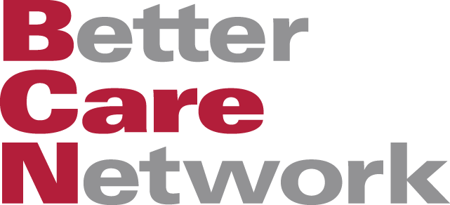
BCN Developing Better Care Toolkit for Practitioners!

At the BCN we are working on expanding our current website to include a new library specifically for practitioners. This library would contain practical tools for delivering better care. While the BCN website currently has numerous policy and research documents from around the world, the new library would focus on training packages and practice guidelines to support the delivery of improved care for children and young people. We need your help to do this!

We would like to include good quality practitioner tools from as many countries as possible on the following topics:
- Preventing separation, family and community support, and positive parenting
- Assessment of needs and suitability of placements, care planning, recording, and monitoring
- Recruiting, training, and supporting alternative carers
- Delivering alternative family based care, implementing deinstitutionalisation, and improving care in institutions
- Preparing children for moves, routines and activities while in care, and contact with family members
- Family reunification, reintegration, and supporting independent living
- Care in emergencies

If you have practice guidelines, forms, training manuals or tools relating to the care of children and you feel these may be useful to others, please can you send them now to swtoolkit@gmail.com. Since we have a very limited translation budget, we are focusing on English language tools, however if you have a translated version of the same tool please submit this also. We will review each document for technical quality and relevance before it goes into the new library.

If you would like to know more about this project or have any questions, please email contact@bettercarenetwork.org

Thank you very much for your support and we look forward to sharing the new tools with you.

