Summary of the Shadow report to the UN Committee on the Rights of the Child on the implementation of the Convention on the Rights of the Child in Burundi
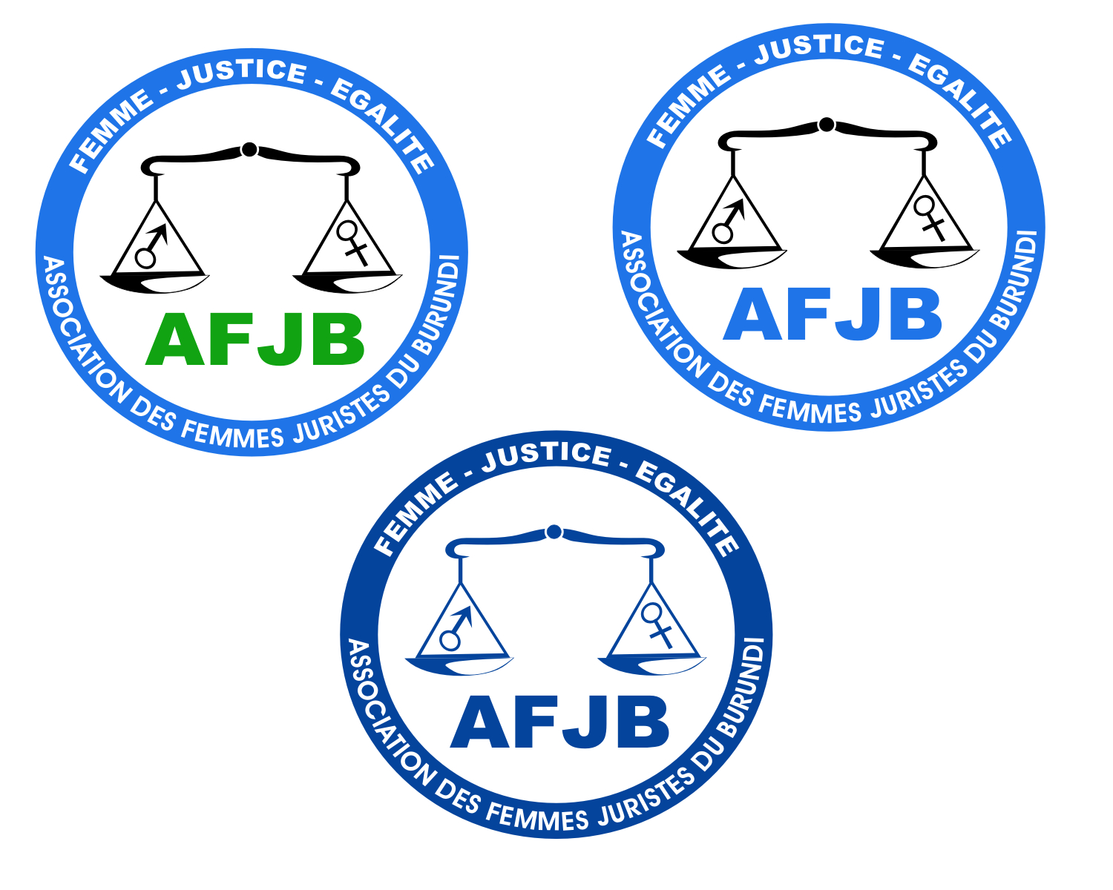

 |  | 
Ligue Iteka | ACAT Burundi | Observatoire Ineza des Droits de l’Enfant au Burundi | Association des Femmes Juristes du Burundi

Reseach team:

Didace KANYUGU and Attorney Armel NIYONGERE
(ACAT BURUNDI):dikanyungu@yahoo.fr and ndarmel2001@yahoo.fr

Attorney Caritas NIYONZIMA (AFJB): caritasfr@yahoo.fr

Furahisha NZISABIRA (LIGUE ITEKA) : nzifurahisha@yahoo.fr

Willy – Fabrice NDAYISABA, Alice KANYAMBO and Marie-Goreth GIRUKWISHAKA
(OIDEB): ob_ineza@yahoo.fr

Introduction.

- Traditionally, the child in Burundi was given particular attention from his/her birth to the time he/she becomes an adult. Today, the situation of the rights of the child is worsening gradually, in the face of the whole society. This is evidenced by the huge number of street children, of children abandoned at an early age either by their parents or their tutors, of raped children, of children deprived of their right to Health and education, of children whose property and inheritance are taken over, of children who are victim of domestic violence and economic exploitation without triggering any protecting measures on the side of the State.

- Yet, Burundi is a party to a number of international and regional treaties and conventions protecting the rights of the child and has incorporated them in nation legislation. Unfortunately, 20 years later, the respect for the rights of the child is far from reality today.

- The NGO coalition which prepared this report aims at providing the CRC with accurate information on the main breaches of state obligations with regard to the Convention on the Rights of the Child.

General Comment of the level of application of the CRC in Burundi

Ratified in 1990, the Convention on the rights of the Child obligates all state parties to strictly implement all principles therein enshrined. In practice, the NGO coalition notes a number of failures on the part of the State Party – Burundi, in the implementation of these principles

Non –Discrimination

- With regard to the principle of Non-discrimination, The Constitution of the Republic of Burundi stipulates that « all citizens are equal before the law which assures them equal protection. None should be subject to discrimination notably on the basis of his origins, race, ethnicity, sex, color, language, social status, religious, political or philosophical beliefs or on the basis of his HIC/AIDS status or any incurable disease » (Article 22).

- Unfortunately, this provision was did not in practice protect equally all children and this is evidenced by :

- The number of Albinos Children who were savagely massacred in Ruyigi and Cankuzo (East of Burundi) only for being albinos. The government should undertake necessary measures to protect any citizen, including Albinos population, against all kind of discrimination;
- The number of street kids who sleep out in the open, the number of children who beg for a living, especially in urban centers;
- The number of children who, instead of going to school, are employed in brickyards, in fishing centers, in bars and pubs, or as carriers of heavy luggage for insignificant wages, without any protection from the state

- The Family Code legalizes discrimination against girls with regard to required nuptial age (18 for the girl and et 21 for the boys)

- The Nationality Code legalizes a discrimination against children with a Burundian mother and a foreign father in the sense that these children do not get Burundian nationality at birth, unlike children whose father is a Burundian, regardless of the nationality of the mother. (Article 2 a.). According to the Nationality Code, children with a Burundian mother would only be accorded Burundian nationality at birth if his paternal affiliation is unknown.

This provision constitutes a violation of article 12 of the constitution which stipulates that children of Burundian fathers or mothers shall have the same rights with regards to the law on nationality.

Just as an example, in 2009, the Burundian police conducted a search for illegal immigrant and several children whose mothers are Burundians have been arrested and eventually deported from in very inhuman conditions.

The best interest of the Child

- With regard to the principle of « The best interest of the Child », national legislation contains some limitations. Indeed, although the family code stipulates that during a divorce case the judge decides on the child custody in the « Best interest of the Child », in practice, the law has little effect on the rights of the child as he is not represented or present during the divorce hearing, and thus has none to defend his interest. Spouses only put ahead their interests and rarely those of children when disputing child custody in court.
- Moreover, according to article 237 of the Family Code, a child cannot file a Paternity Case in court after the age of 22, only one year after his age of majority. The NGO coalition considers that this provision impedes the rights of many children, notably with regard to inheritance as at this age most of them are in impossibility of filing a case.

- The same code does not organize the procedure for children who wish to file a case against the mother who abandoned the mat birth (Maternity case). For example the NGO Œuvre humanitaire pour la Protection et le Développement de l’Enfance en Difficulté (OPDE), has been catering for a girl for the time she was 2 week age, as she had no known parental affiliation.
- It should be noted here that the child emancipation claim can only be filed by the Tutor, while in most cases, the tutor is the one who dilapidate children property and the one against whom the case should be filed. . (Article 356 du CPF). Therefore, the procedure protects the rights of the tutor and not those of the child.

Right to life, survival and development of the child

- The Burundian Constitution proclaims the right to life for all persons, including the child (article 24). Unfortunately, in practice, children are often victims of assassinations and other violation of the physical and psychological integrity. (see reports of human rights associations mentioned in the shadow report)

Economic exploitation

- Although Burundi has ratified the ILO convention 138, child labor is a reality in Burundi. Children under the age of 16 are employed in various areas (business, industries, craft industries, etc.), including night work. and night work for children is
- According to OIDEB reports, hundreds of children are employed in the fishing sector. There even state-owned companies which, during harvest seasons, are employing young pupils, thus depriving them of the right to go to school. Other children, mostly in urban centers, are employed as domestic workers.

D. Civil Rights and liberties

Birth registration
- Birth registration in Burundi is supposed to be mandatory but there is no policy aimed at enforcing this obligation. In practice, there are a number of children who are not registered, which put them in vulnerable situation as thy will be deprived of social services such as the right to free primary education, health care for the under 5 (free in principle), let alone the legal personality. .
From January 2006 to December 30, 2008, OIDEB assisted more than 1500 children in the procedure of late birth registration. The assistance of OIDE is only a drop in the ocean with regard to the huge number of parents’ requests. The NGO coalition therefore calls upon the government to fulfill its duty with no further delay.

Protection against all kind of violence

- The Burundian child is subjected to several kinds of violence. Indeed, within households, corporal punishments are considered as legitimate sanctions and an authorized way of fostering education and correcting the child. Unfortunately, the State has taken no measure to eradicate these punishments, especially that they are culturally authorized. Beating up a child in Burundi is said to be normal.
- The Burundian State should take necessary measures to sensitize both parents and children and to punish perpetrators.
- Moreover, sexual violence in Burundi do not spare children but the state, which has the obligation of due diligence, has not developed any effective strategy to eradicate this phenomenon. The figures of victims increase everyday (see 2007 and 2008 annual reports of SERUKA Center and Burundian League Iteka)

c) Children in conflict with the law

Imprisonment of minors

- The Constitution stipulates that « A child shall be detained only as a last resort, in which case the duration of the detention shall be the shortest possible », article 46.
However, regarding the huge number of children who are rotting in Burundian jails, one can rightly conclude that the detention of the child is rather the rule, not the exception. In July 2009, 500 children were detained.
- According to the same provision, the children should be separated from adults and be given special treatment in detention centers. The NGO Coalition notes that in all detention centers, children are detained in the same cells with adults, those in pre-trial detention and those serving their sentences together.
Worse, some children are born in prisons and or have accompanied their mother in prisons, and are living a prisoner’s life while they have committed no crime. These kids are in de facto detention and in deplorable conditions, inappropriate for their physiological and psychological development. .

- Moreover, there are no necessary social infrastructures and equipments in prison to allow organization of educative and leisure activities for children. Indeed, most of minors in detention are alliterate while the CRC requires that these children have access to education. Detained minors in Burundi have no leisure activities. Les mineurs privés de libertés au Burundi n’ont aucune activité quelconque même celle de nature occupationnelle.

Juvenile justice
- In the judicial system, there is a patent lack of legal procedures and court system for the specific category of minors. They are detained, prosecuted, tried and eventually sentenced by the same courts and following the same procedures as adults.
- Therefore, none of the principles proclaimed in the CRC for the administration of justice for minors such as the investigation in the presence of parents or lawyer, legal representation in camera hearing, the celerity of police and judicial procedures, etc. is respected in Burundi.
- The lack of psychological accompaniment measures for detained children has the consequence that children will most probably commit another offence and then sent back to prison.

Aware of the lack of respect for human rights by the State of Burundi,

Aware of the many violations inflicted to children,

Aware of the low degree of implementation of the CRC by the State of Burundi,

The Coalition recommends the following:

- The Committee should require the State of Burundi to set up special courts and judicial procedures for minors in conflict with the law.
- The Committee should require the State of Burundi to indicate deadlines for the adoption, promulgation and implementation of laws that it has mentioned in its periodic report and to enact code on the rights of the child.

- The Committee shall call upon the State of Burundi to adopt and implement a national policy for the promotion and protection of the rights of every child, not only the vulnerable children.
- The Committee shall recall the State of Burundi to separate children for adults in detention centers and to improve detention conditions.
- The Committee should call upon the State of Burundi to ensure that no minor under 15 is detained and that judicial procedures for the minors above 15 be treated in priority.
- The Committee should recommend the State of Burundi to reform the law on nationality which legalizes the discrimination on the basis of sex against children of Burundian mother and foreign father and to review the Family code which discriminate on the basis of the sex against girls in relation to required nuptial majority.
- The Committee should recommend the State of Burundi to sensitize judges about the prison alternative penalties in order to ensure that detention of minors in fact an exception rather than a rule.
- The Committee should recommend the State of Burundi to realistic actions plans and policies aimed at promoting the rights of the child. Le Comité devrait exiger à l’Etat d’établir des plans d’actions réalistes et des politiques sectorielles relatives à la promotion des droits de l’enfant.

