CAS 
CATHOLIC ACTION FOR STREET CHILDREN
P.O. BOX 709 MADINA-GHANA TEL: 00233-021-313266 --0277-552739
FAX 00233-21-507001
EMAIL: FICCAS@IGHMAIL.COM - http://www.cas-ghana.com/

PLANNING FOR 2006

NEWSLETTER 37

DECEMBER 2005

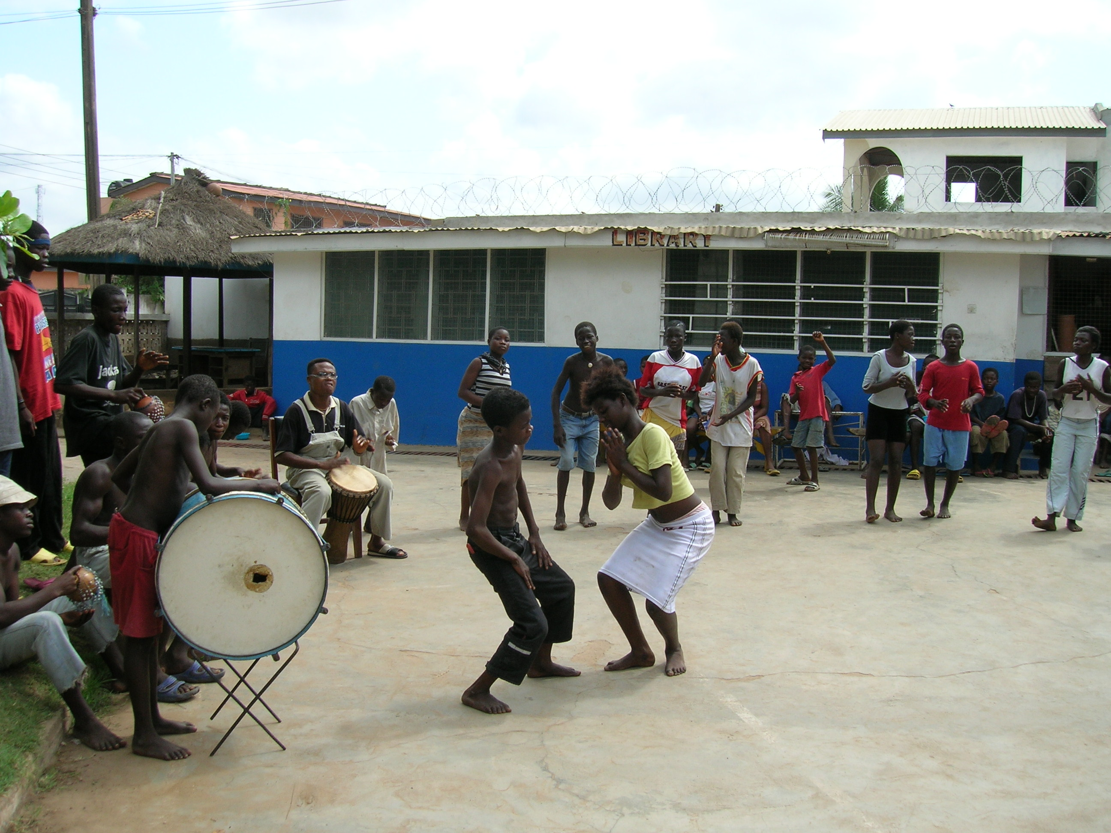
Dear Reader,

A few months ago you have received our newsletter –
Re-structuring CAS.

Today we want to give you an update and report on the plans for 2006. We have asked each department to discuss their plans. We in turn have asked them how these plans can become a reality.

CAS has three main objectives for 2006 namely:
- To understand the street children better and obtain more information on their living conditions and experiences.
- To discover how best these children can be prepared for a better future.
- To remain a service provider for the street children.

Last year, CAS discussed a five year planning program. This plan for 2006 is the bases for the activities for the year 2006.

FIELDWORK:

The main focus of CAS remains in the streets. Most of the street children can be met there and we want to be available to them. During the past years we have met many street children who have migrated from the rural areas of Ghana and surrounding countries. Therefore personnel operating in the streets concluded that all children are having a similar background.

The second generation of street children, those who are born in the streets are welcome at CAS as well, but we now realize that we do not know enough about the background of these children.

What do I experience when I am born in the street? Who is the parent? Who should I listen to ? Who are my friends? How do I survive?

These street children have at a very early age come in contact with crime, drug addiction and prostitution. They do not know anything about their traditional culture. They only know the culture of the streets. Do we at CAS know enough about the culture of the streets? We observe that many street children patronize their freedom. They do not want to be told what to do. They have learnt how to survive. This explains why often the children disappear and return to the environment they know, the streets.

What do we know about the hierarchy in the street?
Street children have to listen to many different people in authority:

- Officers of the Accra metropolitan assembly – AMA
- Officers of the GPRTU- transport
- Persons who control the markets (tax collectors)
- Queen Mothers (those in charge of markets)
- Officers of the Potters associations

Often, they belong to groups and the Gang-leaders are in charge.
Those who operate and sleep in particular areas have to listen to the area-leaders. At times they live in groups of the same ethnic background, then the senior tribe leader is in charge. Or children from the same village stay together. It is not always necessary that they are from the same ethnic background, sometimes, they are organized groups who work together and one is in charge.

Girls who are involved in the sex trade are often “controlled” by pimps, but also boys form groups who have homosexual acts together. This is an agreement among themselves.

Street families often have come to Accra to sell certain items usually food items. However, at times the women are also involved in prostitution. Children of these families have little freedom and often do not attend school.

In order to learn more about their conditions and life style we at CAS have decided to concentrate our activities in the streets and at the House of Refuge.

As part of this restructuring for 2006, CAS as an organization has decided to re-examine its working systems in order to stay focus with our view and mission as service provider with the main attention being the children.

PURPOSE

a) For this new approach a research has to be organized to seek an in-depth background of street children).
To know more about those born in the streets.
And know how Street families live in the streets.

b) Observe the living condition of these children while living in the street. To get to know their parent(s).

c) To know more about the Hierarchical structure of the street.

d) To learn more about their behavior. Why they do not have patience for learning and why they do not listen to any body.

Strategies/Methodology

- Interaction with Children
- Daily visitation to the street
- Traveling to locate families
- Interaction with significant others e.g. market traders,
- Street care giver, street father/mothers
- Street colleague
- Use of anthropology students to help study the background of these children.
- Evaluate the impact of activities through a designed format.

The facilitators of Street Corner Education every day meet different children in the streets. Therefore it is extremely difficult to measure the impact of this activity. We are sure that this exercise is beneficial to the children in general but it could be more beneficial if the individual child could be monitored. This can be done at the House of Refuge, but then more hands are needed. In order to achieve this, we have asked field facilitators to assist the staff at the education department. Extra lessons could be given in the afternoons or individual children could be assisted to learn how to write or read.

MINI REFUGES:
The rent of the Mini refuges has not yet expired. Therefore we should make good use of these rooms and determine whether they should be closed at the end of the period.

Each Mini Refuge is different, the environment as well as the use of the refuge is not the same. During the coming period more efforts will be made to interest street children to visit them.

HOUSE OF REFUGE:

The House of Refuge is the central place from which all activities should be coordinated. Fieldworkers have to report at the Refuge, the Education and Demonstration department as well as the Sponsorship Department are organized from this centre.

The monitoring system has to be improved, the general timetable will be reviewed, and the activity list examined. For all the children who are following a program for the preparation, a format should be designed to monitor their progress.

The department intends to organize group work discussions of all members of staff and volunteers involved. More teaching periods will be organized which includes all subjects. Also other innovative programs could be organized.

The security of the House of Refuge not only includes guarding the property but also advise the children. A new duty rooster has to be made so that the House of Refuge is secure at night but also during the day, this includes the cleaning of the compound and pavement in front of the House of Refuge.

The welfare of the children is important. The health education periods and service at the clinic should continue during the year. Children should be taught how to take their bath and wash their clothing and be told where to go to toilet. These are elementary issues, but street children have never been introduced to them.

DEMONSTRATION DEPARTMENT:

The Demonstration department wants to employ additional instructors for candle-making, weaving and woodcarving, so that the weaving can take off and that the candle-making- and woodcarving-workshop can produce more products.

Equipment and furniture of the candle-making- and ceramic-workshops at Hopeland Training Centre and House of Refuge should be shared. The storage of finished products has to be improved.

Efforts are underway to learn more about marketing especially the local market. CAS sells many of the items made by street children abroad, only a few items are sold locally.

EDUCATION PLANNED ACTIVITIES

The Education department is organizing many activities. However, there are only six members of staff working in this department. Cooperation with other members of staff is therefore essential. As described above, the street corner facilitators will assist the staff in the educational aspects. Often volunteers are assisting as well.

A good timetable, which is respected by all, is a good guide for these activities. This timetable which also includes activities of other departments is essential for a good running of the House of Refuge.

The department wants to improve the computer education, do some Vocational and career counseling, Refurbish the library, start a Pen pal project and continue with:

- Literacy at three levels.
- Drama classes, rehearsals and performances
- Sports at the House of Refuge and Hopeland
- Music and cultural performance
- Friday performances
- Excursions

FAN MILK REPORT AND PLANS

Introduction

Fan milk company ltd / CAS literacy program has been a joint collaboration efforts to assist vendors of Fan milk company ltd to read and write. Three months after a successful commencement of the program another component of the syllabus, which deals with general knowledge, was introduced. This was done in response to urgent need at the time consultation with the then Fan milk company coordinator for the program.

The program since it’s commencement in early 1995 has chalked a modest success, been confronted with challenges, and now looks to the future with hope. Many activities were carried out during the period under review. Our report this year will review present literacy activities at the various depots, the number of depots presently, teachers and Fan-Milk management’s demands.

DEPOT ACTIVITIES

Though literacy program at the various depots go on as usual the morale boosting keep changing because depot supervisors change from one depot to another thus changing support we get on individual perception of the program. This was supposed to be addressed by fan management because we have during a number of meetings emphasized our stand on this.

TEACHERS

At the moment we have six teachers and a coordinator from CAS. The teachers are: Ebenezer Ducan, Stephen Agbeve, Joseph Adotey Acquaye, Abraham Fosu, Richard Manyada, Edward Aklamati and John Fosu.

Classes are given at Circle depot, Abossey Okai, at Teshie Depot and at Nungua depot, at Tema depot, Lapas depot, and at Madina depot.

DEPOTS

The numbers of depots for the past five or six years have been reduced to from eight to six. Nima and Kaneshie depot are not on the list any-longer perhaps due to accommodation problems.

MANAGEMENT DEMANDS

A part from the usual literacy class for the vendors there are other subjects that fan managements felt should be given extra attention. These subjects include Marketing techniques and personal hygiene. Our present syllabus contains these subjects and are used at the depots. But management is of the opinion that emphasis on these should be stressed to meet in total the requirement of the company in line with their literacy program for the vendors.

SPONSORSHIP:

Before a street child can go on sponsorship or be assisted in a different way, a complete social survey report should be written and be verified. This cannot be obtained by the social workers alone. Field staff and others have to assist. Also, the child has to be supervised during his or her training period.
When say 200 street children receive training in various schools or workshops, this supervision can only be done successfully when there are sufficient supervisors. The sponsorship department therefore needs assistance from other members of staff to fulfill this task. Every fortnight a child in training should be visited.

Street children who are in need of more attention will be assisted at the House of Refuge and some of them will be invited to go to Hopeland training centre.
Some of the children could be prepared for sponsorship at the House of Refuge. This approach is a big challenge for the department, could it be done? For sure a lot of cooperation is needed from members of staff of the various departments.

Children are always enthusiastic and ready to go for training. When they are delayed because staff thinks they are not ready as yet, they are very disappointed and at times return to the streets. We the staff know that no promises should be made to the children to avoid these disappointments. The “preparation committee”, representatives of various departments who follow the progress of the individual children and decide on the child’s future, play a crucial role in this matter. Each member of this committee should understand the responsibility.

Schools and workshops should be reselected. CAS works together with approximately 30 schools and 60 workshops. Several of these workshops belong to associations. CAS will approach these associations to obtain their cooperation. By involving the associations, CAS hopes to improve the quality and dedication of the trainers.

Another plan is to upgrade the Lashibi project to a commercial status as well as a training centre and demonstration centre for children. This workshop owned by CAS, could train many more children in various trades.

HOPELAND:
All Staff both at the refuge and the farm should be able to understand and identify individual children who need more attention.

All staff should learn more about the children. Team of professionals to handle/manage children’s welfare

Since children are much younger, there would be the need to reschedule for us to give 24hrs attention at Hopeland. This means more social workers would be needed.

The reality is that, much younger children will be at Hopeland, so we have to decide what to do for them.

Three activities will be organized at Hopeland.
- Farm activities will become a demonstration farm
- Income generating workshop will be managed by the Demonstration department.
- Taking care of street children.

1. During the years the farm could not generate income to sustain its self due to the constant increase of agricultural inputs like costs of feed for the animals. The maintenance costs were also very high. The plan to cultivate vegetables throughout the year could not be materialized as well because of lack of rain, even the dam dried up.

In order to allow children come in contact with animals, we have decided to change the farm into demonstration farm. Two farm workers will be employed to take care of the farm.

2. Income generating workshop could improve their production. Since the demonstration department does the marketing and introduction of the trade, these workshops could be best managed by them. The Manager of Hopeland still could control the activities on their behalf. A good collaboration between the Heads of the Demonstration department and Hopeland Centre is needed.

3. The welfare of the children lodging at Hopeland will be the main priority. Members of staff assigned for this task should operate as a team. They will be assisted by one of the program managers of CAS.

The preparation committee, the members of staff selecting the children should work hand in hand with this team.

To summarize:

- Limit farm activities-change it into a demonstration farm.
- Buildings which will not be used for the animals will be changed for the use of children.
- Income generating workshops will be part of demonstration department. Production has to increase.
- All children who will be sent to Hopeland will receive more attention.
- Staff working with the children will be directly in charge. They will decide about the program, accommodation, use of materials, feeding and educational program.

Finally we want to give you some statistics. We are comparing some statistics published in the book “The Ghanaian Street Child” and the present statistics.

We thank you again for your help and concern and wish you a Merry Christmas and a Happy New Year.

Street children per Region. Records of ten years (see above) compared
With records of 2004-2005 (see below)

NR=Northern Region, WR=Western R. GAR=Greater Accra R.
UER=Upper East R. UWR=Upper West R. FR=Foreigners
AS=Ashanti R. ER=Eastern R. CR=Central R. BAR= Brong Ahafo R.
VR=Volta R.

Bro. Jos van Dinther
Barclays Bank High Street
Dollar $ a/c. 1280941,
CEDIS a/c. 1914639.

