CHILD LABOR AND ITS SITUATION IN NIAS, NORTH SUMATERA
By: Rustam & Lamtiur Tampubolon

Child labor has been a long tradition in Nias of North Sumatera, Indonesia. The December 2004 tsunami and March 2005 earthquake, which worst hit Aceh and Nias, as well as the processes of Nias reconstruction have increased the presence of children in labor force. This article presents some findings of the study on the issue. The study, funded by the ILO-IPEC, adopted a qualitative approach, with observation, in-depth interviews and focused group discussions as the methods, and lasted for three months, June to August 2006.

WORKING CHILDREN AS SEEN BY THE CHILDREN, PARENTS AND COMMUNITY LEADERS

Children, parents and the community leaders share a similar conception of work. In their eyes, the term work refers to both domestic (unpaid) and productive (paid) works. It therefore ranges from safe light work in the home to hazardous hard labor in the river. While the difference between “work” and “labor” makes sense in English, the terms are confused in the local context of Nias.

There is a clear confusion in the perspective of the local people between the work which may facilitate child development and the one which may hinder it. Regardless of the nature and condition of work performed by the children, they always see it as an essential part of a child’s socialization process and a way of transforming important skills to the children. A community leader in the village of Sawõ is quoted as saying, “If we never teach the children to work at an early age, they will never be able to work when they grow up.”

However, when discussing about the issue of working children, it is obvious that the subjects and informants of the study tend to associate the term work to activities which are productive. The people refer the term work more to mana’u gavu (carrying sands) and mana’u kara (carrying stones) than to work in the family fields and least to household chores. It is the productive work which is demanded by the parents from their children and which may signal the differences between good and bad children in the eyes of the parents. When asked “What do you think of a kid who does not work to help you earning some money?” a father in the focused-group discussion said, “He must be a bad kid.” The rest of the group gave their consent to the opinion. The label of good or bad kids is then in a way determined by how much the children can contribute to the family incomes.

While sometimes complaining about the work put on their burdens, some children do not see it as exploitative. Rather, they take it for granted that it is an obligation to work for the family survival. An eleven-year old girl child even said, “I am from a poor family, and I feel happy to work to easy the family burdens.”

TYPES OF WORKS PERFORMED BY CHILDREN

Children in the research sites (sub districts of Lahusa, Tuhemberua and Sawõ) are engaged in a wide range of works. At the age of six, a child is involved in such light chores as washing the dishes and cleaning the house. As the child grows older, the work becomes harder. The child then begins to work outside the house with his or her parents clearing grasses in the paddy or cocoa fields, collecting fire-woods and even breaking stones. Before the child reaches fifteen, he or she is ready to do works of the adult world, with or without the presence of the parents.

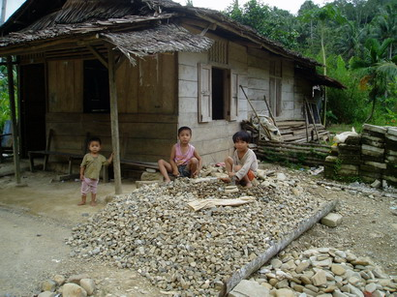
Of all the types of works, two are of specialties in the research sites: collecting sands and breaking stones. Piles of sands and stones are seen along the main roads in the village of Lahusa, Bawõzigõnõ, Hilisataro and some other villages leading to Teluk Dalam. At some points they cover both sides of the main roads, cramping the space of the roads. Dust spreads out of the piles of sands as the wind blows. Girl and boy children as young as six are also seen breaking the stones piled somewhere along the road nearby the housings.
Breaking - stone children in Lahusa

Collecting sands or stones and breaking stones have been a long tradition in the areas. In Hiliduruwa, a village in sub district of Tuhemberua, they have been practiced since 30 years ago. Then, the high demand for sand and stone supplies for the construction works following the 2004 tsunami and 2005 earthquake in Nias has drastically increased the magnitude of the practice. More areas are exploited and more children are involved.

Children are involved in the whole processes of producing sands, pebbles and rubbles. Work on the sands in the beaches includes three stages. First, the sands are scooped with a shovel from the beach and piled on a place away from the beach. Then, the sands are sorted out using a network of fine wire to separate the sands from stones or other objects. Finally, they are put into a bucket, a sack or a one-wheel container pushcart and brought to the road for sale. According to the children, the hardest work is pushing the cart up to the road which is about 50 to 150 meters from the sea shore. A child of about ten years pushes a half loaded container cart, which is about 30 kg, and the older one pushes a full loaded cart which is much heavier than he or she is.

Work on the pebbles from the river requires that children go into the river and collect them. In some cases pebbles are easily found on the dry surface of the river. Children collect the pebbles, put them into buckets and carry them on their shoulders or on their heads up to the road. In other cases children have to go into the water, shovel the pebbles, and throw them onto a two-layer standing wire sieve which separates bigger pebbles from smaller ones and from sands. Bigger pebbles have to be smashed into smaller pieces before they can go on sale.

In search of another kind of stone, the rubble, children climb up a hill and dig the rubbles out of the ground with a pick-axe or a crowbar. A big rubble has to be cracked with an eight kilogram iron headed hammer before it can be taken out of the ground. The rubbles are then smashed with a smaller hammer into pieces sized 5 x 7 cm, 3 x 5 cm or 2 x 3 cm. Some children prefer to do this up the hill while some others choose to carry the rubbles to the road side where they later break them.

Working Hours
Children in the research sites work in different long hours. The working hours range from two to nine hours per day, with three hours as the most cases. Works on sands and stones are never conducted in the evening or early in the morning, but fishing in the sea is. When a child is involved in both works, collecting sands or stones and fishing, the working hours are surely prolonged, as it is the case with a boy child in the village of Sawõ.

Rln, a thirteen-year boy who attends grade six of primary school, starts his day at 4.00 a.m. He goes out to the sea with his father at 5.00 a.m. His father has got only a rowing-boat and Rln has to row the boat against the wave while his father fixes up stuff for the fishing. After about 30 minutes’ rowing he stops and his father begins setting the fishing net. While waiting for the fishing net to be lifted up, Rln does his own fishing with a hook. At 9.00 they stop fishing and head to the shore. Rln reaches home at 10 after cleaning up the boat and the fishing net. He has got only one hour rest before he starts a different work, collecting sands in the sea shore which he does up to 12.30, only 30 minutes before his afternoon school class starts. Everyday he spends six and a half hour fishing and collecting sands, and four hours attending school classes.

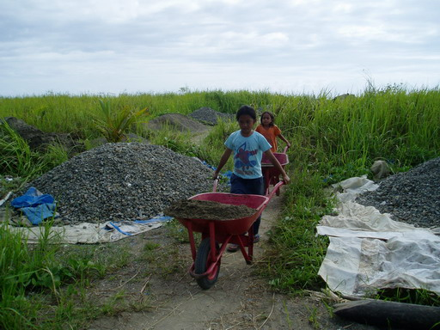
Interviews and focused-group discussions with the children and their parents imply that children have no control over their working hours. How long the children should work is dependent on the following interrelated factors: their parents, the family need, the market demand, and their attendance at school. The study reveals that in most cases children’s entry to work and labor is involuntary. It is their parents who send them to work and control how long the children work. In the parents’ words, “That’s all dependent on the parents.” That the children suffer from verbal and physical abuses when they refuse to work or when they work shorter hours explains this involuntary entry. Parents’ expectation of the children involvement is closely related to the family need. During such hard times as when fishing in the sea cannot be relied on, or before the paddy fields are harvested, children are expected to work longer. The market demand is also contributing to the children’s working hours. When a contractor tells the parents that he needs many trucks of sands or stones, parents would mobilize all the family members to work longer to meet the demand. However, when the piles of sands or stones they have collected are not sold out, parents do not push their children to work longer. Last but not least is children’s schooling. Schooling children generally spend about two to three hours a day working on sands or stones, and children who do not attend schools spend longest hours working. In Simpang Lima, a dropout boy child spends nine hours mining sands in the river. “I start at seven in the morning, at twelve I take a break and resume at one till five in the afternoon. Everyday.”
Girl children working on sands in Sawõ

The Risks
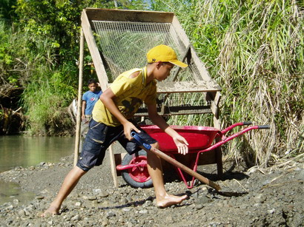
Child involvement in the works on sands and stones exposes the children in Nias to situations which may endanger their health and safety. These children are at risk. The heavy loads of sands and stones the children should carry with the container pushcart or on their shoulders may cause injuries and badly affect the children health. Their small growing bodies are forced to withstand the pressure of about forty kilogram weight of stones on their shoulders. A repetitious pressure of heavy loads on their shoulders proves to have badly affected their health. Their working environment in the hill, the river and the sea may also be hazardous to their safety. To date, the risks facing the children when working on the sands or stones include:
A boy working on a sand mine in Simpang Lima
- Bruises on the shoulder (resulted from heavy loads of stones or sands)
- Slipping and falling down the river or the hill
- Exhausted and burnt out
- Bitten by poisonous snakes
- Hit by stone drop (causing bruises, bone breaks, injuries on the head)
- Deaf due to the constant pressure on the shoulder
- Bleeding cough
- Drown in the sea or in the river
- Death (for snake bites, drown in the river)

When asked what he thought of the work he was doing, a boy child who worked on sands in Sawõ commented:

“I think the work is dangerous. When we push the full-loaded container cart, blood may come out of the mouth. Once I saw my friend having a bleeding mouth at work. When he was pushing the cart, he coughed and vomited blood. He was eleven years old. He worked only for one month. Earlier he said he never had blood cough.”

The risk is also acknowledged by the parents. A father in Bowozigõnõ said, “Once my son got an accident when working. He was carrying the stones, he slipped and fell down. The stones dropped on him and he had to stay in the hospital for two weeks. He could not get up for two weeks.”

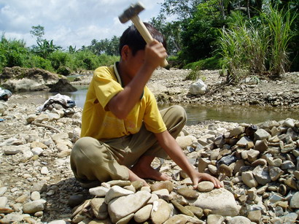
Similarly, in an FGD session with the community leaders in Lahusa, participants recounted incidences related to child involvement in the work of sands and stones, one of which is the sudden flood in the river of Lahusa. People were working in the river when suddenly there was a flood roaring down the river. People who were collecting or breaking pebbles in the river bed tried to escape but five children did not make it. They were drown and washed away. Their dead bodies were found a few days later.
A boy breaking stones in a river in Lahusa

The Payment
The price of sands and stones slightly varies in Nias. In Sawõ 1 m2 of sands is worth IDR. 50.000 to 57.500, in Lahusa it is about IDR. 40.000. The quality and the availability of sands affect the price. The bigger the sands, the higher the price is, and the more sands available on sale, the lower the price will be. Sands and stones will be abundant in the river after a flood.

In most cases children working on sands and stones in Nias do not receive direct payment for their work. Wages they earn from the work are given to their parents who then sometimes give them some pocket money as much as IDR. 5.000 to 10.000 for 1 m2 of sands or stones. Some children receive IDR. 25.000 from their parents for each three-day work. In some cases children do not receive any cash at all for their work, all the money goes to the parents to cover the family needs. A fourteen-year old girl child, who is now dropped out and has been working in collecting and breaking stones since grade five of primary school in Hiliduruwa, says that the money she earns is for the needs of the whole family members. She spends two days working with her father, mother, and two siblings to have IDR. 275.000 worth of rubbles. IDR. 20.000 out of the IDR. 275.000 is said to be submitted to the local government as a tax, and another IDR. 15.000 for the owner of the hill.

PUSH AND PULL FACTORS
The involvement of children in the work on sands and stones in Nias is related to the availability of push and pull factors, some of which are economical in nature while some others are cultural. As a rule, however, a phenomenon is never resulted from a single factor. Therefore, the following list is neither exhaustive nor standing alone. These factors are interwoven and all together contributing to the child involvement in the work force in Nias.

- Poverty
Poverty is the only pushing factor explicitly mentioned by the subjects and informants of the study during each session of interviews and focused group discussions. When asked why children should be involved the works on sands and stones, a mother in Sawõ said, “I know the children should not work because they are still small. But because our living condition is like this, they have to help us. If they don’t help us, what can we eat?” Similarly, a mother in Bawozigene also said, “I have got two kids, they attend classes in the school in the morning, and I send them to collect sands in the afternoon. We force them to work, because if they don’t work, we have no money for our daily needs.”

Parents who send their children to work claim that they earn about IDR. 500.000 to IDR. 800.000 per month. This includes the contribution the children make. To some extent, this statement is true. However, direct observations in the villages and work sites indicate that a family that employs four members working on sands or stones may about IDR. 1,5 million per month.

- Children as an asset
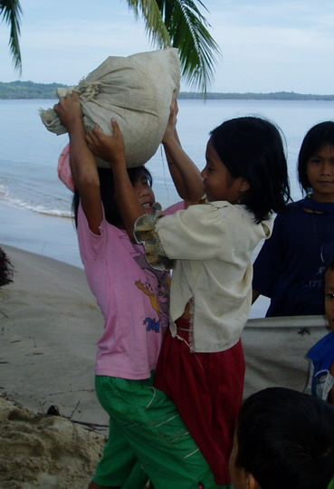
Both parents and children in Nias see children as an asset. Parents feel they have a full control of their assets and have the rights to decide how and to which direction the asset is used. This leads the parents to think they have the rights to push the children to work in the name of transferring acquired life skills or to contribute to the family incomes. Parents believe should be taught to work from a very beginning. A Nias proverb reads “Hafatua ise-ise wamaōdrō eu, na no esolo tola afatō (It is only when a tree is small it can be bent. If it is bent over when it is bigger, it can be broken” A community leader in Lahusa recounted, “In our village, no parents who don’t put their children at work. And I think children should be forced to work, that’s for their future.”

This also leads to the common practice of violence against the children. Child refusal to work often ends up with physical abuses. A mother in Bawozigene is quoted as saying, “Yes we force them to work, and we beat them if they refuse.” Focused group discussions with the children and parents reveal that all children experience beatings and all parents have beaten their children due to their refusal to work. Sometimes the beatings are serious and cause injuries. A father in Bawõzigene said:

“All parents have beaten their children. Sometimes a child is beaten till he gets bruises in his body. He is beaten with a stick on his feet up to his back. The beating may last for half an hour up to one hour.”

Hdn, a twelve year old boy in Sawõ, told us his bitter experience: “Once my father asked me to collect sands. I refused and ran away. He ran after me bringing a wooden stick. He beat me seven times. I cried.”

As an asset, the children feel they have no choice but to obey their parents’ order to work. While some older children may go to work voluntarily to help the parents, most younger children do so because they are afraid of being beaten.

- Construction works
The December 2004 tsunami and the March 2005 earthquake brought about a massive destruction of infrastructure in Nias. The reconstruction of housings, roads, bridges and schools demands a great number of materials, including sands and stones, which are available along the rivers and the beaches in Nias. The need for the supply has created a new job for many people in Nias. People who prior to the tsunami and earthquake worked as fishermen and whose boats were damaged during the natural disaster began to see collecting sands and stones as an alternate job. The high demand for sand and stone supplies has also pulled the involvement of children, boys and girls. In Sawõ, for example, an drastic increase in the number of children working on sands and stones began during the reconstruction of the village bridge destroyed by the earthquake.

- Poor quality of education
Community leaders complain about the poor quality of education in many schools in Nias. Teachers are not qualified, curricula are not met, and facilities are not well provided. A religious leader recounts his experience:

“Once I was working as a teacher at a junior high school in Gomo. I was shocked to find students unable to read and write. I also saw some primary schools where there was only a head-teacher and a school guard who did the teaching in six classes. How could a school guard teach in classes?”

The situation has diminished the courage of some parents to send their children to schools. To these parents, their children schooling is no longer a first priority. Temptation to send the children to work and earn instant cash is then a real threat to the education of children in Nias

Concluding Remark
As a rule, poverty has become a scapegoat for many kinds of exploitation against children, and the economic exploitation is particularly not an exception. However, this study suggests that some other factors also play a significant role to the increased phenomena of child labor in Nias, North Sumatera.

The cultural belief that children are the asset of the family contributes to be one of the underlying causes of child labor in Nias. Being an asset, children are under the management of their parents. Parents’ words are nothing but to be obeyed by the children. Thus, in the name of increasing family’s income and best practice to educate children, the involvement of children in labor is notified.

In addition, the December 2004 tsunami and the March 2005 earthquake also play a role to the participation of children in labor. The disaster brought about a massive destruction of infrastructure in Nias. Therefore, there was a great need for sands and stones supplies. This situation had an effect to the means of local people livelihood. In other words, the need for supply has created a new job for many people in Nias. As the selling methods of those materials are in one truck/car, a family has to force their members to complete their job as soon as possible. It is unavoidable that children are also responsible for this family’s call.

Again, the poor quality of education in sub-districts also contributes to the involvement of children in labor. This situation is added to the location of school which is very far from their homes. Thus, parents are tempted to send their children to work.

In relation to the approaches to prevent/eliminate child labors, religious leaders can play a big role in the community as they are heard especially in the church. The problem rises on the religious leaders themselves as they feel guilty when they have to give advices to the community for not sending their children to work while they know that the community needs cash money. Therefore, the solution to this situation is to empower religious leaders and coincided with that is the provision of economic activity to the family ***

Rustam is a lecturer and researcher at the Research Center of the State Institute for Islamic Studies (IAIN-SU), and at the Center for Child Study and Protection (PKPA), Medan.
Lamtiur Tampubolon is a lecturer and researcher at Atmajaya University, Jogjakarta.

Contact:
Email: utam_p@yahoo.com
Website: http://utam.wordpress.com
Mobile: +628163111483

Office Address:
Pusat Kajian dan Perlindungan Anak (PKPA)
Jl. Abdul Hakim N0 5A Pasar 1 Setia Budi
Medan 20132
Indonesia
Phone: +62 61 8200170, +62 61 8201113
Fax: +62 61 8213009
Website: www.pkpa-indonesia.org

