Haal Ahwal (Aug - Oct 2006)
Quarterly newsletter for Working Children of
District Rahimyar Khan

Published by: PAKISTAN RURAL WORKERS SOCIAL WELFARE ORGANIZATION (PRWSWO)
Editor: Amjad Ali Babar
Reporters: Sajid Muteen, Muhammad Umar & Muhammad Akram

Participation of Ex-Camel Jockey Child in South Asian Children Forum to End Violence against Children

(Reported by Child Rights Club)
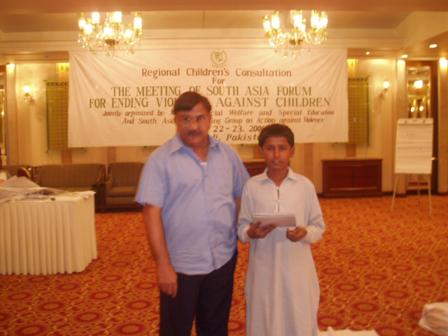

A promising child namely, Ali Raza belonging to Nooray Wali village is Secretary of Child Rights Club (CRC) represented Pakistan while participating in South Asian Children Forum to End Violence against Children, Rawalpindi. The main topic of discussion of the Forum was physical and psychological violence and early marriages. The participating children were from Sri Lanka, Nepal, Bangladesh, Afghanistan and Bhutan. Ali Raza made aware of the participants about the problems faced by children of Pakistan generally and those belonging to South Punjab particularly, emphasizing on camel racing victims returning toward Rahimyar Khan having abundance of grave problems. Ali Raza, himself has been convicting of camel jockey and is fully aware of the problems faced by the children pertaining to the subject under discussion. He actively participated in the session and stand members of a committee led by six members entitled south children Forum Against physical violence. Ali Raza is an inhabitant of a Katchi Abadi, Nooray wali, which has poverty stricken background. His father is a peddler. Ali Raza left his home after six-month stay due to prevailing poverty and hard up situation. The mother of Ali Raza, despite poverty hit circumstances continued studying circle of her offspring. Now Ali Raza has completed his formal education up to VIII class, besides working on Laborious Jobs, aiming to sustain his education with that of his brothers and sisters.

Launching a rally at the eve of International Literacy Day

(Reported by Ali Hussain)
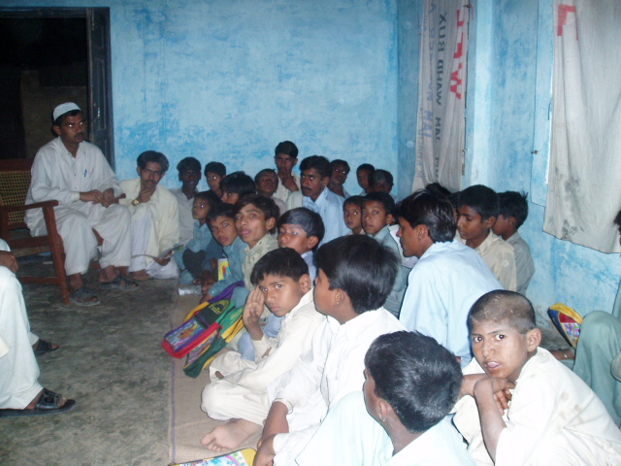

The previous day, a rally was mutually launched by the Child Rights Club and Anti Trafficking committee of Chak No.67/P Hudwali at the eve of International Literacy Day as a joint venture activity, with a core aim to have maximum rate of admission of the children to the school system. A majority of the members of Anti Trafficking committee and CRC including community influential participated at the moment; Notable spokesmen were Religion Leader, Imam Jamia Masjid and president of Anti Trafficking committee, throwing light on the importance of Education in accordance with present scenario. The children were holding play cards and banners with write up messages and slogans related to significant role of getting education. At the end of the event, remarkable number of children got admitted at school.

Children Meeting

(Described by Hafiz Muhammad Bilal)
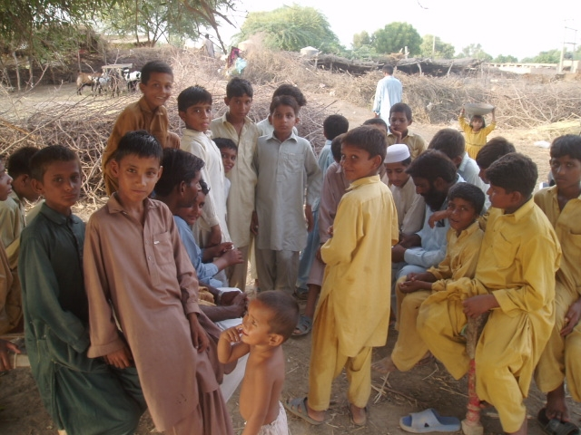

There held a meeting of the children at Chak No. 105/P in which the children belonging to various strata of the population actively participated to create awareness about the rights of the children. The children formed their committee as an initiating step. The committee was named as “SANJ” Child Rights Club. Besides nomination of the offices of president and Secretary, all the process was conducted through ballot system. The main purpose of Sanj Child Rights Club is to create awareness among children about their core problems and specifically related to the rights of the children. All the members of the said committee including Secretary, SANJ decided that they would develop liaison with the parents of children, respective teachers & local community to ensure admission of children towards adjacent schools situated in the locality.

Selection of Ex-Camel Jockey Child to attend World Working Children Meeting, Siena, Italy October, 2006
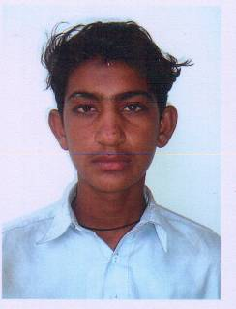

(Correspondent CRC)
A child namely Shahzad Ali belonging to a village of Rahimyar Khan has been selected by Pakistan Rural Workers Social Welfare Organization (PRWSWO) to take part in the above world meeting being organized by ITALINATS. Shahzad has been preying to camel racing jockey, which was trafficked to the Gulf State since 10 years back. Now he is busy in his studying and helps his father’s hand into his business. It is Shahzad’s opinion that no child should be separated from his parents at any cost. He said those who do so are acting as cruel persons. A majority of the kids belonging to Shahzad locale is involved in child labor that is working in various places. Shahzad urged on the need of getting education by the working children while sparing one hour duration at attending non formal schools established by organization so that they may be able to become literate. He said no one could make progress in this mechanical life without getting the ornament of education.

Skill is Wealth

(Described by Lukho Ram)
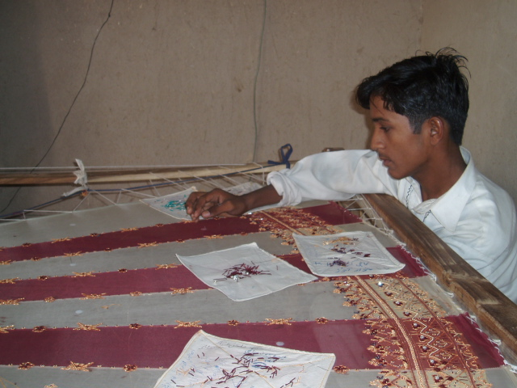

I am Lukho Ram. My parents sent me towards Gulf States for camel racing only because of having lust for money. I was often beaten by my Masool (Camel Racing Headmen). He used to make me awaken till late at night just to serve the horses through provision of fodder. If I failed to do that, he kept on hitting me with blows and toes. I was severely afraid of camel racing with the anxiety to be trodden by the horses if get slipped. After a long time of 5 years trial and trouble, I succeeded to come back to Pakistan. Now I am learning embroidery work with certain perfection. I have now established my embroidery centre, which has paved the way for generation of income to meet financial needs of my family.
Release from the Imprisonment

(By Gul Hameed)
My name is Gul Hameed. We are three brothers and two sisters, belonging to a poor family. I would like to share with you a mishap, which was encountered with me in the past. Detail speaking, two people were quarrelling with each other two month earlier and the people were trying to make settlement of the dispute. But one person hit the fire to the other thus resulted into his death. He dropped his pistol nearby me. The relatives of the murdered person handed me over to the police station. I was not at fault for committing a murder. A struggle was launched by the child rights activists which resulted in my release with the confession that there was some one else except me who had committed the murder.

Recreational Program for Child Labor

Working children participated in the big show of tournament in the city. This was the only team comprising of working children while rest of the team were from school & colleges. This was for the first time that working children took part in a tournament.
What was the fault at my side?
(By Abdul Hameed)
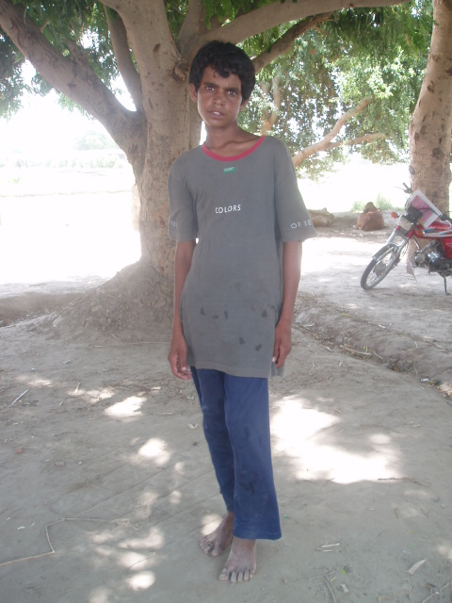
I am Abdul Hameed; I reside in Chak No. 93/P. My father dropped me to the Gulf State for camel racing because of lust for money. A rope round the neck of a camel jockey child, which was circled by a cruel headman, made him put to death. He was expired because of breakage of respiratory system. I was horrified at that scene. I was missing a lot to my parents. During that time I encountered a dispute with a youngster over there. He inserted an iron bar into my leg, which tore of my flesh of the leg. I was sent to the hospital for treatment purpose. I remained there in careless position, which resulted in chronic decay of my leg. I recovered my wound and was asked if I was interested to go to Pakistan? I agreed. Now I am here in Pakistan but with the defect of permanent limping in my leg. I can not run fast, ever pull on with hard work.

For more information, Please contact:-

Project Office: - Pakistan Rural Workers Social Welfare Organization (PRWSWO), House No. 42/A, Scheme No. 3, Block “Y”, Gulshan-e-Iqbal,
Rahimyar Khan, Punjab, Pakistan
Tel: 92-68-5889714 Email: prwsworyk@mul.paknet.com.pk

Head Office:- Pakistan Rural Workers Social Welfare Organization (PRWSWO),
House No. 3, Street No. 1 (East), Faisal Colony, Near Girls Degree College,
Bahawalpur-63100,Punjab, Pakistan
Tel & Fax: 92-62-2282442
Email: farhat2@mul.paknet.com.pk & prwswobwp@hotmail.com

