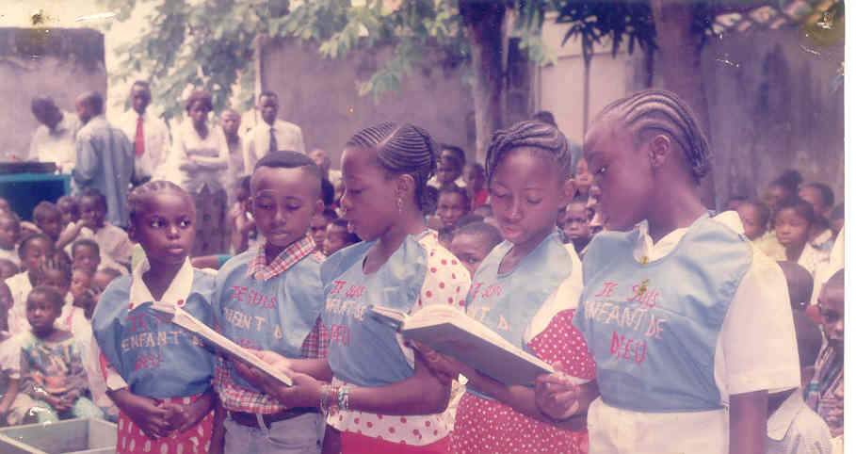

ALTERNATIVE REPORT
ON CONVENTION ON THE RIGHTS OF THE CHILD

Presented by:
PANAFRICAN ASSOCIATION THOMAS SANKARA
NGO with the observing statute near the African Commission
of Human Rrights and People
Member of
The Congolese Federation of Human rights (FECODHO)

5182  551 01 99
E-mail: apts-congo@voilà.Fr ; c-droitsdel homme@yahoo.Fr
Web page: www.apts.uni.cc
Brazzaville, April 2006

SYNOPSIS
 |  | Pages
 | INTRODUCTION | 3
1 | CONTEXT | 5
2 | FREEDOM OF EXPRESSION AND OF INFORMATION | 9
3 | HEALTH,HIV/AIDS; SOCIAL PROTECTION AND WELL-BEING OF THE CHILD | 10
4 | CIVIL LAWS AND POLITICAL OF THE POPULATIONS PYGMIES | 18
5 | GENERAL OBSERVATIONS AND SUGGESTIONS | 20
 | CONCLUSION | 24

INTRODUCTION

On September 2, 1990, the Convention on the Rights of the child came into effect, less than one year after being adopted by the United Nations General Assembly, on November 20, 1989.

At the end of the provisions of this Convention, the States left, nearly 190, have the obligation to take all measurements necessary to give effect to the rights recognized to each child, enacted in this convention.

To ensure of the efforts made by each State left this convention, the General Assembly of the United Nations established a Committee of the rights of the child made up of ten independent experts whose one of the essential tasks consists in examining the periodic reports that the States left in accordance with the article 44 must imperatively subject. Those are invited to transmit their reports:

- every two years according to the ratification or the adhesion;
- thereafter all five years.

By the means of this mechanism of control, the Committee of the rights of the child based in Geneva (Swiss) examines not only the aforementioned report to measure the efforts made to give effect to the Convention, but formula then of the observations in which it presents suggestions and observations.

The Republic of Congo which appears in the number of the States parties since its adhesion on October 14, 1993 must, like all the other States parties discharge this obligation.

The Congolese Government to discharge this obligation has just transmitted his first report near the Committee of the rights of the child.

The Congolese Federation of Human rights of to which belonged the Panafrican Association Thomas SANKARA is pleased with this act and encourages the Congolese government to become from now on constant in the realization of this exercise so that evaluation in the efforts authorized in favour of the translation actually social of the principles enacted by the Convention on the Rights of the child.

Thus with the continuation of the first report of the Congolese Government this report which wants to be alternate was initiated with the invitation of the Committee of the Rights of the of the United Nations. It has as a goal,to share, to supplement the initial report of Congo without claim to be a second national report and, another share, to express the major concerns of the civil society vis-a-vis the situation of the children which is already and remains very alarming in Republic of Congo.

This alternative report is centered particularly on the points hereafter:

- Context and justification;
- Freedom of expression and of information;
- Health, the protection and well-being of the child;
- The fight against the HIV/ AIDS;
- Social protection;
- The judge of the children;
- Rights to education;
- Rights to the leisures, the cultural activities and sporting;
- Access to drinking water;
- Conditions of detention of the children;

- Economic exploitation of the children.

1. CONTEXT
1.1. General situation of Congo

Of a surface of 342.000 K, 2 and with a population of 2,9 million inhabitants approximately, Congo lays out an Indicator of Human Development of 0,494 classifying it to the 144ème world row on 177 countries (figures 2002).

Country post-crisis, Congo saw a certain number of its capacities destroyed by the successive wars. The insecurity is still persistent in the department of Pool. The general governorship is relatively bad and the endemic corruption, of the consent even of the national authorities.

The national capacity of investment is very low and the institutional environment is degraded continuously. The weakness of the agricultural sector is recurring. The statistical data are non-existent and not very reliable.

The rate of prevalence of HIV/AIDS is 7%, while the rate of schooling showed a considerable fall during these last years.

Tally political and institutional

Since the beginning of the Nineties, the Republic of Congo put an end to the monopartism which had prevailed for 30 years and, with the favour of the Sovereign National Conference in 1991, is committed in a process of democratization having led to the adoption of the first democratic Constitution on March 15 1992. The incipient democracy was however put at hard test at once after the presidential election of 1992, this consecutively with the regular disorders which enamelled the socio-policy situation of the country, in particular into 1993/1994 and of 1997 to 1999.

The Constitution from March 15, 1992 was suspended at the end of the war of 1997 and a Fundamental Act was adopted on October 24, 1997 to ensure the transition. New internal tensions destroyed the process and led to a new civil war at the end of the year 1998. An Agreement of Suspension of the Hostilities signed on December 29, 1999 and a National Dialogue led in 2001 to the adoption of the text of National Convention for Peace and the Rebuilding and the installation of a government of transition. A new Constitution elaborate was finally adopted by popular referendum on January 20, 2002, which confirms the democratic orientations adopted in 1991 and poses the bases of the State of right wanted by Congolese.

The presidential, legislative, local and senatorial elections led to the effective installation of the institutions of the Republic at the end of the year 2002.
This new constitution governed a Republic equipped with:

An Executive Power exerted by the President of the Republic elected to the majority poll with two turns, for a seven years renewable mandate once. Supreme Chief of the armies, he is also a chief of the Executive in virtue of the presidential mode. For this reason it names and revokes with the discrtionary high positions of the State.

A Legislative Power exerted by the Parliament made up of two chambers: the National Assembly and the Senate. The Deputies with the national Assembly are elected by the direct vote for a five years mandate. The senators are elected by the indirect suffrage by the local Councils for a six years renewable mandate to the third every two years. The Parliament exerts the legislative power and controls the action of the Executive.

The initiative of the laws belongs jointly to the President of the Republic and to the members of the Parliament. The President of the Republic cannot dissolve the National Assembly and the National Assembly cannot dislocate the President of the Republic.

A Judicial Power exerted by the Supreme Court, the Court of Auditors and of Budgetary Discipline, the courts of appeals and the other national jurisdictions, D ’ authority . The Judicial Power rules on the litigations born of the application of the laws and payments. The members of the Supreme Court and the magistrates are named by the President of the Republic on a proposal from the Higher Council of the Magistrature. They are irremovable. The Higher Council of the Magistrature, chaired by the President of the Republic, is instituted to guarantee the independence of the Judicial Power and is charged to take a decision like disciplinary board and body of management of the career of the magistrates.

A Constitutional Court composed of nine members named by the President of the Republic, including three per direct nomination, two on a proposal from the presidents of each Chamber of the Parliament and two on proposal of the Office of the Supreme Court among the members of this jurisdiction. This court is in charge of the control of the constitutionality of the laws, the treaties and the international agreements. It takes care of the regularity of the election of the President of the Republic, examines the complaints and proclaims the results of the poll.

The High Court of Justice composed by members emanating of the National Assembly and the Senate elected in an equal number by their pairs, and members of the Supreme Court also elected by their pairs. It is entitled to judge the President of the Republic only in the event of high treason. In the event of committal for trial by the Parliament assembled in congress and ruling by a vote with the secret vote in the majority of two thirds of its members, the High Court of Justice is also qualified to judge the members of the Parliament, the Ministers and the members of the constitutional Court for qualified acts of crimes or offences made in the performance of their duties.

The Economic and Social Council, connsultative Assembly charged to support the dialogue enters the various socio-professional categories, of advising the Executive and the legislative and taking part to the development of the economic policy and social of the country. It can be consulted on the draft treaties and international agreements, the projects or the private bills, like on the projects of decrees, in reason of their economic and social nature. It can be seized by the President of the Republic, the President of the National Assembly or the President of the Senate of any, program and plan bill of development, economic and social matter, with the exception of the budget of the State. It can in in addition to being seized of any problem in economic and social matter.

The Higher Council of the Freedom of Communication, body of regulation covering together with the fields and trades of the information and with the communication. It gives technical opinions and makes recommendations on the questions touching with the fields of the information and the communication, about request of the Government, of the National Assembly, the Senate, the services of Justice, the citizens or any other legal entity. It fixes the conditions and decides the attribution and of withdrawal of the chart of the professional identity and suspension or stop of an audio-visual program or a publication non in conformity with the provisions of the schedule of conditions . It has of faculty to initiate and the capacity to inflict financial sanctions with the bodies of press which would have been made guilty of manifest and repeated violations laws and payments governing the freedom of press and communication.

A Mediator of the Republic, instituted by a law of October 31 1998, which is an independent authority charged to simplify and to humanize the relationship between the administration and managed on territory, through a general delegation and departmental delegations. It is entitled to receive any individual request of any person or entity, who estimates, with the problem in accordance with the mission of public utility which is reserved for him and can, by a recommendation, propose the payment in equity of these files.

A National Commission of the Human Rights ; organized by a law of January 2003. Its acts as an independent commission having faculty to initiative , in charge with the follow-up, the Pomotion and the Protection of the Human Rights. It is entitled to investigate, that is to say on the individual or collective requests citizens based on the violation of the Human Rights and fundamental freedoms, when no jurisdiction seized.

A Police Force composed of the national police force, the gendarmerie and the Congolese armed forces.

Local Communities, namely the departments and the communes, who manage freely by councils elected under the conditions envisaged by the law, in particular with regard to their competences and their resources.

This unit constitutes the pillars of the State of right which the Republic of Congo wants to build. Beyond this base, the political engagement to ensure viability and perenniality of it was very clearly expressed by those which were committed managing the destinies of the country and, in particular, by the President of the Republic which, in its program “the New Hope”, details in 12 points its will to promote the good governorship and construction a State of right.

In spite of this will expressed to try to rectify what can be, the real situation arises schematically as follows:

• in the economic plan

- Unimportant growth of the interior product gross;
- The aggravation of the worrying inflation;
- The deliquescence of the banking structure and financial;
- Slowness in the setting of the process of privatization since more than one decade.

- in the social plan

- Destitution very marked of the medical system;
- The absence of a social housing policy ;
- The increase in the rate of unemployment (nearly 50% of the working population);
- The precariousness of the wages and the constant fall of the capacity of purchase;
- The aggravation of the social fracture;

• in the cultural plan, educational and sporting

- the non rehabilitation of the rare destroyed cultural infrastructures;
- the absence of support of promotion for the artists plastics technicians, scenario writers and others;
- accentuated dysfunction of the system of teaching;
- The inadequacy formation-employment.

• in the environmental plan

- the major degradation of the quality of environment;
- the pollution of the medium (air, sea, fresh waters );
- proliferation of the harmful effects (noises, odors stinking and insects vectors of several diseases, etc…) ;

- in the space plan

- depopulation of the rural zones;
- imbalances and the dysfunction of the urban zones;

1. FREEDOM OF EXPRESSION AND INFORMATION

« 1. The child is entitled to freedom of expression. This right includes freedom to seek, receive and spread information and ideas from any species, without consideration of borders, in an oral, written, printed or artistic form, or by any other means of the choice of the child;

- The existence of this right can be object only of restrictions which are prescribed by the law and which are necessary:

2.1. with the respect of the rights or reputation of others;

2.2.with the safeguard of national safety, the law and order, health or public morality.
(Article 13 of the Convention on the Rights of the child)

This article guarantees to each child the right to freedom of expression and information.

The Constitution republic of Congo of January 20, 2002, in its article 9, guarantees the same rights.

Only, in the practice, reality poses problem.

On the level of the media, it is difficult to identify with exactitude the emissions which take part in the reach of this objective and it is necessary to stress that the Republic of Congo does not count any journalist trained especially to this end; the emissions devoted to the children are diffused in sporadic manner and are generally animated by non professional.

More worrying, the phenomenon of the videos clubs which proliferate in the urban centres outwards of any regulation and, developing year after year, profiting from the passivity of the authorities, these videos clubs becomes true schools of the delinquency and depravity of die. Children, all confused ages, will water harmful and harmful films with their blooming. What has any bond with the access to the information required by the Convention on the Rights of the child.

Generally, the information in Congo is ensured by the chains of radio and television of State and deprived. However, these last unfortunately cover for the essential only the great urban centres. The capacity of national cover is thus very largely in lower part of the average.

It is noted however in Congo, a tendency to liberalization sector of the information and communication certainly being able to contribute to mitigate the failures of the State. But to represent this liberalization into practice, the Congolese State trails really the steps.
Indeed, the law n° 8/2001 of November 12, 2001 bearing on freedoms of the information and of the communication misses the text of application, five (05) years after its adoption. It governs inter alia, “the mode of the information and of the communication of the free enterprise” (art 2), “the exercise of the freedom of information and communication can be limited only by considerations holding with the respect for human dignity , freedom and the property of others, the pluralist character of the expression of the currents of thoughts and of opinion, with the safeguard of the law and order , with the technical constraints inherent in the means of communication, like by the need for promoting peace and the culture main roads” (art. 3) “the access to the sources of information is free. The censure is prohibited. No one cannot be worried for its ideas, its opinions. The right to seek, receive and spread, without consideration of borders, information and the ideas by some average of expression that it is within the framework of the limits fixed by the present law is guaranteed” (art. 4)

- HEALTH, HIV/AIDS, SOCIAL PROTECTION AND WELL-BEING OF THE CHILD

  - Health

Convention of the Rights of the child in his article 24 lays out that the child must enjoy the best state possible health, to profit from the medical departments. the State lays a particular stress on the primary care of health and the preventive care, on the information of the population like on the reduction in the infant mortality rate .

In the constitution of the Republic of Congo, in its article 30, he is recommended “the State is guaranteeing public health. The old people and the handicapped people are entitled to protection measures in connection with their physical, moral or different needs, for their blooming.

Between the contents of the two articles quoted above and social reality the report is very disconcerting. If there exist assets, it is side of the legal framework with inter alia:

- the law n° 009/88 of May 28, 1988 instituting the framework deontologic of the professions of health and the social affairs;

- the law n° 014/92 of April 2, 1992 bearing on institution of the National Plan of Medical Development (PNDS);

- the law n° 009/92 of bearing April 22, 1992 statute, protection and promotion of the handicapped person;

- the law n° 06-97 of bearing April 21, 1997 institution and organization of the National Ordre of the Pharmacists.

If it is noted with satisfaction the concern of the Congolese legislator to guarantee the good being of the Congolese child with all the panoply of the useful texts as inter alia as regards health:

- decree 86/392 of March 24, 1986 setting up the primary care of health (SSP);
- the decree n° 89/526 of July 21, 1989 bearing creation, organization and operation of the orders of the professions of health;
- decree 2000-309 of November 3, 2000 bearing operation of the National Order of the Pharmacists;
- the decree n° 88/430 of June 6, 1988 bearing liberalization of medicine;
- the decree n° 98-258 of July 16, 1998 bearing attributions and organization of the general inspection of health;
- decree 84/290 of March 26, 1984 bearing creation of the National Council of Health and the Social Development …

side of the Executive Power on the other hand, one seems to be opposite of another state of spirit, because the existence of the texts is not enough, it is necessary in more one firm will coupled to a political engagement closes which unfortunately been seriously lacking with for consequence the progressive and continuous deterioration of the situation of the child in Republic of Congo (110 deaths for 1000 births whereas the National Plan of Medical Development claimed to reduce it to 70% with horizon 2000 …)

One notes a shortage agent of health in the crushing majority of the rural and semi zones rural.

During the collection the information for the development of present report, it was noted that the Center of health integrated located at Bétou (department of Likouala) is held that by nonprofessional agents, enjoying only a synopsis training first-aid workers given by the Congolese Red Cross. Such cases are multiple in all the departments.

There exists, moreover, no particular precaution to ensure the assumption of responsibility of the children resulting from the poor families “since all is regulated by money without exception, as well worse for the poor ones, whatever the gravity of the cases, as much for the adults as for the children”, regretted Mr NDOUMOU Jean Pierre, Vice-President of the Coordination of the Organizations of the Civil society working in and for Likouala and member of the departmental Council.

The National Plan of Medical Development (PNDS) which aims noble objectives at knowing:

- the improvement of the state of the population by the reinforcement of the system of health of the medical districts;
- the development of the national cover in sight to provide to the population primary care of health (SSP) of quality with their whole participation;
- reinforcement of the national capacity in management of the system of health;

trail to take its marks. The situation seems rather to worsen. What poses today the need for the government of the Republic of Congo to give a detailed attention to it to this vital sector.

It important to announce the creditable efforts accomplished within the framework of the programmes of vaccination against the poliomyelitis with constant support of the co-operation bodies like the UNICEF, the WHO and the International ROTARY DRILL.

    - Right to a healthy food

In 1999, the Committee of the rights economic, social and cultural a its published Observation general on the right to a food sufficient – a crucial importance for the pleasure of all the rights”. The Committee estimates that the essential contents of the right to a sufficient food include the following elements: availability of food exempts substances harmful and acceptable in a determined culture, in sufficient quantity and a specific quality to satisfy the food needs for the individual.

On this question, it is necessary to underline a fact in Republic of Congo, is acted of the phenomenon of “frozen chickens”.

Indeed, a study, fruit of nine months of investigation, surveys and interviews carried out in a country of under area central Africa in occurrence Cameroun, State close to Congo into the phenomenon of “frozen Chickens” attested that this chicken imported from Asia, and Europe, is unsuitable with human consumption and that its consumers are exposed:

- with the salmonellas (bacteria which cause the typhoid fever );
- with gastro-enteritis (ignition of the stomach and the small intestine due to the bacteria which causes violent colics);
- with the myomes;
- with the cardiopathy;
- with hypertension.

This study carried out during 2004 revealed that 83,5% of the 200 samples taken on report usher in eight (8) gone from six (6) towns of this country and analyzed in the Pasteur Center of Yaounde are not in conformity with the microbial criteria. Whereas the microbiological criteria of European Union recommend a maximum of total flora of 500.000/gramme, the majority of the samples take are with more than 3.000.000 (three million) grams.

It is the same for caliciform fecal of which the identified quantities vary from 3.000 with
18.500/gramme. However the criteria of European Union, recommend a maximum of
1.000/gramme.

All the range of information rising from this study attests that the frozen chicken imported in our countries keep silent, especially after our investigation near our customs authorities , the chickens imported by Congo have the same sources as those imported by Cameroun.

Vis-a-vis all evoked realities, the Panafrican Association Thomas Sankara prepared a document entitled “Plea for a rigorous regulation of the importation of chickens frozen in Republic of Congo” and addressed on August 16, 2005 between others:

- Minister of Commercial and Provisioning;
- Minister for Justice and the Human Rights;
- Minister for Health and the Population;
- Minister in dependent and Social Affairs;
- Minister in load of the Agriculture and breeding ;
- Minister for the Police force and the Law and order;
- The adviser with the Provisioning of the Chief of the State;
- Public prosecutor.

Soon close one year, the file seems classified without continuation.
We ask the Committee to examine this question useful for the safeguard of the health of the children.

  - Fight against HIV/AIDS

After the discovery of the first cases of the AIDS in Congo in 1983, the National Programme of Fight against AIDS (PNLS) was set up and developed some urgent programs to alert and mobilize the populations vis-a-vis the threat of this epidemic. In 2004 was instituted to reinforce the fight against the AIDS, the National Council of Fight against the AIDS which has a multisector and multidimensional vocation.

From 1987 to 1997, the PNLS put in building site several programs inter alia:

- an urgency program;
- a medium-term program I;
- a medium-term program II.

These programs had for the essential the following aims:

- knowledge by all of this epidemic;
- the promotion of the responsible sexual behaviors;
- the assumption of responsibility of the cases of MST/SIDA;
- epidemiologic monitoring of the infection to HIV;
- the promotion of transfusional safety;
- dealt with medical, psychological and social of the people infected by HIV/AIDS.

In spite of all the efforts authorized by together of the partners implied to the sides of the government like international co-operation (European Union, the World Health Organization, Funds of the Nations for the children, the French Co-operation, the Belgian co-operation, candianfunds for the local initiatives, German co-operation (GTZ), the Program of the United Nations for the Development, Funds of the Nations for the Population …) like of an NGO roads (Panafrican Association Thomas Sankara, Congolese Association for the Good Family Being, the Congolese Red Cross, Doctor of Africa …) the situation is remained alarming and gallopping.
Since December 31, 2000, one notes a particular implication of the President of the Republic SASSOU NGUESSO and his wife Antoinette SASSOU NGUESSO who is the head of his foundation called “Congo Assistance Foundation”.

For President Denis SASSOU NGUESSO, “… there is danger in the residence and the mobilization of all becomes a requirement …” (speech of the millenium). Since, the National Council of Fight against the AIDS was set up. The government in this impetus started to release from the financial resources to support and instigate the programs, close a Billion F CFA in 2005 and nearly two Billion envisaged in 2006. What made say to Doctor Pierre MPELE; former chief of the inter country program of Africa of western and of the center of UNAIDS and current representing this institution in Nigeria, that “ Congo appears among the models in the political engagement in favour of the fight against the AIDS.

It does not remain about it less than the situation remains alarming with 110.000 infected people including 59.000 women and 15.000 children.

Untill now, Brazzaville, shelters that three centers of tracking and treatment of the people living with HIV. The second city of the country, Pointe-noire lays out as for it only one tracking and processing center .

No other center of tracking and treatment of the people victims of HIV/AIDS is available for the other departments of the country to the instar of the zones or the rate of prevalence is very high; Sibiti (Department of Lekoumou): 9,1 % ; Dolisie (Department of Niari): 9,4 % ; Madingou (Department of Bouenza): 5,3 %, according to the last data of the study of the seroprevalence carried out by the National Council of Fight against the AIDS with the support of the World Bank, in November 2003.

3.3. SOCIAL PROTECTION

Social protection in Congo as in the appreciation of other shutters of the Convention on the Rights of therightsof the child must be appreciated on two levels with knowing:

- the shutter of the standard;
- the shutter of the social practice.

    - Shutter of the standard

Prescribed Convention on the Rights of the child almost entirely find their place in the Congolese constitution into force, the Code of the Congolese Family and other legal instruments of the substantive congolese law are still efforts to make as regards ratification of the international texts in the national legal device .

The law n° 091/89 of bearing November 14, 1989 recasting of the statute general of the public office lays out in its article 211 “whole agent, its or its couple, the people who live with him in a state of pre marriage;

As well as the minors with load be are entitled to the free medical visits and the free medical examinations in the dispensaries and hospitals the public ones of the Republic.
The expenses of hospitalization of the people aimed by the preceding subparagraph are dealt with with 80% of the budget of the State …”

Notwithstanding the relevance of these provisions, social reality gives another face of the setting in œ uvre of Convention.

    - Shutter of the social practice

      - Family benefits for the children

The standard of living of the majority of the Congolese families is very alarming, with 70% of the population living in lower part of the poverty line in spite of the immense richnesses of the country, which poses the problem of the good governorship heard not only in its dimension of management healthy, rigorous and transparent of the public thing, but good governorship also like ideal of dignity and progress with the mechanisms of management directed with constancy towards the concerns aiming at bringing to all if not the greatest work number, food, water, social protection … allowing to go with the opposition to the current practices because, how the Congolese authorities can justify realities hereafter:

- family benefits allotted to the civils servant: 1.200 F CFA per child a month is, nearly 2 Euros per month without taking account of the SMIG nor of the deterioration of the capacity the purchase power and even less the inflation always which gallops;
- this amount knows a large abatement with to leave the 3rd child, the rate is reduced untill to 600 F CFA, almost 1 Euro per month.

The amounts of these allowances date of more than four (04) decades. If one adds to that the ridiculous wages for the parents, the worst still is than the Congolese children whose parents neither work with the public office, nor in the large private companies of the place purely and are simply excluded from its ridiculous social allowances.

What can result in affirming that the contents of the article 27 of the Convention on the rights of the child which enacts the right of the child to an adequate standard of living are still a Utopia for the crushing majority of the children in Congo.

The Judge of the children

The Juvenile court is qualified to consider the infringements qualified crimes or offences, charged to the minors of eighteen yeas old and of the major ones. They are qualified to know cases or health, morality or the education of the minors is in danger.

In each case, the Judge can order an educational measurement welfare at the request of the Guard or the tutor, the minor himself or Public Ministry. The Judge can seize the office in exceptional circumstances.

The rules concerning operation, the competence and the composition of the Juvenile courts are fixed by the Code of penal procedure.

The judge of the children is named by Presidential decree of the Republic on a proposal from the Higher Council of the Magistrature.(Art. 75, 76 and 77 of the Code of the audiences of Congo)

The Judge of the children is a speciality, requiring a particular formation. In Congo unfortunately, the two only judges of children did not receive any particular formation nor of useful equipment to conclude their significant work.

The judge of the children close the Court of Bankruptcy of Brazzaville works in a reduced room, confined with his secretaries, without only one computer if not the antiquated machines to type and does not receive, of the sources worthy of faith, almost any budget for the operation of its institution.

The situation is the same one for the Judge of the children close the Court of Bankruptcy of Point-noire.

In the other Courts of Bankruptcy of the country are their presidents who act as judges children. Whereas for the legal treatment of the questions related to the children, it is very useful to have a Judge of children near each Court of Bankruptcy.

WELL-BEING OF THE CHILD

This aspect of setting the Convention on the Rights of the child articulates on:

- right to education;
- right to a healthy environment;
- access to drinking water;
- the condition of detention of the children;
- the economic exploitation of the children.

In its articles 28 and 29, the Convention on the Rights of the child guaranteed to the child right to education and the obligation of the State to return the obligatory primary education teaching and free for all.

    - Right to the education

While proceeding to the appreciation of the degree of application of the texts relating to the right to education in Republic of Congo, the report emerges hereafter.

In the Eighties, the country had reached the rate of schooling of more than 100% and the efforts of the authorities were visible for at the same time reaching the 100%, and especially from day to day to improve quality of teaching and the material terms of employment on this level. Unfortunately, since the advent of the democracy at the beginning of decade 90, it was observed a progressive and deplorable relaxation on behalf of the authorities.

More or almost more construction of new schools to answer the social request. The classrooms to primary school whose formerly manpower oscillated from 30 to 40 pupils shelter today with two (200) pupils who attend part-time remainder. There is thus an overpopulation of the enrolled pupils . More dramatic, in these rooms in the unhealthy conditions, the children take the courses with very the ground. In these schools, often the toilets availability of the children are only favourable places to transmit the diseases to the children. With that adds another more serious factor, the lack of teaching in hundreds schools in rural zone if this is teaching recruited on the run, without specialized training which takes care of a whole school of the CP1 with CM2. To even equip the aforementioned schools with chalks becomes a difficulty. This table sinks adds the marked demotivation of the teachers who have that ridiculous wages like all the other agents of the State.

Very recently, to face the problem of plethora, instead of fighting it, the Government instituted by decree n° 259/MFPRE/MEFB/METP/MEPSA, an allowance of plethora an amount of 5.000 F CFA is 7,69 Euros. This decree lays out inter alia “It is allotted to the teachers exerting in the class to plethoric manpower, according to the cases hereafter:

- more than 60 pupils, for a teacher of pre-school and teaching primary education;
- more than 50 pupils, for a teacher of the secondary cycle;
- more than 45 pupils, for the teaching of the second cycle of the secondary …”

It should be noted that this decree was taken under strong pressure of the teachers who paralysed by a strike, the courses of the own territory to together require the improvement of their situation, Congo passed very close to that one year white and under constraint, the government thus took after negotiation with the trade unions stopped caused which takes into account of allowance incentive for assignment in the interior of the country, the allowance of additional work of fidelity, the allowance blow of hat and a series of premiums ( framing teaching, of documentation and didactic material, of risk, the multigrade framing, the rooting.)

This sector since being liberalized, one attends a proliferation of private schools which, in great majority do not fill the criteria of reliability in term of buildings and quality. In spite of some warnings of the government against the anarchistic schools, in the facts, nobody moves and is carelessness, the only victim in this moment is the child.

3.4.2. Leisures, cultural activities and sporting

The article 31 of the Convention on the Rights of the child lay out that “the child has right at rest and to the leisures, to deliver itself to the play and specific entertaining activities to its age and to the free participation in the cultural and artistic life which must be recognized by the States left”

This provision of the Convention on the Rights of the child find its place in the Congolese substantive law, only in the facts, it quasi totality if not almost of the school infrastructures equipment on the matter such miss: adapted play-grounds, the material useful for the leisures of the children. Worse, the places formerly available for the exercise of the sports activities in the districts are in the process of disappearance of the continuations of the occupation anarchistic by thirds for the construction of the private dwellings, the libraries are more than rare, even non-existent. Rare what exists was destroyed at the time of the various wars. The French Arts centre, the Arts centre Sony Labou Tansi and the CEFRAD are today the only places where the young people can reach what becomes a privilege instead of rights recognized by the Convention on the Rights of the child.

Access to drinking water

It is in the spirits of all in Congo, the refrain according to which “the water is the life” what is well founded remainder, because on its availability and its quality our good depends or badly to live. It is in this logic undoubtedly that the Convention on the Rights of the child in his article 24. 2 lays out that the State must fight against the disease and malnutrition including within the framework of the care of primary health thanks in particular to the use of the techniques easily available and with the supply of nutritive food and drinking water.

The Republic of Congo is found vis-a-vis the problem of water in one of the most comfortable positions in Africa in the south of the Sahara because it is sprinkled and irrigated well well. It rains almost any year except, June August July and mid-September. But what is curious, is that even there, the Authorities are in the incapacity to guarantee the access to drinking water with all, if not even with the greatest number with for principal victims, the children exposed to the diseases such diarrhoea, the bilharziose, the dysentery, the cholera, the typhoid fever …
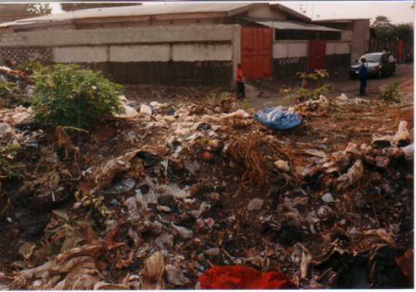
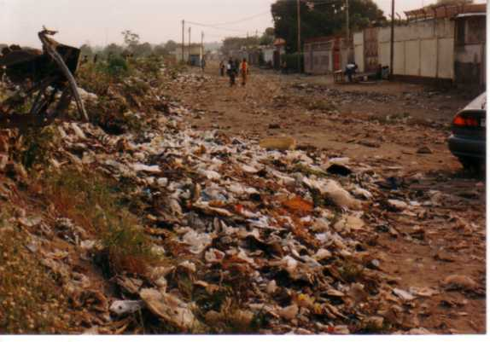

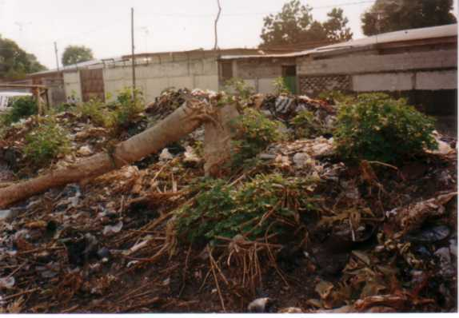

Deposits of rubbish in Brazzaville

In the whole departments, there is any mechanism of collecting and treatment water of drink. Seldom this water is available in the chief towns. It is aduring these two last years only that the place chief department of Lekoumou (Sibiti) is equipped of drinking water. The place chief of the department of Likouala (Impfondo) came to be taken into account “theoretically” within the framework a policy known as “ accelerated municipalization”. But does not run yet even if the Government gives the impression to have already solved the problem since August 15, 2005.

So certain studies attest that 52% of the households had access there (89, 6% in urban zone and 12,3% in rural zone), in 1999, this tendency is degraded; 46,3% had access to drinkable water (73,4% in urban zone and 10% in rural zone) but the attention to be retained are that when one speaks of access to drinking water , it is that which is collected and treated without however solving the true problem of its potability. Indeed, all the operations of treatment of water cancel with the outdatedness and the degradation of the distribution network. water which leaves the taps of the National Company of Distribution of water (SNDE) poses problem. In a chain of private television (DRTV) with more images were diffused presenting populations spirit to complain to have collected water of this single national network with tadpoles, hair, faeces … this in spite of the standards set at the international level (WHO, CODEX ALIMENTARIUS) and national Code of water, Code of Hygiene, Code of Environnement).

    - Conditions of detention of the children

In this heading, the Panafrican Association Thomas SANKARA makes a point of launching an alarm cry on the conditions of detention of the children (minor) to the prison of Brazzaville like elsewhere where it noted the problem of promiscuity between the district of the minors and that of the adults.

The every day, adults with the number of which the criminals, doped and the delinquents of all species share the same court. A teenager imprisoned for infringement with the criminal law of the voluntary aggravated assault, which certain professionals of crimes by the force of the things, to what will await one for the future of such a child.

The Association also noted at the time of its visit at the prison that it exists any condition and particular precaution to guarantee the right of the child imprisoned but in this circumstance, it lost only one right which is freedom and should enjoy all the other rights enacted by the Convention on the Rights of the child. the Association deplores moreover non existence of center of reception for delinquent minors.

    - Economic exploitation of the children

The Convention on the Rights of the child lays out that the child must be protected from any work endangering its health, its education and its physical development, mental, spiritual, moral and social.

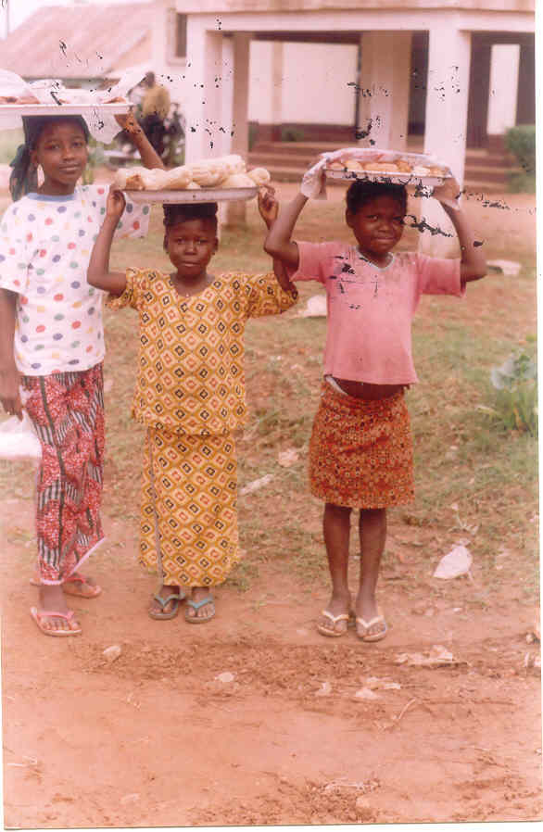

Children salesmen in the street of Brazzaville

For that purpose, the States left must, in consideration of the other international instruments, to take suitable measures relating to:

- the age or at the minimum ages to admission with the employment;
- in the working conditions;
- sorrows and other sanctions …

If, as regards the lawful texts, it is noted the existence of some null and void provisions, or misses it texts of application, the Panafrican Association Thomas SANKARA underlines reality obvious and deplorable of the economic exploitation of the children in Republic of Congo by adults without scruples which recruit them like quasi slaves “BANA MOSSALA ”, which wants to say in French “servants” maybe by the parents for the essential in rural zone which deals with the factors worsening of poverty, resign themselves to use their children for the sale of the pastoral products in the public markets and other places with the eyes and the beard of the Authorities which do not stumble. Some work all the day. Whereas Congo ratified Convention n° 182 concerning the prohibition of the worst shapes of work children and the immediate action for their elimination, on April 29, 2002.

In Brazzaville, as the remainder of the communes of the country, the municipality is unable to set up a mechanism for the clearings out of the WC by lack of suitable machines affirms one, and nature detesting the vacuum, it develops a retrograde, harmful and very dangerous system in general for the health of all and the children in particular namely the clearing out with the hand. All the cleaned excrements, they are not stored in a corner of the concession to be absorbed by the ground, they purely and are simply poured in the streets with same the ground or, by defect, in the already decayed drains and mouthfuls. Since more than one decade that this phenomenon develops on a large scale with Brazzaville, the authorities take any measurement neither to find the adequate solution , nor to sanction those which authorize such facts. These clearers of fortune are generally children whose the age oscillates between 14 and 17 years with a strong propensity of the children coming from the Democratic Republic of Congo.

s
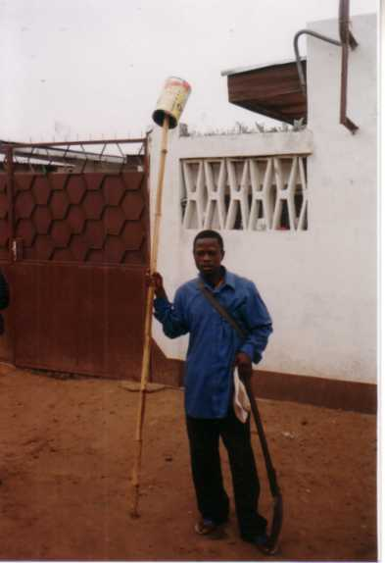
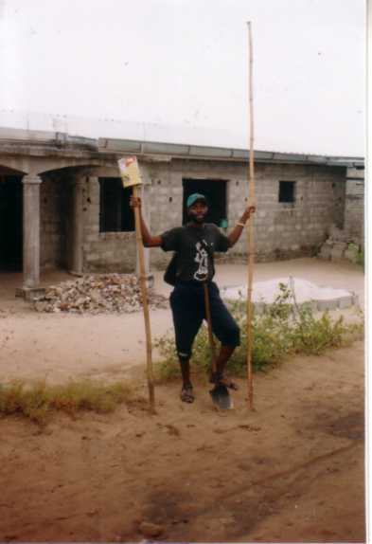
A sight of the child working in the clearing out with naked hands of the WC
in Brazzaville

This fact is so scandalous that one wonders whether the Congolese State is fully conscious of its responsibilities first; because to ratify conventions, to take texts and not to be concerned with apply them is a good manners to repudiate them. The Congolese case appears atypical on the matter.

4. CIVIL LAWS AND POLITICAL OF THE PYGMIES POPULATIONS

Inexistence of the parts Marital status

The pygmies populations almost do not have parts to Marital status. Rare are those which have national charts identity, apart from the Pygmies employed by the forest companies.

The births are not recorded with the register to Marital status. the administration is non-existent in their regions where it is necessary to traverse tens of kilometers to reach the center nearest. Notwithstanding the factors related to the dilapidation of the Congolese administration, the absence of parts of identity and non the recording of the pygmies children to the register of Marital status is the expression of the negligence and the manifest lack of consideration of the Congolese authorities with regard of this minority. Since the parts of the Marital status are the principal documents joining together the components of the legal personality, one can say that from the point of view of the law, these thousands of Pygmies are not recognized by the Congolese State.

It arises that certain agents of the State benefit from this situation to swindle the Pygmies under the pretext of draw up these documents to them. Thus, during 2002, a team of the Center of Identification of the district of MOSSENDJO remained to NGOUA II and makes the turn of the sites of Pygmies for oneself saying to establish parts of identity to them. For that, these agents of the administration coming from the district of MOSSENDJO carried out the collection of 1.000 F CFA by anybody for the recording of the pygmies children of NGOUA II. To date, these agents volitilized and Pygmies ever received neither the birth certificates, nor the national identity card promised.

With the image of deconsideration the bantous have with regard of the Pygmies on the basis of traditional belief antiquated and arbitrary, non the recognition of the legal personality of these thousands of Pygmies is the expression of the disinterest of the managers of the state in their connection. « the Congolese Government does not lay out a program of improvement of the living conditions nor of protection of the Pygmies minorities.In the same way, nowhere in our constitution, it is explicitly referred to this layer minority and vulnerable Congolese which deserve specific legal protection measures”.

With KABO, a locality located in the extreme north of the country, in the department of Sangha, this lack of parts to marital status constitutes a major difficulty for the Pygmies employed in the projects of nature conservation WCS for the realization of the administrative formalities. Mr BRACES ZOMABA, chief WCS, is obliged to carry out all the operations necessary to the regularization of their situation on the level of the departmental administration.

  - Torture and the rape: the daily batch of the Pygmies

WITH NGOUA II, it N ’ is not easy to be Pygmy. Some bantous benefit from this cohabitation to deceive their “rights”. not a week does not pass without a girl Pygmy is not violated by an individual bantou. These frequent rapes proceed in the fields, at the village and even in the boxes of these Pygmies. Bantous do not hesitate to rape the pygmies women with the nose and the beard of their husbands.

On June 25, 2003, Miss KOUMBA, girl Pygmy, by ten the individuals bantous with the bridge Lekoumou then she was violated returned of the fields only for June 2003, plus more than ten case of rapes were noted in this village of NGOUA II.

These acts of collective rapes on the pigmies girl are also held in the police station of NGOUA II. when a woman Pygmy implied in a litigation is brought to this station, it systematically undergoes “the ground with ground” which is the local designation of the collective rape, it is being said, several men pass on the same woman, with the very ground and against its liking. Here, the rapists are not other than the ex-militiamans assigned to this police station to play there the part of agent of the order. Let us recall that to NGOUA II, a locality of 5000 inhabitants, the auxiliary of police force are not framed by a police officer of trade …

Extract of the report/ratio of OCDH, carried out with the continuation of a survey carried out in 2003 with the financial support of RAINFOREST FOUNDATION (a British foundation)

5. GENRALOBSERVATIONS AND SUGGESTIONS

5.1. General observations

The general situation of the Human Rights and particularly of that of the children is very alarming in Republic of Congo where it is of day which does not cart, on a large scale, his batch of violation of theHuman Rights .

In terms of Public and Fundamental Freedoms, this country made remarkable and creditable projections and the process of democratization of the country engaged in 1991 seems to consolidate in spite of the interruption as into 1997 of the continuations of an atrocious war (more than 15000 dead and the many ones disappeared ). If on this level it still remains efforts to be agreed, on the level of the economic, social and cultural rights the situation is scandalous and the children pays a heavy tribe of it.

The principles enumerated in the convention on the rights of the child have by consequent all the sorrows to produce the improvements awaited in the situation desired for the Congolese children, with good statement the greatest number which lives in worst precariousnesses ( 70% of Congolese alive in lower part of the poverty line are less than one dollars per day).

It is allowed that the strict application of the principles required by the United Nations on the human rights in general and of the children in particular (right to satisfaction of the vital needs such care, social protection, food, water of quality, work, education …)
depends partly on the economic degree of development on each country.

But it important to underline that they can be violated because of the action or of the inaction of the authorities : they start to practise and to tolerate all those which leads a country to the desarticulation and disintegration ; for example; the corruption progresses and installs from now on like rule. With the Congolese Treasury, it is no more a secret for anybody in Congo, that to perceive his own funds, it is necessary to concede in an almost obligatory way 10 to 30% of the resources envisaged without that not worrying the decision makers in spite of the denunciations of the economic operators. Even the patients on standby to medical evacuations with the foreign must spend part of the expenses intended for their assumption of responsibility. This situation is so real and becomes cruel when it accompanies a disconcerting impunity. The evil is already such as the President of the Republic with the occasion of his speech on the state of the Nation before the Parliament assembled in congress, on Thursday August 14, 2003, stated “ a State, placed in a context of a generalized impunity, is intended for the role of a “cow with milk”. The impunity multiplies and worsens all the social deviances, like a sparrow which, if it is not driven out, will alert its similar for to eat the grains of the country-woman. The impunity, if it is not stopped, fattens and enlarges the rows of the grave-diggrs of the interests of the State »

With that, it adds facts completely paradoxical and difficult to digest. For example, the Constitution of the Republic of Congo lays out in its article 48 that “any citizen, elected official or named with a high public office are held to declare his inheritance at the time of his taking of and with the suspension of this one, in accordance with the law. the non-observance of this obligation involves the forfeiture of the functions under the conditions fixed by the law. ». But since this constitution comes into effect in 2002 which still lays out in its article 50 “any citizen has the duty to conform to the constitution …”, no congolese authority made the statement of his goods and nobody knew the enumerated forfeiture, the continuation is known with the massive diversions of the resources of the country profit to an europeocentrism elite (villas, bank accounts, schooling of the children, care of the members of the family in the Western capitals). It is also observed, a marked taste of the luxury, lucre, and financing of the great actions of prestige of the remainder glorious instead of public actions interest (road, agricultural track, school, drugs, social protection for all …)

4.1.SUGGESTIONS

In the light of this which proceeds, the writers of this report suggests at the Committee of the Rights of the child to put forth the recommendations hereafter:

with the Congolese Government

- to determine to make the application of the requirements known as of “good governorship” the rule of gold in the management of the public thing;
- to put on foot a coherent and effective program to fight by all the means corruption, the misappropriation and the diversion of the public money;
- to revalorize the school and the teaching function on the together of the territory in tally of an urgency program , as much for the other services of the State;
- to equip Brazzaville in a program in the very short term, services of clearing out and WC and of public health drains;
- to create for each Court of Bankruptcy, the institution of the “judge of children and to equip them with modern budget buildings and equipment of work;
- to revalorize function of the social assistance in the country by equipping this department with personnel in a sufficient number and of the consequent budgets to try so much oneself little to save the lives unweaves some in an enormously considerable number ;
- to make to respect the regulation relating to the detention of the minors and to create with the collaboration of NGO, THE UNICEF, THE UNESCO and services adapted for the minors imprisoned in the prisons;
- to re-examine with raise, the family benefits for the children and to extend them from direct or compensatory manner by the means of the social services to all children of Congo;
- to re-examine in urgency the situation of the private schools (immobilization, quality of teachers …);
- to guarantee the access to the care of quality for all by instituting the social services equipped with the budgets useful for the assumption of responsibility of the poor ones;
- to regulate videoclubs particularly diffusion of pornographic films with the minors;
- to work out and to settle a national program for the socioeconomic and cultural development of the pygmy minority . Within the framework of it program, to guarantee and promote the access to the fundamental teaching of children Pygmies by the creation of the schools near the pygmies villages or will be practised the exemption of any expenses of schooling and free equipment of school stationery;
- to engage procedure to development and the adoption of a law specifically protecting civil laws and political of the members of the pygmy community This law will have:
- to guarantee the right to the physical, moral and physiological integrity of the Pygmies by the systematic repression of the acts of torture, of the cruel treatments, inhuman or degrading including the rape of the pygmies women and racial discrimination and intolerances which are associated there;
- to support the access of the members of the community Pygmy to the management of the public affairs and to reinforce the authority of the persons in charge Pygmies in the villages;
- to penalize the exploitation, by individuals bantous and forest companies, Pygmies, through work heavy and badly remunerated in violation of fair labor standards act;
- to guarantee, protect and promote expressly the right of the Pygmies to the land ownership.

with the financial backers of the bilateral and multilateral funds

If Republic of Congo is well provided in inert resources, it remain obvious it knows enormous structural problems to capitalize its richnesses with the service of the general interest So it is important to profits from the international assistance:

  - formation and recycling of the Executives;
  - external financing in support with the program of the government;
  - support in the negotiations of Congo with the partners of Breton Woods;
    - more constant support in NGO aiming to achieve goals enacted by the convention on the rights of the child in particular and the Human rights in general.

CONCLUSION

As shows it the facts supported in this report the situation of the Human Rights in general and of the Children as a private individual remains very alarming in Congo.

The country is confronted with an excessive debt, which puts it in a late situation live with screw of the bilateral and multilateral backers.

This increasing national debt constitutes a real obstacle with the revival of the economic activity. Without the resolution of this question of the debt, there is little hope to in the near future see, the situation related to the well-being populations and particularly children to improve.

The Panafrican Association Thomas SANKARA supports to this end, the efforts of the Government in progress to reach the initiative of the heavily in debt poor countries. It remains also true that the cancellation of the debt without the improvement of Governorship will not improve large thing as underlines it Professor Charles Zacharie BOWAO in its work entitled “mondiality, between the history and the future” on page 16 acting of Congo that “all is related to a question of political good-will, organization of the authorities and therefore, methodical management of human, financial and natural resources”

Appendix

List of participants in the drafting of the report

- NGO

  - Association Panafricaine Thomas SANKARA ;
  - Fondation Panafricaine de Lutte Contre le Tribalisme ;
  - Association Congolaise pour la Défense du Droit ;
  - Conseil Culturel d’Education pour la Santé ;
  - Ligue Congolaise Droits de l’Homme ;
  - Communauté de Développement et d’Actions Sociales au Congo.

- Individualities

  - Hervé KENGOYA ;
  - Hélène DZING ;
  - Henriette OKEMBA.

Personalities met
1- The Public prosecutor close the Court of Bankruptcy of Brazzaville;
2- The Judge of the children close the Court of Bankruptcy of Brazzaville;
3- The Director General of Social action.

