

Brussels, 23 February 2006

PRESS RELEASE

EFSCW European Forum

Rome - 16 and 17 February 2006

“Child Inclusion as a Challenge to the Mediterranean Partnership of the EU – the consequences of migration on children at risk in Southern European Member States: Analyses, Concepts and Strategies” –

Conference organised in collaboration with the Representation of the European Commission and the Information office of the European Parliament in Italy

The phenomena of increasing migration flows especially with regards to children are representing a growing strain on and challenge for the European Union particularly throughout the Southern European Member State region, which borders many countries of origin.
Which answers can be given at EU level and in the different Member States concerned? Which solutions can be found to prevent the risk of a “ghetto phenomena”? What measures to take at EU- and national level to guarantee a successful insertion of migrant populations including children into the European Union with a special focus on its Mediterranean countries?
Over 70 representatives from EU and international institutions, including high-ranking EU officials such as the European Commission and Parliament’s Vice-Presidents, Mr. Franco Frattini and Mr. Antonios Trakatellis, national and local governments and authorities as well as social NGOs working with children at risk met last week at EFSCW’s European Forum to tackle questions, debate, and make proposals on new child inclusive policies taking into account the aspects of unaccompanied foreign minors, child trafficking, and the consequences of migration on children in EU’s Southern Member States into specific consideration.

After welcoming her guests on behalf of the European Foundation for Street Children Worldwide (EFSCW), the President, Maartje van Putten, recalled: “The integration of migrant children places stringent demands upon the cooperation required of both, social and economic groups and can only be successful, if they work in absolute harmony. This cooperation must also involve the immigrant families as well.“

She insisted on fighting illegal migration and related phenomena like child trafficking. Furthermore, she underlined that a sustainable policy of integration, especially of migrant children, can only function when both national and European policies converge much more closely in the future. In this sense she warmly welcomed the new initiative of the European Commission, co-ordinated by Vice-President Mr. Frattini, to adopt a communication on the protection of children. She reminded that children of migrants should also be considered as part of the solution to the demographic problems facing European societies in the future. This should even be regarded as an economic necessity.

This event, particularly rich in exchange between all above-mentioned actors, successfully assessed the situation and problems of migration and unaccompanied children in the different Member States such as France, Greece, Italy, Portugal and Spain and tackled required solutions to the issues at EU-level. It also clearly demonstrated and established the importance of NGOs as “facilitators” and “dialogue initiators” between different institutions, minors at risk and concerned authorities.

In this respect, Mr. Frattini pointed out the great importance of a “Common European Strategic Vision on Children’s Rights” and the European Union’s moral duty to comply with the UN Convention of the Rights of the Child. As such, he declared the protection of children’s rights as one of the highest institutional priorities to be ensured by a series of measures by the European Commission.

“If we have harmonised legislation in the European Union in the matter of child protection, we do not give criminals the opportunity to take advantage of legislation differences in the Member States”, Mr. Frattini told participants. He continued by taking a strong stand with regard to the disrespect of children’s rights on the pretext of tradition, religion, historical and/or cultural differences. As an example of such intolerable practice, he cited the restrictions for girls to take part in education and the current high rate of female school drop-outs based on religious discrimination and/or violence perpetrated on Gipsy and Roma children under the justification of “tradition and culture”.

“We cannot tolerate the respect of such traditions when they are against the rules and principles of the European Union. As such, principles and tangible actions in the matter of child protection have just been drafted as a result of the debate and a consultancy process between the European Commission and organisations like the European Foundation for Street Children”, he informed delegates.

“We often forget the integration issue. Within the important issue of immigration, we need a specific part focussing on children because they are often neglected and considered as a simple “annex” to their parents immigrated to the European Union”.

He also added that in the past, there was a lack of steady and transparent debate between civil society working for children and public institutions: “It is important the dialogue with you as the addressees of our initiatives”. The adoption of this new strategy that Commissioner Frattini called a “European Charter for Children’s Rights” will take place in June 2006. It will not only be a strategic and political document but also a call for action. Following its publication, it will be discussed in a hearing at the European Parliament to invite national Parliaments to take this call of actions into consideration.

Further important steps toward the safeguarding of fundamental rights including minors’ rights mentioned by the Commissioner were the establishment of the “Agency for Fundamental Rights” foreseen for the end of 2006 which will induce stronger control of detention conditions in Member State prisons, the creation of a “European Criminal Record” to protect children from (sexual) exploitation welcomed by Europol, and the establishment of a “European number to help children in difficulties“; a project that up to now has been opposed by different Member States jealous of their national numbers”.

Special focus was put on the prevention of children’s exploitation and abuse. As such, the Commissioner stressed the importance of awareness on national level and gave the examples of travel agencies, which should not encourage – directly or indirectly – sexual tourism via their tourist promotion and that in case of adoption, the strict compliance with EU rules and regulation in the matter has to be proven and demonstrated.

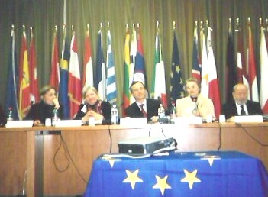

Speech of the Vice-President of the European Commission and
Commissioner for Justice, Freedom and Security, Mr. Franco Frattini (in the middle)

EFSCW European Forum

Representation of the European Commission in Italy – Rome, 17.02.06

Mr. Luis Miguel Pariza Castanos from the European Economic and Social Committee also highlighted the importance of harmonised EU-policies in the matter of children’s rights and stressed the crucial role played by NGOs in the creation of a dialogue between the authorities and young migrants often living in ghettos and isolation.

The Vice-President of the European Parliament, Mr. Trakatellis, declared: “If we consider that immigrants in search for a better life are in most cases driven by economic reasons, EU Institutions and the Member States have to act together to correct this situation. “

Owing to Mr. Trakatellis, a good development assistance plan, the improvement of security and controls on EU borders and the promotion of mechanisms allowing smooth integration into host societies should be the three major pillars of EU immigration policy.

“If we want to strengthen the Euro-Mediterranean Partnership to improve cooperation on illegal immigration and development, we need to allocate adequate financial means to achieve this goal”, Mr. Trakatellis underlined. He pointed out the current budget cuttings on EU funding and assistance programmes, especially regarding youth programmes. “The EU Institutions need to take political responsibility with regard to the question of immigrant children and minors”, he concluded.

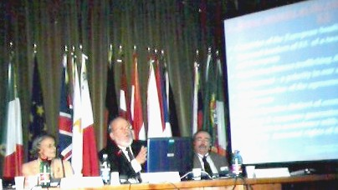

Speech of the Vice-President of the European Parliament, Mr. Antonios Trakatellis
(in the middle)

EFSCW European Forum

Representation of the European Commission in Italy – Rome, 17.02.06

EFSCW’s director, Reinhold Müller, stressed the following points in his concluding remark summarizing main conference results:

- The great importance of NGOs in creating and stimulating the dialogue between different institutions and actors concerned on EU, national and local levels in children’s and youth matters
- The important role of NGOs as “mediators” between institutions and authorities and civil society, as they know the situation in the field - the real problems, issues and needs of children and youth at risk due to the daily contacts of their (often voluntary) work force with this target group.
- The need for up-to-date (statistical) data and more transparency – there is a great lack in reliable data concerning children and youth at risk. This data is of vital importance in finding possible solutions to the problem at EU-level.

In order to improve this situation EFSCW intends to present a “European Report on Street Children” in the next two years which will contain the relevant data and statistics on the situation of these most vulnerable children in the European Member States and the accession countries.

EFSCW’s next big conference which is planned for October 2006 in Athens will deal with the topic of “Social inclusion of Roma children in the educational process as a challenge to the EU expansion process in South-East Europe”. Furthermore, EFSCW’s recently submitted to the European Commission a project within a call of the EU assistance programme DAPHNE which aims at combating violence against women and children. In close co-operation with its member organisations in Greece, Portugal and Italy, the project aims at providing reliable and comparable data and figures on violence faced by street children in three European urban areas (Athens, Lisbon and Palermo) with the goal of preventing such violence and raising public awareness on the issue.
The Commissioner congratulated EFSCW and welcomed all of these initiatives and projects.
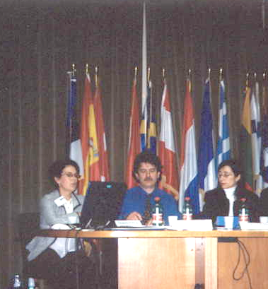

EFSCW European Forum

Representation of the European Commission in Italy – Rome, 16. - 17.02.06

For further information, contact the EFSCW Information and Public Relations Officer by email on melanie.vritschan@enscw.org or by telephone + 32 2 347 78 48.

