
LUBUTO LIBRARY PROJECT FACTSHEET
Bringing knowledge and enlightenment to Africa’s street children
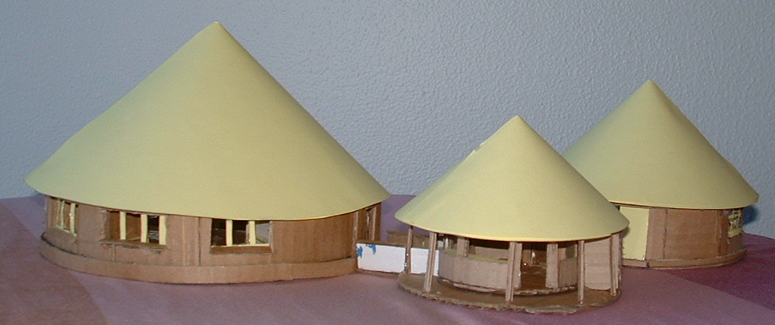
Architect’s model of library in traditional Zambian homestead style: Entry (center), Activities Building (right), Library Reading Room (left) | Construction of 1st Library, Lusaka, Zambia; Completion date: February 2007

- The Lubuto Library Project (www.lubuto.org) is a Washington, DC-based 501(c) (3) non-profit, incorporated in January of 2005 to:

 provide literacy skills and basic education for sub-Saharan Africa’s orphans, street kids and other vulnerable and out-of-school children—most collateral victims of HIV/AIDS—by building and stocking secure, open-access libraries hosted and staffed by local social service agencies working with at-risk children; and

 enlighten US schoolchildren about the impact of HIV/AIDS on their African peers.

- Lubuto Libraries will fill an important gap in services to vulnerable children in Africa by providing a bridge to schools and social services that are beyond the reach of vast numbers of them, particularly the street children.


- The Lubuto Library Project grew from the great success of a makeshift library established in a converted shipping container at the Fountain of Hope in Lusaka, Zambia, in 2001, which has enabled users to pass the secondary school exam and has proven completely sustainable after 5 years with no external inputs.

- Each Lubuto Library will house a first-rate collection of 5,000 primarily non-fiction, sturdy books adhering to careful guidelines (attached) established by expert children’s librarians. The collections are assembled and classified by US student volunteers in community service work. Local-language books will be added to the collections in Africa. Library staff will be trained by professional librarians to offer enriching programs and services.

- Lubuto Libraries will hold events with traditional storytellers—giving the children the opportunity to transcribe and help preserve a vanishing oral culture, as well as create their own books.
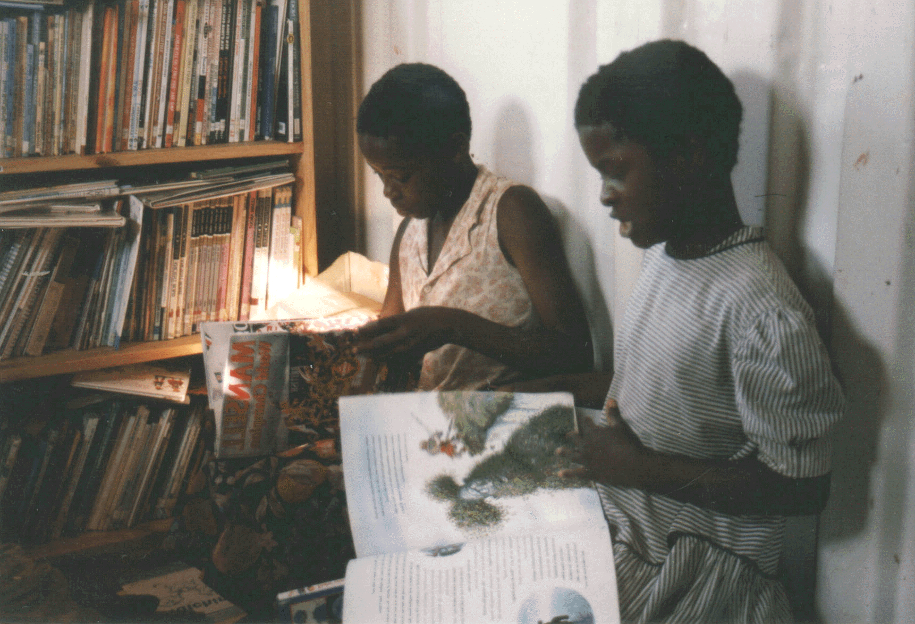
- Lubuto Library Project president and founder Jane Kinney Meyers, MLS, has spent 25 years as an international development librarian, including work with the World Bank and US Agency for International Development. Ms. Meyers lived and worked in Zambia and Malawi for some 7 years.

- The Lubuto Library Project has a regional office in Lusaka, Zambia, which is a registered non-governmental organization.

- The Lubuto Library Project plans to expand into other sub-Saharan African countries, including those that are French- and Portuguese-speaking, after building 100 libraries in Zambia.

- “Lubuto," in the language of the Bemba people of Zambia and the Democratic Republic of the Congo, means "enlightenment, knowledge, and light."

Lubuto Library Project, Inc., 5505 Connecticut Ave., NW, #368, Washington, D.C. 20015-2601, USA  202-558-5609
Zambia Regional Office, P.O. Box 50548, Ridgeway, Lusaka, ZAMBIA
Jane Kinney Meyers, President  mayazi@verizon.net  www.lubuto.org

