1st International JUCONI Conference–For a World Without Violence
“Domestic violence, children and marginalization: challenges and solutions”
Date
- 29th Nov - 1st Dec 2010

Venue:
- Centro de Convenciones Puebla (Puebla’s Convention Centre)
Boulevard Héroes del 5 de Mayo No. 402
City Centre
Zip Code: 72000
Puebla, Puebla
http://www.convenciones-puebla.com.mx/

We will have the participation of internationally renowned speakers, such as:
- Sandra Bloom, M.D.: Trauma/Stress Specialist

- Janine Roberts, Ed. D.: Family Therapy Expert

- Feggy Ostrosky, Ph. D.: Neuroscience Specialist

- Dr. Anita Schrader: Families and Communities Expert

- Dr. Eliana Gil: Play Therapy Specialist

- Lyndra Bills, M.D.: Art Therapy Specialist

- Arthur Rolnick Ph. D.: Economist

Topics:
- Violence, trauma and neuroscience
- Methods and techniques to prevent violence
- Therapeutic educational methods and techniques to treat individuals, groups, communities, and families
- How to prevent and treat ‘vicarious trauma’ present in professionals who work with people affected by intrafamily violence
- Psycho-emotional development
- Social and emotional intelligence
- Creating contained environments

- Parenting schools

- Policies to combat intrafamily and social violence

- And much more…

Activities programmed:
- Plenaries
- Simultaneous conferences
- Specialized workshops
- Thematic/reflexion groups

Recovery Fee:
- MXN $1,000.00 (One Thousand Mexican Pesos ) per participant

Registration period:
- From June to October
- Registration during June and July (50% off)
- Registration during August and September (25% off)
- Registration during October (No Discount)

NOTE: Groups with more than 5 participants will be given an extra 10% off in the period in which they register; it is indispensable to register as a group for the extra discount to be considered.

We will soon send out more more inform on the programme and registration process.

Accommodation Options:
(All fees are in Mexican Pesos, should you want an estimated exchange rate, we recommend this website: http://www.xe.com/ucc/)

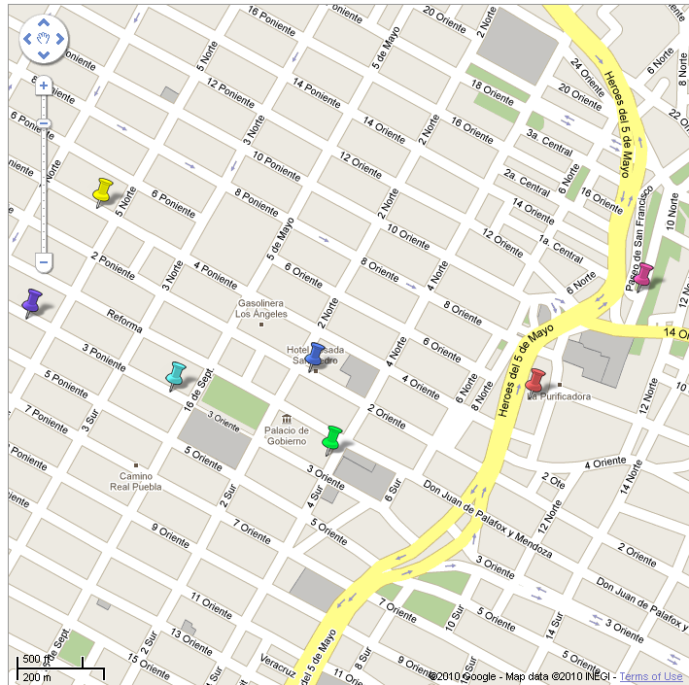


Centro de Convenciones Puebla (Puebla’s Convention Centre)

HOST HOTEL

City Express Puebla Hotel
Calle 10 Norte No. 1406
City Centre
Zip Code: 72000
Puebla, Puebla
Telephone: +52 (222) 2.13.73.30
www.cityexpress.com.mx

Single Room for 1 or 2 People MXN $ 802.40
Double Room for 2 People MXN $ 885.00
Double Room for 3 People MXN $ 991.20
Double Room for 4 People MXN $ 1097.40

To get to the Convention Centre:
Walking Distance: 5 minutes
No Taxi needed

OTHER ACCOMMODATION ALTERNATIVES


Posada San Pedro Hotel
2 Oriente No. 202
City Centre
Zip Code: 72000
Puebla, Puebla
Telephone: +52 (222) 8.91.57.00
http://www.hotelposadasanpedro.com.mx
Room for 2 or 3 People MXN $ 708.00
Room for 3 or 4 People MXN $ 826.00

To get to the Convention Centre:
Walking Distance: 5 to 10 minutes
By Taxi: MXN $30.00


Colonial Hotel
4 Sur No. 105
City Centre
Zip Code: 72000
Puebla, Puebla
Telephone: +52 (222) 2.46.46.12
http://www.colonial.com.mx/

Room for 1 Person MXN $ 670.00
Room for 2 People MXN $ 770.00
Room for 3 People MXN $ 870.00
Room for 4 People MXN $ 970.00

To get to the Convention Centre:
Walking Distance: 15 a 20 minutes
Taxi: MXN $30.00


Santiago Hotel
3 Poniente No. 106
City Centre
Zip Code: 72000
Puebla, Puebla
Telephone: +52 (222) 2.42.28.60
http://www.hotelsantiago.com.mx/

Room for 1 or 2 People MXN $ 420.00
Room for 3 or 4 People MXN $ 580.00

To get to the Convention Centre:
Walking Distance: 15 minutes
Taxi: MXN $30.00


San Ángel Hotel
4 Poniente No. 504
City Centre
Zip Code: 72000
Puebla, Puebla
Telephone: +52 (222) 2.32.27.66
http://www.hotelesenpuebla.com/angel.htm

Single Room for 1 or 2 People MXN $ 400.00
Double Room for 2 People MXN $ 530.00
Double Room for 3 People MXN $ 640.00
Double Room for 4 People MXN $ 760.00

To get to the Convention Centre:
Walking Distance: 20 minutes
Taxi: MXN $35.00


San Agustín Hotel
3 Poniente No. 531
City Centre
Zip Code: 72000
Puebla, Puebla
Telephone: +52 (222) 2.32.50.89
http://www.hotelesenpuebla.com/agustin.htm

Single Room for 1 or 2 People MXN $ 220.00
Double Room for 2 People MXN $ 310.00
Double Room for 3 People MXN $ 350.00
Double Room for 4 People MXN $ 410.00

To get to the Convention Centre:
Walking Distance: 20 minutes
Taxi: MXN $30.00
For further information please contact:

Mayte Romero Abiti
Tel.: +52 (222) 2.37.88.37
E-mail: congreso@juconi.org.mx

