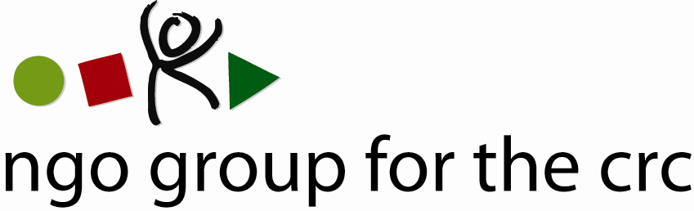

Internship Announcement

The NGO Group for the Convention on the Rights of the Child is looking for interns for 6 months for the period of July-December 2011.
The NGO Group works to promote, implement and monitor the United Nations Convention on the Rights of the Child (CRC). It is a registered network that was formed in 1983 and currently has 79 member organisations committed to all children fully enjoying their rights as defined by the CRC. Its Secretariat is based in Geneva, Switzerland.
The NGO Group is a bridge between the UN Committee on the Rights of the Child, national NGOs and coalitions, international NGOs and other international organisations. At the core of the NGO Group’s activities is the provision of technical assistance and training to national NGOs and coalitions to ensure that they can better promote, implement and monitor the CRC in their national contexts. Through its Secretariat in Geneva, the NGO Group works with national NGOs in over 150 countries as well as the Committee on the Rights of the Child. In addition, the NGO Group works towards mainstreaming children's human rights in the broader UN human rights system.

Job description

Job title: Intern – Child Rights Assistant
Based: Geneva, Switzerland
Mandate: Support the work of the Secretariat in relation to the CRC and the Human Rights Council (HRC)

Main Responsibilities and Tasks
- Monitor sessions of the Committee on the Rights of the Child and prepare analytical reports.
- Assist in the preparation of the pre-sessional working group meeting of the Committee, including logistical, organisational and hosting responsibilities.
- Follow relevant sessions and events of the Human Rights Council and report accordingly.
- Provide administrative and logistical assistance, including for member organisations, thematic sub-groups, and the Executive Committee (writing minutes, arranging meetings, visas, flights, filing, etc.).
- Map child rights national coalitions around the world and update database accordingly.

Person Specifications
- Demonstrated commitment to, and experience in, child rights or related issues.
- Excellent spoken and written communication skills in English, including ability to draft clear and concise reports. A working knowledge of French or Spanish is an asset.
- A university degree in law, political science, international relations or other related disciplines.
- Knowledge of the international human rights legal system and corresponding instruments.
- Strong sense of responsibility and independence as well as good teamwork skills.
- Computer skills including Excel and Word.

A small monthly allowance covering local transport in Geneva and lunch is provided to interns.
Interns are responsible for the relevant documentation that permits them to work legally in Switzerland.

Application Deadline: May 13th, 2011
Please send a CV, cover letter, a writing sample (preferably child rights related) and one written reference by email to:
Roisín Fegan
Child Rights Officer
NGO Group for the CRC
fegan@childrightsnet.org

NGO Group for the Convention on the Rights of the Child
1, rue de Varembé, 1202 Geneva, Switzerland Tel: +41 22 740 47 30 Fax: +41 22 740 11 45
Website: www.childrightsnet.org

