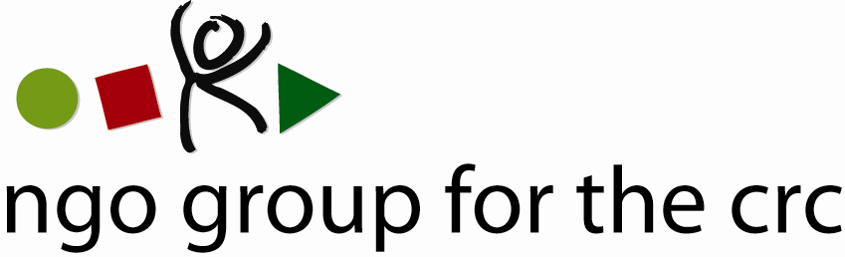

Child Rights Officer (100%)

NGO Group for the Convention on the Rights of the Child

The NGO Group for the Convention on the Rights of the Child is an international network of national and international organisations guided by the vision of a world in which children’s rights are universally recognised and realised. We work to facilitate the promotion, implementation and monitoring of the UN Convention on the Rights of the Child (CRC).
Our small and dedicated secretariat plays a central role in supporting NGOs from around the world, the Committee on the Rights of the Child and children to monitor and implement the CRC.
Location: Switzerland – Geneva
Starting date: as soon as possible
Salary: Geneva NGO salary scale
Contract duration: Initial one-year contract (3 month probation) with possibility of renewal
We are looking for a Child Rights Officer with a strong commitment to children’s rights who has effective experience in (written and oral) communications, capacity building, and monitoring and/or implementation of the CRC. This position involves a combination of project management, technical assistance, writing, training and administration skills. The ideal candidate will be passionate about supporting national NGOs and children to effectively monitor and implement the CRC, have good political sense, be hard working and have excellent drafting skills.
RESPONSIBILITIES
The Child Rights Officer works under the direction and supervision of the Coordinator who manages the Secretariat of the NGO Group. The main responsibilities include:
- Coordinating the effective participation of national NGOs and children in the alternative reporting process of the UN Convention on the Rights of the Child and its Optional Protocols.
- Writing and editing country and session reports, managing the NGO Group’s website and the alternative report database and contributing to publications on the work of the Committee.
- Developing the capacity of NGOs through ongoing technical assistance and training.
- Playing an active role in developing and implementing strategies to facilitate child participation, follow-up of the Committee’s recommendations, and promoting the mainstreaming of child rights in other treaty bodies.
- Working closely with colleagues, member organisations, the Committee on the Rights of the Child, and other relevant UN human rights bodies, intergovernmental organisations, and NGOs.
- Recruiting and managing interns to work on the CRC.
QUALIFICATIONS
The successful candidate will have:
Education & Professional Experience
- Post-graduate University Degree (Master or equivalent) preferably in international human rights law, political science, development/international relations;
- Minimum of 3 years professional experience in child/human rights and proven knowledge of the UN treaty body system;
- Work experience with an NGO and the UN human rights system or other intergovernmental organisation highly desirable;
- Understanding of, or experience in, implementing and monitoring child rights in a national context;
- Experience in supporting meaningful child participation in working on their rights desirable.
Essential Skills
- Demonstrated commitment to child rights;
- Native-level English speaker with excellent written and oral communication skills. Working knowledge of French, Russian or Arabic highly desirable;
- Analytical/problem-solving skills and attention to detail;
- Organisational and time management skills;
- Interpersonal and networking skills , including ability to work as part of a multi-cultural team and with key partners;
- Ability to work under pressure with minimal supervision and achieve desired results;
- Training skills, including planning and conducting trainings on child rights;
- Experience in managing a website;
- Good judgment and strategic planning skills.
How to apply
Your application should be submitted in English and should include your curriculum vitae, a cover letter describing your experience and suitability for the post (max 800 words) , names and contact details of two references including your latest employer, and a brief writing sample in English (unedited by others) .
Closing date for application: 30 July 2010
Please send your application with the reference ‘Child Rights Officer’ to:
recruitment@childrightsnet.org
Please appreciate that due to the volume of applications, only complete applications will be considered and shortlisted candidates will be contacted. Please understand that we cannot respond to phone enquiries.

For more information on the NGO Group, please visit: www.childrightsnet.org

