

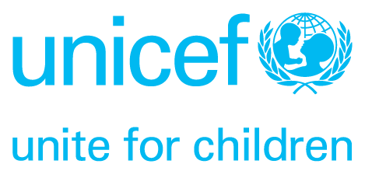
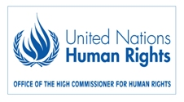


Moral Imperatives to Legal Obligations – In search
of Effective Remedies for Child Rights Violations
12-13 November 2009

Giving children the voice they deserve

The Convention of the Rights of the Child was adopted by the UN General Assembly in 1989, has been ratified by close to all states and is recognized as international law. The Convention does not just state what children’s rights are – it goes much further, obliging governments to take all necessary steps to ensure that children’s rights are realised in their country as well as to co-operate internationally on their fulfillment worldwide. Working with the Convention has paved the way for children to be understood as pro-active subjects of human rights and no longer mere objects of concern.

However, twenty years on, violations of child rights are still rarely addressed in courts, and effective remedies are therefore not available to those children that fall victim to such violations.

“Legal action on child rights is still in its infancy in comparison with, for example, the women’s rights movement” says Roberta Cecchetti, Representative to the UN in Geneva. “When a woman is a victim of a violation of her rights, women’s organisations would immediately take legal action and seek justice. When a child is a victim of a violation of his/her rights, child rights organisations would usually write a report… It is now time to go beyond that and start challenging child rights violations in courts.”

The following examples demonstrate how the rights of children have been litigated in court – but such examples are rare, and the Convention is noticeably absent.

- A group of 18 Roma children from the town of Ostrava in the Czech Republic case brought a case to the European Court of Human Rights in 2000 alleging that their assignment to “special schools” for children with learning disabilities contravened their right to education without discrimination. The case prompted the Czech Republic to change its legislation, but the problem is not yet rectified.

- In reaction to starvation deaths that had occurred in India in 2001, a coalition of Indian NGOs petitioned the supreme court of India for enforcement of national food schemes and the Famine Code, a code permitting the release of grain stocks in times of famine. As a part of this judgment the court also ordered the reinstatement of the school lunches programme which had essentially closed down in most of the states of India. The reinstatement made education an actual possibility for many impoverished children who were reliant on free school mid-day meals in order to be able to attend school.

The rights included in the Convention are still too often considered merely moral objectives. This is a unique opportunity to mobilise civil society and bring the Convention on the Rights of the Child into the courtroom, where it rightfully belongs.

