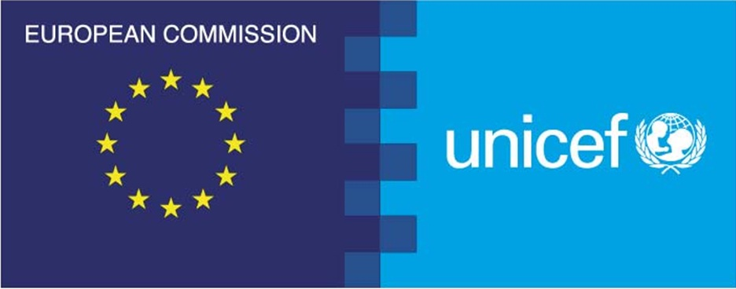
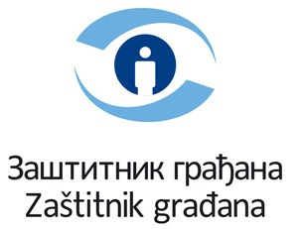 Project financed by the European Union
in partnership with UNICEF

Press release
„PROMOTING GOOD PARENTAL PRACTICE IN SERBIA:
POSITIVE PARENTING AND BANNING CORPORAL PUNISHMENT“

Belgrade, 25 October 2012 – The initiative “PROMOTING GOOD PARENTAL PRACTICE IN SERBIA: POSITIVE PARENTING AND BANNING CORPORAL PUNISHMENT”, created as a part of the Ombudsman and UNICEF cooperation, has been presented today in Belgrade.

Goals of the initiative are to raise public awareness about the values of positive parenting and to promote positive parental practices among parents, as a replacement for disciplining children by using corporal punishment as a method of upbringing.

Official Position Paper by the Ombudsman on Corporal Punishment of Children has been presented at the conference. It lists many reasons to ban corporal or physical punishment of children in all settings, including the family, for purposes of disciplining and upbringing.

“A society that prohibits any form of violence among adults, cannot at the same time accept or even express approval when children are subjected to some form of physical assault, injury or intimidation, even if that is for the purpose of upbringing and disciplining by those responsible for the child growing up. The Ombudsman believes that a legal ban on punishing children with a blow against a part of the body and on using other forms of physical force is precisely the right way to banish the ugly practice both from the family and from parent-children relations. Without the explicit legal ban, corporal punishment is considered to be allowed – despite all the facts as to its harmfulness and appeals by experts” pointed out Tamara Luksic Orlandic, Deputy Ombudsman for Children`s Rights, presenting the position of the Ombudsman.

“Being a parent is one of the most demanding, but also one of the most rewarding jobs that we have in our lives. Unfortunately, there is no equivalent to a driving license for becoming a parent, or a university degree for good parenting. However, parents have two important compasses that should lead them: human rights standards and scientific facts. Both of these send a clear message: children need to be protected from violence, because violence hinders their development. And corporal punishment is a form of violence”, said Lesley Miller, UNICEF Serbia Deputy Representative.

Children and youth do recognize inefficiency as well as harmful consequences of corporal punishment on children. First research among youth conducted by the members of the Youth Counsellors Panel about the youth opinion on corporal punishment showed that over 80% of young people thinks that the children can be taught about the misbehaviour without beatings and recognize that beating can harm both the body and the personality of a child, while 63% recognize that the corporal punishment teaches the children to be afraid, and not to understand. Four fifths of the examinees stated that if their parents explained to them why something should not be done, it would have a greater effect on them than if the parents would beat them. In addition, 82% of them stated that they would not physically discipline own children when they become parents.

In the end, promotional-educative materials designed by the Ombudsman experts “Parenting without beating your children” have been presented to the audience, and they will be distributed to selected schools and primary health centres around the country. The materials contain useful information about the positive parenting and harmful consequences of utilizing physical force on children, as well as suggestions of concrete ways and techniques that can be used in upbringing children efficiently, without violence.

Cooperation of UNICEF and the Ombudsman is realized within a two-year regional project “Protecting Children from Violence in South-East Europe” financed by the European Union with 1,65 million euros. The project is implemented in Albania, Turkey, Bosnia and Herzegovina and Serbia with the aim to strengthen the services that should recognize, monitor and act against violence over children through the strengthened partnership between the civil society and decision makers on the national level.

For additional information please contact:

Snezana Nesic
Advisor in the Deputy Ombudsman team
tel: 064 876 8561
е-mail: snezana.nesic@ombudsman.rs

Sinisa Djuric,
UNICEF Partnership Specialist
tel: 011 3602 113
e-mail: sdjuric@unicef.org

