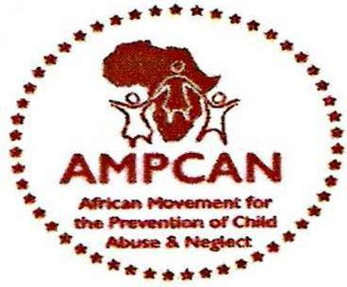
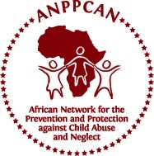


Background -
AMPCAN Ghana working in collaboration with ANPPCAN Regional Office, Nairobi, Kenya and PLAN Netherlands, is organizing The Second International Conference in Africa on Child Sexual Abuse. The Conference is inviting registration of delegates and the submission of abstracts / papers and posters for consideration for presentations at the Conference around the sub-themes of the Conference.

Objectives -
- To ascertain improvement in research and practice on Child Sexual Abuse in Africa
- To identify pertinent issues that hinder or enhance responses to Child Sexual Abuse in Africa
- To provide a forum for learning responses on Child Sexual Abuse globally

Theme -

Taking Stock of the Status of Child Sexual Abuse in Africa since the First International Conference held in 2007 in Nairobi, Kenya

Sub-Themes -
- Building organizational capacity to manage Child Sexual Abuse in Africa
- The role of legislation and policies on Child Sexual Abuse
- Strategies on Child Sexual Abuse prevention
- Child Sexual Abuse in institutions of care and learning in Africa
- Good practices in research and practice on Child Sexual Abuse
- Child Sexual Abuse in armed conflict situations
- Sexual abuse affecting children with special needs e.g. deaf, visually impaired, the physically challenged, and the deafblind
- Sexual abuse relating to the killing, harvesting and selling of body parts

THE SECOND INTERNATIONAL CONFERENCE IN AFRICA ON CHILD SEXUAL ABUSE

Registration of Delegates -
The Conference is inviting potential delegates to register to attend the Conference. The Registration fees are as given below. Delegates are encouraged to register earlier to benefit the low rates.

Registration Categories | Prior to 1st Nov, 2011 | Prior to 31st January 2012
Local (Ghanaian) Students | Cedis 50
International students | USD 50 | USD 80
Ghanaian Citizens | USD 80 | USD 120
Participants from Africa | USD 90 | USD 130
Participants from the rest of the world | USD 150 | USD 180

Call for Abstracts -
The Conference gives an opportunity to interested participants to submit abstract(s), case studies and posters. Participants whose case studies, abstracts and posters are selected will be given an opportunity to present them during the Conference. The deadline for the submission of abstracts and posters is November 25, 2011.

For more information on the conference, registration and abstract submission please visit our website at www.anppcan.org or www.ampcanghana.org and download the Abstract Submission Guidelines and Registration Form.

For More Information -
African Movement for the Prevention of Child Abuse and Neglect
(AMPCAN), Ghana Address: # 200 Westlands Boulevard, West
Legon, Accra. Postal Address: OS 38, Osu, Accra, Ghana
Telephone: 00233302 423239 or 00233 264644997 (Samuel)
Website: www.ampcanghana.org, and www.anppcan.org
Email for Conference: conference@ampcanghana.org

Date: 12-14 March 2012 Venue: La Palm Royal Beach Hotel - Accra, Ghana

For more information: visit the conference home page at www.anppcan.org or www.ampcanghana.org
E-mail the Conference secretariat at conference@ampcanghana.org, enyonames@yahoo.com, or info@anppcan.org

