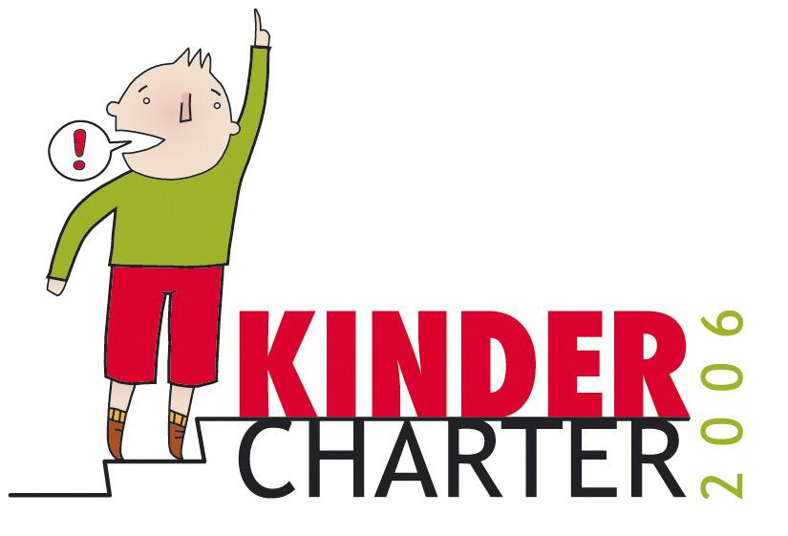
Children &
Local elections
Belgium

In a nutshell:
In Belgium local elections will be organised in October 2006.
As children have no right to vote, the Flemish Child Friendly Cities Network organised an action in order to give children the possibility to raise their voices and to influence the local elections by an indirect way. The Network decided to organise a consultation of children. This consultation has resulted in a CHILDREN’s CHARTER.
This charter is send out to all political parties and to all municipalities to inform them about the desires and the needs of children.

The consultation:
All local youth organisations were invited to co-operate on this charter. We asked them to work with small groups of children. For them 14 posters were developed offering incentives on these themes:
- after school childcare - restaurants, bars, shops
- physicians, dentists - places to live
- children’s participation: experiences - children’s participation: results
- schools - a childfriendly community
- youth work - children’s mobility
- electronic communication - sports
- arts and culture - funny places

The children choose 4 theme’s; they discussed them and they (or a youth worker) wrote their conclusions on the poster. 1300 children living in 60 municipalities were involved in it.
These posters were collected and analysed, looking for the priorities of children as far as it concerns the local authorities.
A new poster was designed and written: in ten slogans the important concerns of children were represented. In a booklet the comments of the children were summarized. We added a few very concrete suggestions for local authorities about how they can a city more childfriendly as the children were asking for.
This information is send out to every municipality, to all the political parties, to all the local youth services and youth councils. They are invited to concretize the demands of the children to the local situation and to take them into account while preparing the campaigns before the elections, and the coalitions after the elections.

These are the concerns of the children:
- Adults can learn a lot from children.
- Hello waiter, I’m not a ghost.
- To be well-behaved during 10 hours, that’s too long.
- What do we want? Just ask us and do something with our answers.
- Let me explore what I like to do (about sports)
- To hear, to sea, and TO DO (culture)
- You can do it better, dear school.
- You know, I prefer the ride a bike.
- Children do know why. (youth work)
- Child is looking for ‘house with garden in play area’

The press had a lot of attention for the concerns of children and more actions are planned via child-oriented media for September.
In January the new local councils, while making their plans for the next 6 year, will be reminded of the implementation of the charter.

Flemish Child Friendly Cities Network

p/a Dr. J. Van Gils
Nieuwelaan 63
B-1860 Meise
Belgium
jvangils@k-s.be
+032 22 72 07 50

