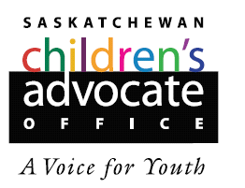

Submission for the Committee on the Rights of the Child
General Day of Discussion

Group 1
The Child’s Right to be Heard in Judicial and Administrative Proceedings

Saskatchewan Children’s Right to Participate and be Heard
in Child Welfare Proceedings

