Republic of Guinea-Bissau

GROUP OF NGOs WORKING ON CHILD MATTERS

ADC, AGRICE, AL ANSAR, AMIC, APRODEL, CASA EMMANUEL, DIVUTEC, FNJP, LGDH, MERS-BODJAR, NATIONAL CHILDREN’S PARLIAMENT, RA, REJE, RENAJ, RENLUV/GC, SINIM MIRA NASSIQUÊ, SOS CRIANÇAS TALIBÉS, TOSTAN G-B

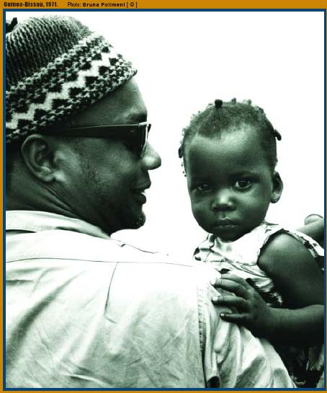

ALTERNATIVE REPORT ON THE IMPLEMENTATION OF THE UNITED NATIONS CHILD RIGHTS CONVENTION IN GUINEA-BISSAU

Facilitator: João S. Handem, Jr.
Coordinator: Laudolino Carlos Medina – AMIC

BISSAU JANUARY 2011

Republic of Guinea-Bissau
NGOs Alternative Report on the Implementation of the United Nations Child Rights Convention in Guinea-Bissau

Table of Contents

Introduction…………………………………………………………………………………………3

- Country Background and the Child ………………………………………………………….7

- General Enforcement Measures (Articles 4,42 and 46.6)……………………………..……10

- Child Definition (Article 1)…………………………………………………………………16

- General Principles (Articles 2,3,6 and 12)………………………………………………….17

- Liberty and Civil Rights (Articles 7,8,13 to 17 and 37a)……………………………...……20

- Family Setting and Alternative Protection (Articles 5,9,10,11,18,20,21,25,27.4)………….21

- Health and Well-Being (Articles 18,23,24,26,27)…………………………………………..22

- Education, Leisure and Cultural Activities (Articles 28,29,31)…………………………….24

- Special Measures for Protection (Art. 22,30,32 and 36,36b), c) and d), 38,39 and 40)…….25

- Conclusions, Perspectives and Recommendations………………………………………….27

- List of NGOs which Co-produced this Alternative Report…………………………………30

- List of Reviewed Documents……………………………………………………..…30 and 31

Introduction

This report is the first periodic NGO publication after the "Initial Alternative Report" written in 2001 by NGOs. It aims at bringing forth NGOs’ contributions to facilitate the understanding of measures taken by the Government, and the progress achieved in implementing the United Nations Child Rights Convention (CRC) in Guinea-Bissau after observations made by the United Nations Committee on Child Rights on the Initial Country Report (This Government Initial Report was prepared in 2000 and examined by the Committee on 22 May 2002). Also intended, is for current report to offer a look at the obstacles and challenges the Government of Guinea-Bissau and other stakeholders face in the field of childhood in implementing child protection policies and mechanisms as provided for in the CRC.

The report covers a long period of about 8 years, instead of five subsequent years anticipated for sending periodic reports to the “Child Rights Committee” (Article 44 CRC). Report is meant to make up for the "1st, 2nd and 3rd NGOs’ Alternative Periodic Report on the CRC Implementation in Guinea-Bissau."
As known, the need for protecting under age children had already been enshrined in the Geneva Declaration of Human Rights in 1924 and, on 20 November 1989, the United Nations General Assembly adopted the Child Rights Convention. Several other instruments have, as a result, been established for Children and recognized by the Universal Declaration of Human Rights (UDHR), also, in the International Plan of Civil and Political Rights, the Covenant on Economic, Social and Cultural Rights, the Statutes and Instruments of Specialized International Agencies and the Instruments for International Organizations interested in child welfare.

In the above context, Guinea-Bissau made several international commitments regarding both the aforementioned instruments and the following:

- The Optional Protocols to the CRC that specify the types of protection for minors;
- Convention 182 of the International Labor Organization (ILO) interdicting the worst forms of child labor;
- The African Charter on Child Rights and Welfare (1990);
- The African Common Position, "an Africa Fit for Children, as the continent's contribution to the UN Special Session (2001);
- The UN Special Session on Children (2002).

The adoption of the UN Convention on Child Rights (CRC) by the General Assembly of the United Nations, without a doubt marked a new stage in realizing the need for an effective child protection in the world in the general and Guinea Bissau, in particular.
Following are major milestones that have marked the commitments made by Guinea-Bissau:
1987:
- Under the umbrella of the State Secretariat, the Government created the Inter-ministerial Child Protection Committee (ICPC), coordinated by the General Director of Planning, extended to an NGO that works with Children called “Associação dos Amigos da Criança” (AMIC)

1990:
- The State Council of the Republic of Guinea-Bissau ratified the UN Child Rights Convention through resolution 20/90 of 18 April 1990, aiming at establishing new ethical principles, norms and behavior for all citizens regarding children;
- Upon creating the Children’s National Commission (CNC) and ICPC, the former was made into the latter’s Technical Committee;
- Guinea-Bissau participated at the highest level at the World Summit on Children in New York. That summit brought together about 60 Heads of State to discuss priorities for action towards improving the situation of children by the year 2000.
1992:
- Under the coordination of the Children’s National Commission, Guinea-Bissau drafted and adopted a National Plan of Action on Children. This Plan was then implemented.
1996:
- The National Children's Parliament was assumed by the National Assembly and its running cost integrated into the overall budget of the National Assembly.
1997:
- Guinea-Bissau started preparing the Initial report on the implementation of the CRC in country. The process was interrupted by the political and military conflict of 1998 through 1999.
2000:
- The Institute for Women and Children and the Ministry of Social Solidarity, Family and Fight against Poverty were created;
- The Initial Report on the Implementation of CRC was finalized and sent to the Child Rights Committee in Geneva;
- The 'Say Yes to Children' campaign was held in Guinea-Bissau. Among the 10 points to be voted mandatorily in all countries of the world, the Bissau-Guinean children have identified three major priorities: (1) Ensuring the health of each child (Fighting against malaria and HIV / AIDS), (2) Putting children first (Child as an absolute priority) and (3) Leave no child out (do not discriminate against any child).

2001:
  - In addition to the Initial Report of the Government, a group of NGOs working on Child Matters in Guinea-Bissau produced an alternative report in 2001. Same report was also presented to the Child Rights Committee in Geneva;
  - Upon invitation of the OAU, UNICEF and Egypt (as the host country), African First Ladies, African governments and NGOs from throughout the continent, gathered in Cairo from 28 to 31 May, in a Pan-African Forum on the Future of Children. In the forum, a Declaration and Plan of Action entitled "The African Common Position, as Contribution to the General Assembly Special Session on Children”, were adopted. The document includes goals and clear guidelines to be achieved by State-Parties in improving life opportunities for African children, the prevalence of HIV / AIDS, implementation of Rights to Education and protection, measures at all levels, solid international partnership in favor of African children and follow-up and monitoring. Guinea-Bissau was represented at all levels required in that forum;
  - The National Birth Registration Campaign for Children was organized by the Government with support from UNICEF and NGOs.

2002:
- The Government of Guinea-Bissau presented and defended in Geneva the Initial Report on the CRC Implementation in country. The Child Rights Committee had essentially recommended continuing the process of harmonizing the national legislation with the CRC and the Convention on the Elimination of all forms of discrimination against women;

- Guinea-Bissau has participated at the highest level in the United Nations Special Session on Children. The Special Session allowed reviewing progress after the World Summit on Children in 1990 and adoption of a document, "a world fit for children" - which features a Declaration and an Action Plan setting out the commitments and measures to be taken regarding children in the next 10 years. Such policy agenda for the future addresses 4 key priorities: (1) Promoting healthy lives; (2) Providing quality education for all (3) Protecting children against abuse, exploitation and violence and (4) Combating HIV / AIDS.

2003:
- African NGOs met in Bamako (Mali) on a Constituent General Assembly and created the Coalition of African NGOs for Children, of which primary objective is to create synergies on the continent so as to provide better living conditions to the African child based on his or her own cultural identity;

- The Ministry of Planning as well as the Institute for Women and Children and some NGOs started designing the National Plan of Action for Children and Adolescents. The Plan aims at ensuring that international commitments made by our country on child matters are implemented, especially, the instruments on the future of the African Child adopted in the forum of Cairo and the UN Special Session on Children in the Fields of Health, HIV / AIDS, Education and Protection.

2004:
- AMIC (Association of Child-Friendly People), Children’s Parliament, IMC (Institute for Women and Children) and UNICEF proposed to Political Parties a political agenda for the Bissau-Guinean children. Same agenda was signed by all political parties that applied for the legislative elections.

2005:
- Drawing on the political agenda, same structures, including AMIC, Children’s Parliament, IMC and UNICEF proposed to the candidates of Presidential Elections an agenda in the form of commitments to respect towards improving the situation of children in Guinea-Bissau. The Agenda was signed by the two major Presidential candidates competing in the second round of Presidential elections.

2006:
  - The meeting of Ministers of Social Affairs from Central and West Africa in Abuja, Nigeria, resulted in a signed "Multilateral Agreement on Cooperation to combat the trafficking of Human beings, especially Women and Children, in Central and West Africa”;
  - The third MICS (Multiple Indicators Cluster Survey) was conducted by the Ministry of Economy and Planning with support from UNICEF;
  - The Report on Human Development in Guinea-Bissau was written by the Ministry of Economy and Planning with support from UNDP.

2007:
- Sub-regional NGOs were convened from 6 to 8 November 2007 in Ouagadougou in a workshop whereby they assessed the status of the recommendations implementation and conclusions on observations of the United Nations Child Rights Committee, especially regarding the CRC implementation.
2008:
- The National Committee for Preventing and Combating the Trafficking of Human Beings was established under the auspices of the IMC (Institute for Women and Children);
- A Conference was held in Rio on the abuse and sexual exploitation of minors;
- The Government wrote and validated its second "Country Report on the Monitoring and Implementation of the UN Convention on Child Rights without the participation of NGOs;
- The National Children’s Parliament Statement was issued with the support of UNICEF, reflecting three priority areas for children in Guinea-Bissau: Health, Education and Protection;
- TOSTAN’s Memorandum of Understanding was signed with the Government of Guinea-Bissau for the Promotion of Human Rights, Hygiene and Health, also, for the Improvement of the Condition of Women and Children, and Fight against Poverty;
- The CRC Report on the Violation of Child Rights in Guinea-Bissau was presented.

2009:
- The group of NGOs working on Child Matters began the drafting process of this "NGOs Alternative Report on the Implementation of the UN Child Rights Convention in Guinea-Bissau";
- The Government with support from UNICEF conducted the "National Consultation on Birth Registration";
- This study was conducted and validation under the title "analysis of the Situation of Orphaned and Vulnerable Children in Guinea-Bissau - Elements for a National Strategy for Social Protection of Orphaned and Vulnerable Children - Ministry of Woman, Family, Social Cohesion and Fight against Poverty”;
- Also, IMC, with the support of UNICEF and participation of key partners working on child matters, conducted and validated a study on the abuse and sexual exploitation of under-ageg children in Guinea-Bissau.

2010:
- Coordinated by the Institute for Women and Children, key partners working on child matters designed an action plan to combat abuse and sexual exploitation of minors.
- State and non-state institutions working on child matters in Guinea-Bissau, including the Institute for women and children, AMIC, UNICEF and Plan Guinea-Bissau celebrated the 20th anniversary of the ratification of the UN Child Right Convention by the State of Guinea-Bissau.
- Still, the IMC, with support from UNICEF and the participation of key partners working on child matters, conducted and validated a study on the trafficking of human beings in Guinea-Bissau, particularly children.
- This NGO Alternative Report on the applicability of the CRC in Guinea-Bissau was disseminated nationwide by the group of NGOs working on child matters.
2011:
- The group of NGOs working on child matters has definitely validated this "NGO Alternative Report on the Implementation of the UN Child Rights Convention in Guinea-Bissau”.

Guinea-Bissau has institutions and NGOs that work on defending and protecting children and domestic legal provisions that provide for children. These include documents such as the Constitution of the Republic, Criminal Code, Statute of Minors’ Judicial Assistance and Sector Court Law. However, the country still reveals weaknesses in law enforcement and has national laws yet to be harmonized with the international instruments for child defense and protection that the country has signed and ratified.
The children’s social protection system is deficient in all aspects, particularly with regard to accessing basic social services and the child protection system. Compounding this situation, there are several unknowns to and overlaps of institutional responsibilities. Furthermore, there are virtually no defined policies and strategies while the coordination and support for children remain virtually nonexistent.

- Context of the Country and the Child

Guinea-Bissau is a small country located in West Africa with 36,125 square kilometers, where it is estimated that there are about 1,548,159 million inhabitants (Preliminary Results of the Third Population General Census and Housing Published by INEC - July 2009). The country is one of the poorest in the world and ranks 173rd out of 175 countries assessed in terms of HDI (Human Development Index).

According to UN figures, 856,000 inhabitants are children, 310,000 of whom are less than five years old, 79,000 actually born in Guinea-Bissau and, in every live 10 births, six children never have their birth registered. The latest data showed that there are 480,000 unregistered children in Guinea-Bissau which puts them in a position of invisible citizens, as there is no document proving they exist (61.1% of children under five (5) years who are not registered - MICS 2006).

The right to life, survival and development is a remote potential in Guinea-Bissau. Around one in each group of five children in Guinea-Bissau (16,000 annually) die before they reach five years, usually of preventable reasons. The number of children dying has fallen but remained high.

Health, medical care, access to food and drinking water are precarious in Guinea-Bissau. The Child mortality rate remains high. HIV / AIDS, malaria and tuberculosis continue to harass the lives of people. The supply of drinking water, improving sanitation and access to decent housing, are still a luxury in Guinea-Bissau. Of every group of 10 children in Guinea-Bissau, 6 use water from improvised wells. Only three in 10 children have access to adequate sanitation. The coverage of basic social services remains very low and the living conditions are inadequately balanced, which jeopardize the rise of life expectancy from 45 years as estimated at birth.
The majority of children in Guinea-Bissau live in extreme poverty with less than FCFA 456 per day to live on. They are thus deprived of decent life and right to enjoy normal housing, food, clothing, education, medical care and security.
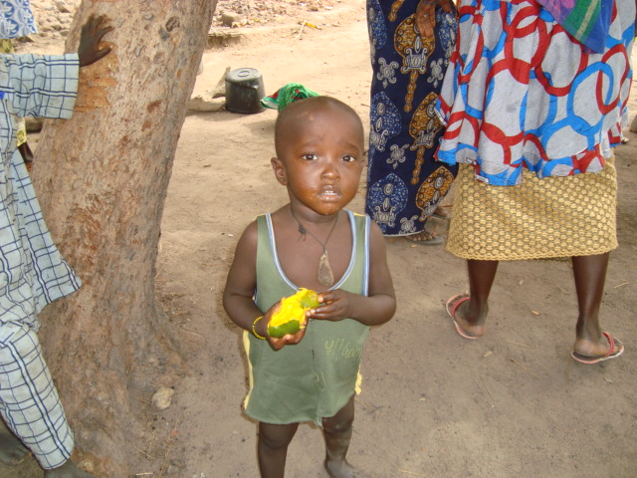

The majority of children in Guinea-Bissau lives in a situation of poverty with less than FCFA 456 per day

Only 19 countries worldwide have banned all forms of corporal punishment for children. Some countries still allow physical punishment in school. Guinea-Bissau has not formally banned corporal punishment by law, but modern pedagogical guidelines of the Ministry of Education ban corporal punishment in public schools. In the community and within the family the child continues to be subject to various forms of violence, including neglect, maltreatment and abuse. In Guinea-Bissau about 80% of children between 2 and 14 years suffered psychological or physical punishment by their mothers / guardians or other members of their household (MICS 2006).
Harmful child labor continues to exist in the Bissau-Guinean society for lack of protection against economic exploitation and all health-endangering work that can prevent the child from attending school.

Although any type of work is prohibited for young children, 39.2% of children aged between 5 and 14 years (41.1% for boys and 37.0% for girls) work or are somehow involved in work activities in Guinea-Bissau.

The right to attend school and have access to education is a fancy for many children in Guinea-Bissau. Only 2 out of 5 children in Guinea-Bissau go to school. However, many school children, especially girls, drop out of school early on for many reasons, including forced and early marriage, working in the field for the family, ethnic ceremonies and rituals, such as excision (female genital mutilation). The large delays in paying salaries and the consequent and frequent strikes and boycotts by unions of public school teachers have seriously compromised the school year and constitute a serious violation of the child’s right to school and education in Guinea-Bissau.

As to child trafficking, it is estimated that the Region of Dakar hosts about 7,600 child beggars and of that pool, 90% are “Talibe” child beggars and 10% are “non-Talibe” child beggars. Of “Talibe” child beggars, 30% are from Guinea-Bissau, and, of “non-Talibe” child beggars, 12% are from Guinea-Bissau. This means that more than two thousand children from Guinea-Bissau beg in the streets of Dakar (According to the study entitled "Child beggars in Dakar Region" November 2007 of "Understanding Children's Work - An Inter-Agency Research Cooperation Project").
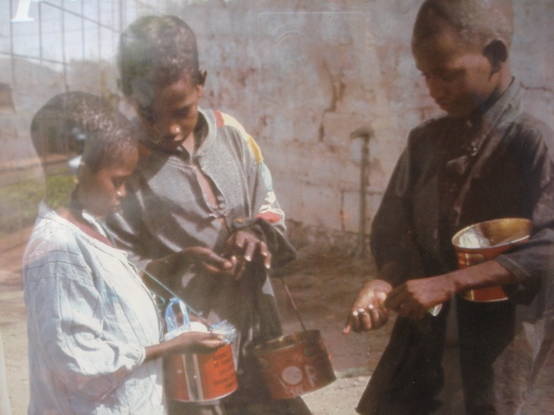

Talibes Children Begging in the Streets of Dakar
About 30% are from Guinea-Bissau

Female Genital Mutilation (FGM) proportion reaches 45.5% of women who underwent excision between 15 and 49 years old. There is no specific law that prohibits FGM restrictively, although a draft law has been submitted to the National Assembly. Trends show that the age in which excision is practiced is shrinking to the point of children under 5 years being subject to this practice that is harmful to both woman and child health. The reasons for this trend are the information and awareness-raising campaigns carried out mainly by NGOs leading teenage girls to refuse such practice. Families induced by traditional chiefs and religious leaders give up their daughters at an early age where the latter cannot defend themselves from such practice.

At least 7.3% of women are forced into early marriage before they reach the age of 15 years and 27.3% before reaching 18 years of age (MICS 3-2006).

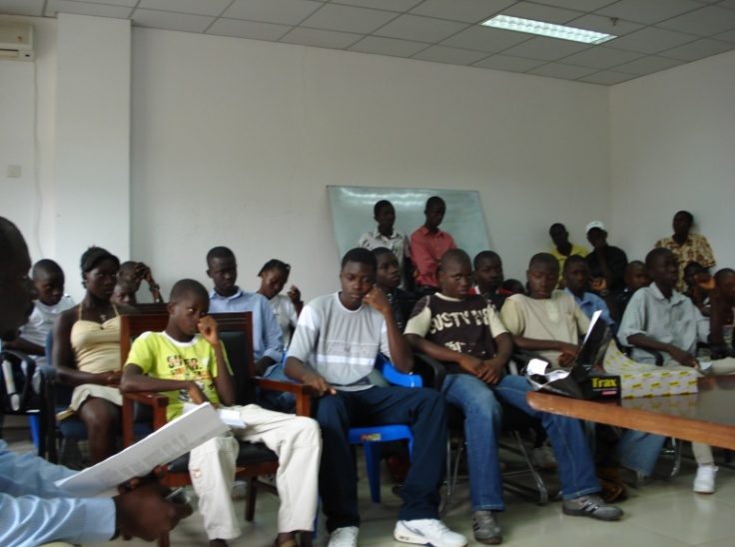
To elicit the children’s opinions and learn what they think about issues that affect and influence their lives in Guinea-Bissau, a National Children’s Parliament was created and institutionally assumed by the State (Institute for Women and Children and National Assembly) and several hearings and consultations with children are organized by NGOs working on child matters.
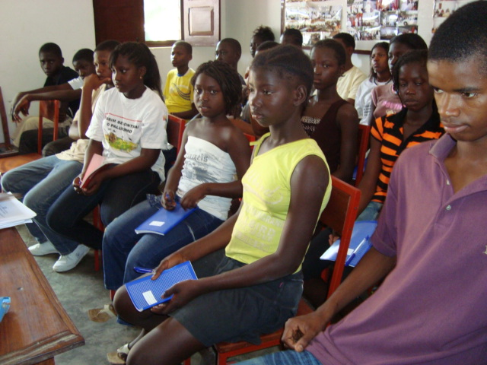
Session on the Regional Parliament of Children |  | Session on the Regional Parliament of Children

The political, institutional and military instability only worsens this scenario. Since independence in 1973, Guinea-Bissau has been a country that has been living cyclically in political and military crisis which has led to the deterioration of the populations’ living conditions and security.

The living conditions of populations, the economic, political and social situations are worsening day by day due to the negative impacts of the 1998/99 war and subsequent political and military crises that followed.
The real gross domestic product of the country did not exceed 1% between 2000 and 2004. The high degree of instability has not allowed successive governments to direct their efforts in seeking ways and means to address development challenges, including poverty reduction and achievement of the Millennium Development Goals (MDGs).

The first report analyzing poverty and the achievement of the Millennium Development Goals (MDGs) shows that the economic and social situation of Guinea-Bissau is deplorable. The same report shows that Guinea-Bissau progressed slowly in achieving the MDGs. Two thirds of the Bissau-Guinean population lives below the threshold of absolute poverty. The persisting economic downturn deepens poverty in the country. The aims of education for all and gender equality progress very slowly in relation to the timeline of international commitments, which set the deadline for completion by 2015.

- Generally Applicable Measures (Article 4,42 and 46.6)

Policy Measures for the Implementation and Harmonization of National Legislation with CRC
The general finding of NGOs is that the process of revision and harmonization of national laws in light of and respect to the principles and provisions of the CRC is very slow (years late). NGOs recognize that the situation of institutional instability and military unrest that have occurred in the country have greatly contributed to this delay, but also recognize that there is weak political will and / or inability to prioritize and accelerate the process. It is inconceivable that the review and harmonization efforts were initiated since 2003 and the process be still not minimally completed to date.

Not only has it escaped the knowledge of any NGO but in practice there has also been no provision to put the common law in accordance with the provisions and principles of the CRC. NGOs believe it is important to begin this process with the involvement of traditional chiefs and religious leaders of different ethnic and religious communities because NGOs think there has been a recrudescence of some negative customary practices that were already in decline or even disappearing which have regained momentum in recent years. Illiteracy, ignorance, lack of rule and discredit of the Bissau-Guinean judiciary system are the main causes leading to this situation.

Forced and early marriage, female genital mutilation, taboo-driven abandonment of children, prohibitions or break (forced school-drop-out) of girls' schooling are among other traditional practices that have increased the most and that go against the provisions of the CRC and other international child protection instruments.
NGOs call for greater State commitment in maximizing its own support and mobilizing technical assistance from international partners, including UNICEF.

Implementation, Coordination and Review of the CRC implementation
Currently in Guinea-Bissau there is no national strategy or policy for children and the action plan designed in 1992 by the Inter-ministerial Child Protection Commission (ICPCI) was formed to cover a decade (1992-2002), but which, for various reasons, was not fully implemented (e.g. the war of 1998/99 was one of the obstacles). Incidentally both the National Commission for Childhood (NCC) and the Inter-ministerial Child Protection Committee (ICPC) would end up disappearing for lack of operation (as a result of insufficient financial and material resources) or because the mission for which they were created faded away.

Still, the Ministry of Social Solidarity, Family and Fight against Poverty and the Institute for Women and Children (IMC) were created after the 1998/99 war to assume the political role of socially protecting the family, women and children. A Specialized Committee for Woman and Child Affairs was also created within the National Assembly.
Under the program of cooperation between the Ministry of Labor and Social Solidarity of Portugal and the Ministry of Woman, Family, Social Cohesion and Fight against Poverty in Guinea Bissau, a partnership agreement was reached on 16 December 2004 among fifteen non-governmental organizations which work in different social areas, especially with children, women and young people with the objective of creating an integrated project to develop a Social Protection Network in the Republic of Guinea-Bissau, aimed at combining efforts to develop synergies serving as enablers to the creation of basic conditions for poor families and communities of different age groups, while seeking to intervene in the successive stages of socio-economic integration.
Likewise, this cooperation seeks to contribute to solving social problems, changing negative behaviors and implementing strategies that promote breaking the cycle of poverty in view of attaining social and economic development of the most vulnerable families and communities of the Bissau-Guinean society.
In 2006, through a joint decision of the Ministry of Public Service, Labor and Modernization of the State and the Ministry of Woman, Family, Social Cohesion and Fight against Poverty, a National Tripartite Commission was established for the Abolition of Child Labor. The Commission comprises social partners, including the Chamber of Commerce, Industry and Agriculture and the Bissau-Guinean Workers’ National Union.
All these structures have in fact been working with NGOs and associations for child protection, defense and development in projects and specific actions, without political guidance or mechanisms to coordinate and monitor the measures envisaged in the CRC.
There was no handover of follow-up work on the applicability of the Child Rights Convention undertaken by the National Commission for Childhood (NCC) and the Inter-ministerial Child Protection Committee with newly created structures, so that for example, there was no initiative to upgrade or design a new "Action Plan for Children" which covers the period going from 2003 to 2013. As a result, enormous difficulties were encountered in coordinating and assessing the applicability of the Convention in Guinea-Bissau.
Resources Assigned to Activities in Favor of Children
Guinea-Bissau has a Children's Parliament institutionally assumed by the State (it is established in the very building of the National Assembly which covers its operating costs through the budget of the National Assembly). In addition to the Children's Parliament, there are various Child Rights Protection Organizations and Associations which hold regular hearing sessions with children to listen to their wishes and the major human right-related difficulties they face, with the assistance of the CRC and other instruments of child rights protection and advocacy.
With the emergence of the "Multiple Indicators Cluster Survey - MICS (UNICEF support to the government) the collection and systematization of quantitative and qualitative data on children and women has improved enough to make them more reliable. These data have improved the perception of the situation of children and women in Guinea-Bissau and have helped to create projects that give special attention to the need of vulnerable children and women for social protection.

Unless due exceptions, national institutions and organizations lack some technical expertise to understanding and analyze the MICS data and that affects the way projects are designed, developed, managed and evaluated in favor of children in Guinea-Bissau. Furthermore, the resources allocated for child-related activities are either very limited or not absorbed. Also noticeable is the withdrawal from Guinea-Bissau of some child-friendly partner-organizations (e.g. the Swedish organization Save the Children - Radda Barnen).
Cooperation with NGOs
NGOs are active in all areas of defense, protection and development of children and some of them are involved in virtually all domains while others opted for specific areas of intervention. We can thus find organizations and / or networks operating in the following areas:
NGOs GENERALISTS
- Education, Culture and Leisure
- Health and Environment
- Child Rights development, defense and protection in accordance with the articles in the CRC

SPECIALIZED NGOs
  - Gender-based and child violence
  - Protection of disabled children
  - Trafficking and exploitation of child labor
  - Giving up excision and harmful practices to the Health of Women and Children in particular

Specifically, NGOs develop the following activities in each area:

Education, Culture and Leisure
- Construction, rehabilitation and improvement of school infrastructure in rural areas (communities building and managing their own schools)
- Training and retraining of pre-school teachers
- retraining of unified (six-year) primary school teachers
- Provision of equipment, furniture and school supplies
- Training and monitoring of Community school management committees (Teachers, Parents and Guardians, Students and Community representatives)
- School canteens and vegetable gardens
- Vocational training and guidance to children / young people
- Social assistance to most disadvantaged and vulnerable students and families (financial and material support)
- Incentives for girls’ education
- School Transport
- Safe drinking water and sanitation in school
- Grants for running schools
- Creation of children's cultural groups (Drama, dance, song, poetry)
- Organization of events and performances by children’s cultural groups (children's festivals of song, dance, poetry and drama)
- Civic mobilization, awareness raising in health and education and dissemination of the CRC by children’s cultural groups
- Commemoration of national, regional and Children’s International Day and Children’s Fortnight)
- Study and exchange visits
- Organization of sport and recreational activities
- Organization of children's carnival

Health and Environment
- Construction and rehabilitation of health centers, basic health units
- Training of Health workers and community traditional midwives
- Mobile Medical coverage
- Family planning, nutritional education and consultation
- Monitoring, medical assistance and supply of medicine to child victims of abuse, sexual abuse or rape and UXO
- Awareness raising and sensitization on Malaria (distribution of impregnated bed nets), STIs and HIV / AIDS, cholera
- Prevention of cholera
- Reproductive health
- Harmful practices to woman and child health
- Environmental education and health
- Behavioral changes

Development, Defense and Protection of Child Rights

- Dissemination of the CRC and other international instruments of child defense and protection:

- Radio information and communication
- Lectures, seminars and meetings
- Child Drama Groups
- 'Djumbai' (i.e. small group discussions)
- Celebration of special Child Days for awareness raising and lobbying
- Sensitization and community mobilization for child development in a healthy and balanced environment

- Child Protection

  - Reporting, assistance and follow up on cases of rape, abuse and maltreatment, corporal punishment and humiliating treatment (amputation of limbs or fingers, burning of hands and other parts of the body)
  - Counseling, negotiation and legal advice (FGM, separation from parents, forced marriage, trafficking and abduction, rape, abuse and maltreatment)

- Lobbying and advocacy on CRC and child-related issues

- Influencing MPs (National Assembly) and the Government to adopt the law on FGM, ratify international instruments for child protection, defense and welfare and harmonize the legislation of Guinea-Bissau with the CRC and other international child protection instruments
- Pressure to adopt policies, strategies and plan of action on childhood
- Pressure to create mechanisms to coordinate and monitor the implementation of the CRC, prevent and protect the child.

- Consulting children

- Through the Children's Parliament
- Direct consultation with children in schools and communities

Gender-based and child violence
- Reporting, assistance and follow up on cases of rape, abuse and maltreatment, corporal punishment and humiliating treatment (amputation of limbs or fingers, burning of hands and other parts of the body)
- Counseling, negotiation and legal advice (separation from parents, forced marriage, trafficking and abduction, rape, abuse and maltreatment)
- Host families in temporary relief and psycho-social treatment
- Lobbying and Advocacy

Protection of disabled children
- Education and specialized training (literacy, sign language, Braille)
- Professional and vocational training
- Shelter and social assistance
- Rehabilitation and social reintegration
- Medical and medicine coverage
- Micro-credit and income generating activities (IGA)
- Culture and Leisure
- Lobbying and Advocacy

Trafficking and exploitation of child labor
- Kidnapping and trafficking (Talibe children or Child Beggars)
  - Child identification and monitoring in the host country
  - Research and location of the child in country of origin
  - Preparation of child return and reintegration
  - Reintegration and personalized monitoring of the child in country of origin
  - Transnational cooperation
  - Development of community actions
- Working children and street salesgirls
- “Meninos de Criação” (i.e. children delivered by parents to a relative for education and care in exchange for domestic service)

Abandonment of Excision and Harmful Practices to the Health of women and children in particular
- Information, sensitization and social and community mobilization
- Training and building stakeholders and beneficiaries’ capacities
- Lobbying and Advocacy for the adoption of the law
- Human rights and community development

The diversification of NGO interventions in development and child rights protection and defense is only possible through the cooperation they nurture not only with international partners but also with the State, namely the Ministry of Woman, Family, Social Cohesion, and Fight against Poverty, the Institute for Women and Children, the Ministry of National Education, the Ministry of Public Health and regional governments. Unfortunately the lack of a national child rights protection and defense policy or strategy and the absence of coordination mechanisms do not allow for medium and long term views and make it difficult to collaborate with NGOs for a more systematic tracking of the applicability of the CRC in Guinea-Bissau.

Disseminating the CRC
The Institute for Women and Children and virtually all Associations and Organizations Advocating for the defense and protection of child rights have greatly contributed, through awareness raising and training, to the dissemination of the CRC in Guinea-Bissau. The raising of awareness is conducted directly with communities and in schools (entertainment, drama, lectures, small groups’ discussions, radio programs, billboards, brochures, video projections, etc.). Both the sensitization and training are cross-cutting components in all projects that benefit children in Guinea-Bissau which is why the CRC or child rights are widely disseminated but not internalized. Unfortunately, there are many obstacles to its ownership, particularly as a result of poor dissemination at the grassroots level, for cultural, traditional, religious motives, also, due to high illiteracy rate.
To date, there is no official translated version of the CRC, which is why individual institutions or organizations do their own translation for the purpose of dissemination. At best, the CRC version translated by Portugal is utilized. Another difficulty is that the legislation of Guinea-Bissau was not adjusted or harmonized with the CRC and other international child defense and protection instruments, which makes their implementation difficult in practice jeopardizing all the work on raising children’s, their families’ and communities’ awareness. Every time there is a violation of Child Rights, it becomes extremely complicated to address the matter through the Bissau-Guinean Justice for trial, punishment and law enforcement as the related judicial processes in the current legislation are inspired by the colonial legislation (Criminal Code of Portugal Overseas Provinces) that is known to have been one of the most backward legislations in the world as in those days the Portuguese government was dictatorial. The population perceives the concerns raised on child rights as being mere propagandas that are futile and meaningless to their real lives.

Decentralization of measures related to child protection
At the central State level, the decentralization of certain welfare services for children has been noticed while there is a clear political will to extend Child support services and social protection to all the regions of Guinea-Bissau, but due to budgetary constraints and limited human resources, it has not yet been possible to reach that level. The lack of facilities or State services in the regions has been compensated with the presence of NGOs Liaison Offices and Representations working directly with grassroots communities throughout the country. This difficulty being experienced by the State could be minimized if there were medium and long term partnership agreements with NGOs coupled with coordination and monitoring mechanism that would integrate NGOs and associations working on child matters.

3. Definition of the Child (Article 1)

Like the CRC, the constitution of the Republic of Guinea-Bissau defines the child or minor as being every human being younger than 18 years. This very provision of the Constitution has not been harmonized with child-related laws that prevail in Guinea-Bissau and that confronts us today with contradictions such as children of both sexes being allowed by law to marry at 16 years of age as long as there is a consent of their parents or guardians. This legislation should be reviewed and adjusted to the law of adulthood allowing both boys and girls to be married without parental consent after they have completed 18 years of age.

As to the eligible age for joining the armed forces, the Bissau-Guinean law is clear, since, only after reaching adulthood can a citizen be drafted into military service. The civil war of 1998/99 and the political and military crises that followed led to the recruitment of children (under 18 years of age) for the war, some of whom remained later on staff of different military units, while others were recruited directly by military commanders based on family and ethnic ties.

It is hoped that this violation be addressed and discontinued when conducting census for security forces as part of the security sector reform and at the initial phase of the official recruitment of young people into the armed and paramilitaries forces.

Contradictions between the ethnic and traditional concepts of the child and the official definition still persist in our society precisely because there is a lack of harmonization of the customary law with the national legislation and the CRC. This is a matter that can only be addressed if the necessary harmonization is completed and the country makes progress in reducing poverty and achieving sustainable economic, political and social development. Economic needs are the main causes of arrangements that lead to girls’ early and forced marriage.

In almost every ethnic group in Guinea-Bissau, a child aged between 10 and 13 years of age gradually assumes responsibilities in the organization of the economic and social life of the family and the community, something that is inconceivable in developed countries where such responsibilities are only assumed when one attains adulthood. One of the biggest damage such early assumption of responsibilities causes in rural areas is when it interferes with the education of both boys and girls, and most seriously with the latter. Family and community-related responsibilities force children to drop out of school or to even never go to school as boys tend to be absorbed with field work and girls with burdens of early marriage and consequent early baby-delivery. Some traditional ceremonies, such as the one called “Fanados”, meaning the initiation ceremonies (Circumcision for boys or excision for girls), coincide with the school period and increase the rate of dropouts.

4. General Principles (Article 2, 3, 6 and 12)
Non Discrimination (Article 2)
The State of Guinea-Bissau supports the principle of non discrimination through the Constitution of the Republic of guinea-Bissau (CRGB), which provides that: "All citizens are equal before the law, enjoy the same rights and are subject to the same duties, without distinction of race, sex, social or cultural levels, religious belief or philosophical belief "- Article 24 of the CRGB.
The above precept has not been achieved due to the compounding poverty and cyclical crises that Guinea-Bissau has experienced. Consequently, discriminatory factors tend to remain or worsen in some respects, particularly with regard to the following:

- Education and schooling: Nowadays, it is not only the above traditional factors that come into conflict with the aforementioned principle but also the following factors:

  - Government delaying five to nine months in paying teachers’ salaries and allowances. Hence, the waves of strikes and boycotts in the area have compromised year after year the normal holding of classes and jeopardized successive school years.

  - Private schools proliferating without meeting the required quality standards and aiming solely at conducting business that earns them easy money by taking advantage of parents’ and guardians’ loss of trust in public schools, of which academic years, as a result of strikes, end up being nullified or students’ are granted administrative transition by the Ministry of Education.

  - Enrollment and tuition fees soaring above the economic capacity of most families who are facing financial difficulties. The number of unemployed or unoccupied people has been increasing dramatically across all age groups in Guinea-Bissau. In short, poverty is reaching alarming levels nationwide and greatly affecting children from most vulnerable families.

- Health and Welfare: The Guinean health system has ceased to be free which leaves out most of the population for being poor. Women and Children are the main victims further confronted with the problem of bribery in hospitals throughout the country. Whoever cannot afford the amount charged for health care, medical analysis and medicines and even tips to entice nurses, midwives and servants is unlikely to receive decent medical care and even to survive, should the seriousness of their health problem requires an urgent assistance or special attention. Consequently, most Bissau-Guineans now resort to the service of traditional healers to address their health problem as the latter’s customer service is personalized and apparently inexpensive (but, in reality, may ultimately be more costly to remediate). Beds in hospitals, including the maternity and pediatrics, are insufficient to the point of a single bed being shared at times by three people. Even the hygiene conditions are very poor, especially with regard to the state of the bathrooms that work, where cockroaches and other pests move everywhere. In Guinea-Bissau, people say that “patients go to the hospital with an illness and come out of the hospital with another illness”, to Illustrate the danger of contamination with other diseases and infections as a result of the aforementioned reasons.

- Disabled Children: are the most disadvantaged in every respect. They suffer in the family setting, out there in the community and throughout the system of health, education and social protection which do not take into account the needs of disabled children for special attention and care. Disabled children represent a great burden for their families and communities who lack economic conditions and materials to meet their special needs. In Guinea-Bissau, households are usually large, which places the disabled child in an even more difficult situation, living with poor health and housing conditions.

The State, confronted with problems of all kinds, is unable to guarantee or provide social protection to people in this situation (very few people benefit from State assistance). They are forgotten somewhere especially when it comes to cases of voluntary infanticide perpetrated on disabled children (e.g. children affected by trizomia 21). Sanctions are very weak when actually applied and that ends up encouraging the same evil practice.

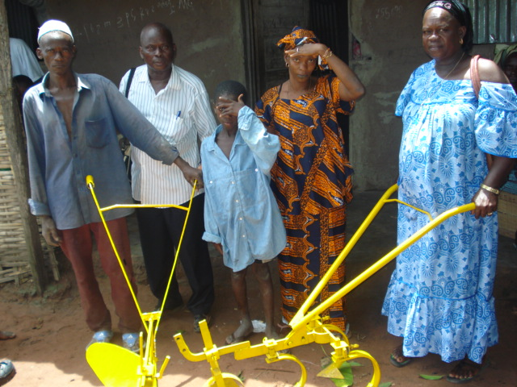
- Working children and "meninos de criação": are the most disadvantaged in terms of rights that assist them as children. They spend most of the time selling in the street or working in the homes of host families. The school is a very remote reality for these children. Often times, they are subject to mistreatment, abuse and rape, especially the girls. Incidentally, this phenomenon is disturbing in Guinea-Bissau because it puts the girls at the mercy of seductive pedophiles who buy all their products and more just to take advantage of them. The worst is that no one denounces this crime, seen like a taboo in the Bissau-Guinean society. At home, it is important these salesgirls bring the expected sales money of the day, otherwise, they are physically punished or not served their share of the day’s meal should they do not manage to sell up everything.
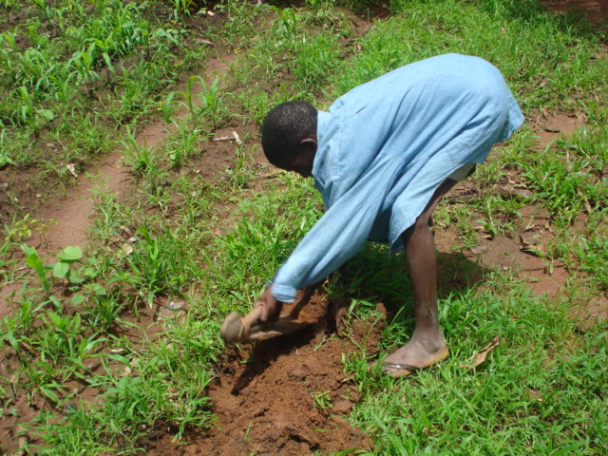

Does this child go to school?

Exclusion is a phenomenon that tends to worsen in Guinea-Bissau, especially with regard to rural populations living increasingly isolated. The State is virtually absent in rural areas and the political, democratic and economic systems do not factor in the interests and needs of the poorer sections. There is no democratically elected local government and the traditional power no longer plays, as a result of social changes and exacerbating poverty, that role of regulator and keeper of political, social and economic balance in the community.

Children’s Best Interest (Article 3)
As far as institutions are concerned, there has been a positive development for the defense of children’s best interests in Guinea-Bissau. Apart from creating the Ministry of Woman, Family, Social Cohesion and Fight against Poverty and the Institute for Women and Children in recent years, several ministries have taken the initiative of creating internal structures in an attempt to give special attention to the child.
The Ministry of Interior has thus established an office that deals with children and women matters and at the Regional Police Stations, services have been set up to protect children and women. The Ministry of Justice created a special Court for the Family and Minors and Work and the figure of Child trustees, who deal with judicial issues related to minors. Still, in the General Directorate of the Judicial Police, a brigade was created for women and children. Within the National Assembly (Parliament) the Specialized Committee for Women and Children’s Matters was also created.
Despite these positive scenarios, the Bissau-Guinean child is not yet deemed as being a priority on the political agenda either of successive governments or Members of Parliament. Suffice it to note how items are ordered in the agenda for parliamentary discussions to confirm this fact.

Less than 1% of the National Budget is set aside to support women and children’s matters, of which more than 95% is used up in paying salaries to civil servants of the Ministry of Woman, Family, Social Cohesion and Fight against Poverty and the Institute for Women and Children. Even the Institute for Women and Children does not have its own statutes, but the Decree of its inception. Only the case of Children's Parliament at the National Assembly can be quoted as an example of when a national institution secured the operation of a child-centered entity.
In face of the increasing violation of child rights, the structures responsible for child protection still lack qualified human, quality material and financial resources, and are often powerless over the large number of cases with which they are daily confronted. The lack of harmonization of the national legislation with international laws that protect and defend children's rights creates difficulties in applying them, and even in procedures.

NGOs have contributed to the extent possible which is why we must not forget that they too have their actions limited to their areas of intervention and often lack sufficient resources to tackle the numerous problems.
Right to Life and Development (Article 6)
As already mentioned in this report, poverty has reached its extreme in Guinea-Bissau and the human development index remains the lowest in the world. Faced with a weak State and civil society the already negative trends tend to worsen.
The degrading state of health and education, infanticide, abandonment of children in reaction to taboos, child neglect by parents and the community have reached worrisome levels reflected in the particular loss of the family’s moral authority and that of the family and society in general.
Guinea-Bissau social, political and economic context and, particularly, its political and military component are the main obstacles to creating an "Enabling Environment to child Life and Development."
Bearing in mind an objective of "A World Fit for Children" in which "children should be physically healthy, open-minded, emotionally stable, and socially competent and ready to learn" we can easily conclude that the conditions and environment in which children grow up in Guinea-Bissau are not favorable for development.

Most children in Guinea-Bissau grow with another older child looking after them or are left by themselves subject to what they can learn in the street. They generally receive food and shelter from parents or guardians who rarely bother to follow up on their development neither in terms of learning nor in academic maturity.

Right to express their opinion (Article13)
The precept of the Constitution in that "Every citizen has the right to freedom of expression and, consequently, the right to opinion" is oftentimes disrespected by the authorities, particularly the defense and police forces and the State as a whole. As a country that lives in constant political and military crises, the cases we have known are mostly of humiliating harassments and detention of politicians, journalists. Likewise, various cases involving ordinary citizens have been recorded. The media are always threatened and accused of being instigators of instability in the country. When this is so, we live in a country where freedom is conditioned by those in political and military power whose philosophy goes like "if you're with me, you're a friend. If you're not with me, then you are an enemy to kill."
In the Bissau-Guinean culture and traditions adults are the ones who decide on behalf of the child since the latter is considered as being the property of their parents or guardians. Still some positive signs were given with the setting up of the National Children’s Parliament and NGOs sessions of consultation with children.

Little has changed in practice. To date, the many recommendations, manifestos, political and presidential agenda in favor of children by the National Children's Parliament and the outcome of the consultations with children have not been reflected in the laws or policies and national strategies.

- Freedom and Civil Rights (Articles 7,8,13 to 17 and 37)

Freedom and civil rights continue to be seriously threatened by cyclical political and military crises which have even worsened in the last 5 to 6 years. Violence and fear seem to have settled for good in the Bissau-Guinean society. The level of insecurity is high and visible in daily life. People claiming State authority come into our homes, arrest and inflict humiliating punishment and even kill people in the face of our children and family (and manage to get away with it). Those are flagrant violations of the CRC and the civil liberties and rights guaranteed by the Constitution of the Republic of Guinea-Bissau.

Forced and early marriage, non registration of childbirth, abandoned children, female genital mutilation and resistance to girls’ education are practices that continue to violate freedom and civil rights in Guinea-Bissau.
Reversing this trend is targeted by the Government enormous childbirth registration efforts (although the strategies used to date have not delivered great results as proven by the existence of some 480,000 unregistered children) and the emergence of several associations and organizations defending human rights in general, and those of women and children in particular.

- Family Setting and Alternative Protection (Articles 5,9,10,11,18.1, 18.2, and 20,21,25,27.4 and 39)

Unfortunately, the family setting is experiencing severe degradation due to the worsening of poverty (most families live on less than FCFA 500 per day, equivalent to less than US$1 per day). Delinquency and prostitution among young people are covered up or encouraged by parents’ failure to address them, thus resulting in younger children growing up in a morally degrading environment. Housing conditions and hygiene are degrading. Promiscuity is high due to family clusters of more than 10 members living in homes with one or two bedrooms and more often without toilets or latrines. Country life no longer secures good livelihood, causing many children to be handed over to relatives or friends in urban areas where they end up being exposed to all sorts of risks, affecting mostly girls who start to have sex as early as from 10 to 13 years old, depending on their physical development. In general, girls are raped within the host families and the crime is camouflaged to not draw the attention of organizations that defend human and child rights and the authorities.

Alternative protection is currently guaranteed to orphaned children, also, children whose parents are in extreme poverty as well as those abandoned children, by institutions such as the Catholic and Evangelical churches, the SOS Children’s Village (there are 3 in the country), Home of Blind Children and “Casa Emmanuel”. Child victims of trafficking, particularly, Talibes children are hosted in transit centers of AMIC and SOS Talibes Children in Bissau and in the Eastern provinces of the country. The State does not have at present any reception center (the few that exist are in total ruin, as for instance, Mores Boarding School), but the Ministry of Woman, Family, Social Cohesion and Fight against Poverty and the Institute for Women and Children are collaborating with NGOs to assist in securing temporary protection to vulnerable children.

Adoption is another alternative means of child protection, but which, due to system weakness, has contributed to handing children over to adoptive families without measuring the risks. The legislation on child adoption must be reviewed and liberalized without disregarding the danger of their use for trafficking in minors.

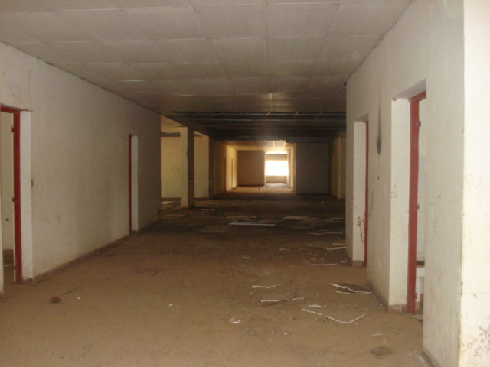
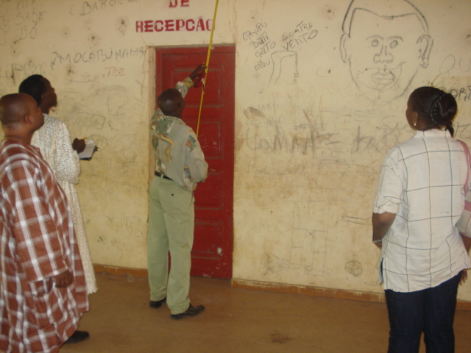

Former Mores Boarding School in na advanced stage of disrepair and abandonment

- Health and Welfare (Articles 18, 23, 24, 26 and 27)

Child health in Guinea-Bissau glooms a worrisome picture mainly because of the prevailing high rates of malaria, diarrhea and infectious and respiratory diseases. Furthermore, what is more worrisome is the degrading stage of most health infrastructures, coupled with the lack of equipment and means of conducting diagnostics, the poor quality of health-care customers’ service and corruption in the sector. It is worth noting that this sector is confronted with salary arrears, unpaid subsidies and inadequate working conditions.
The health sector depends heavily on cooperation and international aid as the National Budget is barely sufficient to pay salaries and general running costs. The State has limited capacity to invest in infrastructural building and rehabilitation as well as furniture and equipment purchase for hospitals and health centers, although such weakness has been minimized with foreign aid and NGO projects but not surmounted nationwide. Central and regional health coverage remains weak and disproportionate to the number of inhabitants.
Children and women are more penalized by the serious situation weighing on the health sector which is also relative to the nation’s condition of extreme poverty. The costs of medical care and treatment are above the average income of households. This situation contributes to having people look for alternatives that fall within their financial capacity. Usually, the demand for traditional healers comes first as an affordable substitute to modern treatment, but is only boosting a business which attracts many charlatans and endangers people's lives.

There are specific issues that the country must tackle and address. These include the high rate of mortality among children and young people, also, maternal mortality, malarial prevalence and malnutrition, low coverage of immunizations, cholera and meningitis epidemics, infectious and contagious diseases and so forth. The desired solution may not come true if the current sick and corrosive system is kept.

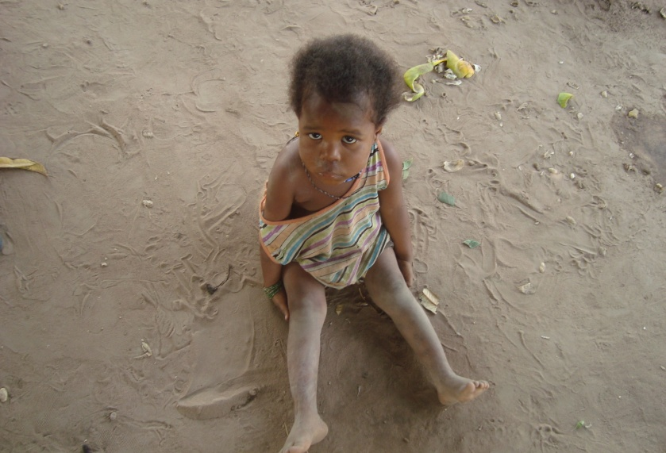

This child’s health can be endangered by lack of Hygiene

In light of the above, the Bissau-Guinean health system needs an indepth review whereby new policies and strategies can be adopted in order to improve access to basic sanitation and health services for the most vulnerable populations in general, and children and women in particular. That necessitates good political will to achieve the millennium development goals or head at least in that direction.

The lack of adequate sanitation facilities and access to safe drinking water at grassroots levels, including schools, is a problem that adversely affects children’s health and welfare. Here again, foreign aid and NGOs contributions have been decisive in minimizing problems, but the fact remains, as indicators show below, very serious:

HEALTH AND WELL-FARE INDICATORS |  | MEASUREMENT
Children under five years of age affected by ponderal, moderate nutritional insufficiency | MICS  2006 | 19.6 | %
Children under five years of age affected by severe, ponderal mutritional insufficiency | MICS  2006 | 4.0 | %
Average life expectancy from birth (in years) | MICS  2006 | 45 | Years of age
Children and young people’s mortality rate | MICS  2006 | 223 | Per 1000
Taxa de mortalidade infantil | MICS  2006 | 138 | Per 1000
Children that received complete set of vaccinations | MICS  2006 | 39,9 | %
Familier owning at least na impregnated bednet | MICS  2006 | 43.6 | %
Children under five years of age weighing below normal (%) |  | 31 | %
Population with no Access to water (%) |  | 41 | %
Population without sustainable Access to improved sanitation (%) |  | 65 | %
Rate of absolute poverty (< 2 US$/Day) | Human Development Report GB - 2006 | 64.7 | %
Human Development Index (HDI 2004) | Position | 173 | of 175 countries
Human Development Index (HDI 2004) | HDI | 0,348
Prevalência de HIV/AIDS (15-49 anos)  HIV/AIDS prevalence among people between 15 – and 49 years old |  | 3,8 | %

The disabled children’s right to well-being is not respected at all in Guinea-Bissau. They tend to be discriminated and isolated from the rest of the society as a result of religious beliefs, taboos, unenforced legislation and lack of a specific law mandating their non-discrimination and respect as human beings. There is no system of surveillance to monitor the disabled children from birth so as to prevent infanticides, especially of those born with trizomia 21 and / or other physical or mental impairments. While hospitals and schools are not ready to welcome and accommodate these children, the existing medical facilities and special schools are insufficient. There is a school of Braille for the blind and sign school for deaf-mutes, initiated by local NGOs that work on defending and protecting disabled people. Partnerships with the Ministry of Education and the sub-regional and international institutions and organizations are the only support mechanisms that lead to the creation of both specialized schools.

- Education, Leisure and Cultural Activities (Articles 28, 29 and 31)

The education of children has experienced an increase in the number of schools in Guinea-Bissau due to the dynamics of private initiatives from NGOs and religious groups. The State itself has invested through the "Firkidja Project" in school infrastructure across the country, having built 73 new schools with 255 classrooms. However the suitability of offers has room for improvement in terms of availability of classrooms and trained teachers. Large number of schools does not offer the required six-year program to complete primary education. Drawing from the Ministry of Education data for the 1999-2000 school year, of the 842 existing primary schools (public, private and madrassa) only 477 (56.6%) offered a full program of six years. The other schools offered programs ranging from one, two to three years of education.
Guinea-Bissau is among the sub-Saharan countries encountering greater difficulties with the universal primary education goal for 2015. When compared with the average achieved in different regions of Africa in 1998, which is 60% in sub-Saharan Africa, 54% in West and Central Africa, 67% in Eastern and Southern Africa, the net primary enrollment rate in Guinea-Bissau was between 45.3% and 47% in 1999-2000. In 2003-2004, the country hovered between 54% and 56%, leaving a large mass of children out of school or delayed in their education (47.7% for young girls and 43.3% for boys). The analysis of the net enrollment rate by level of education shows that in 2003 only 3 out of 10 children who reached school age were enrolled in a school. This rate decreased as the level of education increased. Hence, most students enrolled in the educational system in Guinea-Bissau are of different ages from those allowed for attending the level in which they are enrolled. The late enrollment and high rate of repetitions in different stages and years of education as well as the rate of dropouts and subsequent return of many children to the school system explain the situation. Some students attend school at later ages than those required for a given level of education.

The overall rate of adult illiteracy was at 63.4% in 2000. By gender, there were 76.2% for women and 47.4% for men during the same year. The high level of illiteracy stemmed from people’s limited access to education and very low rates of school attendance.
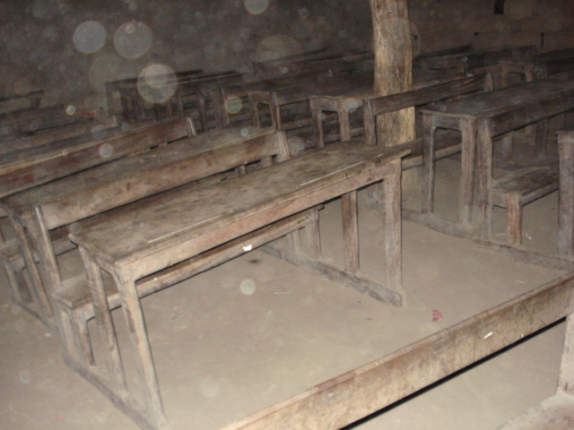
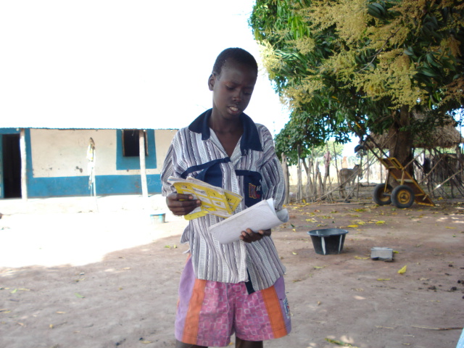

Shool for the majority of Bissau-Guinean children such as the one above

The resources allocated to the education sector are insignificant, if not nonexistent, coming essentially from international cooperation. The estimated expenditure for education goes primarily to paying salaries. Aware that wages account for 80% of state funds since 2000, it becomes easy to conclude that the ratios based on resource estimates are far from translating the actual weight of education and health, as major employing sectors, in the country's public finances.

In Guinea-Bissau, there are virtually no leisure facilities for children and no such effort is visible. The situation is even more worrisome as nightclubs take advantage of the opportunity to attract children with evening musical programs, dancing competitions and beauty contests. Early on, children start acquiring defects that parents cannot control. Among these defects are crime, prostitution and drug use. Violence and disobedience to parents and the rules of good moral character become the new way of being and child affirmation. Authorities do not cooperate and children feel more and more encouraged to attend public places in hours not inappropriate for their age. The projection of pornographic pictures for example is not controlled in movie houses neither in terms of time-of-day nor in terms of age-limits for audience. Anyone who has paid money can enter. The important thing is making money, whereas harm to public morality no longer matters.

- Special Protection Measures (Article 22, 30 and 32, 36 and 36b), c) and d), and Articles 38, 39 and 40)

Child Soldiers

The Constitution of the Republic of Guinea-Bissau does not allow child conscription, but parties involved in the political and military conflict of 1998/1999 used children in their armed forces and are still failing to comply with Law No. 3/80 of 5 May and Decree No. 20/83 of 9 July relative to compulsory military service. Commanders of various military units or battalions recruit young people directly based on family and ethnic ties. These young people have never been sworn in and tend to merely obey the chief who recruited and trained them. Another way into the armed forces for young children in Guinea-Bissau is owing to the fact that high-ranked military officers live in the barracks with their families. When their children grow up and reach a certain physical maturity they join the ranks directly and begin using military uniforms and weapons and their names end up being listed for census. It is hoped that the current census of defense and police forces, if followed by the desired reform, will get around the current situation and help initiate the process of recruiting young men and women officially into security forces as required by law. Likewise, there are cases of child-mechanical apprentices in military camps who eventually join the army without going through an official and legal recruitment.

Exploitation of Child Labor

Child labor is an old practice deeply rooted in the Bissau-Guinean society. Since ancient times, children work in the field at early age taking on responsibilities for food security in the household and community. This is a progressive process whereby each age group is assigned a specific task and responsibility aimed at that cultural and social education. They learn about the environment where they live, to plow the land, care for livestock, and fish, craft and produce tools for protecting and managing natural resources. Finally, they learn the profession of their predecessors and to behave in accordance with rules that the family and the community have set forth to be part of their identity and own selves. It appears that there is no exploitation of child labor, but the world is changing and human beings too. Nowadays, with the depletion of resources that used to be provided by the earth and the consequent rise of poverty, some of these rules no longer fit the needs of families and communities and people start burning steps. We see very young children today attempting to fulfill tasks that used to be normally performed by older age groups. Another problem is the rural exodus of young manpower. Consequently, mostly elderly men and women and young children are to be found in the communities, which is why children are obliged to lead the life of adults and end up working like slaves.

In urban areas, “meninos de criação” are the ones who do the work of maids and go out selling in the street. These children’s rights are denied due to their condition of poverty and exploited by host families and their own parents. Rarely do they have the opportunity to attend school and many of them are maltreated and sexually abused. They are children exposed to various dangers, especially of violence, humiliation and rape. When they do not comply with their duties, not only are they inflicted corporal punishment, also denied their right to a meal. Rarely do they have the opportunity to go to school and, when they do, are at a disadvantage relative to other children for always being weary workers.
There are other ways of exploiting child labor in sales, bars, restaurants and apprenticeship in mechanical workshops, panel beating, locksmith and carpentry. Here again there are not entitled to any salaries but fed with meals bought in the street. Bottom-line is that it is hard to draw the line between apprenticeship and socialization and between work and exploitation. One should beware of this aspect in the whole process of the child’s learning and socialization.

All the above stems from lack of opportunity for a dignified life within the family setting where there is general poverty while the State remains unable to create conditions of well-being and prosperity for the country.

Sexual exploitation of under-age children

Sexual exploitation of under-age children is a dissimulated crime in the Bissau-Guinean society where it is being seemingly accepted. When it comes to a girl being raped, she is the one usually blamed for having dared provoking the man. There is general unawareness of pedophilia and sexual harassment in Guinea-Bissau, even at the Police where constables always scold child-victims in these terms: “Why did you go to his room? Did you not know disgrace could happen? Perhaps he did not give you what you had expected so you now decide to play the victim of innocence? These words may be twisted around depending on the social status of the victim's family. In general, cases of the sort may or may not be followed up on till trial and, even if the rapist is tried and convicted, he may well not serve the sentence. No need to mention the level of corruption within the police and justice where law enforcers tend to favor whoever gave them more money. The Institute for Women and Children and NGOs try to support child-victims and even assist them with legal advice in some way. Still, the results are far from reaching the desired level.

Sexual abuse tend to be hidden when occurred in a family setting because family members deem it shameful to let the rest of the community know that their daughter or niece has been disgraced by her own father or uncle. Also, parents, especially mothers, are often aware that their daughter is getting into prostitution but pretend being unaware of the latter’s source of income for financing daily meals. While the authorities conduct no raids to curb such practice, the entire society pretends there is nothing major to be alarmed.

The absence of a specific law against child abuse, fear of reprisals, cultural practices, impunity and the slowness of justice make of Guinea-Bissau a safe haven for sexual abuse and child exploitation.

- Conclusions, Perspectives and Recommendations

Children’s situation in Guinea-Bissau raises concern owing to the country’s complicated context and inability to overcome the cyclical political and military crises. Poverty is reaching extremes never imagined before and, worst of all, it is now affecting middle-class families visibly unable to find better alternatives than striving for their survival. Rural communities are increasingly vulnerable and urban centers, instead of providing the usual employment or self-employment opportunities, are now engendering dangers and evils.
The absence of State is compensated with the presence of NGOs which, despite their limited resources, work with people on looking for solutions and local alternatives and sustainable autonomous for development and protection of their interests.

NGOs working on Child matters have given their voluntary contribution and organized themselves in defense of the rights and best interests of children in the following areas:

    - Dissemination of the CRC and other international instruments of child defense and protection (including community mobilization)
    - Health of children and women
    - Child education and schooling, particularly girls
    - Capacity-Building
    - Child protection in social and developmental terms

NGOs working on child matters recognize that, despite the difficult environment, there has been progress in setting up national structures to protect and defend child rights and genuine efforts, although slow, towards harmonizing CRC with other international defense and child protection instruments ratified by Guinea-Bissau and still consider that there is a favorable environment in terms of institutional cooperation with the various State structures and international organizations involved in this field.

Given the problems identified and need to find solutions that are feasible and suitable to our context, NGOs recommend:

- That national policies and strategies be adopted for the promotion, defense, protection and development of children under the auspices of the Government, including the Institute for Women and Children and with support from international partners, including UNICEF, Plan Guinea-Bissau, Save the Children Sweden and national NGOs as well;
- That an inclusive "National Plan of Action for Children" be developed for the period between2010 and 2015;
- That the structure or institution responsible for monitoring the applicability of the CRC in Guinea-Bissau be clearly defined;
- That a mechanism be created for coordinating and monitoring activities not only in the field of childhood but also the very impact of these activities on child life and development. Said mechanism should include the various institutions and organizations working on child matters in Guinea-Bissau;
- That the harmonization of the Bissau-Guinean legislation with the CRC and other international instruments for defense and protection of child rights be finalized with the utmost urgency;
- That Government stays on top of the National Assembly for the latter to approve of the Law against Female Genital Mutilation and adopt other special laws relating to child trafficking, abuse, sexual exploitation, labor, and the like;
- That measures be taken to reduce early and forced marriage and the age for marriage be made equal for boys and girls when they reach adulthood or are 18 years of age;
- That the Bissau-Guinean education system be reviewed and modernized to raise the level and quality of education;
- That the State give priority to health, education and the protection of women and children, by increasing the budgetary allocations to those sectors;
- That a long-lasting, sovereign solution be found to reduce or end the school system downtime and ensure equal and complete, quality academic years for students of all public, private, "madrassa" and community schools;
- That the State recognizes the vulnerability of children and women by facilitating their access to free health and education;
- That rules and regulations be adopted on the operation and inspection of places of entertainment, including nightclubs and movie lounges (with appropriate scheduling and entry-age restrictions as prescribed by law);
- That suitable and adequate leisure and recreational spaces for children be created as appropriate to their ages;

- That measures be taken to monitor and crackdown on the importation and sale of dangerous child-toys;
- That the emergence of structures that support the development of children be created or encouraged at the grass-roots level;
- That the court of family, minors and work be decentralized at the national level and that violators of child rights be severely punished irrespective of their political, social and economic position (zero tolerance to offenders);
- That especial attention be paid to disabled children in terms of legislation, law enforcement, social protection, health and welfare, education and vocational training and that buildings and public institutions take into consideration the needs for disabled children to have easier access to those services;
- That hygiene be improved in schools, health centers, urban centers and the communities in order to bring about a healthier environment and living condition for the children;
- that efforts be redoubled to facilitate access to safe drinking water and food to all rural and semi-urban communities by increasing water sources and improving local agricultural production;
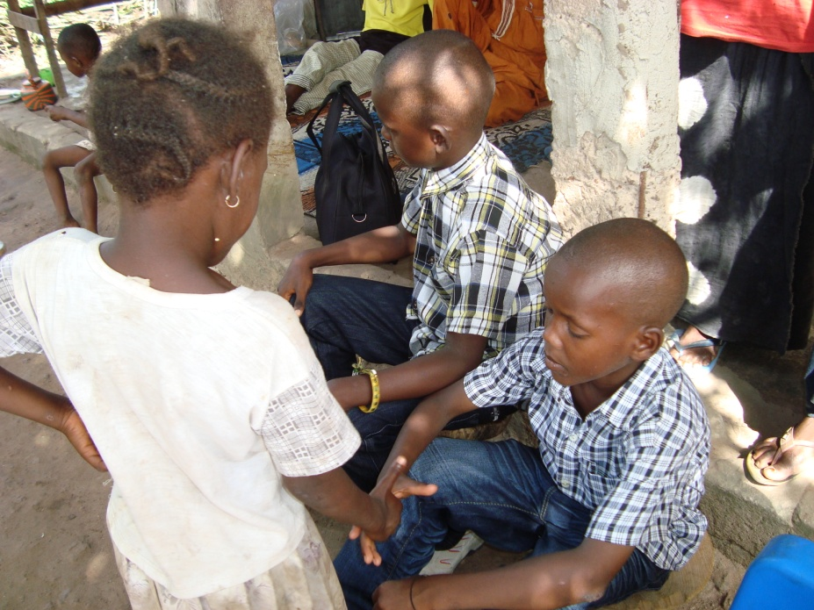
- That from now to the year 2015 a "Meeting or National Conference" on the "Applicability of the UN Convention on Child Rights in Guinea-Bissau" be organized.

Going back home and shaking a friendly and brotherly hand seems to be an unthinkable dream for many children such as the one above.

9. List of NGOs that co-produced the Alternative Report
1. ADC, Association for Child Rights
2. ADIC-Nafaya, Association for Supporting the Development of Local Initiatives
3. ADS, Association for Sustainable Development
4. AGRICE, Bissau-Guinean Association for Rehabilitation and Reintegration of the Blind
5. ALANSAR, Islamic Developmental Organization
6. AMIC, Association of Friends of Children
7. APRODEL, Association for the Promotion of Local Development
8. ASPAG, Bissau-Guinean Association for Sanitation and Environmental Protection
9. CASA EMMANUEL, Host House for Orphaned, Abandoned and Excluded Children
10. DIVUTEC, Bissau-Guinean Association for the Study and Dissemination of Appropriate Technology
11. LGDH, Bissau-Guinean Human Rights League
12. MERS-BODJAR, Rural Association for the Development of Socio-Economic Activities in the Region of Biombo
13. PNI, Children's National Parliament,
14. RA Help, Cooperation and Development Network
15. RENAJ, National Network of Youth Associations
16. RENLUV / GC, National Network to Combat Gender and Child Violence
17. SININ MIRA NASSIQUE, Association for Combating harmful practices to Woman and Child Health
18. SOS CRIANÇAS TALIBÉS, Alert and Protection of Child-Beggars
19. TOSTAN GB, Hatching and Sharing Experience

10List of Consulted Documents

- Guide Pour Les Organisations Non Gouvernemental Établissant Des Rapport Destinés au Comité des Droits de l’Enfant – Édition révisée (1998) – Groupe des ONG pour la Convention Relative aux Droits de l’Enfant.
- Plano Nacional de Acção Para a Infância (Resumo) – November 1992, drafted by the Inter-ministerial Commission for Child Protection (ICCP).
- Relatório do Governo Sobre a Aplicabilidade da Convenção dos Direitos da Criança na Guiné-Bissau – Ministry of Social Solidarity, family and Fight against Poverty and the Institute of Women and Children -- Fodé Abulai Mané and Paulina Mendes, INEP - December 2008.
- Universal Declaration on Human rights – 1924.
- The United Nations Convention Child Rights Convention – Nvember 19899.
- “Consultas Nacionais das Organizações e Movimentos de Crianças Sobre a Revisão a Meio Caminho da Posição Africana Comum Sobre a Criança: “Uma África Digna das Crianças” – CONAFE e ANPPCAN – September 2007.
- Study on “Child Beggars in the Dakar Region” – Understanding Children’s Work – in Inter-Agency Research Cooperation Project.
- Multiple Indicators Custer Survey (MICS 3 – 2006): Monitoring the situation of children and Women in Guinea-Bissau – Ministry of Economy and Planning - June 2006.
- Relatório Nacional Sobre o Desenvolvimento Humano na Guiné-Bissau – PNUD GB – 2006.
- Relatório Alternativo Sobre a Implementação da Convenção dos Direitos da Criança na Guiné-Bissau – Grupo de ONG Que Trabalham no Domínio da Infância – João S. Handem Jr. - July 2001.
- Relatório do Governo Sobre a Aplicabilidade da Convenção dos Direitos da Criança na Guiné-Bissau – Ministério dos Assuntos Sociais e Promoção Feminina – Eduardo Sanca – INEP – September 1997.
- Consulta as Crianças da Guiné-Bissau Sobre a Revisão a Meio Caminho da Posição Africana Comum Sobre a Criança: “Uma África Digna das Crianças” – Laudolino Medina – AMIC – September 2007.
- A Dimensão Sócio-Cultural de Comportamentos Face ao Sida na Guiné-Bissau – Secretariado Nacional de Luta Contra Sida (STNLS) – António Isaac Monteiro, Paulina Silva e João Ribeiro Butiam Có – INEP – Outubro 2005.
- Abuso e Exploração Sexual de Menores na Guiné-Bissau – Instituto da Mulher e da Criança – João Ribeiro Butiam Có e Paulina Silva – INEP – December 2006.
- Cicatrizes de Mulher – Livro de Sofia Branco sobre a mutilação genital feminina na África e em particular na Guiné-Bissau.
- Análise da Situação das Crianças Órfãs e Vulneráveis na Guiné-Bissau – Elementos para uma Estratégia Nacional de Protecção Social para Órfãos e Crianças Vulneráveis – Ministério da Solidariedade Social, Família e Luta Contra a Pobreza – 1.º Draft – Lídia Germain e Alfredo Handem – October 2008.
- Boletim Oficial N.º 08 de 28 de Fevereiro de 2008 – 3.º Suplemento – Publicação das Resoluções da Assembleia Nacional Popular n.º 23/2007:Aprovada a Carta Africana dos Direitos e do Bem-Estar das Crianças, n.º 24/2007: Aprovado o Protocolo Facultativo à Convenção sobre a Eliminação de todas as Formas de Descriminação da Mulher, n.º 25/2007: Aprovado o Protocolo à Carta dos Direitos Humanos e dos Povos relativos aos Direitos da Mulher em África.
- Observações Finais do Comité de Direitos da Criança sobre o “Relatório Inicial da Guiné-Bissau” adoptado na Sessão 804.º a 7/06/02 em Genebra.

