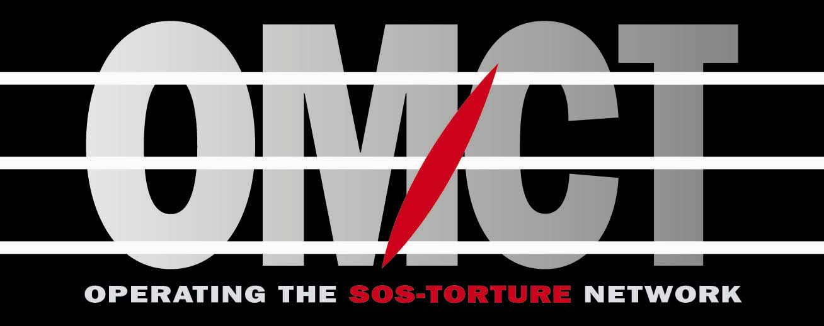
World Organisation Against Torture

is pleased to invite you to the HRC’s side event

Strengthening of the UN mechanisms for the protection of children’s rights

2 – 4 pm – Thursday 21st September

Palais des Nations, Room IX

Panellists

Mr. Noberto Liwski
Expert member of the Committee on the Rights of the Child

Mr Juan Miguel Petit
Special Rapporteur on the sale of children, child prostitution and child pornography

Mr. Vitit Muntarbhorn
Chairperson of the Coordination Committee of Special Procedures and former Special Rapporteur on the sale of children, child prostitution and child pornography (1991-1994)

Mr. Paulo Sérgio Pinheiro
Independent expert of the United Nations’ Study on violence against children

Mrs. Nakpa Polo
Member of the African Committee of experts on the rights and welfare of the child

will provide statements followed by a debate with the public.

Moderator: Eric Sottas, OMCT Director

Translations will be available into French, Spanish and English

