^{5th} HRFC Newsletter

On Happy Children Home, Charfession, Bhola Island
Period : January 2006 – June 2006

To: TDH- Netherlands, Sponsors / Friends of Charfassion orphanage
Project Code: BD 003A (Happy Children Home/ orphanage- a project of HRFC)

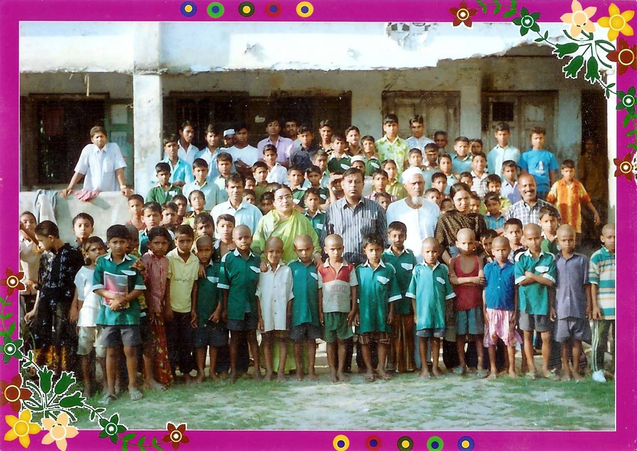

A view of the Charfassion Orphanage. Our boys , staff and visitors from Department of Social Services (DSS) of The Ministry of Social Welfare, Govt. of Bangladesh ( Lady, Deputy. Director, DSS and officials ), on March 10,2006

Dhaka Contact:
Human Rights - First the Child (HRFC)
Att:A.H.M.Mainuddin Ahmed (Jahangir), Chairperson
Esha Garden, House – 23A, Road -113A, Flat-4A, Gulshan-2
Dhaka-1212, Bangladesh. E-Mail: mainuddin_ahmed2002@yahoo.com
Web: www.bypecom.com/jahangir, Telephone: 0187-513168

July 08, 2006

Prepared by: Based Chowdhury: Director (Hon.) HRFC

REPORTING PERIOD
January 2006 to June 2006

Report of: Human Rights- First the Child (HRFC)

0.1. Introduction:

Children are the holy human being, the dream of the parents and the best future human resource of a nation. But because of the socio-economic, cultural and political reasons children are identified as privileged and underprivileged class. Underprivileged children are again have different names viz. orphans, destitute, working children, war victims, disables, etc. and it is very pity that the orphans, the distressed and disables are the most distressed and vulnerable among the child population.

The orphans, destitute children and children with disabilities are deprived of all sorts of basic human rights like proper foods, shelter, clothing, health –care, education and like the most important needs of children i.e. love and care of the parents. Besides, these children live under a large amount of threat of being the victims of trafficking, kidnaffing and sexual abuse.

Charfassion orphanage, the happy home for the orphans and the destitute children has been in service since 1970. The TDH – Netherlands the lone donor of the orphanage for the last ten years has saved lives of at least 255 orphans and the destitute children through their honored support they extended to run the institute as designed by the management. It is true like daylight that unless the support was available these children could be victims of any of these tragedies like psychological and sexual abuse, all forms of slavery, child pornography, trafficking, hazardous works and victims of domestic violence. Every child has rights to live a decent and just life in the society. The mental and psychological growth of child only possible where proper rights of the children established and ascertained. Basic needs of the children of this home are well addressed and rights are ensured in the light of the United Nations Conventions on the Rights of the Child (CRC).

0.1.1 OUR Objectives

i. To alleviate the suffering and thus improve the living condition of millions of underprivileged children in general; and orphan/destitute/ children living in street situation in particular;
ii. To provide a safe home and family environment to orphans and children living in street situation;
iii. To provide food and clothing as the priority call for human being;
iv. To guarantee Medicare services in order to ensure necessary growth for the children;
v. To make access to formal education and organize livelihoods training.
vi. To organize cultural and excursion programme with a view to increased cognitive development;
vii. To provide counseling support for the development of vision of life.

0.1.2. Greatness to humankind:

Humanity deserves the kind support of ‘one for another’ who really needs. It is the inner objective of the creator and being practiced since the beginning of human civilization. Natural calamity and other types of disaster crop up frequently leaving the humankind in mammoth hitch and glitch. Victims find it awesome for salvation amid problems to come across sometimes simply in order to continue existence and growl for assistance. Kind hearted people step forward to contribute for the sufferer. The initiative for the establishment of the orphanage under the situation of dire need of the children left by the incredible natural disaster popularly known as ‘Mountain Height’ tidal bore accompanied by storm carries the sense of humanity. Great man with crying heart for the sufferer stepped on and the residential centre for the tidal bore affected children with no trace of parents and no way to go accommodated with his individual resources. Since then the centre continues services to the most vulnerable children for survival and build career to be self supporting and contributory to national development. We wish the greatness keep on again and again when the human kind is in need.

0.1.3. Credibility of the Orphanage in the locality:

The orphanage was established by a benevolent Landlord (locally known as ‘Mian’) at a time when the lives of a huge amount of children was on the cards of death having no trace of their near and dear ones just after the devastating tidal bore in the offshore island Bhola in 1970. The humanity was howling for looming support for the survival of the children who are the first target of natural calamity or manmade crisis. The initiative was appreciated by philanthropic organization and bighearted people in the country and overseas as well. Most distressed children found their home, food, clothe, health services, as well as education which are the first category basic needs of any children. The official records and documents strongly advocate that the objective of establishing such a compassionate home for the distressed children, not been cherished with individual or social gain except but the wellbeing of the children under life threat. The management of the institution has so far been proved honest, dynamic and transparent as well. Inmates of the orphanage, even under the increased trends of collapsing of the norms, values and ethics of the children in the context of current society are holding unlike trends being capable of drawing appreciations of the community around. Poor people are in honest confession that the institute is the best example of safe home that focuses building the career of distressed children along with the prime needs of survival. Thus the home, raising its proud head high, renders services to the holy children who otherwise could easily be the prey of death or crime syndicate.

0.1.4.Main Activities:

I. Mainstreaming education, Foster care and Caring and provide safe home for orphans
ii. Early stimulation program
iii. Awareness campaign about hygiene and health issues
iv. Medical assistance, vaccination & de worming.
v. Children development centre
vi. Giving them psychosocial counseling
vii. Child protection and legal Aid ; stop child trafficking, ensure safe home and protection and advocacy for implementation of UNCRC at all levels
viii. Institutional care for orphans-empowerment ( a Home for 100 orphans )

0.2. PROJECT ACTIVITIES

0 .2.1. Inmates in the school as per enrollment

Primary 81 |  |  |  |  |  | Secondary 19
Grades | I | II | III | IV | V | VI | V11 | V111 | IX | X |  | Total
No. | 22 | 20 | 17 | 18 | 4 | 2 | 3 | 4 | 5 | 5 |  | 100

The above matrix depicts the number of inmates of the orphanage continuing in the government’s mainstream school for the education session January – December’06. In the primary school the figure is 81 and almost four times higher than in the secondary school.

School result of the children is something for which the home is reputed in the locality. Current results in the secondary school certificate exam (first public exam) once again endorse the reliability of the statement.

0.2.2. Distribution of children according to age category:

Age category (Years) | Number of children
15 - 18 | 10
12 - 14 | 09
05 - 11 | 81
Total | 100

The matrix above spells out the gravity of the vulnerability of children without supporting guardians. Younger children are exposed to more susceptibility; and supports for them are immense need failing of which the situation will aggravate and the problem will heighten. Availability of the provision for survival becomes the main concern and many falls in trap of the traffickers and loses their lives under cruelty. The orphanage management thus puts highest priority to the younger children for admission and support.

0.2.3. Technical Education of the children: the future inclusion

Having the scope to get hold of education is a right of the children though often it is considered as an opportunity. The United Nations Conventions on the Rights of the Child (UNCRC) has underscored this right and reminds the ratifying countries for it full implementation. Education as a continuous process thus has general and technical aspects. One who has the facility and talent to go for continuation in a higher tier will prefer general and technical education for a longer period while the people with poor economic background under demand of going for earning should prefer technical education after having basic general education. Keeping in mind the orphanage management is attaching more emphasis on technical education alongside general one.

Education in the mainstream school will continue for the children upto grade ten at the present context so long ‘vocational certificate course’ not available; and technical strong market driven course will follow for children who complete grade eight in the mainstream school. This course will be designed inline with the competence of the children and the standard curriculum conducted by the reputed organizations. Selection of children for specific trade will get highest consideration the interest of the children on the trade. The idea is at the preliminary stage will get finalized through a process of workshop, review as well as sharing.

0.2.4. Beneficiary children till date and the mainstreamed ones:

Over the three and half decades the home enrolled 1475 orphan/destitute children and most of their starting age was 5 to 6 years. As per the institutional rules children reached their age at 18 were given farewell and that figures 1375. Personal contact with those children reveals that 750 of them are well established in different occupational niches and rests are also doing good in their own personal and family lives. Goodbye time of every inmate makes the whole environment of the centre emotional and heavy since the long attachment of 10 to 14 years reminds plentiful events and experience. Every sensible person can imagine the tough responsibility the home management discharges for the children for such a stretched period and the cost involved for each child. But the management is proud about the contentment the children feel in the centre.

0.2.5. Services for the inmates of the home

i.. Residential accommodation is provided to 100 children at the orphanage.
ii. Children receive 3 times food daily and two sets of dress yearly.
iii. Medical care is provided to children through registered physicians.
iv. Social and educational care for all the children: all 100 children attend school as per daily routine and do attend sports & cultural activities, etc.
v. Home gardening compulsory for all, work to live and earn dignity

0.2.6.Management of the home:

0.2.6.1. Management committee

Day to day management of the home is entrusted to the paid staff headed by one Senior Teacher and closely supervised by the Director (Honorary). However, the 5 member Project Management Committee (PMC) is the functionary body who monitors the implementation of the activities of the home as well as the management aspect. The tenure of the committee is two years and duly approved by the Department of the Social Services, Government of the People’s Republic of Bangladesh. The PMC is virtually advised by an Advisory Committee which is comprised with the local Member of Parliament (MP), the Administrative head of the upazila i.e. Upazila Nirbahi Officer (UNO) and other elites of the society. However, these committee advices the Chief Executive i. e. the Chairperson.

0.2.6.2. Paid staff of the home

There are nine salaried staff who eventually are the core human resources relentlessly performing the tough job of implementation and management of the orphan and distressed children living in the home. The positions are as follows:

1. Teacher cum Social Worker - 3
2. Caretaker - 2
3. Cook – 2
4. Aya (Home mother) - 1.
5. Cleaner - 1

“lend us a hand “--HRFC
    - A day of the Home from 5:30 a.m. to 10: 30 p.m.( our daily activities)

Time | Description of works | Supervised by
5:30 to 6:30 am | Wake up call, cleanness of teeth, etc. | Care taker
6:00 to 6:30 am | Discipline and physical exercise in open air | Teachers cum Social Worker (sports and cultural activities)
6:30 to 8:30 am | Home education and for senior student preparation for schools home tasks. | Teachers cum Social Worker (All 3)
8:00 to 9:00 am | Breakfast, bath etc. | Cook, Teachers, Aya
9:30 am | Going to school | Teachers
12:30 am | Small children return from school and take food and rest. | Cook and Teachers
2:00 to 3:00 pm | Children from High School class (vi-x) & take food | Cook and Teachers
3:00 to 3:30 pm | Rest | Teachers
3:30 to 4:00 pm | Accomplishment of home tasks given by school | Teachers
4:00 to 6:00 pm | Gardening, cultural activities , games and sports. | Teachers and care taker
6:00 to 7:00 pm | Taking food and washing praying etc. | All staff
7:00 to 10:30 pm | School lesson preparation, home works, going to bed, etc. | All staff

0.2.7. List of the Daily Feeding (average) per child:

1. | Rice | 200gm
2. | Wheat/Ata | 250gm
3. | Dal/Pulse | 25gm
4. | Vegetable | 120gm
5. | Fish/Egg | 100 gm. (Weekly 2/3 times)
6. | Meat | 50 gm ( 2 times in a month )

“Child first”- HRFC

0.2.8. How do we spend TDH-N Fund for the Children:

(Say 1 NLG =100%)
30% are being spent for staff management / personnel cost.
50% are being sent for educational cost (Fees, books, etc)
10% are being spent for cultural activities, game and sports.
10% are being spent for cloths and social expenses.

0.2.9.. DRESS / UNIFORM FOR BOYS

Dress / Uniform / Logistic supports are being provided to each orphan with TDH-N approved fund, during the reporting period:
1. Shirt 1 (One)
2. Lungi 1 (One)
3. Full pant 1 (One)
4. Half Pant 1 (One)
5. Gangee 1 (One)
6. Sandal (Chapoll) 1 (One)
7. One set of playing uniform to each one. (Both for cricket & football team)
8. Two sets of school uniform to each

0.2.10 Social, cultural and general Activities of the Children:

i.Social activities of the children :
include home gardening, farming, fishing. The boys of the orphanage work in a 30-acre farm to grow their own paddy and lentils. We also provided feeding for 500 needy children in nearby villages. HRFC did support a large number of destitute families through initiating different income generating activities, especially to aid the girls child within their family or to a neighbor. Boys of the orphanage carry out community work, take part in repairing roads and help out the elderly to renovate their thatched houses which are damaged as a consequence of storms. Thus, HRFC helped thousands of destitute families in the Bhola Island.

ii. Cultural Activities:
The boys attend cultural shows, occasionally arranged in the campus. As a part of recreation and sports, a football team has been formed. The players received guidance in the playground from an appointed coach regularly, which has been rewarding. Here encouraged by the results. HRFC extended the facility to provide full-fledged outdoor game outlets for the boys, including cricket, volleyball, basketball, badminton with the financial aid from TDH Netherlands. A library for children is being established at the orphanage buildings to help children to form habits of reading with the financial aid of TDH-Netherlands..

iii. Health programs:
HRFC’s present health program relates health and nutrition. The orphanage avails hired services of a local clinical physician for fascination, deworming and diagnositicianing the common diseases. If needed, patients (students) are referred to hospital . Diet and medicines are given by HRFC which is also covered under the TDH-NL grant:

iv. Home Gardening;
The Orphanage in Charfassion has its own orchard. The children use to take nutrition’s fruits with their daily meals, and thus meet their nutrition needs. HRFC plans to provide ‘Tiffin’s during the school hours and refreshments in time of games and sports. But, as the management staff is inadequate (in total 9 only). The HRFC is not in a position to introduce it right now. Besides, the children receive improved diets once a month, and on festivals like ElDs and other religious festivals, Independence Day, Bengali New Year etc. Their daily caloric intake of average 1600 has been raised to 1700 ( “ Minimum Requirement:1800 Caloric”) to meet the basic nutrition needs, as they will require at their tender age as they grow up.

0.3. case stories of i. Master Billal and ii. Master Ibrahim

0.3.1.Case history: Master Billal Hossain Noman

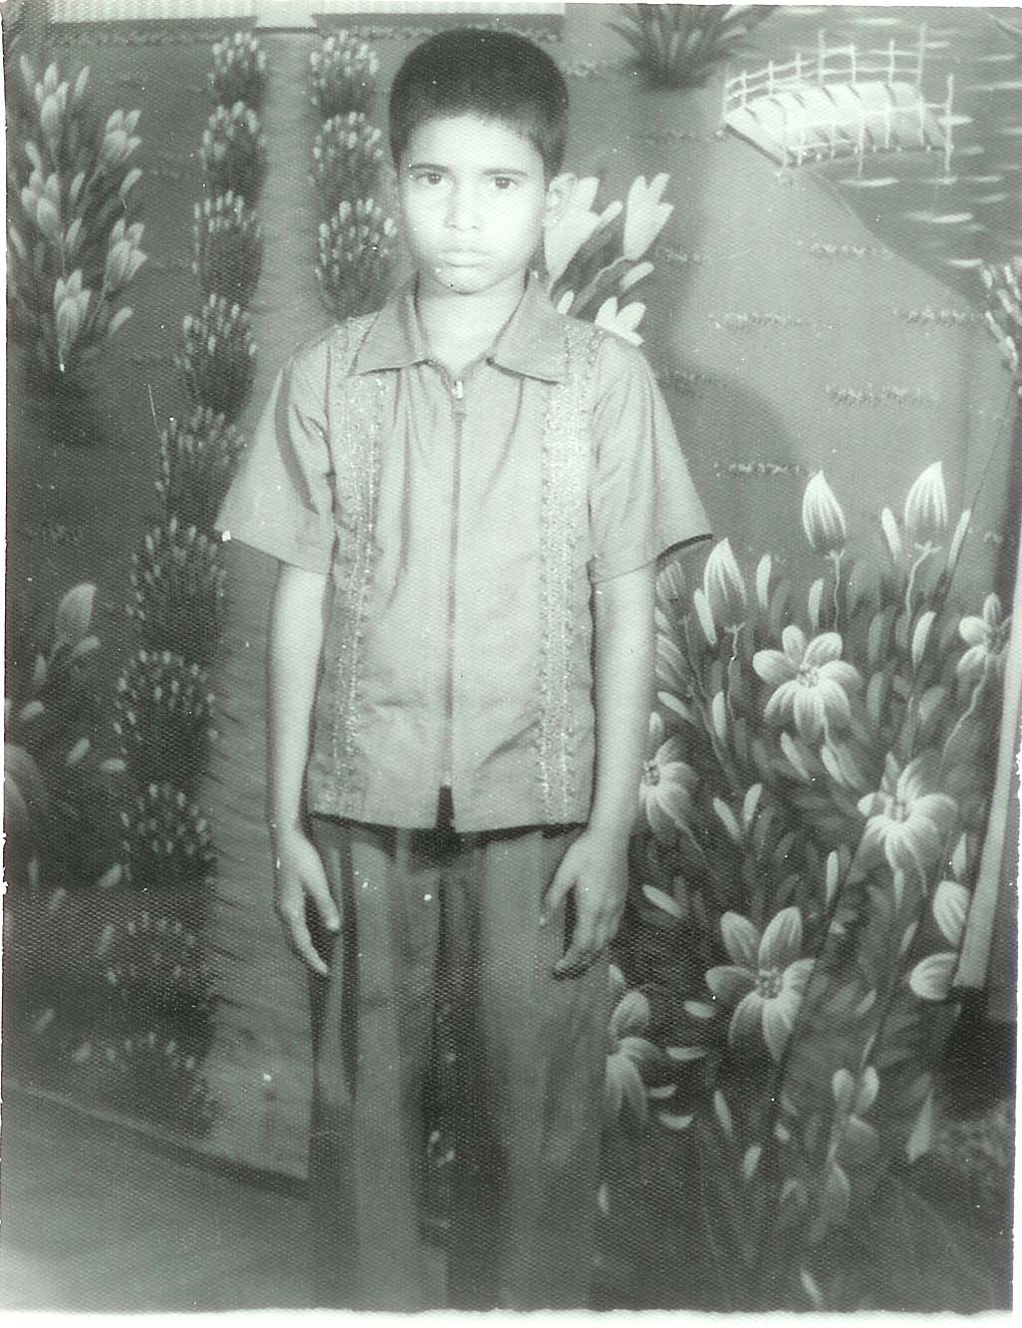

“My son once will be a government high official and the departed soul of his father will be delighted” – said by Billal’s mother.

Billal Hossain Noman is the only child of his parents. All the hopes and aspirations of his parents centered on him. They dreamt once Billal would stand on his own feet and does all the good for them and the society which will elevate their position as well. But the universal proverb ‘man proposes but god disposes’ materialized in their life. The sudden accidental death of Billal’s father stormed the entire plan. His mother had to pack up and take shelter to her poor parent’s home uprooting all the attachments with her husband’s house.

Billal’s father was a poor rickshaw puller plying three wheelers in the road of Charfassion. Somehow he could manage two times food with his meager income but they were happy with all they had. Billal’s father used talk to his mother that they wouldn’t go for too many children. He would send Billal to school and after completing education at local school, Billal would go for college and university for higher education. And once he will be a high ranking government officer, everybody will praise Billal’s performance and they will feel honoured. But one day when Billal’s father was engaged in rickshaw pulling, all on a sudden one high speed bus crushed his rickshaw and Billal’s father succumbed to injury on the spot. Billal was two years old while his mother was only seventeen at the time of Billal’s father’s death. Finding no other alterative the young women took shelter to her brother’s house who were also not in a position to extend financial support to their sister and her infant boy. However, the safe shelter was important for her since life of young women become victims of lot of problems like sexual harassment under such situation.

The dreams of Billal’s father always run after her (Billal’s mother)and because of that, the young widow of 17 years ( now aged 21 yrs) determined not to get second marry in order to keep boosting the mental state of Billal high. She started working in others house as domestic aids and also in the agriculture field (not very much usual in the country context) for subsistence. In such way she had been passing her days with untold hardships and searching avenue for support to Billal for education. Being suggested by one well wisher, Billal’s mother brought her beloved son to Charfassion orphanage. The management being convinced admitted Billal to the orphanage in one vacant seat in the month of March 2006.

Billal has been admitted into a government primary school in grade one. He has been provided with home and school dress, necessary educational accessories and he is happy with all these supports. He is happy with his new inmates in the orphanage and also with the teacher and other management staff of the orphanage. His mother initially used to visit Billal in the orphanage every week and now every month regularly. His mother is happy that her son has got safe shelter, food and educational opportunity which she has been looking desperately in order to materialize the dream of her late husband and see established her son in the society. Moreover she is relieved from serious anxiety that her son will not be target of the trafficking agents who offer different hopes to the children of poor family to overcome the pains of the daily family life. She told the orphanage management about her apprehension centering her son.
Billal is sincere to his homework in the orphanage and appreciated by the teachers in the school. He wishes to see smiling face of his mother and salvation of the soul of his deceased father.

0.3.ii Case history of Master Mohammad Ibrahim
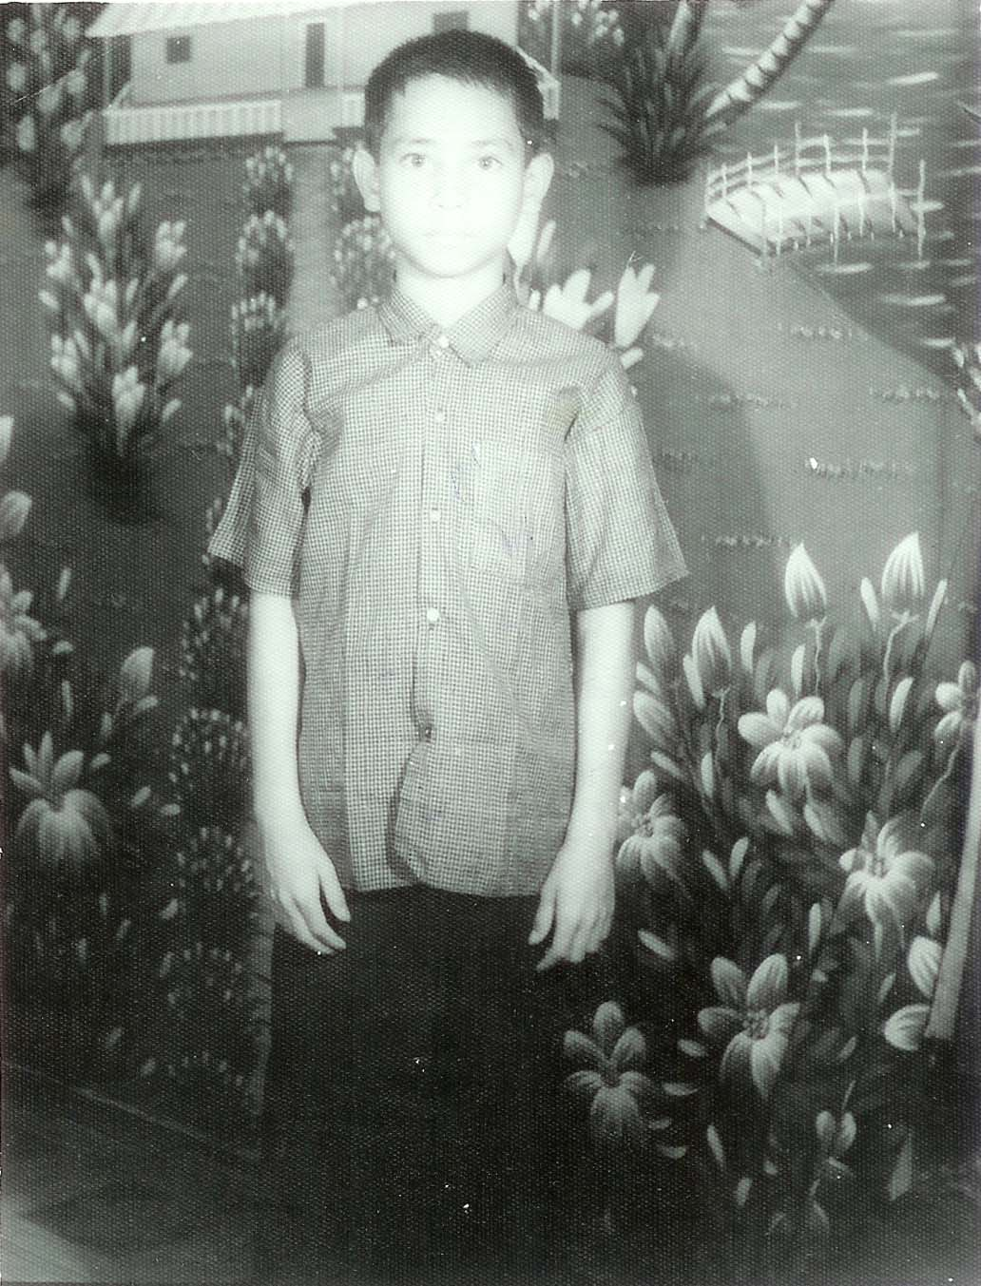

“I’m now relieved of the anxiety that my son will not be the prey of traffickers any more” – comment of Ibrahim’s mother.

Mohammad Ibrahim is eight years old. He is an inmate of the Charfassion orphanage and currently is a student of grade two in a nearby government primary school. He is a meritorious boy and committed interested to his study. Teachers of the orphanage and also in the school hope to see him with good record in the exams.
Ibrahim hails in the remote village of Charfassion Upazila which is very badly connected with the upazila headquarter. His father was a poor agriculture labour and died of diarrhea when Ibrahim was four years old. It is learnt that because of the bad communication he couldn’t be taken to the upazila hospital and of course poor financial background was also the important reason behind not being treated on time by the competent physician.

Ibrahim has another younger brother and his mother maintained the family of three members through her service in the houses of well off family as domestic aids. His mother expressed her untold sorrow that she couldn’t feed her children two times regularly with her meager income. But she wants to send her children to school and see them educated. Ibrahim was going to school but her mother failed to provide them food, treatment, clothes and educational accessories other than book that the school authority provides as government support.

Ibrahim’s mother because of her strong interest in education was looking for scope for her son particularly Ibrahim. She was asking to everyone how she could get contact with Charfession orphanage where she learnt that it provides residence, food and education as well to orphan children. Through the reference of one elite of the locality one day she could manage to come to Charfession orphanage and described all the tragedy of life and future hope centering the child Ibrahim.
In vacant seat of the orphanage, the management admitted Ibrahim and in consultation with the nearby government school admitted him in grade two of the primary school without any delay. The management is hopeful that Ibrahim will cut good figure in his study and one day will be able stand in his own feet and make her mother a happy woman who wished to see it through all her pains and misery.

It is important to refer here that children living with serious financial, in other word, food crisis get untold frustration and then leave parents; and become victims of trafficking being lured by the agents for a life where there will be no scarcity of basic needs. The orphanage in Charfession is considered thus a big opponent of the trafficking gang who helps children of distressed family construct their career in order to stand on their own feet and live a decent life. Ibrahim like other inmates of the orphanage now completely secure from being victims of trafficking.

0.4. Monitoring visits: Jan-June,06

Visits contribute in improving the performances of a project. The TDH official visited two times at Charfassion as a part of their regular monitoring visit. During the visit, the TDH-N officials of Bangladesh, were able to have close exposure and dialogue with the inmates to learn the life styles and stories of the boys of the orphanage.

During the period, the officials of Dept. of Social Services of Govt. of Bangladesh visited the orphanage two times along with Thana Social Services officer of Charfassion as well the Local Member of Parliament one time in May,19,2006

At the orphanage, TDH official came face to face with the boys as well with management, in an informal and non-threatening mode, which both sides found useful and rewarding.

The dialogue which they have had there, which provided them a new experience, learning and new insights, which perhaps intellectually are exciting, practically relevant, and most enjoyable. Visits help in boosting morals of the orphans and help in creating understanding.

“rights of the child first”- HRFC
0.5. Financial Statement for 2006

Budget:
a) Budget for January 2006 December 2006: In Taka
Feeding – Tk. 25x100x365 days 912,500.00
(two meals 10/+10/+ one breakfast+5/)
b) Education: Part time salary, Social Expenses
(TDH-Netherlands Contribution for 2006) 641,731.00

Total Cost: 1,554,231.00 (100%)

Income Sources:

a) Government (50 boys x 400 x 12)= 2,40,000.00
b) TDH-N Contribution for 2006 641.731.00
c) Homes Income (Land & Others)
90,000.00
d) Donation
1. Mrs. Cindy Gelpi ,Slidell, Louisiana ,USA 68,009.00
Bottom of Form
US$ 365/ sponsored a child (by TT) Taka 25,620/
2.Eng.Sidiqur Rahman Kind worth Taka 18,000/
3.Chairperson of Hrfc: cash /kind Taka.25,000/
-------------------------- Taka 68,009/
-----------------------------
( US$ 15,290- ) 1,039,740/00 (67%)
*Actual shortage yet 33%
to meet by 2006 (US$7,566-) 514,491/00 (33%)

(US$ 22,856- ) 1,554,231/00 (100 %)

1 dollar = 68 Taka, 1 Euro 80 Taka.

Actual Shortage for the year 2006 in US Dollar 7,566- (Taka. 514,491). These shortage of funds are to raised yet to meet market debt for 2006.

0. 6. HRFC APPEAL
The Human Rights - First the Child (HRFC) strongly believes that in this universe most of the compassionate works are initiated by the benevolent people/welfare organization; and keep on going maintaining its all standards and pace with the support of the benevolent people and organizations determined to serve the suffering humanity. This believes has further been strengthened through the cooperation and assistance the concerned extended so far during the three and half decades. This efforts need to continue since the service to the suffering humanity would continue.

The Human Rights-First the Child (HRFC) group attract the attention of the right people to work for and support the suffering humanity where children are focused first who in the time ahead will lead the country. Please visit the happy home, pass a night with our beautiful children and decide how you can contribute.

0.7. Conclusion:

The happy home for the orphan children in Charfassion has been continuing with the support of TDH – Netherlands for almost a decade. Children of the home are growing with hopes and aspiration and never feel scared because of the love and affection they have in the centre which they need desperately for normal psychological set up to look forward positively. The vision of the children will get shape if the support continues the time ahead. Thanks to TDH-Netherlands family for supporting 100 orphans for a decade.

Further the residential building of the orphanage is at a stake and unless efforts are taken without more ado, awful disaster may happen in the lives of the inmate children and the staff engaged in for the services of the children.

Howe ever, HRFC strongly believes that The Tucker Foundation as well Dartmouth College, NH,USA ( at the Leadership of Dean Stuart C. Lord ) will keep on their efforts to give shape the design of the new Orphanage building as they consider inline with the mobilization of resources. Thanks to Tucker Foundation and Dartmouth Trustees for showing kindness to 100 orphans.

It’s our great pleasure to acknowledge heartfelt contribution and cordial assistance of all concern, particularly Mr. Mathew K. Sueoka, for The Architectural Design of The Charfassion Orphanage, Bangladesh as well “Hopscotch Network Groups” of USA. Thanks also to Ms. Cindy GELPI, Louisiana, USA ,for her commitments to work for the children in CRISIS.

Besides, the organization incurs huge deficit to provide food and other support to the children of the home. The Chairperson is continuously in touch with the potential donors for the humanitarian assistance in order to bestow secured and decent lives to the children struggling for survival and easy prey for the traffickers engaged in the most heinous work in the world. It is beyond imagination right at the moment what might happen if everything doesn’t go but it is true that services for the orphan children would suffer. It is therefore, the kind appeal to the benevolent organization and individual to respond positively in order to continue the support to the distressed and orphan children to grow as potential human being and lead decent lives

VISIT WEB Pages: to know more about Charfassion Orphanage
www.dartmouth.edu /projects/ Charfassion Orphanage
www.hopscotchnetwork.org

