NATIONS UNIES  HAUT HAUT COMMISSARIAT AUX DROITS DE L’HOMME | 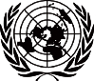 | UNITED NATIONS  HIGH COMMISSIONER FOR HUMAN RIGHTS

Téléfax: (41-22) 917 9022 the
Télégrammes:UNATIONS, GENEVE
Téléx: 41 29 62
Téléphone: (41-22) 917 92 16
Internet www.ohchr.org
E-mail: mandrijasevic-boko@ohchr.org
REFERENCE: MAB/ United Nations Study on Violence against Children

Address:
Palais des Nations
CH-1211 GENEVE 10

4 October 2006

Excellency,

The Committee on the Rights of the Child wishes to refer to the report of the Independent Expert for the United Nations Study on Violence against Children (A/61/299), to be discussed in the Third Committee of the General Assembly on 11 October 2006. The Committee welcomes the report and recalls that in its letter to the Secretary-General in 2001, requesting an in-depth global study, it urged that it should “lead to the development of strategies aimed at effectively preventing and combating all forms of violence against children, outlining steps to be taken at the international level and by States to provide effective prevention, protection, intervention, treatment, recovery and reintegration.”

The Committee commends the fact that the Study was developed through a participatory process and extensive consultations, in particular through the nine regional consultations in which representatives of States, regional and intergovernmental bodies as well as civil society organisations, national human rights institutions and others took active part. In particular it welcomes the direct engagement with children and young people and respect for their contributions in the process led by Professor Pinheiro.

As the report underlines: “Member States have already made commitments to protect children from all forms of violence. However, we must accept – from children’s testimony during the Study process, as well as reflected in research, that these commitments are far from being fulfilled. The core message of the Study is that no violence against children is justifiable; all violence against children is preventable. There should be no more excuses. Member States must act now with urgency to fulfil their human rights obligations and other commitments to ensure protection from all forms of violence” (para. 91).

The Committee wishes to strongly urge Member States to endorse the report and its recommendations, to commit themselves to fulfilling their obligations under the Convention on the Rights of the Child, its Optional Protocols and other instruments and to meet the time bound key goals set in the report (see para. 116).

In particular, the Committee wishes to support the recommendation that a Special Representative on Violence against Children should be appointed as soon as possible, “to act as a high-profile global advocate to promote prevention and elimination of all violence against children, encourage international and regional cooperation and ensure follow-up to the present recommendations” (para. 120).
…/…

- 2 -

Now that the scale and universality of the problem of violence against children, in their homes, schools, other institutions, the workplace and the community has been made more visible and placed on the international agenda, it is essential that momentum is not lost. There must be a high-level, high profile focal point for follow-up as well as appropriate coordination among key UN agencies.

The Committee appreciates that there may be some hesitation over establishing an office of Special Representative during the current period of UN reform and when the mandates of some related special procedures are under review. The Committee considers that such pragmatic considerations ignore the urgency of the situation now placed so clearly on the international agenda.

The Graça Machel Study on the impact of armed conflict on children – also requested by the Committee on the Rights of the Child - led to the appointment of a Special Representative to the Secretary-General. That Office has ensured that that particular issue has been highly visible and significant progress through monitoring and advocacy has been achieved. There is no duplication in the proposed appointment of a Special Representative on Violence against Children, who would be tasked to ensure that there was collaboration and not duplication among the various special procedures involved. The Committee on the Rights of the Child already highlights the Study and its recommendations in its concluding observations on States parties’ reports. It looks forward to working closely with the Special Representative and with key UN agencies on follow-up.

The Committee hopes that Member States will ensure the establishment of the Special Representative with an adequately resourced office. Children should not be asked to wait any longer for concerted and coordinated action to address this disturbing problem and the momentum created by the Study process in all regions must not be lost.

Please accept, Excellency, the assurances of my highest consideration.

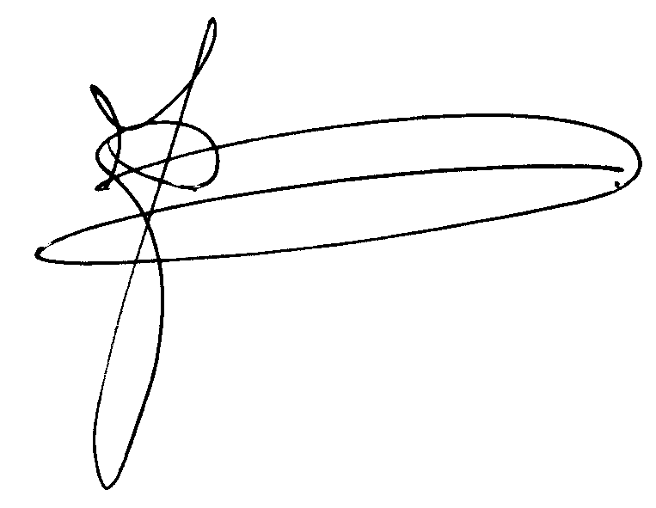

Jakob Egbert Doek
Chairperson
Committee on the Rights of the Child

