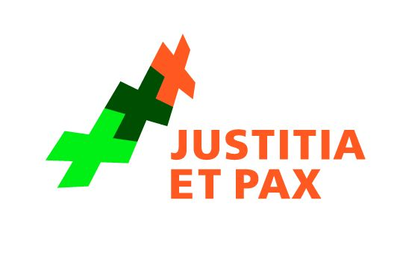


Justice and Peace Netherlands
Dutch Section of the International Commission of Jurists (NJCM)

NGO submission to the 50th session of the Committee on the Rights of the Child

Human rights of ‘1F’ children in The Netherlands

Background: General Pardon and 1F-exception
In 2001, the Asylum Act 2000 came into effect. There was a long and intense political debate on the status of asylum seekers who entered the Netherlands before the Asylum Act 2000 came into effect and who were still in asylum proceedings. In February 2007, the newly elected government agreed on a general pardon for asylum seekers who entered the Netherlands before 2001.

It was decided that the general pardon would not be applicable to asylum seekers against whom were serious reasons for considering that they had committed one or more of the international crimes as stated in Article 1F of the Refugee Convention 1951. A large group that is affected by this ‘1F-exception’ are asylum seekers from Afghanistan, who were employed by the Afghan military secret police KhAD/WAD. They cannot be expelled because of the principle of ‘non-refoulement’. The government encounters tremendous difficulties in prosecuting them for the alleged 1F-crimes, due to a lack of criminal evidence. In only three cases, the Dutch government was able to criminally prosecute people who had been denied entry because of article 1F of the Refugee Convention 1951. As a result, approximately 700 asylum seekers still reside illegally in the Netherlands, because they cannot return to their home country for fear of being treated inhumanely, while they have no prospect of obtaining a form of legal status and without being held criminally responsible for the alleged crimes.

Children of ‘1F-asylum seekers’
Some of the asylum seekers concerned already had children before entering the Netherlands. Most of these children are now between the age of 14 and 17 years old. They grew up in the Netherlands and consider themselves to be Dutch. Because of the ‘1F-exception’ of their parent, the general pardon does not apply to them either and they are not granted a residence permit. There are approximately 200 children in this situation in the Netherlands. The insecurity about their future and their current living conditions are a threat to their health and their development.

Human rights violations
- Violation of article 2 of the Convention on the Rights of the Child (CRC): the children are discriminated against because of the status and alleged activities of their parents. Children of persons with a ‘1F-exception’ are automatically considered a threat to the public security. Individually, the children meet all the requirements for a residence permit under the general pardon.
- Violation of article 3 of the CRC: the best interest of the children is not given primary consideration. Both government and parliament have stated that there is a conflict between the interests of the children and the general interest of the country not to be considered a ‘safe haven’ for persons suspected of having committed an international crime. The concern is that family members of the 1F-asylum seekers will indirectly provide this safe haven when given a residence permit. In accordance with article 3 of the CRC, in such a conflict of interests, the best interest of the child should be given primary consideration.
- Violation of article 12 of the CRC: the views of the children are not given due weight in accordance with their age and maturity. Even though ‘1F-teenagers’ clearly state that they want an individual consideration of their application for a residence permit, for example through an NGO that a group of 20 Afghan teenagers have launched, the government does not take their views into consideration.
- Violation of article 22 of the CRC: the children, who are seeking refugee status, are not granted a broad range of human rights set forth in the CRC and other international human rights instruments because they are not given a residence permit.
- Misuse of international human rights law: The government has stated it cannot consider the children individually for a residence permit because children should not be separated from their parents, according to article 9 of the CRC and article 8 of the European Convention on Human Rights. By using these arguments, the government misuses human rights instruments against the best interest of the children.

Recommendation
Children who entered the Netherlands before the Asylum Act 2000 came into effect and whose parents are not granted a residence permit because of the ‘1F exception’, should, in accordance with their age and maturity, be considered individually for a residence permit if they wish.

Contact information
Justice and Peace Netherlands: Friederycke Haijer, +31703136800, f.haijer@justitiaetpax.nl
NJCM: Franka Olujić, +31715277748, njcm@law.leidenuniv.nl

Regeling afwikkeling nalatenschap oude Vreemdelingenwet: gevaar voor de openbare orde, paragraph c.
Comité foute kinderen bestaan niet.

