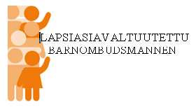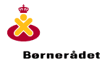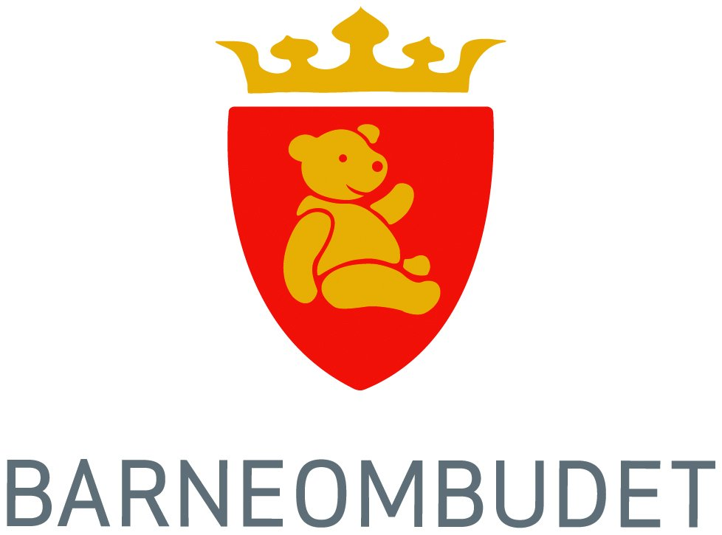

Statement from the Ombudsmen for children in Finland, Sweden, Iceland, Norway and Denmark.
The Nordic Ombudsmen for children hereby call on the governments in Finland, Sweden, Iceland, Norway and Denmark to actively work for the UN General assembly to appoint a Special Representative to the Secretary-General (SRSG) on violence against children at its 62nd session in 2007.
The UN Secretary General’s Study on Violence Against Children, submitted to the General Assembly in 2006, documents the extent of violence against children and shows the destructive effect that this violence has on children, their families and society in general. The brutality and the violence against children undermines the rule of law in societies where this is allowed to develop.
Violence is a reality for millions of children around the world. This affects boys and girls, of all ages, all social settings and all nationalities. They face violence at school, in their local communities, in institutions, in their place of work – and in their families. Children are beaten, are subject to sexual abuse, are tortured and are even murdered. The abusers are often the very persons who are supposed to protect the children – parents, guardians, teachers, employers and the police. The UN Violence Study shows the need for immediate action in order to react to, and put an end to all forms for violence against children on a global level. So far, only 18 states in the world have explicit laws prohibiting all forms of violence against children.
The main aspects of the Violence Study are:
- No form of violence against children can be justified
- All violence against children can, and should be ended
- All states have a responsibility to ensure this
Based on the findings of the Study, the Nordic Ombudsmen for children hereby call on the governments of Finland, Sweden, Iceland, Norway and Denmark to actively work for the UN General Assembly to call for the appointment of a Special Representative to the Secretary General on violence against children. The Ombudsmen also call on the Nordic governments to take the initiative to allocate the funding necessary to initiate this office, and to ensure such funding is maintained in the future.
The SRSG should cooperate with the UN bodies, member states, civil society, children and young people, and be a high profile spokesperson who can monitor the implementation of the recommendations of the Violence Study and ensure concrete action worldwide so that violence against children can end.
Our Nordic countries have a long tradition of promoting children’s rights and a long commitment to prevent and abolish all forms of violence against children. It is consistent with this commitment that we lead the way in establishing a Special Representative so that this work can be strengthened worldwide.
The mandate for the Special Representative should be:
1. To highlight and focus on all forms of violence against children and to mobilise all forces that can end this violence
2. To support and monitor the implementation of the recommendations of the Violence Study
3. To identify examples of best practice to fight all forms for violence against children
4. To coordinate and communicate with all key actors in this work.

Lena Nyberg, Sweden, Ingibjorg Rafnar, Iceland, Maria Kaisa Aula, Finland,
Charlotte Guldberg, Denmark, Reidar Hjermann, Norway

