Child Protection Action Research
in Tribal Villages in Rajasthan, India

Project # T3530-19-5

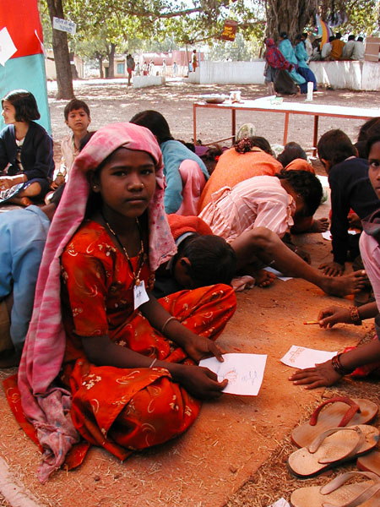

Final Research Report

Submitted to the Child Protection and Gender Equality Program of
the Canadian International Development Agency

Principal investigators:

Charumitra Meharu | Tegan Wong-Daugherty
Sankalp – SWRC | Falls Brook Centre

Date of Report: June 2004

Acknowledgements

The research team consists of all the youth and women in the village level groups who helped with the surveys, village mapping and dissemination of results through this action and rights-based participatory study. The youth are all rural youth from tribal or otherwise marginalized communities of Shahbad and Kishanganj Blocks within the district of Baran, Rajasthan. Since the youth forum and children’s fair were organized in February 2003, the youth have formed their own organization called Yuwa Shakti Sangathan (youth energy united), which continues to work collectively for the rights, protection and development of their communities. The women groups with whom we worked throughout the project have also formed their own association called Jagrat Mihila Sangathan (the Awakened Woman Association). It is indeed due to the vigilance and ground-level work that these two organizations contribute to the betterment and uplifting of their own communities that we are able to document such incredible achievements during the last two years. It is also important to recognize all the support, commitment and creativity with which the members of the voluntary organization, Sankalp, have tackled the seemingly overwhelming development challenges faced in this area since 1983. Finally, it is through the direction of the Barefoot College that much of the approach for youth participation was inspired both in our work in Baran and the work Falls Brook Centre has begun in rural New Brunswick with youth and children there.

We also thank all the various NGOs, VOs, and agencies in India who have assisted along the way, namely: Doosra Dashak, Pravah, Sandhan (Jaipur), Akal Sangarsh Samiti, Majdoor Kisan Shakti Sangathan, Janhit Trust, People’s Union for Civil Liberties, Centre of Environmental Concern, Ram Mandir Chikitsalaya (Kota), and Doctors without Boarders.

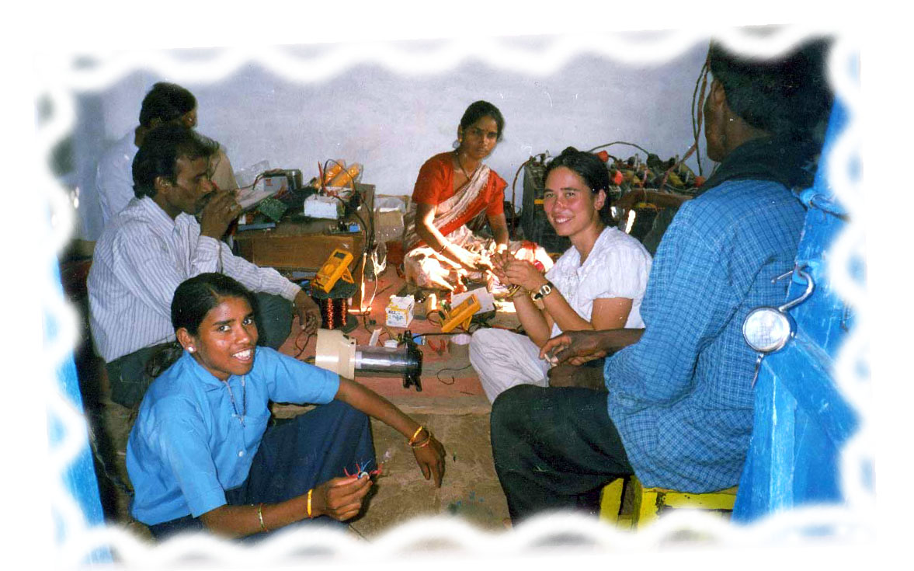

Table of Contents
Acknowledgements 1
1.0 Executive Summary 3
2.0 Project Rationale 5
OBJECTIVES: 5
GEOGRAPHIC LOCATION 6
KEY ISSUES ADDRESSED 6
3.0 PROject Partners 8
4.0 Research Framework 9
5.0 Project design and implementation 11
6.0 Research Activities 13
EXTENSION OF RESEARCH AREA 13
FORMATION OF CADRE AT MASS LEVEL 13
DROUGHT MANAGEMENT 14
MOBILIZATION OF GOVERNMENT 14
SURVEYS AND MONITORING 14
7.0 Research Findings 16
SITUATION OF TRIBALS 16
NEEDS-BASED ISSUE FRAMING 16
INITIATIVES 16
THE RIGHT TO FOOD 16
ACCESS TO HEALTH 18
WATER 19
EDUCATION 20
PROTECTION AGAINST HUMAN RIGHTS ATTROCITIES 25
RIGHT TO WORK 26
PROTECTION & MANAGEMENT OF NATURAL RESOURCES 27
PARTICIPATION IN LOCAL GOVERNANCE 28
8.0 Results and dissemination: 30
9.0 Project Management 31
10.0 Lessons Learned 32
List of Annexures: 33
Glossary 34

1.0 Executive Summary

In order to impact policies regarding child labourers and tribal children facing discrimination in rural India, local people need to gain the capacity to design and implement their own community responsive research and solutions. Therefore, this child action-research involved adolescents and women as key participants, researchers, and stakeholders in the entire research process. This approach, some term the Barefoot Approach, is based on the premise that the target beneficiaries of any programme are the best policy advisors, researchers and technicians for developing local solutions that will respect the local conditions and culture. The participatory process was designed to be inclusive by using local knowledge, language, mapping & communication tools based on imagery, puppets and personal interviews to ensure accessibility of all appropriate people, many of which were functionally illiterate. In this project, the core research team included tribal men, women, and youth from over sixty-three remote rural villages.
In the first year of the research, a severe drought hit the region and starvation deaths were reported in many of the tribal communities across Baran District. The local administration was reluctant to accept that the deaths were due to a rising food security crisis, and with each passing day the situation worsened. SANKALP and Falls Brook Centre recognized that the format of the research needed to be changed to address the immediate need to find out the actual state of food security in the affected villages. The core research team did an initial survey and social mapping of 50 villages. The baseline data collected indicated that we faced an emergency and immediate action was necessary to determine how widespread the famine had become. The research team, 557 youth, and the local women’s groups were able to conduct an extended survey that covered 5780 families in 102 villages. The drought survey gave an extensive examination of the status of families in the most-at-risk communities in Baran District.

The results were disseminated to district, state & national governments, and shared with other NGOs and donor agencies. Tribal youth and women shared what was happening in their families and the families they had surveyed. World-wide attention was brought to the drought situation in Baran. Changes in the district administration ensued. Over the next months, emergency food supplies were distributed and famine relief work sanctioned. Moreover, the research process embodied an organized movement of local youth and women, (hitherto the most marginalized within an already vulnerable community) to work collectively to make change happen for t he protection of their rights. The drought survey and the impact on government decisions has brought forth a whole new way that local people can organize and advocate for their rights, that is based on participatory research methods. It has opened new channels of dialogue with government and has energized local people to organize and speak up. Finally, it has changed irrevocably the approach we will take to face development challenges and has proven that participatory-research is a powerful component of community development.

The resourcefulness of the adolescents to take on responsibility and leadership during the drought survey set the groundwork for the launch of the children’s parliament and youth forums, a key component of our child action research. It was important that the premise behind forming these children’s organizations was independent of the research project. The youth were given the opportunity for issue-based training during the three-day forum. At the end of the forum, youth met and decided whether or not they wanted to form a village youth group. Youth from 63 villages decided to form youth groups, and as a collective, they decided that they would form a regional youth organization in order to connect their efforts in a larger sphere. This organization, called Yuwa Shakti Sangathan (Youth Energy United), is now its own separate entity. The youth are identifying the challenges and the priorities they can take up themselves.

The process by which children can fully participate needs to be based on their own experience and must build positive models for their roles in organization and governance. For example, distinction was made from corruption seen within the present governance structures, and what the values behind leadership and responsible governance should look like. In forming their own organizations, they have an opportunity to understand the dynamics of working together and leadership from their own experience. Their key involvement in the drought survey transformed the climate of their own confidence to affect change for the protection of their families and communities. The youth have seen that corruption and ineffective government programs can be changed, and that it is their responsibility as citizens to participate actively in issues affecting their lives and those around them.

“We are not begging for help, we are standing up for our rights to food, our rights to survival.” ~ Jusram, member of the Children’s Parliament (Bal Panchayat) from the village of Rajpur

Once the participatory process was set up, issues were identified to address within the project. Rural education schemes were examined as to their curriculum, teaching support, community involvement, enrollment and attendance, and their relevance to the issues facing rural and tribal communities. From the first year consultations, livelihood-based curricula was developed specifically for tribal youth. This was presented to the Tribal Welfare Department of the Indian national government. They agreed to support a pilot year of a National Tribal Youth Training Centre, based on this curricula. Meanwhile, rights-based research and advocacy continues: campaigns on the right to food, water, health, education, work and a life free of human rights attrocities have all begun in a growing collaborative effort of people and organizations across Rajasthan.

The adaptability of the action research provided real context to do community participation work. There were no pre-destined outcomes or results written into the proposal, rather there was a process that was outlined for participation. This allowed each community to consider their own resources and capabilities for livelihood-based initiatives of their own. It also ensured that the review of education needs of the Sahariya was determined not by urban based professionals, but by people who were living and working directly in the area.

In addressing child protection, children’s rights must be explained in the context of human rights. In the drought situation, child protection could not be separated from the rights of the whole village population. In understanding their rights, children became aware of the rights of their mothers, their uncles, and their grandmothers and became advocates for their whole community. The project went beyond the original intent of its objectives by establishing a powerful framework through which action-research based on human rights can be implemented in marginalized communities. The result has been actual on-the-ground interventions that reflect not only an improvement in child protection, but an overall understanding and participation of Tribals in the protection of their own basic rights.

2.0 Project Rationale

“This is why we embrace the path of struggle
So that our lives are not drowned in pools of tears and sorrow…
So that our evenings are free of fear, nights free from shackles of apprehension, the eyes of twilight have no trace of defeat”.

- translated excerpt from a Hindi protest song

This action-based research project sought to advocate and demonstrate participatory models of education and development of tribal communities that empowers the people and children to direct their own needs. The process of the research itself is meant to capacitate (1) local barefoot researchers to identify the vulnerabilities and resourcefulness of their villages; (2) villagers and children to address child rights and protection issues at the village level; and (3) through the identification of their needs and rights, empower villagers to develop and implement solutions themselves.

Collaboration and Liaising was done throughout the project with other NGOs, government agencies, public representatives, media and concern citizens in order to bring in focus the ongoing alienation of the people in Shahbad and Kishanganj, in particular the situation of the tribals.

The goal was to create the local capacity to address child rights and protection issues at the village and at the home level. If marginalized villages are given the opportunity to direct their own development, through the identification of their needs and rights and responsibility to develop and implement solutions, then sustainable empowerment will be achieved. The process and the results of the research are equally important for the long-term uplifting of the Sahariya people.

OBJECTIVES:
- To develop an integrated effort to empower the Sahariya people and children educationally, socially, culturally and economically
- To understand the specific vulnerabilities and resourcefulness of Sahariya children as child labourers and as children facing systemic discrimination
- To affect government policies surrounding Sahariya’s capacity building schemes, by engaging them in the process and sharing the results of this highly-participatory methodology of approaching tribal development.
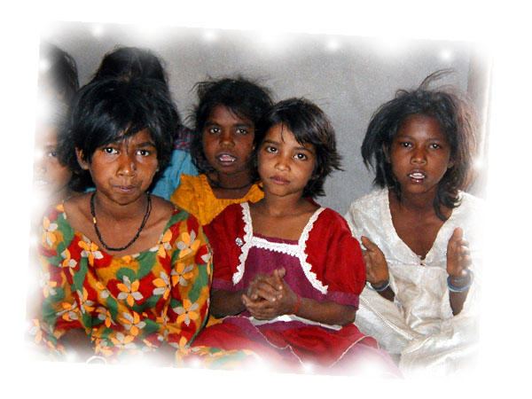

GEOGRAPHIC LOCATION

The research focused primarily on tribal communities living in Shahabad and Kishanganj blocks, which are within the district of Baran in southeast Rajasthan. This area is characterized by extreme deprivation: far from urban centers, the villages are not connected by railways and in many cases still not connected by roads. These villages, especially in Shahabad block, are challenging for development planners. Degraded forests cover nearly half of the landscape. Several small rivers criss-cross the blocks making transportation and communication a serious difficulty.

The inhabitants of these blocks are economically impoverished and socially reclusive. ‘Sahariya’, the only indigenous tribe of the state lives in this region. They comprise about 34% of the total population in the blocks. Although they once had their own self-governance system, they now survive on the verge of destitution. Forests were their lives, their soul. Because of massive deforestation due to outside business interests, they have been uprooted from their traditional lifestyle, losing self-confidence and self-esteem.

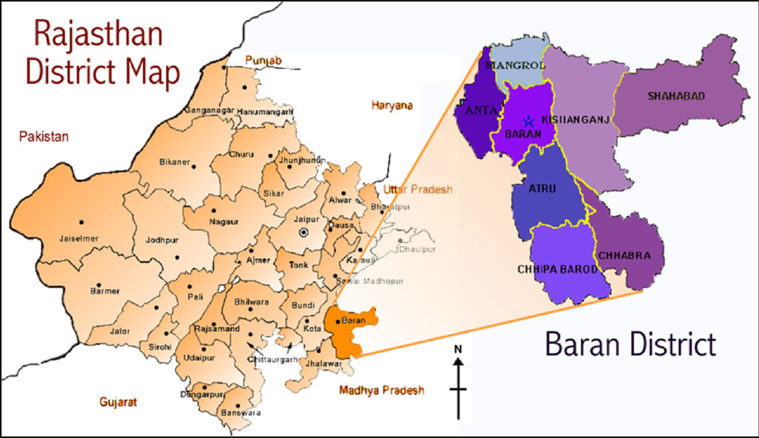
Figure 1: District and Block level map denotes the geographical area of investigation

KEY ISSUES ADDRESSED
1. Rural & Tribal Education
Every child is expected to contribute to family work activity, but the education they receive incapacitates them. It is vital to link education with respect for the cultural and environment context of the Sahariya people in a way that supports their own community development and environmental restoration. This action research has focused & addressed issues of education for tribal and marginalized groups in this area. The study examined the cumulative experience of Sankalp since 1983 and worked with students and youth to design innovative curricula that works not only on literacy and numerical skills, but goes beyond to address the need for tangible livelihood skills based on the rural realities: both the possibilities and the challenges.

2. Child Protection
The Government of India ratified the Convention on the Rights of the Child on December 2nd 1992 and since then, a pro-child national plan of action has been developed to implement the provisions of the convention. Yet, despite over fifty years of independence and constitutional assurance of free and compulsory education up to the age of fourteen, a significant number of children do not have the opportunity to enter school, and there are various reasons for it.

This brings the question how useful is the current education system in providing skills and confidence to children so that they can grow up as capable and responsible citizens, especially when the system shows little respect for tribal culture and knowledge. This action research will focus on understanding the reasons for tribal children not entering schools and search for alternatives to make education contextually relevant to their lives.

Child protection must be visualized within the political, social and economic framework. The children in the study area are for the most part child labourers and work alongside their family members to support the limited family income. In the last 50 years, the situation of the tribals has changed dramatically from one of independent forest –based livelihood to a community at risk forced to migrate as minimum wage labourers in order to survive. When labour is not available, the tribals face chronic hunger and malnutrition, which particularly affects children’s growth and development and ability to learn. Societal discrimination has labeled the tribal children as slow, inarticulate and lazy students. Yet neither the historical nor socio-economic context of the tribals is understood or taken into account.

Due to discrimination, extreme poverty, inappropriate development schemes, children are not provided the necessary skills and knowledge they need for community life. Until and unless child is politically, socially and economically secure in his/her environment, talking of child protection is meaningless, and for that reason these issues need to be collectively addressed and made into a mass movement amongst local people.

3. Development Schemes & Community Participation
Every year the Indian government commits a significant amount of money and resources to tribal development schemes; but very few benefit from these schemes. Tribal people demand no accountability, because the system is foreign and they do not know how to exercise their rights or responsibilities as citizens. Decisions made affect their lives and the lives of their children, yet they are without tribal involvement. In order to build the capacity to participate in a democracy, one needs to work on democratic education and participatory-based development programs.

There is need to mobilize, empower and organize the marginalized communities to direct their own development solutions. The research process involved local youth, women, and anyone from the area willing to work for the needs of the wider community of people at risk. The goal was to create the local capacity to address child protection rights and issues through the formation of mass level organizations of youth and women with the skills and confidence to work for the protection of their own rights and those around them.

4. Environment and Rural Livelihood
There is a strong need to understand education, livelihood, and development in the context of the tribals and their relationship to the environment. Providing mainstream education will not be enough. Without any economic intervention, the community cannot improve on their standard of living. Previously the Tribals had always relied on their immediate environment and surroundings for their livelihood, until these resources were totally lost. For this reason, environmental restoration is a key element contributing to the well being particularly of the tribal community. The vulnerability of this community to environmental stress, as seen during the severe drought that hit this area, is one of the crucial factors contributing to the most severe fight for child rights: the most basic right to survival and life. Access to water, food & health were addressed through rights-based research that by the end of the second year spanned 175 villages.

3.0 Project Partners
FALLS BROOK CENTRE:
Recipient Organization
Established in 1990 by Executive Director Jean Arnold, Falls Brook Centre (FBC) is a not-for-profit, registered charitable organization. It is a sustainable community development, and demonstration centre located on 400 acres of farm and forestland in Carleton County New Brunswick. FBC has a number of Canadian and international partners and connections that aim towards an exchange of knowledge and expertise in order to build sustainable communities.

Working with Children at Risk:
FBC has entered into a partnership with local schools and Community Partners for Youth at Risk to provide extra-curricular activities to engage rural youth and youth at risk in global education activities. Staff at FBC receive special training to work with youth at risk, in particular identifying self-esteem issues, and working with respect and understanding with youth that may have history of sexual and/ or drug abuse. There are Canadian parallels to the Indian tribal situation, in terms of self-esteem issues, loss of rural livelihood, and challenges faced by First Nation communities. This project would augment, especially at a policy level, implementation of programs for tribal children in rural India and inspire creative child-rights protection solutions within our own rural communities of New Brunswick.

THE BAREFOOT COLLEGE:

Partner Organization
The Barefoot College is a well-established Indian organization serving the needs of rural communities since 1972. Based in village Tilonia of Silora Block of Rajasthan state ,it was founded by Bunker Roy. The Barefoot College operates with the objective of using the existing skills and knowledge of people from village communities for providing basic needs - drinking water, health, education, energy, and local employment. SWRC has been working with solar energy technology and training since 1986, with tremendous success. The Centre has trained rural youth and women as solar technicians, installed over 40 kW of photovoltaic panels, including units in 300 adult education centers across 10 states of India, constructed over 500 solar lanterns, and completely powered the College’s 60,000 square foot campus in Tilonia with solar energy. In India, SWRC works in over 100 villages, in an area of about 500 square miles, reaching a population of more than 100,000 people. The SWRC Barefoot College model has been replicated in 23 other villages in 13 states of India. The Government of India, the United Nations Development Program, and the European Commission fully support Barefoot College’s approach to rural solar electrification

The Barefoot Approach is the foundation of all programs. “Barefoot” means the use village wisdom, local knowledge, and the practical skills available. NGOs across India now incorporate this approach.

History of collaboration between SWRC and FBC:
Falls Brook Centre has maintained a long-standing working relationship with SWRC, since 1989. In fact much of FBC’s renewable energy and educational outreach programming has been based on lessons learned from working with SWRC. Through CIDA’s Partnership Branch, FBC and SWRC initiated 40 night in remote villages of Baran district, Rajasthan in 2000 –2002. This initial experience was the impetus for starting this action-research.

SANKALP SANSTHA:
Nodal organization for the research
Sankalp Sanstha was established in 1983 in the village Mamoni by three friends, who were initially trained at the Barefoot College. Shahbad is one by the most backward areas of Rajasthan. It was once called kala-pani of Rajasthan (Black zone area); and the only primitive tribe of Rajasthan, SAHARIYA’ resides here . These situations motivated a group of three friends to start Sankalp Mamoni ,a village on state highway had one of the biggest colony of Sahariyas at that time. Various works were taken up initially: running non-formal education centres, digging hand-pumps ,health project ,minor forest produce,and other development issues. From 1987 until now, Sankalp has focused primarily on education. Sankalp was the nodal organization for the implementation of the 40 new Night schools established between 2000 and 2002.

4.0 Research Framework
It is a widely accepted fact that participatory planning is essential component of the developmental process. Whatever may be the objectives or focus of the project, involvement of community is necessary from planning to implementation. When the Child Protection Research Proposal was initiated in Tribal Villages of Shahbad Block of Baran district of Rajasthan, India, participation of community was ensured at each and every step:
- At Community Level: by creating forums of youth, of women, of children, and village committees amongst the marginalized groups.
- At Governmental Level: to affect government policies surrounding child protection research, and to build mechanisms, which are transparent and accountable to the people.
- With other NGOs for addressing the relevant issues jointly.

Initially in the project, it was stated that 20 tribal villages would be selected from the Shahbad and Kishanganj blocks for carrying out research. But the scenario was very different when things actually started taking place. Rather than working in 20 villages, many villages were involved in the research area for various reasons:
- To ensure that every child enjoys full range of human rights, appropriate developmental schemes must respect the experiences and context of the children’s lives. These children are for the most part child laborers and face extreme poverty. Because of their tribal identity and the current and historical discrimination faced, self-esteem is extremely low. These issues need to be addressed collectively among the youth themselves and the larger community, including village women, village committees, NGOs and government agencies working in the area.
- This research cannot be seen in limited framework. While working on the project, various issues of concern have emerged; and which cannot be overlooked. There is strong need to mobilize and organize community to address their rights, collectively fight out exploitation and discrimination so as to create an environment free from fear for their children.
- To affect governmental policies, a mass people’s movement is needed. The formation of a cadre of village youth and women which can act as a pressure group and attract attention of people is one important way to ensure the voice of marginalized people are heard. A small group may not be able to create that same impact.
- Lastly, when the project shifted to crisis management during the drought, it was very necessary to find out the actual food security situation in the villages. Youth and women from over 90 villages came together to join the research team in collecting family-wise data from 5780 villages in 102 villages. From that point on the research embarked on a larger mission, firstly to save lives of those in immediate danger of starvation. From that point on ‘research’ could no longer be something written down on some paper and filed away in a distant library. Action-research had proven itself as a real tool for participatory development as there was real energy amongst the marginalized groups to continue for the betterment of the situation of the most vulnerable and oppressed groups in the region.

STRATEGY:

In order to mobilize, empower and organize community: (1) to address child protection issues; (2) to direct their own development through the identification of their needs and finding solutions; and (3) to achieve sustainable outcomes, we focused on building local capacity in the field of action & rights-based research from the outset. It is the community, which knows what it actually wants. For establishing participatory, decentralized management systems and transferring the ownership in the hands of community, community should be self-dependent and be able to unite as their own pressure group to address issues as they arise. Therefore it was thought necessary to create structures at the village level which can constantly work for community, irrespective of the time frame of the project.

The steps taken were:
A. Community Forums Created at the Village Level:

- Youth Forum ‘Bal Manch’ -forming the groups of adolescents at the village level, motivating them - to make positive changes towards socio- economic conditions of society.

- Children's Forum ‘Bal Panchayat’ -forming the groups of children to promote child participation and gradually empowering them to be active partners in development process.

- Women's group ‘Jagrat Mahila Sangathan’ -to ensure participation of women in development, decision making, creating support for adolescent girls and to recognize them as individuals, the women's group is created at village level.

B. Formation of Mass level Team:
- Yuva Shakti Sangathan: All the youth forums are organized under one banner, to organize youth collectively.
- Jagrat Manila Sangathan: Organizing women on common platform to address their issues collectively.
- Bal Panchayat: Collective forum of children of Jagaar Centres (Night Schools) for democratic education and learning to play their roles in participatory governance, giving voice to children to identify their unique challenges and to determine solutions.
- Networking with NGOs & State Level Organisation: Collaborating with NGOs / Agencies working on the same lines to address issues of child protection and making policy level interventions.

C. Empowerment of Groups
System of trainings & meetings of the all forums with academic & organisational inputs has been developed, so that these groups can be self reliant and can be prepared to take ownership in their hands.

D. Building Skills and Capacity of Barefoot Researchers
Throughout the project, trainings and meetings were held with the researchers in order to upgrade skills and give academic input when needed. The researchers are themselves from the local area and in the future can play an active role in providing constructive leadership. Their key involvement in this project insured active participation of community; provided inputs on different issues and direction for where the action based research needed to focus in order to make the most impact.

E. Interaction With Government:
Interaction with Government at Local, District, State and National level was started early on so that the public officials could be sensitized to understand the socio-cultural context of tribals and understand what development means in their terminology. These officials talk the language of laws and criterion, which village people do not know or understand. To make policy level interventions, it was essential to liase with these functionaries at various levels.

The strategies and process adopted were directed towards making a decentralized, sustainable management of community development and to ensure the transfer of ownership of any gains made in the hands of community for whom the projects are ultimately meant.

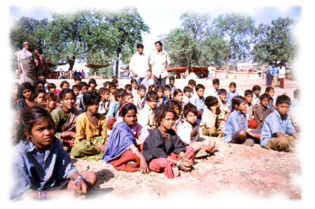

5.0 Project design and implementation

Phase I : Research preparations
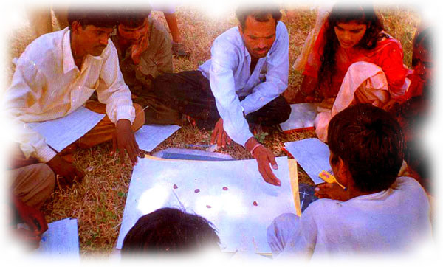
Starting in May 2002, the core action research team was selected and trained on issues of child rights and action-research. Initial workshops were held with the team on how to collect information, conduct interviews and on what parameters would be useful to protect the rights of at risk populations. Background research on the different layers of government schemes for tribal welfare and below poverty line schemes was gathered as well as current education initiatives underway in the region. Researchers and project coordinators developed community mobilization materials and 20 tribal villages were selected from the Shahbad and Kishanganj blocks of Baran district, Rajasthan. Community mobilization meetings were held, along with youth dialogues resulting in the initial formation of village-level youth groups. Social mapping training was done with the core group and then initial social mapping was conducted in the selected village.

Phase II: Community motivation and mobilization
The action research process changed dramatically in September 2002 when absence of rain in Baran District (less than 60% of normal rainfall) caused a serious humanitarian food security crisis. This was particularly pronounced in the Sahariya communities. The initial surveys, social mapping and interviews revealed the deplorable state of people’s lives in the villages as a consequence of the fourth successive year of drought. The survey was extended to 50 villages by the core research team and this is how the severity of the situation: that people were succumbing to hunger and starvation deaths, became known.

The government initially denied that the deaths were due to starvation and did not declare an emergency situation. The initial baseline data collected by the research team indicated that indeed there was cause for concern and we needed to find out how widespread the drought was affecting people’s very survival. So community mobilization needed to involve others. Given the level of organization that already existed with the women groups, we engaged them as full partners in the process early on. The youth were also contacted. Together the research team, 557 youth and women’s groups were able to conduct a wide spectrum survey that covered 5780 families in 102 villages. From this point on we could no longer limit the extent of the research to merely 20 villages. It was apparent that the larger participation would create the mass movement needed to affect government policies and actions.

Phase III: Formation of Children’s Organizations
The resourcefulness of youth to take on responsibility and leadership during the drought survey set the ground work and the precedent for youth and children’s full participation in the whole research process. During the introductions of youth at the opening assembly of the Youth Forum, Jusram, a night school student from the village Rajpur came forward to talk about his experience in conducting the survey. He said “We are not begging for help, we are standing up for our rights to food, our rights to survival.” In that statement he embodied the premise behind our approach to participatory action research. The youth and children organizations were formed not as passive participants in the research project, but as their own premise to work to identify the challenges and the priorities they can take up themselves. The drought survey has transformed the climate of their own confidence to affect change for the protection of their families and communities. Through documentation and communication, the youth have seen that corruption and ineffective government programs can be changed, and that it is their responsibility as citizens to participate as actively as they can in issues affecting their lives and those around them. They have formed their own cadre, Yuwa Shakti Sangathan, to work on issues collectively. Since embarking on the campaign for the right to food, the youth have since participated in the public hearings and protest for the right to work, against human rights atrocities, the regularization of land for the Sahariyas, and are working on livelihood-based initiatives ranging from aquaculture to solar electrification at the village level.

Phase IV: Case Studies
The drought changed the whole framework of the research project. Activities and subsequent research was based on needs that arose during the initial work in the field. Main issues taken up were the right to FOOD, HEALTH, WATER, EDUCATION, HUMAN RIGHTS, WORK, FOREST & PARTICIPATION. The initiatives taken within each of these broad themes are described in the next section.

Phase V: Research Analysis
Due to the nature of this research project, analysis went hand-in-hand with each issue that was taken up. Participatory research by its nature must meet the needs of the beneficiaries. When these needs are immediate it is essential that the analysis and dissemination of the findings come in a timely manner and then are used to the purpose of addressing issues using whatever means necessary. As such technical expertise was sought as was needed to compile data in a comprehensible form that then could be used to strengthen the voice of those marginalized groups as they presented their experiences in more personal and intimate accounts and actions.

Phase VI: Development of Intervention Strategy and Dissemination of Research
The Indian government is the biggest development agency working in the region, but it needs to be mobilized, sensitized and informed about the people and their issues. The Sahariyas have become used to living in alienation and have a long history of mistrust of schemes brought to them from officials and outsiders. While working to mobilize the community to raise their voices, effort was made to sensitize the officials at every level.

We have been in constant touch with government officials to bring to their notice the status of people, their problems and possible solutions. Reports of surveys and information received from the field needing immediate attention of bureaucrats were provided to them constantly. Bureaucrats were contacted at the Block, District, State and National level in order to apply pressure for resolving definite infringements of constitutional rights of the Sahariyas and other marginalized groups in Baran.

We have succeeded in attracting the attention of political figures. The Chief Minister himself visited Shahbad during November. Ever since independence of India, he is the first CM to visit such interior regions. Mrs. Sonia Gandhi, leader of Opposition also visited this area in June 2003 to hear and understand problems of people. Shri D.S. Bhooria, Chairman of the Schedule Caste and Tribal Commission of New Delhi, visited the area to understand the status of existing primitive tribals and what actually needs to be done for them. Many other state and national key officials visited the area during the past 7-8 months

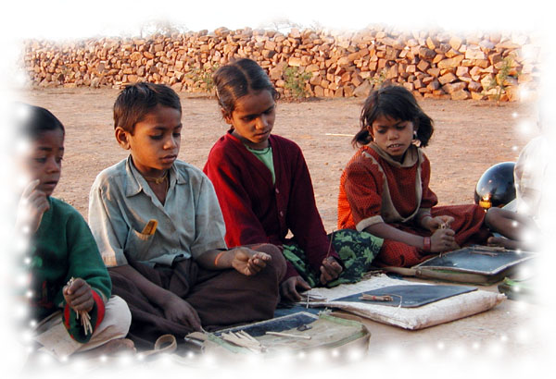

6.0 Research Activities

EXTENSION OF RESEARCH AREA

The area of research project was extended for two main reasons:

1. The Alarming Drought Situations:
Because of the alarming situations of drought, it was necessary to take steps for protection of humankind at a mass level. Tribals were the worst hit victims of the recent drought in Baran district of Rajasthan. The deteriorating conditions of drought brought overall scarcity to a situation that was already on the edge of survival. That was the time when all the people needed help.

2. Attracting the attention of policy makers

For attracting the attention of policy makers to the situation of the Sahariyas inhabiting Shahbad and Kishanganj Blocks and living almost on the verge of destitution, we needed to address the problems at a larger scale.

Despite the fact that this is the only primitive tribe of Rajasthan state, which needs special protection and sensitive understanding - just the reverse happens with them. No attention has been paid nor have sincere efforts been made by the Government to understand what development means in their context. So many human rights are violated in their case. Until and unless people unite at mass level and attracts attention of Government, policy makers, and planners, this scenario will never change. Therefore rather than limiting the number of villages to 20, nearly 175 tribal village groups were collectively included in the research.

FORMATION OF CADRE AT MASS LEVEL
As stated before that various emerging issues which needs to be addressed for long term, and cannot be limited to time frame of the project. Secondly the strategies & the processes should work in direction of transferring ownership in the hands of community .An effective leadership and cadre of groups working with commitment to serve and collectively addressing then issues is needed. YSS, JMS and Bal Panchayat organizations are examples of such cadres.

BAL PANCHAYAT: is group of children and young adolescents of the Jagaar Centres. These children are committed to work for children, right and are in process of learning democratic values and playing their role in governance systems.

YUVA SHAKTI SANGATHAN (YSS): Over the last year and a half, youth forums have been created within Research Project and in close collaboration with Doosra Dashak Project. Various educational activities have been undertaken for them. These groups are not only motivated to work within their own village community, but united, fight for child-protection, take initiatives to participate in their own development process and making positive changes to socio- economic conditions of society. YSS is an association of youth of Shah bad and Kishanganj Block. The term 'Yuva' means youth, 'Shakti' means power / energy and 'Sangathan' means organization/unity. The term means 'organizing the power/strength of youth' to address rights and protection issues at the level of many villages & many marginalized villages need the opportunity to direct their own development and implement solutions. All the village level youth forums are the members of YSS.

A series of meetings and workshops were organised with this group and it was decided to set-up two volunteer-run YSS offices, one in Bhawargarh and the other in Shahbad. These offices are monitoring independent activities that the youth are now organizing. They have started collections of grains and some money in order to support their own activities and meetings.

JAGRAT MAHILA SANGATHAN (JMS) is cadre of 'aware women' of Shahbad & Kishanganj block, committed to work towards the uplifting of women and adolescent girls. The women groups in the villages were formed under other projects -like Shiksha Kanni Project, Lok Jumbish, ICDS, and thus were formed with specific objectives or focus for the limited time while the project existed. This time women decided to set their own priorities and unite on one platform. This group has been in existence for past two years. They are not only strong supporters of adolescent girls, but have helped in creating place for Youth Forums too. For decentralised management; they are working on same pattern as YSS. They have taken strong initiatives for betterment and to ensure social justice. They organized two strong protests against atrocities in past six months. There is net impact is on the increased participation of girls in YSS. Many girls joined the adolescent camps. Memorandums were given by them to ensure justice and make policy level interventions.

Both the cadres work hand in hand to ensure equity, justice and rights.

DROUGHT MANAGEMENT
In the year 2002, the whole state of Rajasthan faced a situation of severe drought. This was the fourth consecutive year of drought for the people of Baran District. Since this area normally has the second highest rainfall in the state, people of this area are really not used to drought situations.

The tribal communities were the most affected as they do not have tendency of storing grains. In past years, when food becomes scarce they would borrow from local agriculturists against debt. However, during this drought even the local agriculturists did not give them wheat as they themselves had dwindling amounts. There was no other source of livelihood where people could earn money to buy grain. This led to severe malnutrition and famine. The deteriorating conditions of drought brought overall scarcity to a situation that was already on the edge of survival. Overall, distress and pathos prevailed in the area. Field workers who went to these villages brought with them sad and alarming news. The only question in eyes of everyone was “what will happen now?” “Will we see people dying slowly and slowly?” By end of September, chronic hunger led to starvation and deaths were reported in the area. Children were the first ones to become prey to these situations.

MOBILIZATION OF GOVERNMENT
When people reported the deplorable state of field to the administration, there was constant denial and refusal at local level rather than helping them out of crisis . A well planned and quick strategy was needed. First of all the government needed to be mobilized. Starvation deaths were reported in the area. Yet not realizing the gravity of situation, there was hardly any preparation on the government’s side to meet this crisis . It was decided that :
- Constitution of India ensures dignified existence to all its citizens. When it is denied, people should raise their voice collectively to make the system work .It is their right .
- Survey will be conducted to collect data on extent of drought and its impacts ; and then these bring facts and figures before administration .
- All the people should collectively work at this time to save people at risk.

SURVEYS AND MONITORING
After an initial survey of 50 villages by the barefoot researchers and project coordinators, it was revealed that the situation was dire. More information was needed, but further surveys would need to be done with expediency in order not to lose any more lives. The youth and women groups were contacted to help. Then 102 villages were selected with their help to ensure that the most affected areas would be covered. Other NGOs working in the area were also contacted to help. Once the data was compiled, facts & figures were put before the government. The survey became a powerful tool for mobilizing the community. Ever since then, the youth and women groups have continued to monitor situations in the villages. These situations have played important role in uniting people to fight for their rights collectively, empowering them to assess situations and play their role in governance system.

While completing the survey, the whole team when through an empowering experience. The process included a door to door survey of 5780 families; a village-wise analysis of data, feeding the information into the computer; and building intervention strategies. This set of activities enhanced the interpersonal skills of the team members, especially the adolescent girls and boys. It provided opportunities for effective communication. They also learned how to arrive at consensus and work in a team for the uplifting of the deprived and marginalized groups. Since the youth and woman had participated in each of these steps, they come to know the situation in each village, interventions that were recommended and took ownership over the process by which to disseminate and act as a pressure groups to see that issues were addressed.

It was also recognized that a single assessment was not enough. It was important to provide constant support to people at risk. Jagrat Mahila Sangathan, Yuva Shakti Sangathan and Bal Panchayats played this role powerfully through the identification of vulnerable groups, liaising with Sankalp, other NGOs and Government agencies. These village groups began to respond to issues beyond the scope of the drought to address human rights abuses, taking sick people to hospitals, ensuring availability of food, asking the government to start labour work to generate employment, monitoring the labour work, preparing nutrition food and running nutrition centers, proper monitoring of public distribution system.

Education is not merely attaining literacy and numerical skills, but can be a powerful tool for organizing people and should result in action. In this case, the survey had acted as a tool for mobilizing and uniting people, so that they could stand up and ask the system to protect them and ensure their most basic fundamental right…
the RIGHT TO LIVE

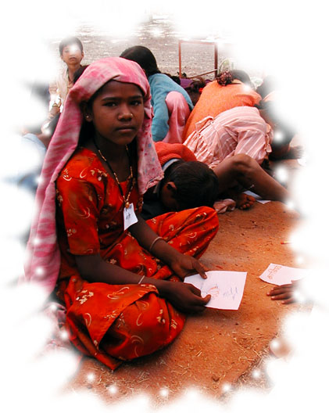

7.0 Research Findings

SITUATION OF TRIBALS
Even in normal times, when there is no drought, the condition of the tribal community is as follows:
- No permanent source of employment is available. Seasonal and casual employment is sometimes available and migration for labour work is common.
- Degradation of local forests, signifies decreased minor forest produce collection
- Majority of Sahariya land is not irrigated which limits the agricultural productivity on own lands and increases vulnerability in situations of drought
- When people do not have work they have to bear with the hunger
- Overall, the local wage rates are quite low
- Due to low monthly income, sick people often are not treated in time
- Due to low monthly income malnutrition is prevalent, especially in women and children
- Virtually no benefits are received through the selected government low income category schemes (B.P.L, Antodyaya, and Annapurna)
- There are high incidents of tuberculosis

Conditions during the drought:
- No employment whatsoever
- Local agriculturalists could not provide labour to local labourers as they were also affected by drought
- Availability of minor forest produce decreased, as even big trees succumbed to the lack of water
- System of bartering grains against debts has stopped
- Famine Relief Work started late
- Public Distribution System has utterly failed to provide for those most in need
- People have no money to fulfill basic needs of food, clothing, health treatment, etc. This means that their purchasing power is virtually nil
- Sick people could not get treatment as there is no money available

There is a fine line between the normal situation of deprivation and that seen during the drought. The deteriorating conditions of drought brought the existing scarcity to the edge of disaster. Chronic hunger led to severe malnutrition; people became and started dying.

NEEDS-BASED ISSUE FRAMING
The drought situation accentuated the existing state of marginalization and deprivation. Once the immediate threat of famine was abated. It was necessary to take a broad view of the challenges faced in order to move towards more stability and sustainability. The drought crisis brought this area into the lime-light. The drought survey provided guidance as to where government schemes were inadequate or not achieving positive outcomes. We also had an expanded team now prepared to work on issues collectively, namely the YSS, JMS and the Bal Panchayat.

In effect, the whole scene of Sankalp and Falls Brook Centre’s research and community development work changed towards research-backed advocacy. It was now obvious that child protection could not be isolated from the protection needs of families and communities. As such the issues addressed are not specifically focused on the rights of the child, but the rights of a people to self-determination, respect, and ultimately to survival. What has begun is a movement within the tribal communities of Baran District to work collectively and start raising their voice when met with injustice. This movement is just beginning and it is being led by the women and the youth from whom the needs-based issues were identified as : food, health, water, education, human rights, livelihood, forest management, and participation.

INITIATIVES

THE RIGHT TO FOOD

New initiatives started as a result of the drought survey:
- NUTRITION CENTRE
These centre were started to check malnutrition in children, pregnant women, lactating mothers, TB patients, old , and disables people after the initial survey of drought
Presently there are 40 centers running in two blocks.

- GRAIN BANK
It was apparent that food shortages would continue at the very least until the crops could be replanted and harvested. Famine relief work provided some of the daily wage directly in food grains. In order to ensure availability if grain on a more long-term basis, community grain banks were started as a pilot project. If a family had extra grains they could bring some to the grain bank and the amount given was recorded and keep in a grain storage hut. Then as families ran out of grains they could come and withdraw their grains from the bank. Meetings were held in 15 villages and the pilot project was initiated in 9 out of them. The proper system still needs to be worked out. A visit of villagers and workers was organized from 14th to 23rd June 2003 to study the grain bank system developed by Centre For Environmental Concerns in Hyderabad.

Improvement of Existing Services
- AANGANWADI CENTRES:
As a pressure of prevailing situations and media report on drought, all the Aanganwadi Centre service are being strictly monitored. Aanganwadi centers are run under Integrated Child Development Scheme of the Indian Government for children from 1-6 years of age, pregnant /lactating mothers and adolescent girls. Proper supply of nutrition food was ensured in these centers. The number of children able to access these centres was increased during the drought period. Aanganwadi workers were given the instruction to provide nutrition to the people whom they identified at risk.
- UNICEF then started 50 new centre in Shahbad and Kishanganj blocks.
This has increased the coverage of protection and services for those communities at risk as identified through the surveys and monitoring information gathered by the research team.

 | SHAHBAD: | KISHANGANJ:
Existing Aanganwadis | 94 | 111
New ‘food center’ Aanganwadis | 99 | 126
Total | 193 | 237

- PUBLIC DISTRIBUTION SYSTEM:
This is a government run system of food distribution to supply subsidized food rations to people identified under the BPL (below poverty line)scheme. It was only during the time of the drought that most of the tribals came to know that system like PDS existed or what its purpose was. Many deficiencies in the program were identified (see Appendix googo) Since then lots of improvements have been made: for the first time, ration cards were made for those entitled, rate list were written on the shops, complaints of the people were heard, dishonest dealers were thrown out, problems of the dealers were addressed. It is accepted by the Government that this system was not properly working, and they committed to make improvements.

- MID-DAY MEAL:
As per the orders of Supreme Court Of India, mid-day meals were provided in all Government primary schools. But during drought, a special order was given to all the schools to run mid-day meal scheme even during summer holidays (From May to June). Jagaar Centres, being considered as alternate school and not Government school, were previously not provided grains. But when we questioned this system, Government provided grains to these centers to. All the children in Jagaar Centres are now provided sweet porridge along with other nutrition supplements.

RIGHT TO FOOD CAMPAIGN
- PUBLIC HEARINGS:
Public hearings (jan sunwais) are a useful tool of conveyance of public. Many Jun sunwais were organised in order: to assert the right to food and making people aware of their entitlements; to expose corruption in food-related programmers, and to hold the state accountable to its responsibilities. Strong network of NGOs working with 'dalits /marginalized people, within India and facing drought & similar type of problems in their areas attended hearings that brought people together from across India. It provided the opportunity to share their experiences and voice their concerns collectively. JMS, YSS, and Sankalp workers participated in the meetings held in New Delhi, Chittorgarh and Kelwara
At the Kalwada Jan sunwai, attended by more than 30 IAS officers, government officials were confronted with a detailed and accurate picture of ground realities. The local BDO took active part in the process and helped to address the problems.

- SUPREME COURT ORDERS:
'Right to Live' is fundamental right of each citizen of India. But when people started dying of starvation, a petition was filed in public interest. All the organizations / NGOs working for marginalized people supported the RIGHT TO FOOD CAMPAIGN' and we organized under one banner. On the basis of information received from field area from different parts of India, PUCL had filed a Petition in SUPREME COURT of India for ensuring 'Food and Work to all'.
SUPREME COURT passed various orders in this connection to all the State Governments (For the full text of the order and other details, see www.righttofood.com )

LATEST SUPREME COURT ORDER ON THE RIGHT TO FOOD (2 May 2003)

1. Direction pertaining to doubling of employment creation:
The Supreme Court has directed the Government of India to double the resource allocation (both grain and cash) for the Sampoorna Grameen Rozgar Yojana (SGRY) for the months of May, June and July. The relevant portion of the order is copied below:

“ . . . We direct that on pro rata basis, the recommendation that present SGRY scheme should be expanded at least doubled be implemented, both in regard to allocation of food-grain as also cash, for the months of May, June and July. The State Government shall lift those allocations and ensure the same reach those for whom it is meant."

2. Summary of other important directions:
- Famine codes will be binding in the months of May, June and July. However, if better measures are incorporated in other schemes, these may be implemented instead.
- Government of India to clarify its response to the Abhijit Sen Committee report by August 8, 2003.
- Government of India has to evolve a system of ensuring that all poor families are identified as BPL.
- Licenses of ration shop dealers to be cancelled if they (i) do not open on time, (ii) overcharge, (iii) retain ration cards, (iv) make false entries in BPL cards, or (v) engage in black marketing.
- BPL households are to be permitted to buy grain in installments.
- The following groups to be given Antyodaya cards: (1) Aged, infirm, disabled, destitute men and women, pregnant and lactating destitute women; (2) widows and other single women with no regular support; (3) old persons (aged 60 or above) with no regular support and no assured means of subsistence; (4) households with a disabled adult and no assured means of subsistence; (5) households where due to old age, lack of physical or mental fitness, social customs, need to care for a disabled, or other reasons, no adult member is available to engage in gainful employment outside the house; and (6) primitive tribes.
- States that have not implemented the order on mid-day meal scheme to immediately start providing mid-day meals in at least 25 % of the districts with priority to poorest districts).

For the full text of the order, see www.righttofood.com. You can also obtain it from the website of the Supreme Court using the reference number of the case ("PUCL Vs Vol. and Ors" No. 196 of 2001).

ACCESS TO HEALTH

MECHANISM FOR REACHING OUT TO SICK/OLD/PEOPLE AT RISK/ MALNUTRITION CASES

Through survey and through cadre groups working for community in the various villages, sick/old/people at risk were identified and provided needed help. Till now, more than 700 people could be saved from hunger by providing wheat flour. More than 1200 people have been provided medical care and medicine free of cost.

NUTRITION CENTRES started in 40 villages of Shahbad and Kishanganj block, where children from 1-5 years of age are provided nutrition food. Action Aid has financially assisted 12 centres. These centers are running with help of community. Supplementary food, made out of roasted groundnuts, grams, rice and jaggery was given to them. Proper steps to ensure cleanliness and hygienic conditions are followed. Every month, malnutrition survey of children from 1-5 years of age is being done in these centers

MALNUTRITION SURVEY:
After the reports came out in the media about starvation deaths in Shahbad, an exploratory mission was taken by international organization "Doctors Without Borders'. MUAC screening for children was done in a few villages, and pockets of malnutrition were detected. The survey was done after the government had initiated the distribution of supplementary food, the vaccination programme, and famine relief food-for-work programmes. Despite this, the mission revealed ongoing problems of access to primary health care and sanitation for many villages.

"Doctors Without Borders' identified Sankalp for maintaining a surveillance system and taking MAUC survey .One workshop was organized by them. Since then this survey is being conducted in all the Jagaar Centre& Nutrition centers. Constant monitoring has helped in reducing infant mortality rate and malnutrition in the area. It has also helped in identifying other health problems of children.

EXISTING HEALTH SERVICES:
There was serious criticism of health services of two blocks. Access was non-existent or very difficult in remote areas. Vaccination coverage is also poor. (SEE 'Health System in Shahbad and Kishanganj Blocks Baran District' by Tom Quinn in Annexure). As a consequence of questioning, media reports and frequent visits of higher-level officials, some improvement in health services were made:
- Hospitals were provided necessary medicines; and more systematised.
- Regularity of doctors ensured.
- ANMs are now available at their rural headquarters.
- Frequent visits of the officials of DOT programme (for TB)
- Vacant posts of Doctors / ANMs were filled.
- Mobile teams of doctors visiting the area.
- Medical camps organized by District Administrations.

MEDICAL CAMPS: Health facilities are seriously missing in the remote area of Shahbad. Distance, low motivation, reluctance to change, indifferent attitude of the concerning officials, quality of services, and costly treatment are enough reasons to worsen the scenario. Medicals camps have been organized from time to time to reach to people who cannot afford treatment or travel on their own. Specialised doctors provide services. Many doctors /organizations have volunteered to provide their services and help. Medicines are distributed free of cost to the patients. Care is taken to ensure referral services continuously for chronic or seriously ill patients. Five camps have been organised during the course of this research project.

WATER
- Through surveys, all the villages/ colonies with water problems were identified. This information was sent to local administration and it was ensured that attended the problems. New borings were done in the villages where was no source of clean drinking water.
- In remote villages or village with acute water crisis, tankers brought emergency supplies of drinking water.
- Initially, when relief programmes started, no attention was paid to create or repair existing water sources. Through our pressure and interaction with Government, many relief works were diverted towards creating water sources. In the span of 8-10 months, many old anicuts were repaired and cleaned. New anicuts have been constructed. New enhance watersheds were developed. In total more than 40 water conservation projects were repaired or created due to the collection of informations and the resulting proposals presented to the District government.
- Communities, financially assisted by Sankalp and Doosra Dashak, in villages, dug new small water ponds. Most of these constructed ponds are amidst forest area. With the idea to start joint forestry management with youth groups.

DEMONSTRATION OF WATER HARVESTING TANKS:
2 Water Harvesting tank of 2 thousand liters capacity each has been built in Mamoni for demonstration. The roof top harvesting has been linked to these tanks.

NATIONAL WORKSHOP ON DRINKING WATER AND SANITATION
A five day national workshop on drinking water and sanitation was held in Delhi from 24-28 June 2003. 86 Grassroots NGOs from 18 states of India participated in it. 214 representatives from all sections including government and international agencies. Volunteer Organizations, individual volunteers, farmers, elected representatives, grassroots women leaders and members press were invited. Sankalp was one of the participants. The Ministry of Water Resources sponsored it in collaboration with the Global Rain Water Harvesting Collective. This was an experiment in establishing an innovative partnership that involved the free and frank sharing of experiences primarily findings ways and means to reach drinking water and sanitation services to the poorest of the poor rural communities. Striking features of the workshop were
  - Training on water testing
  - Presence of government and donor agencies provided opportunity to the organizations interested in financial assistance for rooftop harvesting in schools/community places.
  - Presentations of work done by various agencies on Watershed management.
  - Training on water mapping, a CDRom developed at Barefoot College, was organised.
  - Orientation of funding agencies.
  - Discussion on National Policy on Water Management.
  - Serious criticism of Government on inter-linkages of river. Free and open dialogue between policy makers and public. (More details in Proceeding Report, given in Annexure)

EDUCATION
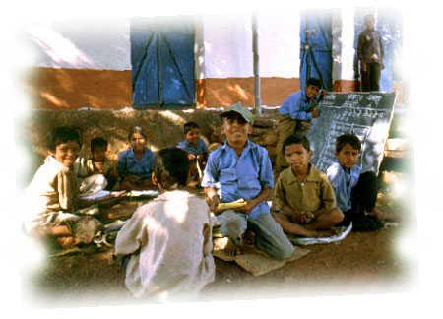
As the project states "Education" in this context goes far beyond formal schooling to embrace the broad range of life experiences and learning processes which enable children, individually and collectively, to develop their personalities, talents and abilities and to live a full and satisfying life within society.

As such, all the activities conducted are so designed that it becomes tool for learning in itself. The first condition to learning is doing it. This approach is built within the strategy.

JAGAAR CENTRES:
In 2001 SWRC, SANKALP and Falls Brook Centre started 40 night Jagaar centres in Shahbad and Kishanganj Block for the children from the most deprived communities. Jagaar Kendras are mainly running in the night and offer education to the students who cannot come to school during daytime. What is noteworthy is most of children coming to the schools are Sahariyas, and 70 % of them being girls. .This is a clear indicator that the schools are reaching the most deprived groups. During daytime the school building is used by YSS or JMS, and becomes vibrant learning center. These schools were financially assisted by CIDA fund till March 2003. It is important that these schools are maintained and supported. These are indeed the schools for the most marginalised groups who are not reached from the existing education schemes. We were faced with some difficulty of how to keep these schools open once the CIDA funding ended. We approached many agencies for support, but each had its own agenda and they were unwilling to maintain the innovative, decentralized approach that was working so well for the situation of these communities. With great effort, the salaries of the instructors were managed. And we were constantly under the pressure of financial crisis. Recently, one business firm (M/s. Gokal Das Images& Co.) at Bangalore has agreed to sanction budget of 5 lacs annually for Jagaar Centres.

PREPARATION AND COLLECTION OF TLM
Curriculum for the Jagaar centers was already decided, but only units and exercise books had been developed for the first five units. Five more units were designed and completed under the research project. These units provide curriculum in major themes of : math, literature, political science, environment and social studies. But the curriculum is designed in a framework that reflects the rural environment and rural livelihoods.
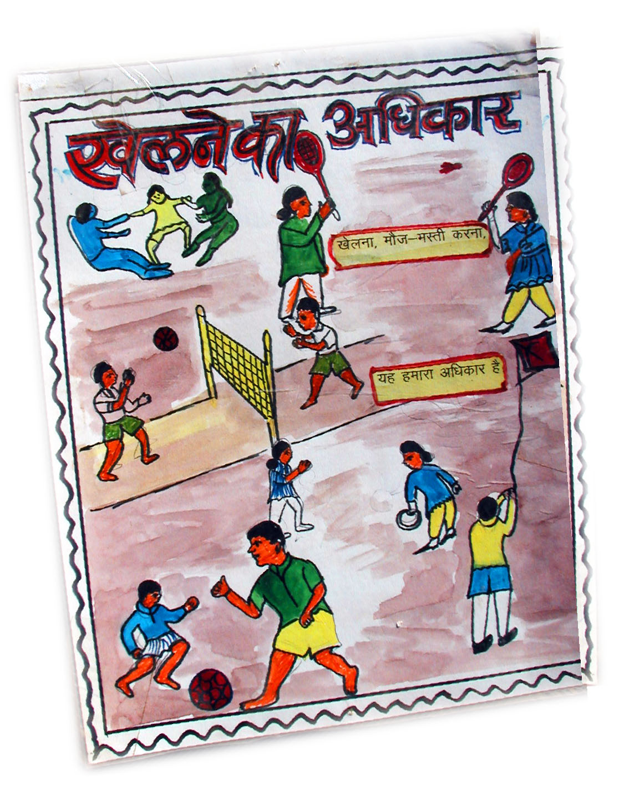
Subjects covered:
- Acquisition of literacy and mathematical skills.
- Physical and emotional health and well-being.
- Information relating to their legal rights.
- Existing governance-system, panchayati raj, government programmes and democratic education.
- Understanding village dynamics, aspects of development,
- Existing government policies and programmes for the betterment of the underprivileged Panchayati Raj system and link it to the development of their respective village
- Ability to communicate their thoughts effectively, using different medium of expression.
- Natural resources - environment-related issues, importance of sustainable development, understanding natural resources, systems, processes, and development of awareness of their local natural environment, and its interrelationships at various levels. Environmental degradation, ecological cycles and linkages with problems such as droughts and floods detail. Natural resource management in local context - water harvesting, making projects for forest regeneration, and creation of a tree nursery.
- Understanding physical and emotional self, understanding of body -its structure and functions, Reproductive health -puberty, sexual health. Body needs and all related aspects of health.

Examples of Teaching and Learning Materials in the form of educational kit, books, cassettes, wooden toys, Science Project Packages and CDs were also purchased. Working with the Master Trainers, many TLMs were adapted to address local themes and now al the maps, puzzles and wooden toys are produced at Sankalp by the youth apprentices in the wood working shop.

BRIDGE COURSE
One-month bridge course was organized for those students of Jagaar Centre who were regularly studying for past 2 years. Intense work on was given on competencies for V standard and examinations in the formal system were set-up. 82 children participated in this camp, 52 boys and 30 girls, out of which 41 students (26 boys and 15 girls) successfully cleared examination of V standard.

IMPROVEMENT IN RETENTION
This year, retention in schools has improved, as people did not migrate in search of finding labour work. So much of relief work was generated this, which community had not seen in their life span. This demonstrates how crucial livelihood is to school retention. In normal years, many tribal communities are forced to migrate to find labour for 4 to 5 months. There are no provisions within the regular schools for the children of these families and so the children can not follow their studies. Within the Jagaar Centres, some short term hostels were set up for communities where migration was prevalent. This enabled the children to stay at the school under the care of the teacher, but it required donation of food supply, which is normally a struggle. With famine relief work supplied, families were able to make do and not need to migrate. This was the most significant reason why retention, especially in the tribal schools, improved during the drought.

GLOBAL CHILDREN’S FRIENDSHIP AWARD
This is the prize given by all children of world for outstanding work in the field of child. Elections are organised throughout the world and children one out of three nominees. This award is given by Queen of Switzerland who is global friend of this forum. All SWRC night schools and schools running in its project areas are members of this forum. This occasion is tool for educating children on their rights also knowing problems faced by children in the world. Stories of the nominees and outstanding work done by them are told to them. Children then vote to select the best work they like. This year too, the election was conducted on 8th March and nearly 3800 students (2450 boys and 1350girls) from Jagaar Centre and other schools participated in it. Children's fair was also organized on the same days.

NATIONAL TRIBAL CENTRE (NTC) FOR PRIMITIVE TRIBAL GROUP (PTG)
The situation of PTG is different form other tribal group living in deprivation. They are more vulnerable even amongst the tribal group, characterized by low literacy rates, stagnant population. lack of basic amenities and economically have not been able to address there is no viable options at present. The present Government schemes have not been able to address the educational needs nor the economic development of PTG.This is partly due to extreme alienation exploitation and stigmatism towards these groups that has gone on for ages in mainstream. Some credible and long-term activity needs to be started urgently to restore the confidence of PTG on government.
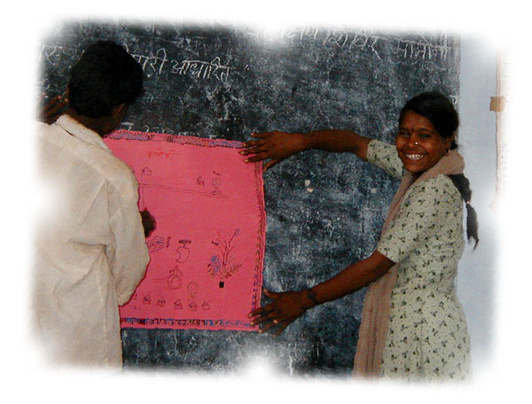
Recently sanctioned by Ministry Of Tribal Welfare, Government Of India, for imparting technical training to Primitive tribes of India. This centre has started within the premises of Sankalp Sanstha, based in village Mamoni for Sahariya tribe, the only PGT identified in Rajasthan. This centre has started as a joint effort by two voluntary agencies - SWRC (also known as Barefoot College) and Sankalp, which is working within Sahariyas since 1983.This centre will concentrate on developing the capacity and confidence of PTG boys and girls.

NTC is conceptualized as centre that promotes and imparts trainings for developing confidence and capacity of young disoriented boys & girls from these primitive tribal groups and equip them from migrating to cities for jobs. The informal, non-structured community-to-community approach will be tried in this NTG, where voluntary groups in other states will be invited to send the unemployed semi-literate youth for training in various skills that they can apply in their own community when they return. NTC will also contribute in preserving their life style and work -style. The youths will be motivated to set up their own indigenous legally registered voluntary group so that they could earmark for PTGs.

Trainings of various trades -like
- Solar Technicians
- Plumbing
- Cement Roof-Tile Making
- Coal briquettes
- Welding
- Social Forestry& Natural resource management
- Computer Training
- House Wiring
- Automobile repair
- Carpentry
- Agriculture /Fish Farming
- Communication Skills -theatre, puppet-making, video shooting
- Mechanical works
- Health Based Works
- Local Governance and Citizenship
- Need Based Training
At present, 25-30 girls, 15-20 boys from Rajasthan and few from Orissa are receiving~ training as barefoot solar engineers. A hostel for Sahariya children will be shortly started.

TRAINING OF MASTER TRAINERS
Over the last one-year and a half, various educational activities have been undertaken for adolescent boys and girls under the Doosra Dashak, Research Project and Jagaar Centre project to understand their needs, aspirations, socio-cultural framework, pressures of existing environment etc.
Within the span of 2 years, 5-6 three month' camp have been conducted Experiences of these camps was enriching as well as provided more insight to the emerging needs of youth and issues of the training.
Initial camps were conducted with help of Sandhan, Shiksha Karmis and Field unit team. But to make these camps /trainings as regular activities, a team of master trainers who could carry out this work on regular basis was required. SANDHAN helped and conducted the training of the master-trainers for Doosra Dashak Project.
But soon it was realized that:
- MTs were available for different time slots, not for full time of training. This causes disturbance in-between the training. The teachers should be attached to the programme fur the full duration of the programme, to ensure continuity in the teaching learning process.
- The new MTs took quite some time to understand the adolescents, their learning pace.
- Training organization depended upon the availability of teachers, rather than availability and convenience of the teachers.
- Training was one time activity to provide education to youth. But to make learning a continuous process and for upgrading skills of participants, teachers familiar with the participants was needed who could guide them, upgrade their content and prepare materials for continuing education as follow-up programme of post-camp.
Instead of preparing part-time master trainers, the need to build a team who could conduct trainings, and work full-time for continuing education, was essential. Therefore it was decided by Doosra Dashak that a group of 8 trainers, 4 males and 4 females, be selected and taught to conduct the trainings on regular basis.

RIGHT-BASED TRAININGS FOR TRAINERS, TEACHERS, and COMMUNITY WORKERS
The emphasis in the intervention programmes was mainly on health, general awareness, legal rights, and communication (through puppetry, theatre and journalism). Monthly-two-day trainings were held with trainers, night school teachers and community workers and some members of the women’s groups inorder to create the local capacity to address child rights and protection issues at the many levels. Trainers will need to understand the environment as learning needs are guided by the environment. Development issues needs to be addressed through whole community. Work with adolescent girls needs extreme mobilization of the community.

The trainers must understand the community, as well as the societal position of women, and adolescent girls and boys. This will involve social, cultural, economic, and political analysis, and the eventual learning and understanding of the community’s needs emerging from the process.

Some of the key issues taken up included:
- Teaching fundamentals: (1) developing skills to access knowledge; (2) learning: what is it, how do different children learn, how environment affects learning, how to relate subject matter to everyday realities
- Life Skills - understanding what we mean by life skills, inculcation of life skills by making activities, weaving it in the subject matter, developments of these skills in one’s own self.
- Curriculum - Understanding the process of framing curriculum, the contents and methodology of transacting it, framing and shaping curriculum in training modules as per training needs.
- Creativity and activity-based teaching, improvising activities, making booklets with the participants improvising activities.
- Integrating science and technology into different subject matters
- Development of teaching & learning materials.
- Evaluation and monitoring own teaching skills and the learning outcomes of students
- Planning and Conducting of special camps and trainings for children and youth

Each training period emphasized self-expression, gender sensitization, understanding curriculum & subject matter, preparation of teaching aids, literacy, mathematical skills, evaluation and monitoring.

THREE MONTH'S ADOLESCENT CAMPS
- Three month's camps for adolescent girls was organized, starting from 23 February 2003 and ending on 15th May 2003. 59 girls from 7-8 villages of Kishanganj participated in the training and achieved the level of III, IV and V level. Emphasis is mainly on common issues like: health, general awareness, legal rights, communication, environment, functional literacy, numeric, and life skills. This group is also our active partners in the research action project undertaken in Shahbad & Kishanganj area.
Till now 4-5 camps for adolescent boys and girls have been organized for time to time.

RIGHTS-BASED TRAININGS FOR YOUTH
Several trainings were held with core youth group to build understanding and relate local issues with the rights-based interventions on issues of health, general awareness, legal rights and communication (through puppetry, theatre and journalism. The goal of the trainings was to impart confidence and skills by which youth will be able to deal with issues related to their physical and emotional health and well-being; make informed choices in the social and political context, through access to information relating to their legal rights, and by developing their desire to exercise these rights; able to communicate their thoughts effectively, and express their opinions fearlessly.
Not only this, rigorous training with the community to develop their understanding to establish adolescents within their own community.

MASS EDUCATION
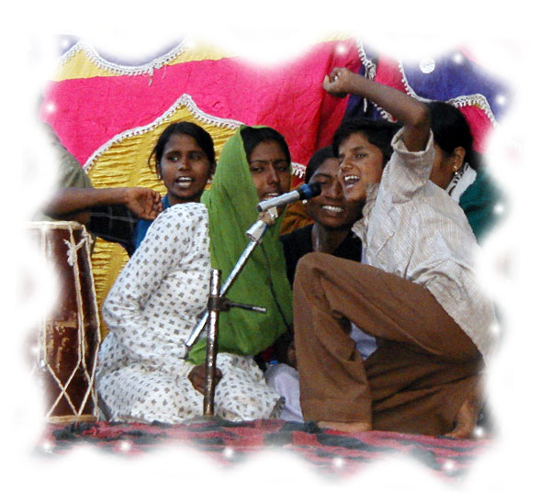
This has been the most powerful tool that has come from the process of building local capacity for protection of rights. This is education that can occur in the midst of large groups and gatherings (i.e. fairs, forums, rallies, conventions) through the use of puppetry, songs, role plays and other tools of popular education. We followed a progression from formation of village-level groups to hosting fairs and forums to working with cadres-level trainings and then returning to work at the village level. The programme is implemented as a ‘people’s movement’ following the inderlying principals of ‘campaign mode’ , ‘voluntarism’, and using a ‘participatory aproach’. ‘People’s movement’ means involving along with the children, the district administration, people’s committees, woman’s organizations and teachers at different levels in the campaign. It was an important tool used in this project to elicit participation from a larger group of youth.

The Children / Youth Fairs are means of building up the confidence and skills of the youth to participate. The atmosphere of the fairs are joyful, full of song and dancing, different boths are set up with information displays on issues ranging from reproductive health to political education, solar energy and magic/games. The fairs bring together youth from different villages and allow them to explore, learn and take part with various activities. It builds confidence to try new things and meet new people. This prepares the way for greater participation in the youth forum.

The Youth Forum took place following the one-day fair. Workshops were given on eleven different issues from reproductive health to water conservation to child rights and woman’s rights. It also explored the benefits and challenges of working collectively using role-plays. Communication skills were developed as youth learned new songs and as each youth presented themselves on stage by talking into the microphone. It also became an important tool for creating organizations and organizing a larger public campaign. The most tangible outcome was the formation of Yuwa Shakti Sangathan, a cadre of youth willing to work for the good of their various communities.

Creating organizations, organizing protests/conventions/rallies/public hearing can give them a sense of their collective power, an ability to assess the possibility of change, and to question the policy makers/planners /implementers. It is form of political education. They give the participants new insights into processes and institutions that are normally beyond their reach. A public hearing is also a practical form of people's participation in the democratic process.

PROTECTION AGAINST HUMAN RIGHTS ATTROCITIES

The main objectives of the project were: understanding the specific vulnerabilities and resourcefulness of Sahariya children as child laborers and as children facing systemic discrimination and developing an integrated effort to empower them to address their own issues and affect policies meant for their development.

As stated earlier that protection was needed at two levels:
- Firstly it was necessary to take steps for protection of people because of the alarming situations of drought
- Secondly, Sahariyas, the only primitive tribe of the state has long history of exploitations. Many human rights are violated in their context. Now it's the time for them to raise their voice against atrocities inflicted on them, and demand policy makers to ensure their rights and opportunities for making their lives better.

FORMATION OF CADRE AT MASS LEVEL
Group of people who can collectively organize to address their issues, strong organization of community in needed. Group of dynamic people who provide active guidance and committed to service of mankind are needed for this purpose the cadre of people were created. YSS, JMS and Bal Panchayat organizations are outcomes of such cadres.

UNDERSTANDING SPECIFIC VULNERABILITIES
It is important to create group, and more important is empowering the group to understand, identify & prepare them to address their issues. This is gradual process of learning in which each individual participates and learns by doing it. Drought situations taught this lesson of vulnerabilities within no times. Through surveys and facing these situations themselves, YSS/JMS/Bal Panchayat understood the not only the process of identifying vulnerable areas/people, but also approach to crisis resolution.

PROTEST AGAINST ATROCITIES
Heart rendering stories of exploitation of tribals can be heard in this area and the tribals have never retaliated against the atrocities united. The reason being that self esteem is low, that they leave before the battle actually starts. In such circumstances participation in development schemes or to directing their own development seems a distant dream. Most essential is to build their lost identity, self-confidence and self-esteem. This protest was strategically decided so there could be catharsis of the anger within them, and the unity and solidarity may revive the original; fear free Sahariyas, ready to participate healthily in each and every activity.
The purpose of any scheme started by government or any other project is defeated until and unless we work on self-esteem, personality development, and readiness for participation,

Unity and solidarity of organizations of YSS and JMS has provided strength to them.
To some to extent, the victory of tribals, in One-day protest against police in January 2003 by tribals of Gigcha village under leadership of Kalli Bai, a member of JMS also played important part. A Sahariya mate was badly beaten by other community in this village. The wave of victory of this event also worked as incentive for another protest.

For the first time, tribals united to break long silence and fight against atrocities inflicted on them on the festival of Holi (20th March 2003) in a real organized manner. Details of the incident is given in the annexure under the article "how many Battles to fight" and article by Jean Dreze.

This protest was initiated by JMS, YSS members and tribals of Mundiar village led for nine days, starting from 21st till 19th April 2003 in front of SDO office at Shahbad .For 9 days, people were on living on road under tents. When justice was denied at district level, members of JMS met and gave memorandum to Chief Minister Of Rajasthan, as a quick response the district level were instructed to take prompt actions. Nearly 150 -200 villages participated in this protest, also supported the movement by collecting money and grain. Other NGOs /people also participated in it. Enquiry of the incident was conducted by PUCL (People's Union For Civil Liberties), Women's Commission At state level. This incident once again attracted the attention of people on the situations tribals are facing
PROTEST ended on 29 when District level officials came to the protest site and accepted the demands of the people. The wave of the victory of the tribals has now spread in the area: has been strong factor of building self-esteem. For the first time they realized that even they could dictate then terms and conditions and officials accepting it. Ever since then many incidents have taken place in the villages where people collectively went to the administration and got their work done.

Demands accepted after protest
- The revenue officer (tehsildar) has been sent to Ajmer (his concerning department) and enquiry has started against him. Till the completion of enquiry, he will not be posted anywhere.
- 7 policemen have sent from here.
- Labour work has been started for the Sahariyas of Mundiar.
- Ration shop license of Guddi has been (cancelled.
- After the medicals reports are received and if suggest atrocity on Gulab, she will be paid compensation and strong actions will be taken against the people involved in the incident.

RIGHT TO WORK
Sahariya tribals were basically nomadic people dependent mainly on forest produce for gaining a means of livelihood. As a result of deforestation, they have suffered heavy exploitation in the hands of government functionaries and elites. Now they are forced to find work as daily labourers; and that is available only for a few months a year in the best of circumstances.

During the drought, there was no employment for people. Local agriculturalists could not provide labour to local labourers as they were also affected by drought. Availability of minor forest produce decreased, as even big trees succumbed to the lack of water. System of bartering grains against debts had also stopped. The deteriorating conditions of drought brought overall scarcity to a situation that was already on the edge of survival. Chronic hunger led to severe malnutrition; people became sick and started dying.

To save people from this disaster, relief work was requested following an intensive survey which identified the villages where people were worst affected by drought. Just few days after, Government started relief work at war level to save people from starvation. But this type of relief work was started for the first time due to the status of people as well as pressure of media and people. It is likely that Government will stop relief work as soon the rain starts, thus leading to search for employment. It is most essential to provide work to the 'marginalized, vulnerable people' and ensure better standard of living.

A group of concerned people/NGOs have now united and started demanding the law on the EMPLOYMENT GUARANTEE ACT .The aim of this act to safeguard the right to work. The fundamental entitlement defined by the Act is as follows:

Every adult in the rural area of Rajasthan shall have a right at guaranteed employment for doing unskilled manual work at the statutory minimum wage, and to receive the wages thereof within a fortnight in accordance with the provisions of the act and the programme made there under.

OTHER ASSOCIATED ACTIVITIES:
International Women's Day Celebration
The 8th of March is the internationally celebrated Women's day. Women, youth and other community members of JMS celebrate this occasion every year. It was decided that this year's issue for women would be the ‘Right To Work’. This occasion was used to organize women on this issue. Meetings were conducted at the cluster level. Meetings were held in 4 clustres of Bhawargarh and 10 clustres of Shahbad (15-20 villages in each clustres). Sports, recreational activities were organised along with understanding of issues of right to work and Employment Guarantee Act .
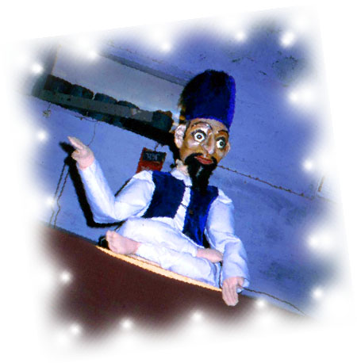
After the meetings and celebration, a commitment to organize on the right to work was achieved. The women then decided to organize two subsequent events. A rally in Shahbad and Kishanganj on May 1st, and a Convention on the Right to Work. The youth (YSS) joined in with the organization of this conference. Leading up to the convention, a communication team of women/youth traveled from village to village to explain the issue to people and collecting resources (money/wheat...). They beautifully executed this work and impact could be seen in the conference in May.

Rally on Labour day (1st MAY):
Nearly 450 members from 70 villages participated in the rally at Shahbad and at 500 people at Kishanganj. All the labourer class united in the rally. Pamphlets on Employment were circulated and memorandum to the block level administration to implement employment guarantee act. Thousands of people signed the memorandum. Problems related to drought situations emerged from many villages and were put up before the administration. Message and invitation to all the people was given to attend convention on 18th MAY 2003.

May Convention On Right To Work:
The success of Dharna paved the way to a huge Sahariya Sammelan on 18 May, which gave a major boost to the right to work campaign in Rajasthan May Convention On Right To Work was held at Shahbad on 18th May 2003.Nearly 3000 people from 150 village of Shahbad and Kishanganj participated in this convention. Memorandum signed by the people present was sent to the Chief Minister of Rajasthan demanding right to work and making law on Employment Guarantee Act (on the pattern of Maharashtra)
Three main demands laid down were
- Employment should be guaranteed to people.
- To implement the orders issued by Supreme Court Government.
- Annapurna Anna Yojna cards should be issued to Sahariyas. (As per the scheme Sahariyas will be given fix quantity of grain at Rs 2.00 per kg.)
- Other organizations, who participated in the convention were Majdoor Kisan Shakti Sangathan, Rajasthan Majdoor Morcha, Barefoot College Tilonia, Cecoy Decon, ASSEF A and other concerned individuals. .
This movement will continue till the demand is accepted.

PROTECTION & MANAGEMENT OF NATURAL RESOURCES
FOREST RESTORATION
The life and identity of tribals can be understood only in the context of the forest. Forests are their lives and souls. Their very existence - culturally, socially and economically- depends on the forests. They were victims of exploitation only when thrown out of the forests. The current scenario is that the forests ‘belongs’ to the government, no more to them; denuded barren lands where there were lush green forest and water level has gone down tremendously. A sincere effort needs to be done for the conservation of forests and reviving the culture of the tribals in context of environment. So far, the activities that has been in this direction include:
- Awareness building amongst the youth, JMS and children on the environment and minor forest produces.
- Planting trees with children in Jagaar centers.
- During the drought, proposals to the administration to take up water harvesting ponds and making protection walls for forest land as part of relief work. As a result, many enhanced water ponds as well as protection walls have been made.
- Projects on Joint Forest Management have been submitted to the Government. Plantation work has already been started in Village Gigcha by the Government at their level (for which on of the project was written).
- Many enhanced water catchments were made in the forest area, so that plants could survive as well as animals will get water to drink.

The long-term goal is to get Shahbad & Kishanganj area declared as SCHEDULED TRIBE AREA, so that tribals will have control over forests. Memorandum to Chief Minister, Nation leader Of Opposition Party and Chairman of SC/ST Commission has been given in this connection.

AGRICULTURE
Training of all core staff and youth leaders was done in Nov 2003 on the topic of integrated agriculture. Topics included: soil & water conservation techniques, benificial herbs, composting, mushroom propagation, improving milk production in small-scale dairy operations. Work is underway now at Sankalp to create a small-scale agricultural demonstration of vegetable growing and composting.

HERBI-CULTURE
An organisation in Andra Pradesh was contacted for conducting a training on herbaculture. The training will be done with interested adolescents from YSS and women from JMS. There is immense scope of planting herbs in the area.
We have also contacted knowledgeable Vaidya (Ayurveda Doctor) in Nahargarh, Kishanganj. He has very good information on herbs and that can be planted locally. He has provided information on herbs and conducted a workshop with traditional healers. The field workers identified these traditional healers.

PARTICIPATION IN LOCAL GOVERNANCE
Participation in the system - which is so hierarchical, where ignorance prevails, self confidence and esteem is extremely is low and wide gap between government and the people - is slow and has long way to go.
The strategy adopted for the implementation of the programme is designed to provide participants (YSS/JMS/Bal Panchayat/Researchers/Community members, through Mass Education Programme) with life skills, to strengthen the capacity to human rights and to promote a culture that is infused by appropriate human rights values. The goal is to empower them to express their views and, build their capacities to participate in the governance system healthily for their own development.

The activities conducted in this direction were:
- Survey /Resource Mapping and Analysis to develop critical, analytical skills and understanding the issues / assessing vulnerability/extent or gravity of the problem.
- Formation of mass level organizations so that they may realize their collective strength and have confidence that collectively they can change the world. A clear impact of this could be seen after drought survey. When youth and women started demanding their rights from public representatives/Government.
- Taking Leadership: YSS and JMS have already started working independently, working with wider village community, and addressing their issues.
- Participation in Ward & Gram Sabhas - Pre-requisite of successful democracy is participation in political system. Gram sabha is most important forum for participating in local governance. Surprisingly, when media was reporting low participation in these forums in other parts of India, there was net increase in participation in the villages of Shahbad and Kishanganj area (more we have where we have our village level groups).
- Three Months' camps/Orientation Programme for youth and young adolescents.
- Protest has proved excellent tool for building self esteem, self respect and confidence. Is an indication that no injustice will be tolerated, and if such things happen again people will protest against it. Enough exploitation has been tolerated in the past, but no more. System is meant to provide justice and work for them.
- Participation in Movement For Employment Guarantee: Details of the movement has already been in detail in above section.
- Constitution has provided Right To Live each Indian Citizen. But circumstances at times are such that they make life miserable and almost make living difficult. Adding to the misery is the fact; even the government, which is elected by us & for ourselves also overlooks these situations. Violation of human right is offence and should be questioned. Asking for Employment Guarantee is also a step in this direction.

March for 'citizen's participation in the electoral process'
Ever since its independence, democratic form of government has existed in India. But not participating in the system kills the soul of democracy. There is wide gap between rulers and public. Dialogue between the two needs to be initiated and democratic spaces needs to created.

To increase political awareness, JAN NITI ABHIYAN (Towards People Mandate) has been started at state level. This is group of organizations and individuals headed by Majdoor Kisan Shakti Sangathan, committed to increase political awareness. National elections took place October-November. Prior to the elections, a group of 40 to 60 people, representing the various organizations, including JMS and YSS, visited villages in 8 districts to raise awareness on the electoral process. Much awareness was raised for casting votes, deciding the priorities of development.

Every time each political party publishes its mandate yet the participation of people isn’t sought to know what actually they want. The voters many times do not even know for whom they are casting their vote.

Plays and meetings were organized at the local level to explain the India’s democratic system, the role of the panchayati raj, human rights, and the recent Supreme Court decisions regarding the right to food and employment guarantees for marginalized peoples. Through joint concensus at these meetings a people’s agenda was formed. A memorandum to District Administration is given in this connection.
Five people from Shahbad & Kishanganj participated in this mission: Radhe Shyam (Sankalp Worker), Ramkanya (JMS) ,Pinki, Lal Chand (YSS) and Chetu (Bal Panchayat). They traveled for 17-18 days with the march.

Two interesting events occurred during the march:
- When the group reached the village of Nokha (Bikaner), there was group of people fighting for the right to information. A protest was organized before the administration. The group joined in the protest on their own accord.
- Later, in a meeting in a school of Jodhpur, Chetu sang a song on the right to food “Roti casava”. The principal and was so happy to see the confidence of this boy that she presented him a gift.

Experience and information from all visited places have been collected, and this was put before Chief Election Commission of India.

BPLSURVEY:
BPL Survey was organized by the government between June 15th and July 15th, 2003. This survey is done once every 5 years to identify families below poverty line. Much information was provided by the youth and JMS. They helped with the local surveyors in survey. Gram Sabha was then held on August 15th where names of the people was read out loud before people. The members of YSS/JMS took on the responsibility to ensure that right people were selected within that Panchayat circle.

MEMORANDUMS TO THE GOVERNMENT /PUBLIC REPRESENTATIVES
To attract attention of the government /public representatives towards the problems of the area and in particular Sahariyas, and demand for their rights, memorandums were given to Chief Minister, Leader of the Opposition, and Chairman SC/ST commission - (copy of memorandums enclosed)
Three memorandums to Chief Minister Of Rajasthan
- First Memorandum informing him on status of drought situation.
- Second memorandum presented to him again to ensure justice to the tribals of Mundiar village.
- Third memorandum to declare this area as SCHEDULE TRIBE AREA, for implementation of orders of Supreme Court and few other demands.
- The same memorandum, stated in the third point was given to Mrs. Sonia Gandhi, Leader of the Opposition.
- Another memorandum was given to Shri D.S.Bhooria, Chairman of SC/ST Commission to request that he declare this area as schedule tribe area, and to declare Kherua community as Tribals.

8.0 Results and dissemination:
Overview of results seen thus far

SN | OUTPUT DESCRIPTION: | PRIMARY  PARTICIPANTS | TARGET GROUPS | IMPACT
A. | Information sharing and dissemination:
1. | Report of Drought Survey and Recommendations | Consolidation by whole team and with full collaboration of Doosra Dashak | - Government  - Akal Sangash Simiti  - Danida  - Doctors without Boarders  - Distribution Public Hearings  - Asia Social Forum  - Action Aid  - CIDA (provided in the midterm report) | - the main concerns brought forth in the drought survey have received national and international attention  - district magistrate was replaced and famine relief work sanctioned in all regions hit by drought  - Danida gave support for water harvesting projects  - Action Aid supported 12 nutrition centres  - Doctors without Borders did a subsequent study and chose Sankalp as the nodal agency for ongoing monitoring of malnutrition
2. | “Famine and Relief” | Sandhan with information and pictures provided by Sankalp and Doosra Dashak | - Danida  - Government  - CIDA | This was a summary of the consolidated results of the drought survey along with future projects that still need funding
3. | “On the Path to Participation”  22 minute documentary video | Bhanwar Ghopal (Camera); and Falls Brook Centre | - CIDA  - One World Film Festival  - NB Schools  - Presentations  - Barefoot College | Received positive feedback in various audiences. Will be used for workshops along with dissemination of research results in Canada and India.
4. | The Sahariyas of Rajasthan: An Introduction | Charu Meharu and FBC | - Government  - India Media  - Other NGOs working in the area | Used for articles in the press and increasing awareness among the public of the history of exploitation of the Sahariyas in thi
B. | Knowledge Creation
1. | New Curriculum Developed for Jagaar Centres- based on language, arithmetic, environment, democratic education, health. | NS Teachers, Master trainers, workers, Charu | - Tried out in 3 months camp with the children  - Applied to the open curriculum developed for Open Middle School that has been started by Doosra Dashak | - more conscious of rights, health, better understanding of surroundings, more informed and the level of confidence better  - children now playing leadership roles for the service of those in their village and even those to whom they feel rights are not being respected

9.0 Project Management

The Barefoot Approach is applied in many aspects of community development work by Sankalp and the Barefoot College. Yet, typically the realm of research is identified with the educated coming from outside and collecting data then returning to their office to write a report. In the case of this project, the research has been guided by the people on the ground. The role of Falls Brook Centre was more administrative and attempting to keep up with all the directions the participatory process has taken. This is the result of more decentralized process where people felt they could make decisions based on the realities at hand.

Still accountability needed to be ensured, so where we focused the most attention was on the process of participation and local capacity building. This focus ensured that the most people were involved in trainings relevant to their lives. We maintained an open door policy with all trainings and forum. We invited 300 youth to participate in the youth forum, 457 youth arrived. This was a clear indication that the themes we were addressing were relevant to the lives of these youth. Action-research revealed its true potential during the drought crisis. It would have been impossible to reach all the villages it the process had not been participatory from the outset. The power of people from these communities examining their own situation and then evaluating it with increased awareness and understanding of their own human rights is the most significant capacity building outcome that is emerging from this project.

Sankalp played the most key coordination role for the direction of this project. Falls Brook Centre facilitated project planning, gave suggestions on various participatory activities, and assisted with building linkages between various NGOs and government agencies. Barefoot College played a supportive role throughout, especially when dealing with the Central Indian Government and European Funding Agencies. It has been a good partnership from all sides, and solid friendships will remain.

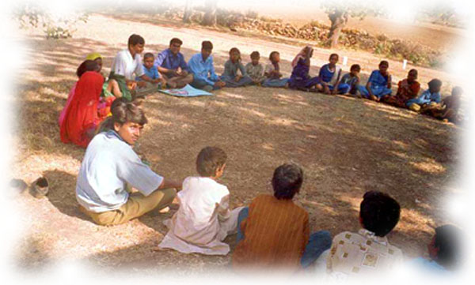

10.0 Lessons Learned

- Child rights and Child Protection must be worked on within a holistic view of family, village and community-at-risk. If the situation is precarious for the community, it will be all the more detrimental to the child.
- Participatory processes must be responsive and flexible enough to truly address needs as they arise. The success achieved in this project was possible because there was enough flexibility to move on the humanitarian crisis as it arose.
- Surveys can be excellent tools for mobilization and education, provided the people for whom the survey is meant are part of the process from its execution to analysis
- It empowers researchers to understand their rights and take responsibility to work towards raising their voices and collective efforts for the protection of children and adults facing situations of adversity
- Issues of common interest unite people. If training and education is framed on issues of local relevance, people will be interested and come of their own accord. Education within this context empowers.
- Fighting against atrocities where no injustice is tolerated is an excellent tool for building lost self-esteem
- If media is used for the right cause, it can be of great help in attracting the attention of people related to the development field
- Collaborations with multi-sectoral groups lends credibility and widens the reach of a people’s movement
- North –South partnerships become more valuable with ongoing contact and collaboration.
- Longer vision of international funding agencies is needed. The span of time for this and the Night School Programme was very short.

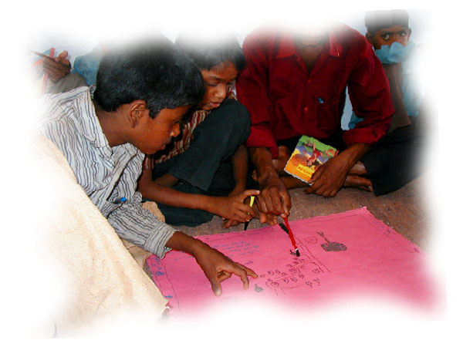

List of Annexures:

- Fighting out Atrocities (article writen in ‘Our Voice, Sankalp’s newsletter)
- Shariya women resist repression, Shahbad dharna enteres second week
- Letter to the Collector, Baran by Shri K.S. Gopal from the Centre for Environmental Concerns, Hydrabad
- Rajasthan Drought’s worst victims
- Right to Food Campaign
- Memorandum to Sonia Gandhi (President of the National Congress Party)
- Proposals to the collector asking to sanction watershed projects
- Second Drought Survey Analysis
- Memorandum to Shri D.S. Bhuria, Chairman of the SC/ST Commissioner
- National Workshop on Drinking Water and Sanitation proceedings

Glossary

Bal Mela Fair for children

Bal Manch Children’s forum

Bal Adhiveshan Children’s Convention

BPL Below Poverty Line designation given by Indian government

Panchayati Raj Local Self Government at village level

Gram Shabah All registered voters of a Panchayat. The Gram Shabah must meet at least two times a year and have at least 20% of all members attending.

Sarpanch Panchayat President

Dharna A sit in strike or protest

Kalajantha Theatre troop

Tehsildar the revenue officer

VOs Voluntary Organization

YSS Yuwa Shakti Sangathan, which is a cadre of youth formed within the blocks of Kishanganj and Shabhad. ‘Yuwa’ means youth; ‘Shakti’ means power /energy; Sangathan means Association/United
.
JMS The Awakened Woman Association

