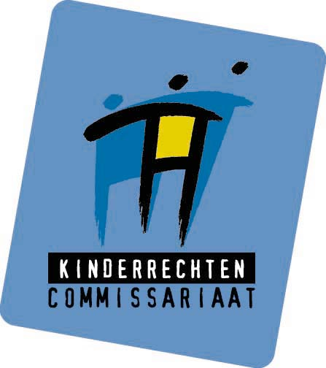

campaign on children’s rights
in the elementary schools

Children’s Rights Commissioner’s Office

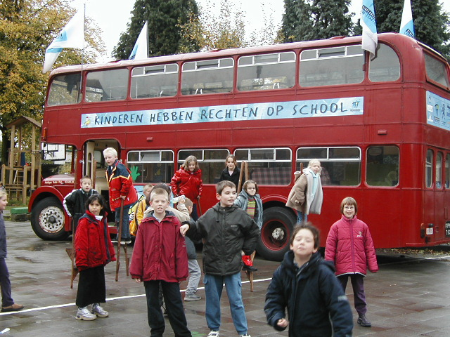

Background information
on the campaign on children’s rights in the elementary school
of the Children’s Rights Commissioner’s Office

Children spend most of their childhood at school. Children have the right to education, there are not that many people who question that. Nevertheless, children also have rights in education, in their school. The right to participate is such a right. This participation right involves the right to be involved in school affaires, to participate, have a say and to be taken seriously.

Participation of children in elementary school

In some elementary schools interesting participation initiatives are being developed and are taking place. However these initiatives are still fragmentary and local. Examples are school parliaments, discussion groups, school councils, questionnaires and suggestion boxes. At this moment such initiatives are neither explicitly stimulated nor financed by the authority.

Campaign on children’s rights in the elementary school

The Children’s Rights Commissioner’s Office wants to stimulate the participation of children in the elementary schools. The UN Convention on the Rights of the child guarantees the rights of children, which also apply in schools. The Convention guarantees the child’s right to express his/her views freely in all matters affecting the child and states that there should be given due weight to the views of the child.
The Convention stipulates that children have the right to meet and unite.
The Convention states that education should be directed at the development of the child’s personality, talents and physical abilities to their fullest potential and fostering respect for basic human rights.

Campaign: What?

By means of the campaign ‘rights of children in elementary schools’ the Children’s Rights Commissioner’s Office wants to inform children from the Flemish schools about their rights and encourage them to exercise these rights. To exercise your rights you have to be aware of them. Children who know their rights are better equipped to claim them. Children are given ideas, suggestions and clues to practice their right to participate. Teachers are being informed about the possibilities and opportunities offered through participation at school.

The most important message is that pupils have the right to give their opinion at school and that they have the right to move a proposal, to make changes at school. Pupils are encouraged to ”make school together” with their teachers, the principal of the school and all other persons involved. “Making school together” requires a permanent dialogue between all relevant actors. It also means taking each other seriously and treating each other respectfully.
The Children’s Rights Commissioner’s Office doesn’t want to propagate any specific method’s of participation. In the campaign in general as well as in the specific project children are inspired and encouraged to participate in different ways (formally or informally).

Structure of the campaign

For different parts of the campaign the Children’s Rights Commissioner’s Office collaborates with different partners.
The campaign is built on three main elements: the Children’s Rights Festival, the distribution of information material and the schoolparticipation project.

1. The Children’s Rights Festival
The campaign started off with the Children’s Rights Festival on the 22nd of September. The festival offered children a place to experiment with their rights. The main theme of the festival was: children's rights in schools. In an active way children could find inspiration on exercising their rights at school. About 8.000 people visited the festival. The festival was set up in collaboration with child rights organizations and schools who work in a participatory way.

2. Distribution of information and action-tips
In the beginning of October information was sent to all Flemish elementary schools.

2.1. The ‘Megaphone’

True participation calls for instruments that help children to exercise their rights. The ‘Megaphone’, a booklet full of practical action-tips and advice for pupils was published. The ‘Megaphone’ consists of stories about children who take concrete actions to do something with their right to information, privacy, association, to give their opinion, to be heard, to leisure and culture.
The action-tips explain pupils how they can work, step by step, to realize an idea or to make known a problem and do something about it.

2.2. Telephonic helpdesk
The existing “Children’s Phone” shall also be the helpdesk for pupils who want some advice to realize their ideas at school.

2.3. A Newspaper for teachers
Participation at school is impossible without the active support of teachers. Teachers and pupils should “make school together”.

The teachers’ newspaper was developed to correctly inform the teachers: The aim is not to make children the boss in school. On the other hand the paper also explains what’s in it for the school, what the school can gain by letting their pupils participate. The paper also informs the teachers that letting pupils participate is no free option but an obligation for the school, given the Convention on the Rights of the Child.

3. The schoolparticipation-project

The schoolparticipation project wants to introduce and stimulate participation of pupils in the elementary school. A ’participation-bus’ will tour around Flanders visiting 30 pilot schools. In the 30 selected schools an interactive process will be set up between pupils, teachers, principals of schools and other relevant school actors. They will take stock of problems and ideas and work together on a school-charter.

3.1. Introduction of participation

The Children’s Rights Commissioner’s Office encourages children to get involved, to think along, to take part in the conversation, the decision making and in the execution of a plan.
Children should be able to exercise their participation rights at school. The project also wants to encourage teachers and principals of schools to give children opportunities to participate. That’s why the dialogue between pupils, teachers and principal of schools is the main topic.

3.2. Selection of pilot schools

All Flemish elementary schools were invited to subscribe to the project. 269 schools subscribed.
30 schools were selected on the basis of geographical position, origin of the school (public/private school) and size of the school.

3.3. Concrete practice

The project is addressed to all teachers, pupils and principal of the school from elementary school. Classes 5 and 6 from the elementary school play the most important role because they have the task to make the school-charter taking into account the views of classes 1, 2, 3 and 4. In this they get assistance from a professional who’ll guide the process.

3.3.1. A package for each class

For each class there is a “package” in accordance to their means of expression.

Classes 1 and 2 receive a “participation box” in which there is a disposable photographic camera, coloured pencils and paper, in order to visualize their ideas and proposals concerning their school.
Classes 3 and 4 can use the “chat-box”, a room where they can speak in front of a camera. They can express their ideas and proposals to change the school out loud.

Classes 5 and 6 get support of an external assistant offering them a setting to dialogue with each other and their teacher on an equal basis. A specific game was developed to work on participation issues. During the three they go through the different stages of the game in order to finalize the school-charter.

During the first session the pupils and their teacher make an inventory of the problems in the school and their ideas to make a change. By voting they select the main issues.
Before the second session the pupils have to investigate (in small groups) the feasibility of the selected issues by informing themselves through all possible channels.

During the second session – 4 weeks later – pupils confront feasibility with gathered information. Before the third session they start working on one or more achievable goals/issues. Another task is to examine the ideas and suggestions given by the other pupils of the school through their pictures, drawings and videotapes.

During the third session – again 4 weeks later – pupils and their teacher make a school-charter based on the inventories of session one and two.

The purpose of the charter is that it leads to concrete results and actions in the school. All pupils, teachers and the principal of the school receive this charter.
The principal gives his comments on the feasibility of the charter in a clear and understandable way. Guidance by means of coaching sessions for teachers, principals and pupils are being organized.

The main purpose of the project is not merely the product, the charter, but is also to stimulate a long lasting process of participation. All people concerned can use all gathered experiences to give participation in school a more permanent and structural character.

3.3.2. Kick-off

The project takes off with the arrival of the schoolparticipationbus at the school gate. This is a double-decker, restyled into a children’s rights information point. In the bus there is an information corner for children and one for teachers. Pupils and teachers can also listen to a tape were pupils from other schools talk about their school council and an evaluation report for teachers.
Pupils from all classes visit the bus. The pupils of classes 3 and 4 make use of the “chat box” situated on the first floor of the bus.

Next to being a catalyst for the pilot school, the bus also serves as antenna to other schools and (local) media.
During lunchtime and from 15h30 until 17h30 the bus is open for parents, teachers, and principals from other schools in the region, the media and other interested persons. The Flemish elementary schools are informed about the locations and the dates when the bus can be visited.

3.3.3. Timing

The project started the first of October. All schools will have finished their third session by March 2002. The 30 charters will be drafted and finished.
The Children’s Rights Commissioner’s Office will monitor the implementation of the charters and the progress schools make.

In may 2002 an evaluation shall take place. Representatives from each pilot school, pupils as well as teachers and principals will share experiences, pitfalls, …
The (gathered) information shall be used to encourage other schools and to advise the authorities about participation in elementary schools.

Article 12
Article 15
Article 29

