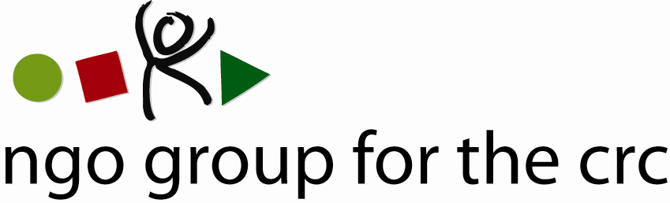

Open-ended Working Group on an Optional Protocol to the Convention on the Rights of the Child, second session, 6-10 December 2010

Compilation of joint oral statements delivered by the NGO Group for the CRC

Joint statement – Closing Remarks on the Optional Protocol to the CRC
Delivered on 10 December by Anita Goh, Advocacy Officer of the NGO Group for the CRC

Mr Chairman,

Thank you for giving me the floor.

On behalf of the NGO Group for the Convention on Rights of the Child, a global network of 77 national and international child rights NGOs, I take this opportunity to offer our sincere thanks to you as Chairman of the Open-ended Working Group.
We are particularly grateful for this week of important and constructive dialogue which we regard as a significant step towards consensus on the Optional Protocol.

Under your stewardship the dialogue between States, experts, and non-governmental representatives has been open, constructive, and positive and has demonstrated the commitment of all the parties present to the fulfilment of children's rights under the Convention and its Optional Protocols.

The rationale for having this new communications procedure is really to ensure that all children can have access to an international complaints mechanism that will address violations of their rights in an appropriate and child-sensitive manner, if national systems fail them.

One issue of particular concern for the NGO Group is therefore the accessibility and effectiveness of the future communications procedure to all children, including those who will not have a legal guardian or identifiable parents, and for victims who might not be identifiable.

On a symbolic day like today, Human Rights Day, we are confident that all States can commit to work towards creating an effective and accessible mechanism for all children.

We look forward to further discussions in this vital mechanism in the coming weeks and months.

Again, thank you, Mr Chairman.

Member Organisations
- 3D Three – Trade, Human Rights, Equitable Economy
- Action for Children and Youth Aotearoa
- African Child Policy Forum
- Anti-Slavery International
- APPROACH Ltd. – Global Initiative to End all Corporal Punishment of Children
- Arigatou International
- Associated Country Women of the World
- Association for Rural Development and Action Research
- Association of Networks for Community Empowerment
- Baha'i International Community
- Child Helpline International
- Child Rights Information Network
- Child Rights Network Switzerland
- Children’s Rights Alliance
- Children’s Rights Alliance for England
- Christian Children's Fund Inc.
- Coalition Against Trafficking in Women International
- Consortium for Street Children
- Defence for Children International
- DevCon - An Association for Rural Development
- ECPAT International
- Education International
- Egyptian Foundation for Advancement of Childhood Conditions
- EuroChild
- European Association for Children in Hospital
- Every Child
- Fédération Internationale des Communautés Educatives
- First Nations Child and Family Caring society of Canada Incorporated
- Friends World Committee for Consultation (QUNO)
- Fundación Privada Intervida
- Human Rights Watch
- Inter African Committee on Traditional Practices Affecting the Health of Women (IAC-HTPS)
- International Alliance of Women
- International Association of Youth and Family Judges and Magistrates
- International Baby Food Action Network
- International Catholic Child Bureau (BICE)
- International Council of Jewish Women
- International Council of Women
- International Falcon Movement Socialist Education International
- International Federation of Social Workers
- International Foster Care Organisation
- International Inner Wheel
- International Institute for Child Rights and Development
- International Movement "ATD Fourth World"
- International Play Association: Promoting the Child’s Right to Play
- International School Psychology Association
- International Social Service
- La Voix de l’Enfant
- Maryknoll Office for Global Concerns
- National Aboriginal Islander Child Care
- National Coalition for the Implementation of the UN Convention on the Rights of the Child in Germany
- Penal Reform International
- Plan International
- Plataforma de Organizaciones de Infancia
- Proyecto Solidario
- Red Latinoamericana de Acogimiento
- Red Latinoamericana y Caribena por la Defensa de los Ninos, las Ninas y los Adolescentes
- Resources Aimed at the Prevention of Child Abuse and Neglect (RAPCAN)
- ROC (The “Right of the Child” NGO)
- Roshni Homes Trust
- Save the Children – Alliance
- Soroptimist International
- SOS-Kinderdorf International
- Terre des Hommes International Federation
- WAO Afrique
- War Child Holland
- Werkstatt Okonomie
- Women's World Summit Foundation
- World Alliance for Breastfeeding Action
- World Alliance of YMCAs
- World Association 0f Girl Guides and Girl Scouts
- World Jewish Congress
- World Movement of Mothers / Le Mouvement Mondial des Mères
- World Organisation Against Torture / SOS Torture (OMCT)
- World Union of Catholic Women's Organisations
- World Vision International
- Young Men’s Christian Association of Costa Rica

See list of members at the end of the statement

