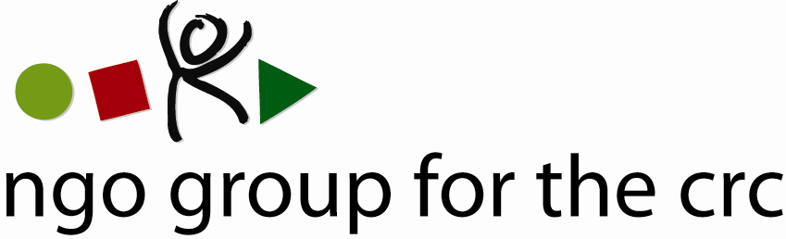

Open-ended Working Group on an Optional Protocol to the Convention on the Rights of the Child, second session, 6-10 December 2010

Compilation of joint oral statements delivered by the NGO Group for the CRC

Joint statement on Articles 1 and 2 of the draft Optional Protocol to the CRC
Delivered on 6 December by Anita Goh, Advocacy Officer of the NGO Group for the CRC

Thank you Mr Chairperson.

This is a joint statement on behalf of the NGO Group for the Convention on the Rights of the Child, a global network of 77 national and international NGOs whose mission is to facilitate the promotion, implementation and monitoring of the Convention on the Rights of the Child.

Mr Chairperson,

We would like to first congratulate you for your re-election and to thank you for the draft you have prepared.

Before addressing articles 1 and 2, we would like to reiterate the importance of the process we are starting today.

As stated by the High Commissioner this morning, it was clear from the session last December that such a new Option Protocol was needed. Such a communications procedure for the CRC will reflect the status of the child as a rights-holder, with a right to have an international remedy when national systems fail to address violations of their rights.

Regarding Article 1:

We welcome the reaffirmation of Art. 3.1 of the CRC on the best interests of the child as a guiding principle for the Committee when developing its new rules of procedure and when examining communications.

For this overarching provision to be complete, however, we recommend the inclusion of an explicit reference to the children’s right to be heard in line with Art. 12.1 of the CRC.

We therefore support the suggestion made by the Committee of the Rights of the Child and by several delegations to include a paragraph indicating that, in all actions taken under the protocol, the views of the child will be given due consideration.

Regarding Article 2:

On the issue of the scope of the communications procedure:

We strongly support the position of the Committee on the Rights of the Child and of many delegations to delete the opt-out option for the two existing Optional Protocols currently envisaged in the draft text in order to ensure that the communications procedure does indeed apply to all the children’s rights obligations accepted by a State party and to avoid any differentiation between rights.

On the representation of the child:

We believe that the Committee on the Rights of the child will be in the best position to determine whether representatives are acting in the best interests of the child victim and support the positions of several delegates who stressed that this matter should be reserved to the Rules of procedure of the Committee.

We would also like to stress that the notion of “legal capacity” only exists at the national level and any insertion of such terminology in the draft Optional Protocol would produce a contradictory situation where a child would be envisaged as an object rather than a subject of rights under this special communications procedure, while he or she enjoys unrestricted access under all other existing communications procedures.

Art. 2.4 as it is currently drafted is essential to ensure that all children, including babies or young children, who cannot consent or give authorisation, may be represented. Also; in cases of a conflict of interest between the parents and the child, or the legal guardian and the child, the current draft would ensure the child can be represented by another actor, such as a social worker, under the communications procedure if their rights are violated.
In such cases, Art. 2.5 offers the necessary safeguards by giving the Committee the power to assess whether the communication is submitted in the best interests of the child.
Thank you.

Member Organisations
- 3D Three – Trade, Human Rights, Equitable Economy
- Action for Children and Youth Aotearoa
- African Child Policy Forum
- Anti-Slavery International
- APPROACH Ltd. – Global Initiative to End all Corporal Punishment of Children
- Arigatou International
- Associated Country Women of the World
- Association for Rural Development and Action Research
- Association of Networks for Community Empowerment
- Baha'i International Community
- Child Helpline International
- Child Rights Information Network
- Child Rights Network Switzerland
- Children’s Rights Alliance
- Children’s Rights Alliance for England
- Christian Children's Fund Inc.
- Coalition Against Trafficking in Women International
- Consortium for Street Children
- Defence for Children International
- DevCon - An Association for Rural Development
- ECPAT International
- Education International
- Egyptian Foundation for Advancement of Childhood Conditions
- EuroChild
- European Association for Children in Hospital
- Every Child
- Fédération Internationale des Communautés Educatives
- First Nations Child and Family Caring society of Canada Incorporated
- Friends World Committee for Consultation (QUNO)
- Fundación Privada Intervida
- Human Rights Watch
- Inter African Committee on Traditional Practices Affecting the Health of Women (IAC-HTPS)
- International Alliance of Women
- International Association of Youth and Family Judges and Magistrates
- International Baby Food Action Network
- International Catholic Child Bureau (BICE)
- International Council of Jewish Women
- International Council of Women
- International Falcon Movement Socialist Education International
- International Federation of Social Workers
- International Foster Care Organisation
- International Inner Wheel
- International Institute for Child Rights and Development
- International Movement "ATD Fourth World"
- International Play Association: Promoting the Child’s Right to Play
- International School Psychology Association
- International Social Service
- La Voix de l’Enfant
- Maryknoll Office for Global Concerns
- National Aboriginal Islander Child Care
- National Coalition for the Implementation of the UN Convention on the Rights of the Child in Germany
- Penal Reform International
- Plan International
- Plataforma de Organizaciones de Infancia
- Proyecto Solidario
- Red Latinoamericana de Acogimiento
- Red Latinoamericana y Caribena por la Defensa de los Ninos, las Ninas y los Adolescentes
- Resources Aimed at the Prevention of Child Abuse and Neglect (RAPCAN)
- ROC (The “Right of the Child” NGO)
- Roshni Homes Trust
- Save the Children – Alliance
- Soroptimist International
- SOS-Kinderdorf International
- Terre des Hommes International Federation
- WAO Afrique
- War Child Holland
- Werkstatt Okonomie
- Women's World Summit Foundation
- World Alliance for Breastfeeding Action
- World Alliance of YMCAs
- World Association 0f Girl Guides and Girl Scouts
- World Jewish Congress
- World Movement of Mothers / Le Mouvement Mondial des Mères
- World Organisation Against Torture / SOS Torture (OMCT)
- World Union of Catholic Women's Organisations
- World Vision International
- Young Men’s Christian Association of Costa Rica

See list of members at the end of the statement

