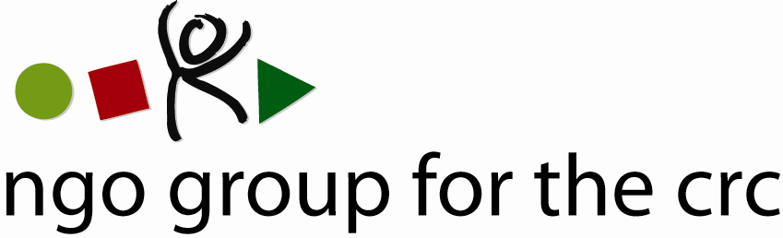

Open-ended Working Group on an Optional Protocol to the Convention on the Rights of the Child, second session, 6-10 December 2010

Compilation of joint oral statements delivered by the NGO Group for the CRC

Joint statement on Articles 3 and 12 of the draft Optional Protocol to the CRC
Delivered on 6 December by Anita Goh, Advocacy Officer of the NGO Group for the CRC

Thank you, Mr Chairman,

This statement is made on behalf of the 77 member organisations of the NGO Group for the CRC.

We welcome the statement made by Serbia and Slovenia and strongly support the inclusion of collective communications in the draft.

Collective communications will complement individual communications by allowing communications that do not require the identification of an individual victim. The delegation of Austria asked for examples of cases where plaintiffs would not come forward through the individual procedure. Mexico mentioned the case of street children, we can also think of victims of sale, victims of child labour, and any other category of children who will most certainly not use the individual communication procedure because of fear of reprisal from those violating their rights or because they do not trust national systems.

Under the collective complaints system of the European Social Charter system, complaints were brought regarding the right to education for children and adults with autism or to ensure that the rules against under-age labour was enforced, particularly work within the family. They did not identify individual victims but concerned identifiable groups of child victims.

To make sure that those categories of children can also have an international remedy if national systems fail them, it will be essential to allow for the actors who hear about those violations, namely the national human rights institutions, ombudspeople and NGOs, to “step in”, so to speak, and bring those issues to the attention of the Committee.

We understand the confusion of many delegations as to the relationship between collective communications and the inquiry procedure. Inquiry procedures are an established procedure to address grave or systematic situations whereas collective communications are meant to cover situations where children may be too vulnerable or victimised to use individual communications. They would moreover serve to develop the Committee's jurisprudence by pointing at implementation gaps.

As pointed out by Liechtenstein, such duplication could be avoided by changing the threshold for collective communications and allow them for those cases where the children will not be able to use the individual communication procedure.

We therefore strongly support the suggestion to change the threshold of Art. 3 to avoid this duplication, as suggested by Liechtenstein.

We agree with Iran and others in that the ECOSOC status is not a valid requirement to allow standing of NGOs and that local and national NGOs that might not have the ECOSOC status because they do not work at the UN level, will be the best placed to know about children's rights violations on the ground.

We would therefore support the deletion of the ECOSOC status requirement in the text.

Thank you, Mr Chairman.

Member Organisations
- 3D Three – Trade, Human Rights, Equitable Economy
- Action for Children and Youth Aotearoa
- African Child Policy Forum
- Anti-Slavery International
- APPROACH Ltd. – Global Initiative to End all Corporal Punishment of Children
- Arigatou International
- Associated Country Women of the World
- Association for Rural Development and Action Research
- Association of Networks for Community Empowerment
- Baha'i International Community
- Child Helpline International
- Child Rights Information Network
- Child Rights Network Switzerland
- Children’s Rights Alliance
- Children’s Rights Alliance for England
- Christian Children's Fund Inc.
- Coalition Against Trafficking in Women International
- Consortium for Street Children
- Defence for Children International
- DevCon - An Association for Rural Development
- ECPAT International
- Education International
- Egyptian Foundation for Advancement of Childhood Conditions
- EuroChild
- European Association for Children in Hospital
- Every Child
- Fédération Internationale des Communautés Educatives
- First Nations Child and Family Caring society of Canada Incorporated
- Friends World Committee for Consultation (QUNO)
- Fundación Privada Intervida
- Human Rights Watch
- Inter African Committee on Traditional Practices Affecting the Health of Women (IAC-HTPS)
- International Alliance of Women
- International Association of Youth and Family Judges and Magistrates
- International Baby Food Action Network
- International Catholic Child Bureau (BICE)
- International Council of Jewish Women
- International Council of Women
- International Falcon Movement Socialist Education International
- International Federation of Social Workers
- International Foster Care Organisation
- International Inner Wheel
- International Institute for Child Rights and Development
- International Movement "ATD Fourth World"
- International Play Association: Promoting the Child’s Right to Play
- International School Psychology Association
- International Social Service
- La Voix de l’Enfant
- Maryknoll Office for Global Concerns
- National Aboriginal Islander Child Care
- National Coalition for the Implementation of the UN Convention on the Rights of the Child in Germany
- Penal Reform International
- Plan International
- Plataforma de Organizaciones de Infancia
- Proyecto Solidario
- Red Latinoamericana de Acogimiento
- Red Latinoamericana y Caribena por la Defensa de los Ninos, las Ninas y los Adolescentes
- Resources Aimed at the Prevention of Child Abuse and Neglect (RAPCAN)
- ROC (The “Right of the Child” NGO)
- Roshni Homes Trust
- Save the Children – Alliance
- Soroptimist International
- SOS-Kinderdorf International
- Terre des Hommes International Federation
- WAO Afrique
- War Child Holland
- Werkstatt Okonomie
- Women's World Summit Foundation
- World Alliance for Breastfeeding Action
- World Alliance of YMCAs
- World Association 0f Girl Guides and Girl Scouts
- World Jewish Congress
- World Movement of Mothers / Le Mouvement Mondial des Mères
- World Organisation Against Torture / SOS Torture (OMCT)
- World Union of Catholic Women's Organisations
- World Vision International
- Young Men’s Christian Association of Costa Rica

See list of members at the end of the statement

