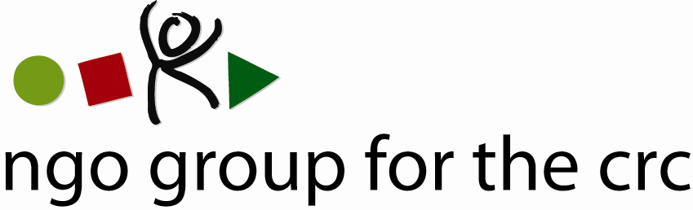

Open-ended Working Group on an Optional Protocol to the Convention on the Rights of the Child, second session, 6-10 December 2010

Compilation of joint oral statements delivered by the NGO Group for the CRC

Joint statement on Articles 4 to 6 of the draft Optional Protocol to the CRC
Delivered on 7 December by Anita Goh, Advocacy Officer of the NGO Group for the CRC

Thank you, Mr Chairman,

This statement is made on behalf of the 77 member organisations of the NGO Group for the CRC.

We strongly support Articles 4 and 6, as currently drafted in the proposal.

Regarding Article 4:

We would like to stress that it will be very important to make sure that all communications can reach the Committee without any time limit, especially in the case of children, who might encounter special obstacles in reaching this procedure and might not be aware of the existence of this international communications procedure within the time limits proposed by some delegations.

While regional courts, such as the European Court, are close to potential complainants and well-known by them, it is clear that international communications procedures do not enjoy the same level of knowledge at the national level.

We are thus concerned that time limits, as the one suggested by some delegations, would in practice limit the access to this communications procedure and would strongly suggest to avoid adding any such limits.

In addition, we would like to recall that regional courts do not have competence to adjudicate cases under the CRC or its OPs. Though regional courts may refer to those international instruments, they are not bound to apply their provisions and therefore, any decision taken by such bodies should not prevent complainants from using the communications procedure we are discussing now.

With regard to exceptions to exhaustion of domestic remedies:
It is the standard practice of other treaty bodies that domestic remedies need not be exhausted if it can be shown that they are “not effective, not available or unduly prolonged”. Article 4 d only recalls those exceptions while recalling the duty of the Committee to interpret them in accordance with the complainant population concerned, that is to say, children.

With regard to the format of the communication:
We support Brazil's approach of reserving this matter for the Committee's rules of procedures. If States were to decide to include that communications should be submitted in writing, we would like to stress that it will be important to not preclude the submission of other types of material.

Regarding Article 5 of the proposal:
The NGO Group fully supports the possibility of interim measures. The point of such measures is to ensure that the right to complain and seek a remedy is not rendered ineffective through irreparable damage to the complainant. This is an essential part of any communications procedure, as without such measures, irreparable damage to the complainant would make the submission of a communication to the Committee useless.

Therefore, in addition to the possibility for the Committee to request interim measures, it will be indispensable to make explicit the requirement for States Parties to implement the interim measures requested.

We thus support the suggestion made by the Committee on the Rights of the Child and Liechtenstein, to expressly include in the text of the OP a requirement that States parties shall take all appropriate steps to implement the interim measures requested by the Committee.

Finally regarding Article 6:
We welcome and support the statements of several States in support for keeping the three months requirement. While we understand the arguments of federal States, it is essential to ensure that the communications procedure is handle in a swift manner both by the Committee and the responding States and to take into account the impact that delays may cause to a child's well-being and development.

With regard to the anonymity of communications:
We agree that in the context of individual communications, States would generally need to know the identity of the victim and we would like to support the suggestions made by several states that also include the possibility of withholding the identity of the victim in exceptional circumstances. We particularly welcome the proposal made by Finland on that matter.

Thank you, Mr Chairman

Member Organisations
- 3D Three – Trade, Human Rights, Equitable Economy
- Action for Children and Youth Aotearoa
- African Child Policy Forum
- Anti-Slavery International
- APPROACH Ltd. – Global Initiative to End all Corporal Punishment of Children
- Arigatou International
- Associated Country Women of the World
- Association for Rural Development and Action Research
- Association of Networks for Community Empowerment
- Baha'i International Community
- Child Helpline International
- Child Rights Information Network
- Child Rights Network Switzerland
- Children’s Rights Alliance
- Children’s Rights Alliance for England
- Christian Children's Fund Inc.
- Coalition Against Trafficking in Women International
- Consortium for Street Children
- Defence for Children International
- DevCon - An Association for Rural Development
- ECPAT International
- Education International
- Egyptian Foundation for Advancement of Childhood Conditions
- EuroChild
- European Association for Children in Hospital
- Every Child
- Fédération Internationale des Communautés Educatives
- First Nations Child and Family Caring society of Canada Incorporated
- Friends World Committee for Consultation (QUNO)
- Fundación Privada Intervida
- Human Rights Watch
- Inter African Committee on Traditional Practices Affecting the Health of Women (IAC-HTPS)
- International Alliance of Women
- International Association of Youth and Family Judges and Magistrates
- International Baby Food Action Network
- International Catholic Child Bureau (BICE)
- International Council of Jewish Women
- International Council of Women
- International Falcon Movement Socialist Education International
- International Federation of Social Workers
- International Foster Care Organisation
- International Inner Wheel
- International Institute for Child Rights and Development
- International Movement "ATD Fourth World"
- International Play Association: Promoting the Child’s Right to Play
- International School Psychology Association
- International Social Service
- La Voix de l’Enfant
- Maryknoll Office for Global Concerns
- National Aboriginal Islander Child Care
- National Coalition for the Implementation of the UN Convention on the Rights of the Child in Germany
- Penal Reform International
- Plan International
- Plataforma de Organizaciones de Infancia
- Proyecto Solidario
- Red Latinoamericana de Acogimiento
- Red Latinoamericana y Caribena por la Defensa de los Ninos, las Ninas y los Adolescentes
- Resources Aimed at the Prevention of Child Abuse and Neglect (RAPCAN)
- ROC (The “Right of the Child” NGO)
- Roshni Homes Trust
- Save the Children – Alliance
- Soroptimist International
- SOS-Kinderdorf International
- Terre des Hommes International Federation
- WAO Afrique
- War Child Holland
- Werkstatt Okonomie
- Women's World Summit Foundation
- World Alliance for Breastfeeding Action
- World Alliance of YMCAs
- World Association 0f Girl Guides and Girl Scouts
- World Jewish Congress
- World Movement of Mothers / Le Mouvement Mondial des Mères
- World Organisation Against Torture / SOS Torture (OMCT)
- World Union of Catholic Women's Organisations
- World Vision International
- Young Men’s Christian Association of Costa Rica

See list of members at the end of the statement.
OHCHR, “23 Frequently Asked Questions about Treaty Body Complaints Procedures”, available at http://www2.ohchr.org/english/bodies/petitions/docs/23faq.pdf

