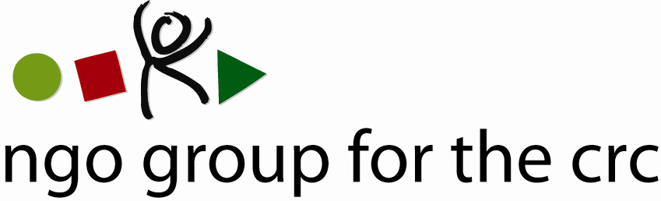

Open-ended Working Group on an Optional Protocol to the Convention on the Rights of the Child, second session, 6-10 December 2010

Compilation of joint oral statements delivered by the NGO Group for the CRC

Joint statement with the International Commission of Jurists on Articles 10 to 14
Delivered on 7 December by Anne-Sophie Lois, Geneva representative of PLAN International

Thank you Mr Chairperson.

This is a joint statement on behalf of the 77 NGOs member of the NGO Group for the CRC and the International Commission of Jurists.

Mr Chairperson,

With regard to Article 10:
Inquiry procedures are a key complementary tool to individual and collective communications and are a standard provision in instruments establishing communications procedures.

We welcome and support the provision of time limits set for the inquiry procedure as stated in Art 10.1, 10.4 and 10.5 (“without delay”, “within three months”). This would ensure a swift communications procedure and avoid any unnecessary delay that would be detrimental to children’s development, especially in the case of “grave or systematic violations”.

With regard to Article 10.6:
We support the position of Liechtenstein. The wording proposed in the draft is indeed agreed language from other similar instruments, such as Article 11.7 of OP ICESCR.

We very much welcome and support the proposals made by France, Liechtenstein, Slovenia and others, to remove paragraphs 7 and 8 of Article 10. A position also shared by the Committee on the Rights of the Child in its comments paper.

This would reflect the best practice enshrined in Article 33.1 of the Convention for the Protection of All Persons from Enforced Disappearances (CED), which does not allow for any opt-in or opt-out but still requires the consent of the States concerned before organising any country visits.

With regard to international assistance and cooperation:
We support Article 14 as it is drafted.

Thank you, Mr Chair.
Member Organisations
- 3D Three – Trade, Human Rights, Equitable Economy
- Action for Children and Youth Aotearoa
- African Child Policy Forum
- Anti-Slavery International
- APPROACH Ltd. – Global Initiative to End all Corporal Punishment of Children
- Arigatou International
- Associated Country Women of the World
- Association for Rural Development and Action Research
- Association of Networks for Community Empowerment
- Baha'i International Community
- Child Helpline International
- Child Rights Information Network
- Child Rights Network Switzerland
- Children’s Rights Alliance
- Children’s Rights Alliance for England
- Christian Children's Fund Inc.
- Coalition Against Trafficking in Women International
- Consortium for Street Children
- Defence for Children International
- DevCon - An Association for Rural Development
- ECPAT International
- Education International
- Egyptian Foundation for Advancement of Childhood Conditions
- EuroChild
- European Association for Children in Hospital
- Every Child
- Fédération Internationale des Communautés Educatives
- First Nations Child and Family Caring society of Canada Incorporated
- Friends World Committee for Consultation (QUNO)
- Fundación Privada Intervida
- Human Rights Watch
- Inter African Committee on Traditional Practices Affecting the Health of Women (IAC-HTPS)
- International Alliance of Women
- International Association of Youth and Family Judges and Magistrates
- International Baby Food Action Network
- International Catholic Child Bureau (BICE)
- International Council of Jewish Women
- International Council of Women
- International Falcon Movement Socialist Education International
- International Federation of Social Workers
- International Foster Care Organisation
- International Inner Wheel
- International Institute for Child Rights and Development
- International Movement "ATD Fourth World"
- International Play Association: Promoting the Child’s Right to Play
- International School Psychology Association
- International Social Service
- La Voix de l’Enfant
- Maryknoll Office for Global Concerns
- National Aboriginal Islander Child Care
- National Coalition for the Implementation of the UN Convention on the Rights of the Child in Germany
- Penal Reform International
- Plan International
- Plataforma de Organizaciones de Infancia
- Proyecto Solidario
- Red Latinoamericana de Acogimiento
- Red Latinoamericana y Caribena por la Defensa de los Ninos, las Ninas y los Adolescentes
- Resources Aimed at the Prevention of Child Abuse and Neglect (RAPCAN)
- ROC (The “Right of the Child” NGO)
- Roshni Homes Trust
- Save the Children – Alliance
- Soroptimist International
- SOS-Kinderdorf International
- Terre des Hommes International Federation
- WAO Afrique
- War Child Holland
- Werkstatt Okonomie
- Women's World Summit Foundation
- World Alliance for Breastfeeding Action
- World Alliance of YMCAs
- World Association 0f Girl Guides and Girl Scouts
- World Jewish Congress
- World Movement of Mothers / Le Mouvement Mondial des Mères
- World Organisation Against Torture / SOS Torture (OMCT)
- World Union of Catholic Women's Organisations
- World Vision International
- Young Men’s Christian Association of Costa Rica

See list of members at the end of the statement
Under the CED, the Committee, if it “receives reliable information indicating that a State party is seriously violating the provisions of [the] Convention”, may, “after consultation with the State party concerned, request one or more of its members to undertake a visit” of the State.

