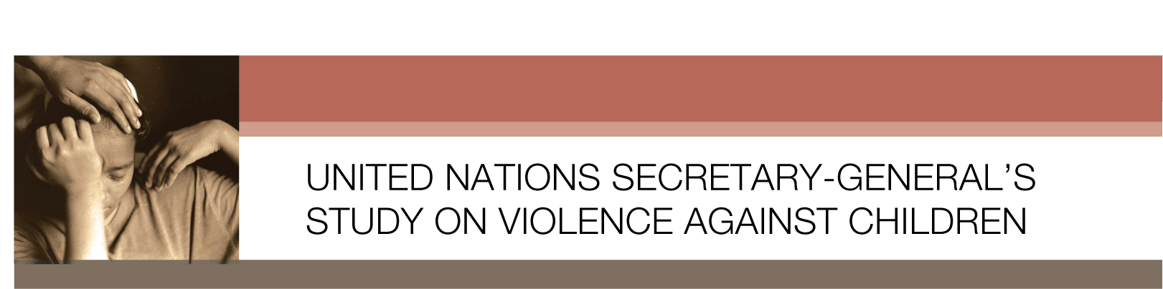

Summary

Key Messages

The key messages of the Study, which are reflected in the recommendations are:
(a) No violence against children is justifiable. Children should never receive less protection than adults;
(b) All violence against children is preventable. States must invest in evidence-based policies and programs to address factors that give rise to violence against children;
(c) States have the primary responsibility to uphold children’s rights to protection and access to services, and to support families’ capacity to provide children with care in a safe environment;
(d) States have the obligation to ensure accountability in every case of violence;
(e) The vulnerability of children to violence is linked to their age and evolving capacity. Some children, because of gender, race, ethnic origin, disability or social status, are particularly vulnerable;
(f) Children have the right to express their views, and to have these views taken into account in the implementation of policies and programs.

Background

The UNSG’s Study on Violence against Children was produced through a consultative process involving nine regional consultations, responses to a government questionnaire submitted directly to the Independent Expert, a call for public submissions, a series of 14 expert thematic meetings on various aspects of the issue, consultation with the Inter-agency Group on Violence against Children, and guidance from an editorial board.

Following the presentation of the Secretary-General’s Study on Violence against Children to the General Assembly in October 2006, the resolution on the rights of the child adopted by the Third Committee of the Assembly (A/C.3/61/L.16) encourages Member States and requests United Nations entities, regional organisations and civil society, including non-governmental organisations, to widely disseminate and follow up on the Study.

The resolution calls on relevant organisations of the United Nations system (19) “to explore ways and means, within their respective mandates, by which they can contribute more effectively to address the need to prevent and to respond to all forms of violence against children”. The resolution also requests the Independent Expert to promote the initial phase of follow-up. During 2007, the Independent Expert will call upon Governments, UN organisations, regional organisations, national institutions, civil society, and other partners to provide inputs to a progress report he will prepare for the 2007 General Assembly.

Implementation

The Study Report calls for implementation of 12 overarching recommendations, complemented by additional recommendations which are specific to each of the settings of home and family, educational settings, institutions for care or detention, the workplace and the community. (More information on these can be found in the full document available at www.violencestudy.org) In particular, the timeframe refers to these being integrated into national planning processes by 2007, including the appointment of a focal point, preferably at ministerial level. Prohibiting violence against children by law and initiating a process to develop reliable national data collection systems should be achieved by 2009. States should provide information on implementation of these recommendations in their reports to the Committee on the Rights of the Child.

The 12 Overarching Study Recommendations

1. Strengthen national and local commitment and action: This refers to establishing a national focal point on violence against children by the end of 2007, to coordinate actions, and especially to ensure that actions to stop violence against children are integrated into national planning processes by 2009.

2. Prohibit all violence against children: This refers to legal reforms including implementation of laws to stop all forms of violence against children, in all settings, including all corporal punishment, harmful traditional practices, such as early and forced marriages, female genital mutilation and so-called honour crimes, sexual violence, and torture and other cruel, inhuman or degrading treatment or punishment, as required by international treaties.

3. Prioritize prevention: This refers to preventing all forms of violence against children in all settings by addressing underlying causes, as well as more immediate risk and protective factors.

4. Promote non-violent values and awareness-raising: This refers to transforming attitudes that condone or normalize violence against children including via public information campaigns which promote non-violent values and protect children in all media coverage.

5. Enhance the capacity of all who work with and for children: This refers to developing the capacity of all those who work with and for children to improve prevention, detection and responses.

6. Provide recovery and social reintegration services: This refers providing accessible, child-sensitive and universal health and social services, including legal assistance to children and, where appropriate, their families.

7. Ensure participation of children: This refers to States and their partners actively engaging with children and respecting their views.

8. Create accessible and child-friendly reporting systems and services: This refers to establishing safe, well-publicized, confidential and accessible mechanisms for children, their representatives and others to report violence against children.

9. Ensure accountability and end impunity: This refers to building community confidence in the justice system by bringing all perpetrators of violence against children to justice.

10. Address the gender dimension of violence against children: This refers to the integral role of gender biases in violence against children, and that States should promote and protect the rights of women and girls and address all forms of gender-based discrimination as part of a comprehensive violence-prevention strategy.

11. Develop and implement systematic national data collection and research: This refers to the urgent need to improve data collection and information systems by 2009, in the context of a national research agenda and agreed international indicators, and with particular reference to vulnerable subgroups.

12. Strengthen international commitment: This refers to States ratifying international treaties and implementing international standards agreed to.

