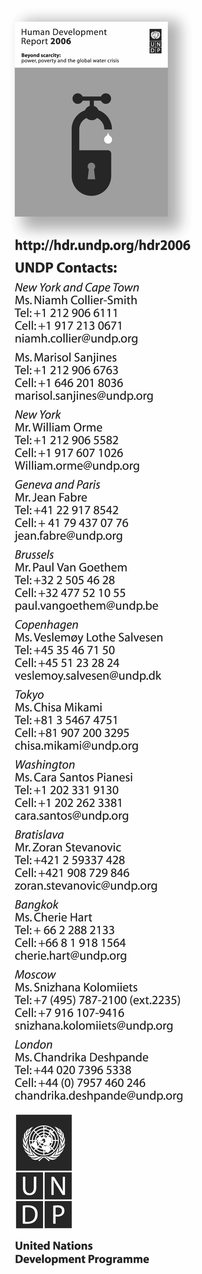
Strictly embargoed until 15:00 Cape Town (13:00 GMT, 08:00 New York) 9 November 2006
Why children die for lack of a toilet
World sanitation crisis causes millions of avoidable deaths,
and contamination from human waste is largely to blame,
says UNDP’s Human Development Report

Cape Town, 9 November 2006—Simply installing a flush toilet in the home increases by almost 60 percent a Peruvian child’s chances of surviving to her first birthday, according to data in the 2006 Human Development Report documenting the often-fatal consequences of inadequate sanitation in developing countries.

The Report shows that the efficacy of human-waste disposal is one of the strongest determinants of child survival around the world. Improving sanitation in the home— advancing from open defecation to using a pit latrine to installing a flush toilet—
reduces overall child mortality by about a third, say the authors of the Report, entitled Beyond scarcity: power, poverty and the global water crisis.

More than 2.6 billion people still lack access to proper sanitation, and 1.1 billion people have no regular access to clean water. As a result, 1.8 million children die from diarrhoea each year, making the disease the second-largest cause of global child mortality, says
the Report.

The toilet may seem an unlikely catalyst for human development, but the Report provides abundant and powerful evidence to shows how it benefits people’s well-being. Research shows that in Peru, access to a flush toilet reduces the risk of infant death by 59 percent, compared with an infant in a household without adequate sanitation. In Egypt, similarly, data show the risk of infant death plummeting by 57 percent in households with toilets.

“ ‘No access to sanitation’ is a polite way of saying that people draw water for drinking, cooking and washing from rivers, lakes, ditches and drains fouled with human and animal excrement,” said Kevin Watkins, head of UNDP’s Human Development Report Office and the report’s principal author. “It means that in slums like Kibera, outside Nairobi, people defecate in plastic bags and throw them into the street because they have no other option.”

The crisis in water and sanitation is—above all—a crisis for the poor. More than 660 million people without sanitation live on US$2 or less a day, and more than 385 million live on $1 or less a day. That said, coverage rates for sanitation are far lower than those for water even in higher-income groups: A quarter of the richest 20 percent of people in developing countries have no access to improved sanitation, says the Report.

The Report lays out the following steps as prerequisites for progress:
- Better political leadership: Leaders need to send a clear signal that sanitation
is part of their national development policies.
- Ensuring public participation is part of national planning.
- Investing in demand-led approaches through which service providers respond
to the needs of communities, with women having a voice in shaping priorities.
- Through innovative financial arrangements or subsidies, extending financial support
to the poorest households to ensure that sanitation is an affordable option.
- Addressing inequality by identifying who has access and who does not. This would include supplementing the current MDG sanitation target with explicit targets for reducing inequalities based on gender, wealth and location.

- Developing a Global Action Plan on water and sanitation to mobilize finance, support developing-country governments’ use of local capital markets, and enhance capacity to act, while also acting as a focal point for public advocacy and political efforts.

Access to basic sanitation is a crucial human-development goal in its own right; for millions of people, the absence
of a safe, private and convenient toilet facility is a daily source of indignity, as well as a threat to well-being. But it
is also a bridge to far-broader human development. The lack of basic sanitation drags down the benefits of access to clean water, and the health, gender and other inequalities caused by a sanitation deficit systematically undermine progress in education and wealth creation, and foster poverty.

Unfit for discussion

Instead of being recognized as the international emergency it is, sanitation is entirely absent from political campaigns and public debate. The realities of open defecation are relegated to backroom politics, and as a result, progress has been glacial, says the Report. The authors point to stigma as one of the greatest obstacles.

The parallels between the stigma of sanitation issues and that of AIDS are both instructive and troubling. Until fairly recently, the Report points out, the cultural and social taboos surrounding HIV and AIDS impeded development of effective national and international responses, at enormous human cost.

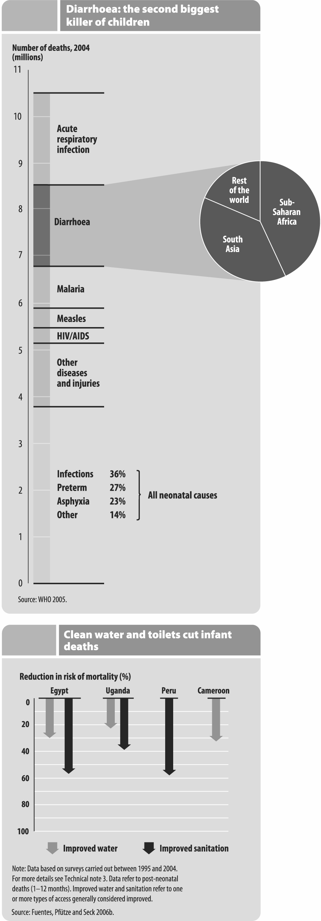
That taboo has been weakening, partly because of the scale of the HIV/AIDS scourge—but also because the condition afflicts all members of society, without regard for social or economic status. Because the crisis in sanitation overwhelmingly targets the poor, its taboo remains stubbornly intact.

Women’s burden

Gender inequality is a second major impediment to progress. Young girls, particularly after puberty, are less likely to attend classes if schools do not
have suitable hygiene facilities, and the authors estimate that about half the girls in Sub-Saharan Africa who drop out of school do so because of poor
water and sanitation facilities.

Studies from Cambodia, Indonesia and Vietnam show that women consistently rank having a toilet high on their list of priorities for a life of dignity and good health, but their voices are seldom heard. Empowering women may be the most effective way to increase demand for sanitation, says the Report.

From the ground up

The Report offers concrete examples of how grassroots action combined
with government leadership can improve sanitation for the poor. In the Orangi slum of Pakistan’s capital, Karachi, near-universal participation in a grassroots sanitation project has helped bring about a drop in infant mortality from
130 deaths per 1,000 live births in the early 1980s to fewer than 40 deaths
per 1,000 live births today.

Ten years ago, Bangladesh had one of the lowest levels in the world of
access to proper sanitation in its rural areas. Despite being one of the world’s poorest countries, it is now on target to achieve nationwide sanitation coverage by 2010, thanks to a ‘total sanitation campaign’ promoted by NGOs and
local authorities. The campaign appeals to three drivers of change: disgust,
self-interest and a sense of individual responsibility for community welfare. The same approach is now being employed in Cambodia, China, India
and Zambia.
The report stresses, however, that while community-led initiatives are critical, they are not a substitute for government action.

What needs to happen?

The biggest barrier in sanitation, the authors conclude, is the unwillingness of national and international political leaders to put the growing crisis on the international development agenda. Tackling the problem requires greater awareness of the real costs—not just to poor people, but to societies as a whole—of ‘no access to sanitation,’
the Report says, arguing for wider recognition that sanitation is a basic human right.

* * * *

BROADCAST FOOTAGE ON THE 2006 HDR IS AVAILABLE under embargo from Wednesday,
1 November at http://hdr.undp.org/hdr2006/media. For broadcast enquiries, please contact Boaz Paldi, boaz.paldi@undp.org, +1 917 213 7520.

ABOUT THIS REPORT: The Human Development Report continues to frame debates on some of the most
pressing challenges facing humanity. It is an independent report commissioned by the United Nations Development Programme (UNDP). Kevin Watkins is the Lead Author of the 2006 report, which includes special contributions
from UK Chancellor Gordon Brown, Nigeria’s former Finance Minister Ngozi Okonjo-Iweala, President Lula of Brazil, Former US President Jimmy Carter, and UN Secretary-General Kofi Annan. The Report is translated into more than a dozen languages and launched in more than 100 countries annually. Further information can be found at http://hdr.undp.org/hdr2006. The 2006 Human Development Report is published in English by Palgrave Macmillan.

ABOUT UNDP: UNDP is the UN's global network to help people meet their development needs and build a better life. We are on the ground in 166 countries, working as a trusted partner with governments, civil society and the private sector to help them build their own solutions to global and national development challenges. Further information can be found at www.undp.org

