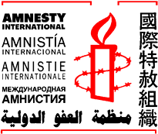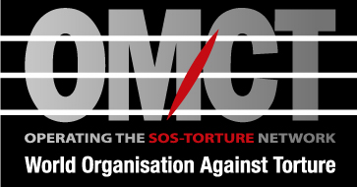
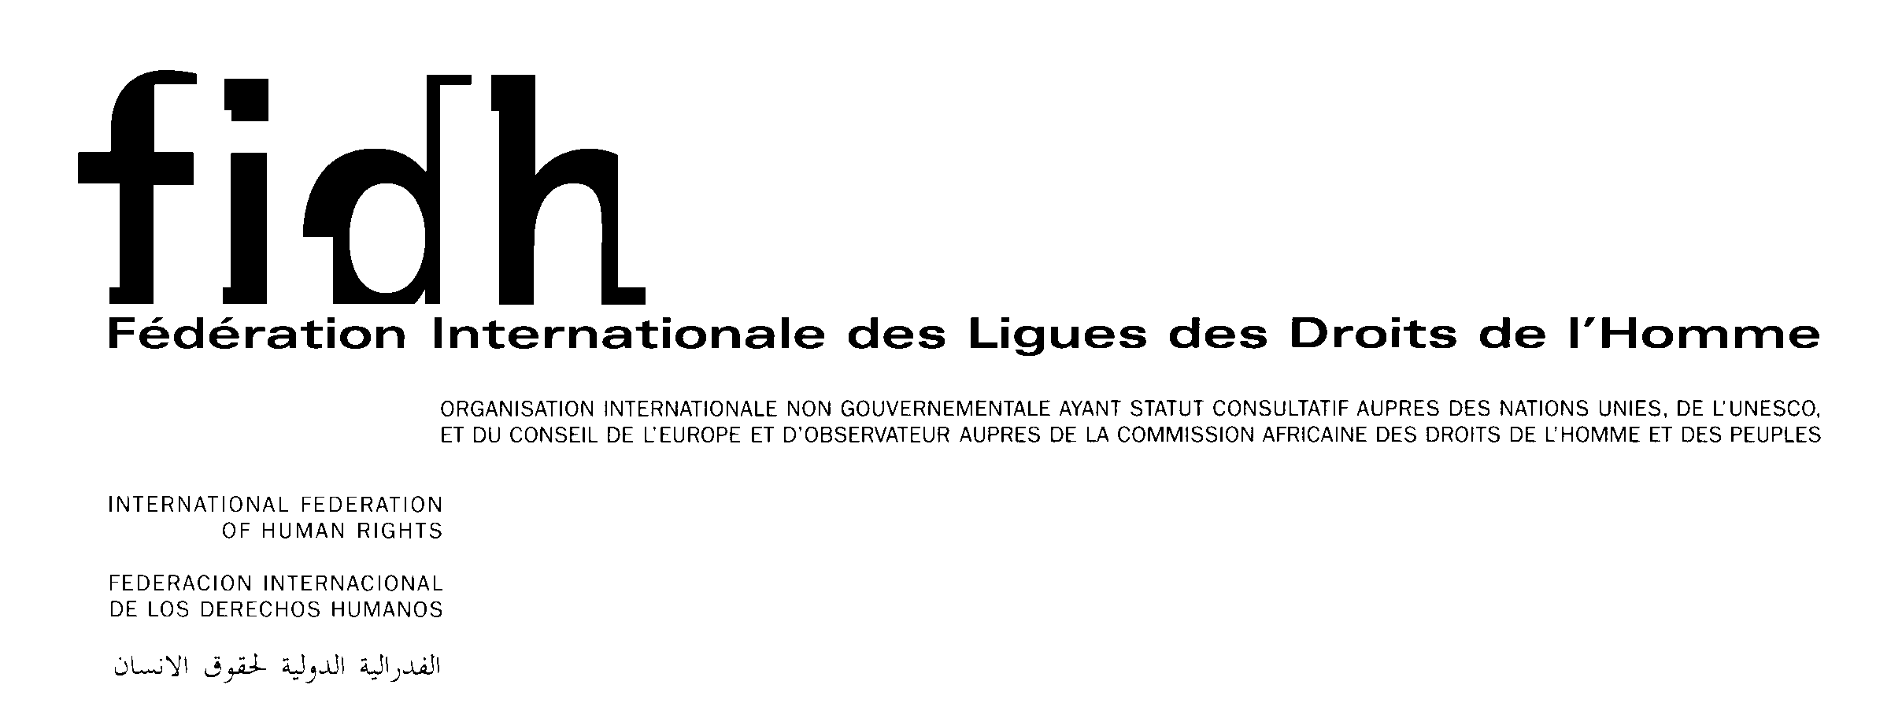
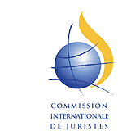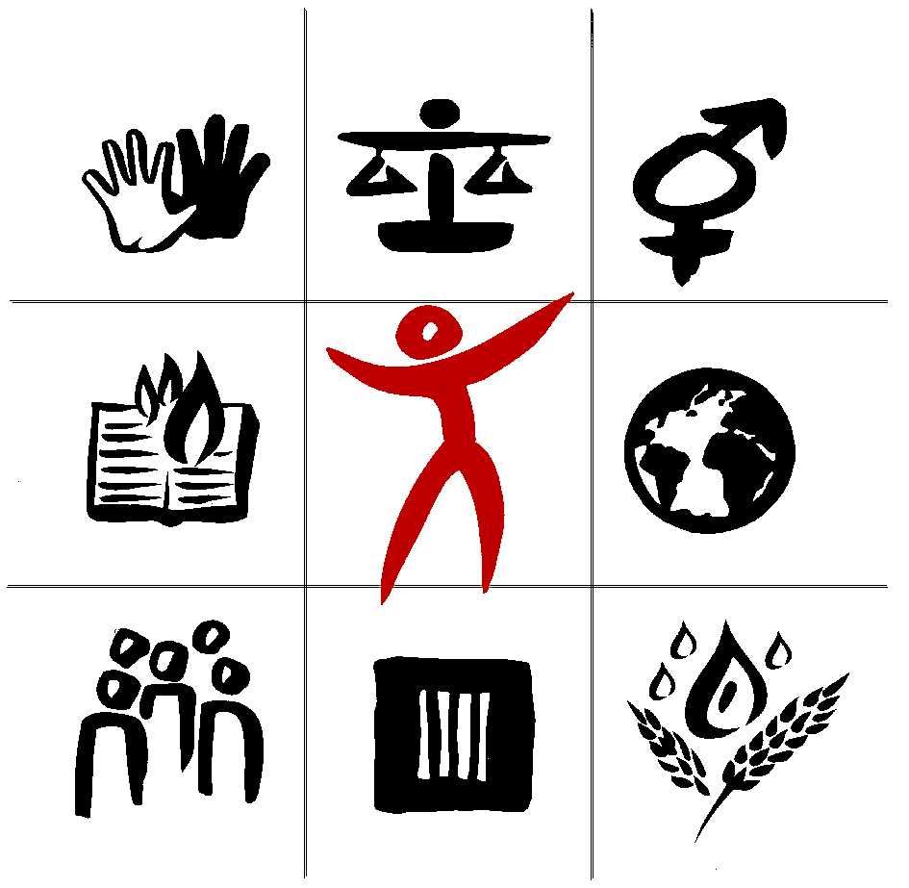

Joint statement by Amnesty International, International Commission of Jurists, International Federation of Human Rights, International Service for Human Rights, Human Rights Watch and the World Organisation Against Torture on the Progress report of the Working Group on the Universal Periodic Review (UPR)
Geneva, October 2, 2006
The Universal Periodic Review is among the most important innovations associated with this new Council. If properly designed, the review will help remedy the selectivity problems that beset the Commission on Human Rights and provide an effective foundation for much of the Council’s work. We consider that the Universal Periodic Review must be a continuous process with distinct stages: preparation by independent experts, the interactive dialogue itself, and response by the Council to the outcome of the review, and follow up to the recommendations arising from the review. Here we will address three elements that would be critical for the success of this process:
- Independent expert review and synthesis of the available country-specific information to distill this material into a list of key issues for review and questions to be addressed by the government in the review;
2. An outcome for each review with concrete conclusions and recommendations and an agreed procedure to ensure effective follow up, and
- A substantive role for NGOs, including the possibility to submit information for consideration, and to participate in the interactive dialogue with the state under review.
Independent expert analysis during the preparation of each review is essential to facilitate a substantive and well-informed interactive dialogue. The participation of independent experts would also significantly contribute to a consistent and objective process for every state and be an important safeguard against efforts at politicization.
Each UPR review should have a concrete outcome, to which the state reviewed should be afforded the opportunity to respond. In addition to findings, the outcome could propose a range of measures, including recommendations to provide capacity-building and technical assistance, calls for visits by special procedures; establishment of an OHCHR fact-finding mission or field office; or appointment of a country-specific Rapporteur. The outcome might also be to keep a country under review before the next universal periodic review of the state; to recommend that the Security Council consider the situation given its potential impact on international peace and security or the application of the Responsibility to Protect of the international community; or to recommend that the General Assembly suspend a Council member for gross and systematic violations of human rights.
Information from non-governmental organizations should be included in the dossier to be examined in the expert analysis. National and international NGOs with substantial knowledge of the situation in the reviewed state, regardless of ECOSOC accreditation, must have the opportunity to contribute to the review. NGOs should also be afforded an opportunity to comment and ask questions during the interactive dialogue session.
Mr. President
Our organizations have noted and share the importance attached by the International Women's Rights Action Watch Asia Pacific to the objective of the Council using the UPR to encourage the fulfillment of states' obligations and commitments to respect women's human rights.

