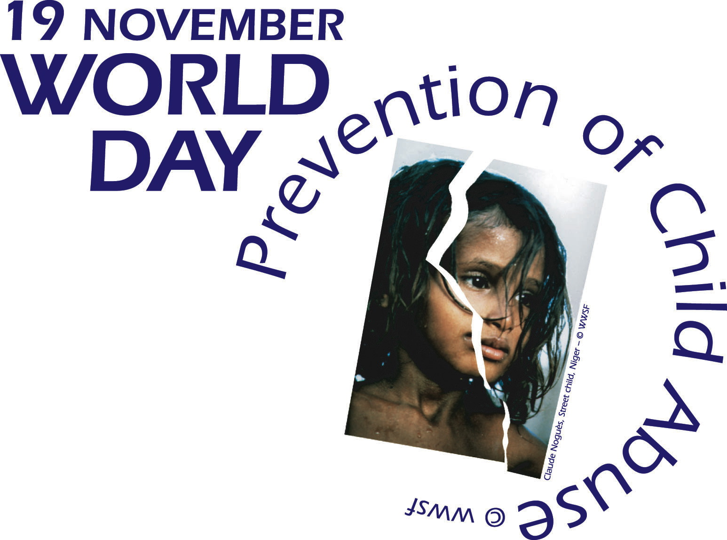
World Day for Prevention of Child Abuse

Friday, 18 November 2005
Palais Wilson, 52 Rue des Pâquis, 1201 Geneva
Entry free. Registration is obligatory for security reasons at the Palais Wilson,
Office of the UN High Commissioner for Human Rights

Conference - Debate / Betty Makoni Prize* - Award Ceremony

“Progress in preventing child abuse - Annual Review IV”

Preliminary Program

17h15 Opening
Micheline Spoerri, Geneva State Counselor – President DJPS (tbc)
Message from the High Commissioner for Human Rights
Welcome: Elly Pradervand, WWSF Executive Director
Report on international coalition: Laure Maitrejean, WWSF Co-ordinator - Children's Section

17h45 Betty Makoni Prize - Award Ceremony
Honouring four laureate organizations from around the world for innovative prevention activities

18h00 Presentations - Debate
 Prevention in Switzerland
- Prevention in Geneva Schools, Dr. Paul Bouvier, Service de Santé de la Jeunesse - Geneva
- Prevention via education, Ms. Andrea Burgener Woeffray, Kinderschutz Schweiz
- Prevention by groups of professionals, Mr. Georges Glatz, Département des Institutions et des relations extérieures - Lausanne
- Public campaigns for prevention, Béatrice Geissbuhler, Marche Blanche
- Prevention on Internet, Ms. Tiziana Belucci, Action Innocence Genève

 Prevention at the regional, international and United Nations level
- Prevention via the theatre, Sylvie Hervé, “Chimères” - France
- Global prevention campaigns, Kimberly Svevo, International Society for Prevention of Child Abuse and Neglect, ISPCAN (tbc)
- Prevention in church programs, Ben Remos, World Council of Churches
- Violence prevention in schools, UNESCO (tbc)

19h30 Reception / Interviews

Interpretation French/English

All participants are requested to present an Identity Card at the entry of the Palais Wilson for security reasons.

*Prize Betty Makoni
Betty Makoni is a remarkable child rights advocate in Zimbabwe. Herself victim of abuse in her childhood, she used her experience to fight against all forms of child abuse and founded in 1998 the Girl Child Network which includes today 155 clubs and offers various training programs including prevention of child abuse to thousands of girls. Known as an outstanding community leader in her country, Betty has so far protected and rehabilitated more than 20'000 girls, victims of rape, early marriages, genital mutilation and other forms of sexual abuse. Naming the Prize after her, honours Betty Makoni’s exceptional commitment to child abuse prevention.
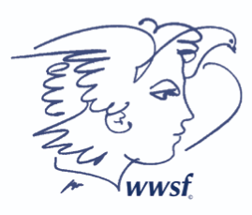

Organisation: WWSF Women’s World Summit Foundation / Fondation Sommet Mondial des Femmes
11 Avenue de la Paix, 1202 Geneva, Switzerland
Tel.: +41 22 738 66 19 / Fax: +41 22 738 82 48 / E-mail: wdpca@wwsf.ch / Internet: www.woman.ch

