Aftermaths of War for Children: Georgia

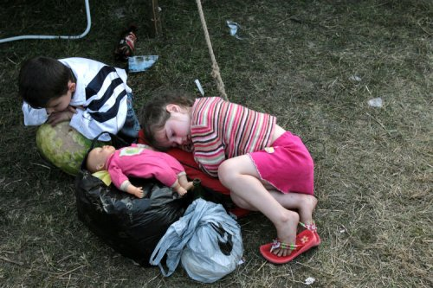

Office of the Public Defender.
Child’s Rights Centre.
Georgia

2008

The war destroys the life of the people involved in it,
especially, that of old and disabled people and women.

But nevertheless, the most painful blow comes on the
country by mutilating the future generations
physically and spiritually.

The war that started on the territory of Georgia on August 7, 2008 caused 128 100 internally displaced people.

“This conflict has been a disaster for civilians,” said Rachel Denber, Europe and Central Asia deputy director at Human Rights Watch. “An international security mission should be deployed to help protect civilians and create a safe environment for the displaced to return home. And international organizations should also send fact-finding missions to establish the facts, report on human rights, and urge the authorities to account for any crimes.”

Growing humanitarian crisis also indicate the urgent need for the deployment of a mission to enhance civilian protection.

Among displaced people 33 360 are children. Only in Tbilisi 1800 of them are under age 2.

The number of displaced children on the other side of the conflict is unknown to us.

These children have experienced all the horrors that war can bring. Most of them need psychological aid as this was especially traumatic for them.

They were there when their villages were being bombed, they saw how their houses were burning, and their parents, neighbours and relatives dying; they fled from home and kept walking during 4-5 days through forests and burnt deserted villages, seeing dead people on their way.

One minor escaped together with his neighbours. His house was burning and father put him into the chimney and he escaped from the roof. Thus father saved him but himself died together with the rest of the family - wife and another son.

The 11 years old minor from the poor family died in his home yard when the city of Gori was bombed.

While traveling in bombed city of Gori we saw many horrible scenes and this is one we remember most of all: a burnt house, an old woman sitting in a half-burnt armchair in front of the house, a man, standing beside her and a coffin close to them; children are playing nearby…

The Child’s Rights Centre of the Public Defender was aware of the conflict aggravation much earlier before its manifestation: the Centre has organized children’s educational-entertainment summer camp, where the children from different regions of Georgia were spending their holidays. On August 3 we received a phone request from the local authorities of the Georgian villages of South Ossetia to prolong stay of the children from their region as the situation there has become tenser and they worried for children. They even asked us to receive some more children. Later they’ve changed the decision: after the camp was over we distributed the children from South Ossetia to other places.

The displaced 70 years old lady of Mordovian origin escaped from the village Kurta and kept walking 4 days together with 94 year old neighbour and 78 year old disabled husband. On her way to Tbilisi she saw completely burnt down villages, scenes of looting, killed people lying on the ground; and the whole family among them: parents and two minors about 9 and 11 years old.

We posses no exact statistical data yet of children died in this war…

Now part of the displaced people is returning back home and this is no less dangerous than it was to be there during the attack.

Human Rights Watch researchers saw and photographed unexploded submunitions from cluster munitions in and around the villages in the Gori district of Georgia. There are hundreds of unexploded submunitions in the area. Submunition “duds” explode if picked up or otherwise disturbed.

Cluster bombs are indiscriminate killers that most nations have agreed to outlaw, Marc Garlasco, senior military analyst says.

Highly dangerous unexploded bomblets now litter farms, roads and pathways in the villages. “People remaining in these areas don’t realize the dangers these submunitions pose and are at serious risk of injury or death if they handle, or even approach, the bomblets”, Garlasco says.

For other internally displaced people going back home is yet impossible. They are located in camps, public schools, kindergartens. Their living conditions are inappropriate.

Many European and American countries have rendered the humanitarian assistance to the displaced children.

As for the governments of Ukraine and Poland they did what these children mostly need – they will visit these countries and spend the time with their hosts – Ukrainian and Polish children.

The Public Defender of Georgia, together with other state authorities and non-governmental sector coordinates the humanitarian provisions and psychological aid for displaced children as our aim is to provide the child’s welfare.

The future generations of this small world should live together in peace.

In this direction a leading role belongs to the ombudspersons for children.

The Public Defender of Georgia and the Child’s Rights Centre of his office appeals to you, all the ombudsmen of Europe to participate intensively in the process of returning these children to the worthy life, despite of their ethnic origin and which side they belong to.

