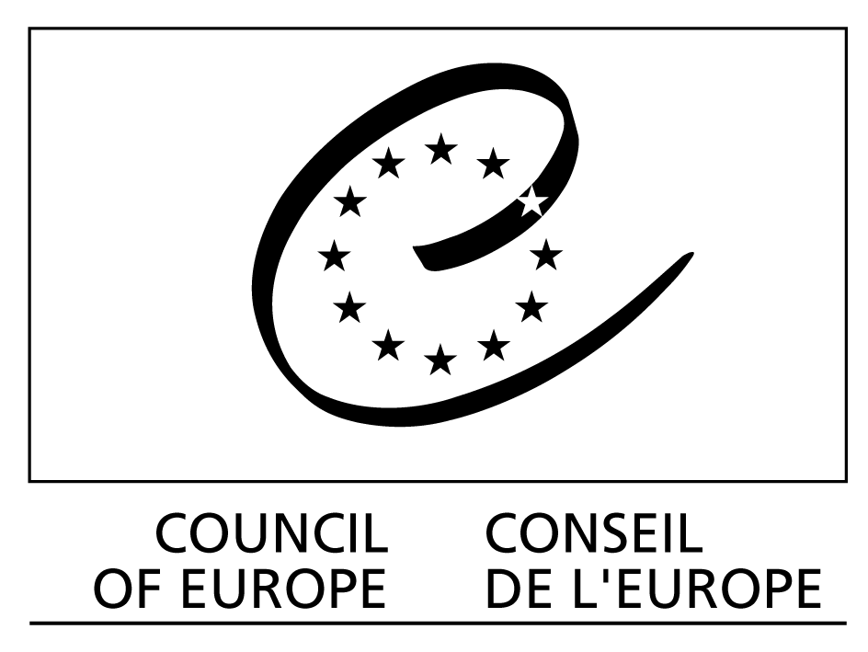

Construire une Europe pour et avec les Enfants

building a Europe for and with Children

Ref : Children (2006)1

Strasbourg, 15 February 2006

Building a Europe for and with Children

Launching conference

Monaco, 4-5 April 2006

INFORMATION DOCUMENT

Document drafted by the Secretariat of the Programme

I. Building a Europe for and with Children Programme (2006-2008)

The programme “Building a Europe for and with children” is being implemented further to the Third Summit of Heads of State and Government of the Council of Europe (Warsaw, May 2005). It is a response to both the mandate assigned to the Organisation to guarantee an integrated approach to promoting children’s rights and the decision to launch a three-year action programme covering the social, legal, educational and health dimensions of the various forms of violence against children.

The objective of the programme “Building a Europe for and with children” is to help decision makers and all players concerned to implement general awareness-raising, information and prevention policies with an eye to the effective respect and promotion of children’s rights in general and, in particular, of their right to protection against any form of violence.

This programme comprises two closely linked strands: the promotion of children’s rights and the action programme “Children and violence”.

Promoting children’s rights

The member states of the Council of Europe have entered into numerous commitments under general human rights conventions and specific conventions on children’s rights and their protection against all forms of violence. These texts include the European Convention on Human Rights, the revised European Social Charter and the United Nations Convention on the Rights of the Child. Furthermore, the Council of Europe has adopted a wide range of conventions and recommendations directly or indirectly relevant to children.

The programme will endeavour to help states effectively to honour their commitments by assisting them in devising integrated children’s policies, establishing the requisite structures, developing networks and producing tools and working methods, as well as resources for informing, training and raising the awareness of the general public and the players directly concerned. Special attention will be paid to the participation and consultation of children and their access to information.

This project is geared not only to implementing the existing legal instruments but also to developing new standards where the law is ambiguous or incomplete. Our primary ambition is to remove discrepancies between the texts and the real-life situation.

Action programme on “Children and violence”

This project concerns combating violence against children by implementing integrated prevention policies and alerting professional circles and the general public to the problem. It is based on four pillars (the “four Ps”): protection of children, prevention of violence, prosecution of criminals and participation by children.

In pursuing the objectives of this programme we shall be formulating instruments and methodologies suited to the different places or types of violence (family, school, resident institutions, the community, media, sexual exploitation and abuse). The main priority will be to draw up recommendations for implementing national and local integrated prevention policies and strategies.
Particular attention will be paid to very specific types of violence against children, namely violence that remains concealed behind a wall of silence or taboos (notably sexual abuse and corporal punishment) and the new forms of violence stemming from the use of the new information technologies (pornography on the Internet and harassment via mobile phones).

All Council of Europe bodies and departments will be involved in pursuing the objectives of the programme “Building a Europe for and with children”. We are hoping to ensure coherency among all the projects on children in the Organisation’s programme of activities in order to secure an integrated policy at Council level too.

Partnerships with the United Nations specialised agencies, the European Commission, non-governmental organisations (NGOs) and professional networks will be reinforced and consideration given to opening up to the private sector.

II. Launching conference (Monaco, 4 and 5 April 2006)

The launching conference held in Monaco at the invitation and with the support of the Government of the Principality has two aims.

Firstly, we would like to experiment with a forum that is open to all the main players involved in children’s policies and to the children themselves. Where the governments are concerned, representatives of the relevant ministries (particularly education, health, social affairs, youth and justice) will be invited to set out their priorities and difficulties in implementing their policies. The debate on promoting and protecting children’s rights will be enriched with contributions from local authorities, parliamentarians, international (governmental and non-governmental) organisations, the private and voluntary sectors, as well as independent experts. Children will have an active part to play in all the work, helping us to find better ways of informing them, consulting them and involving them in decision making throughout the programme.

Secondly, we are hoping to identify priority activities and the necessary partnerships for eradicating violence against children. By selecting two difficult subjects (sexual abuse and corporal punishment) we are hoping to break down the wall of silence surrounding violence against children and in so doing launch the effective implementation of the action programme “Children and violence”, initiated in the wake of our Third Summit of Heads of State and Government.

The conference will be preceded, on 2 and 3 April, by a seminar. Around 20 children and young people will be attending to prepare their contributions to the debates.

III. Conference themes and working methods

In addition to presenting and discussing the overall programme, the two dimensions “promoting children’s rights” and “children and violence” will be addressed in greater depth in the discussion on the four themes:

- Promoting children’s rights, information and awareness-raising: introducing a European strategy. In order to involve all public and private players, conference participants will be presented with proposals for a coherent pan-European strategy;

- Participation by children: guaranteeing access to information and developing consultation procedures. Participants will be invited to consider the methodologies and experiments being developed in various countries in order to highlight recommendations to be implemented under the programme. The children attending the conference will have a frontline role to play in this debate, informing us of their analysis of the situation and their suggestions;

- Combating sexual abuse of children in the cyber-era. Fighting sexual exploitation and abuse of children has been a Council of Europe priority for more than 10 years. With the development of new technologies such as the Internet and third generation (3G) mobile phones, criminals have found new ways to exploit children. This conference will discuss these new problems, and will examine international legal instruments designed to protect children against sexual abuse and assess their ability to meet these new challenges;

- Towards a Europe free of corporal punishment: priorities and strategies. Eradicating all forms of violence against children is a central objective of the overall programme. The conference should pinpoint the action that will be needed in the coming years in order to achieve the effective abolition of corporal punishment.

The working methods scheduled for the conference stress participation by children and interaction among participants. A Round Table is planned for each of the four main themes. This exchange will involve two children, one government representative, one parliamentarian and one private or voluntary sector representative. The subject will be introduced by a person well-known for his or her expertise and commitment. A chairperson will call on members of the round table to speak on the questions arising from the introductory report and queries from the audience. A rapporteur will draw up a summary of the discussions, to be presented at the end of the conference.

The working languages of the conference will be French and English.

IV. Participants

Participants at the conference will be the following:

- Member state delegations. Delegations from Council of Europe member states should not exceed a maximum of five members. States are invited, when deciding on the membership of their national delegation, to ensure the involvement of all the ministries or national bodies concerned, and also one national NGO working in this field, possibly including youth organisations.

- Members of the Council of Europe’s Parliamentary Assembly and the Congress of Local and Regional Authorities.

- A group of some twenty children and young people.

- Representatives of intergovernmental organisations.

- Representatives of civil society. In addition to the NGOs included in the national delegations, the main international non-governmental organisations (INGOs) working in this field will also be invited to the conference.

- Independent experts and representatives of the relevant professional networks.

- Entrepreneurs interested or involved in promoting children’s policies.

Conference venue

The conference will be held at the Grimaldi Forum, 10 Avenue Princesse Grace, 98000 Monaco, on 4 and 5 April 2006.

