CHILD BUDGET WORK IN INDIA: HAQ’s EXPERIENCE

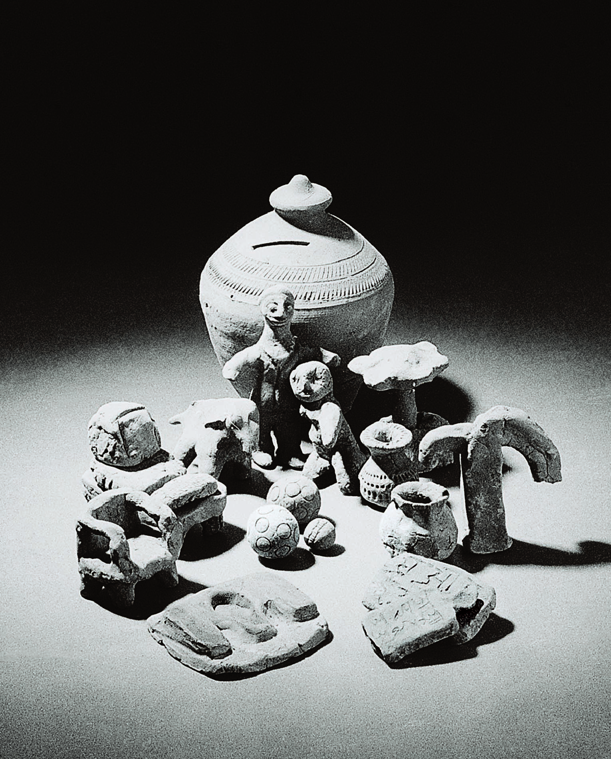

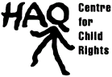

HAQ: Centre for Child Rights
208, Shahpur Jat, New Delhi-110049. Ph: 91-11-26490136
Tel fax: 91-11-26492551 E-mail: haqcrc@vsnl.net, haq.centreforchildrights@gmail.com
Web: www.haqcrc.org
HAQ: Centre for Child Rights works towards the recognition, promotion and protection of rights of all children. Although active since 1998, it was formally registered under the Societies Registration Act in June 1999. The organisation has grown out of the recognition of the need for building and strengthening a child rights movement in India. In doing so, HAQ’s emphasis is on the need to look at the CHILD in an integrated manner and fill the conceptual and practical gaps, making crosscutting linkages between different categories of children and issues affecting them. At HAQ we believe that child rights and children’s concerns have to be mainstreamed into all developmental planning and action, and must also become a core developmental indicator.

Inherent in HAQ’s work is the monitoring of the state performance in the realisation of the rights of all children through the laws, policies and governance systems it sets up to achieve the same. Child Budget analysis is an important tool for monitoring government’s commitment towards its children.
Child Budget Analysis: HAQ’s Initiative

The child budget work in India began in 2000 with HAQ: Centre for Child Rights taking on a decadal analysis of the Union Budget. Such initiatives in budget analysis were already being undertaken in the country at state level with respect to Dalits, tribal and rural development etc. However the focus on children was missing from any such analysis.

The decade of the 1990s marked many changes for India and its children. While India made some significant commitments towards ensuring children their basic rights, it also launched the "era of globalisation". Both these had an impact on children’s lives. On the one hand there has been progress in the overall indicators, with the lowering of infant mortality rates, increase in child survival, increase in literacy rates and fall in school drop-out rates. At the same time the issue of 'Child Rights' in India today, is facing the dichotomy between India's commitment to its children and the process of globalisation.

India ratified the Convention of the Rights of the Child (CRC) in 1992. The 90s was also the decade that saw several new initiatives for children in the wake of global and regional commitments. On 19 March 1997 India submitted its first report to the UN Committee on the Rights of the Child. The Committee’s Concluding Observations had stressed on the need for the State Party to take all necessary measures, including allocation of required resources (i.e. human and financial) and ensure appropriate distribution of resources at the central, state and local levels, and where needed, within the framework of international co-operation. It felt that the State Party should develop ways to establish a systematic assessment of the impact of budgetary allocations on implementation of child rights and to collect and disseminate information in this regard.
HAQ’s report, India’s Children and the Union Budget, was released in September 2001.

It was therefore felt that a decadal analysis would enable us to get a more comprehensive picture of government’s commitments to children and how they were being translated into financial commitments. HAQ’s report, India’s Children and the Union Budget, was released in September 2001. This was the first phase of our work. Since then HAQ has been undertaking child budget analysis every year (see www.haqcrc.org).

While the experience of undertaking the decadal analysis helped HAQ gain an understanding of the process of budgeting and develop a methodology for analysis, it was limited in its scope as it concentrated only on the Union Budget. Since a large share of the allocation and expenditure is made in the states, a study of the state budgets is necessary to enable a holistic understanding.

The Union of India comprises of 28 States. Each State government formulates its own budget. A State budget consists of allocations it makes on its own and what it receives from the Union or Central Government. The States are the main implementing agency of the programmes and schemes. Any understanding of the children and budgets would therefore remain incomplete without undertaking child budget work in the States. Over the years the methodology is being tested and fine-tuned.
Child Budgeting as Government’s Mandate

“After gender, the next logical step for the Department of Women and Child Development as a nodal Department for women and children is the analysis of public expenditure on children…. A pioneering effort was made by HAQ: Centre for Child Rights, in their publication ‘India’s Children and the Union Budget” (Annual Report, DWCD.2002-2003 pg. 143).

“…. The approach adopted was broadly based on the pioneering effort by HAQ Centre for Child Rights. This initiative has been continued in 2004-05” (Annual Report, DWCD. 2004-05. pg.114).

“The analysis presented in this report… Pioneering work in this area by HAQ: Centre for Child Rights is also acknowledged.” (Annual Report 2005-06, Ministry of Women and Child Development, Government of India, pg. 131)

Recognising this, in 2002, HAQ decided to undertake Child Budget work in three sample states (Andhra Pradesh, Himachal Pradesh, Orissa). In 2005, two more states, Uttaranchal and Jharkhand were added. Work has also started in Uttar Pradesh, West Bengal and Assam in 2006. In all these States, HAQ works with partner organisations that it supports to undertake child budget analysis. This ensures that the capacities of state level organisations are built. The partners also carry the advocacy around the analysis forward at the local level.

The success of HAQ’s child budget work lies in the recognition it has received from the Government of India. Following, HAQ’s report in 2001, Government of India undertook child budget analysis for the first time in 2003, drawing upon HAQ’s methodology. In October 2005, the Government of India announced that it would be undertaking child budget work in the Centre as well as the States, just as it would undertake gender budgeting. Child Budgeting has since been also included in the Government’s National Plan of Action for Children (2005).

Using Child Budgets for Advocacy: How can it be effective?

The Child Budget analysis can be used by groups undertaking the analysis on their own or by others who work with children, as a tool for monitoring State commitment, advocacy for changing allocation and expenditure patterns and holding government accountable. Child rights groups and campaigns are using HAQ’s reports for their own advocacy. The findings have been used to write the last shadow report to the UNCRC Committee as well as make a demand for allocation of adequate financial resources in the election manifestoes of political parties in the 2004 General Elections and drafting of plans for the government.

Budget analysis is only one of the tools for monitoring government performance and ensuring state accountability. It cannot be the only tool. While undertaking child budget work HAQ has been acutely aware of this. HAQ’s Children and Governance Programme has shown that child budget analysis is an even more effective as tool for monitoring and advocacy, when it is backed by other initiatives such as a situational analysis of children in the country, the monitoring of legislative and judicial performance of the government, and that is what HAQ is engaged in today.

