Supplementary Report on the State Report
of the Islamic Republic of Iran about CRC
June 2004

Society for Protecting the Rights of the Child in Iran (SPRC)

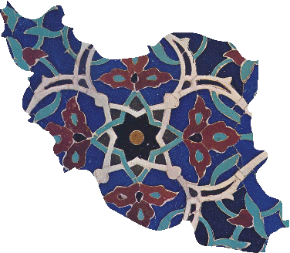

Iran in the World
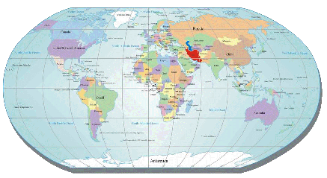

Iran in the region
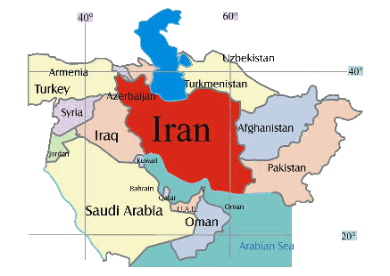

Iran
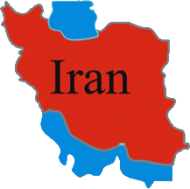

Introduction
Iran is a geopolitically significant country with an area of 1,648,195 square kilometers, having a great variety of geographical and climatic differences. The population of Iran includes a great range of traditional, tribal to modern life styles.

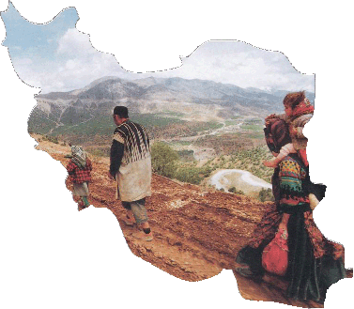

Three-fourths of the population of about 70 millions is under 30 years of age, among which are 18,000,000 school-aged children. So, the issue of children is crucial for the future of the nation.
Contents

- A few general comments on the first periodic report of the I.R. of Iran
- Cluster I. General Measures of Implementation
- Suggestions for Implementation
- Cluster II. Definition of the Child
- Suggestions for Implementation
- Cluster III. General Principles
- Suggestions for Implementation
- Cluster IV. Civil Rights and Freedom
- Suggestions for Implementation
- Cluster V. Family Environment and Alternative Care
- Suggestions for Implementation
- Cluster VI. Basic Health and Welfare
- Suggestions for Implementation
- Cluster VII. Education, Leisure and Cultural Activities
- Suggestions for Implementation
- Cluster VIII. Special Protection Measures
- Suggestions for Implementation
A few general comments on the first periodic report of the I.R. Iran:

- The report does not include the two suggested opening clusters, i.e. I. General Measures of Implementation, and II. Definition of the Child, which are both crucial for the evaluation of implementation reports.

- The report is mainly descriptive and less technical.

- Although the report highlights the efforts undertaken, there exists a great gap between these efforts and the huge variety and extent of the factual needs of the children in Iran, e.g. children working on the streets, needs for pre-schooling, problems of single mothers, etc.

- The report reflects overlaps between accomplished attempts and running projects along with future plans.

- In general, legal aspects of the situation of children in Iran are mainly affected by inefficiency and in congruence with laws and regulations, e.g. definition of the child, child-unfriendly nature of some laws (e.g. the absolute ownership status of the father), on one hand, and lack of adequate executive and effective monitoring of existing laws, e.g. compulsory, free-of-charge primary education, or the choice of the more liable parent for custody, which though legislated in year 2000, is still practiced occasionally.

- NGO movement with child/mother objectives in Iran is not reflected in the report; there are tens of NGOs, working voluntarily in different areas of child issues.
Cluster I. General Measures of Implementation

- The ratification of CRC in Iran has been along with reservations. There is no clarification of either the extent or the contents of those reservations. This situation makes the evaluation of the article 4 (implementation obligations) not attainable.

- In spite of some visible governmental attempts to make the convention widely known, they do not seem to be satisfactory. These attempts are not yet strong enough to create awareness raising in the public.
Suggestions for Implementation:

- The extent of the reservations should be clarified.

- Reports should refer to accomplished steps. Running or future projects can be attached to the report as appendices.

- The state should specify probable examples of article 41.

- A high commission for coordination and monitoring of the implementation attempts is still missing. (UNICEF has been supporting the cause.)

- A powerful steering committee should be planned and put into force.

- Regional and social need assessments should determine priorities.
Cluster II. Definition of the Child

This cluster is not dealt with in the state report, although it is one of the main issues of concern about CRC implementation in the country.

Childhood ends at 9 for girls and at 15 for boys.

- Although a good achievement has been attained (2003) about raising the minimum age for marriage (from 9 to 13 for girls, while still 15 years for boys) this age is still very low and yet the father of the girl can obtain extra permission from a court and reduce the age down to 9 at his own wish.

- For different areas of life, the maturity concept differs: marriage at 13 for girls, right to vote at 15 for both sexes, getting a driver’s license at 18, liability for violating the law at 9 for girls, whereas this same girl needs a written permission from her father if she wants to marry at any given age, even 40 years of age.
Suggestions for Implementation:

- Clarification of the definition of the child^{(* )}

- Abolition of the vast differences in age of maturity between the two genders. ^{(**2)}

- ^{(**1) & (**2)} are delicate areas of concern, because of “Sharia”, but “Shia” allows different interpretations of maturity – which already some higher clericals refer to.
Cluster III. General Principles

As referred to article 2, we can identify at least 2 groups of discriminations: social-regional, and gender-based.

- Due to the natural environment, size, and diversity of the country, there are some poverty stricken and deprived regions in the country – according to an official statistical report of the ministry of health (year 2000), which has been supported by UNICEF and some other UN agencies, up to 50% of the births (in at least 3 states out of 29, and in some rural areas) are undertaken by non-experts, the consequences of which on survival, health and development are obvious.

- Gender discrimination is notorious, as already mentioned under the definition of the child, and its consequences for the juvenile justice. The Islamic ransom for girls is half the boys, and a girl inherits half the share of a boy.

State’s efforts for protection in general and in the deprived areas are far behind the basic needs of children and their families on health and education services.
Suggestions for Implementation:

- Equalization of the age of attaining rights and liabilities between the genders

- Equalization of ransom, heritage, witness status for both sexes
- Attaining the best interest of the child needs strong child-friendly legislation and execution

- Abolition of all discriminations in education

- Serious infrastructural and cultural attempts to diminish poverty and all kinds of deprivations from the deprived and poverty stricken areas

- Paying special attentions to girls to help them overcome centuries of discrimination in all areas of life
Cluster IV. Civil Rights and Freedom

A burning example of violation of the right to identity and nationality is the case (thousands) of children born to mixed-nationality marriages – especially with Afghan fathers. In these cases the child cannot obtain the nationality of the mother. Having no identity documents leads to having no access to formal schooling and health services. A majority of the children working on the streets are either in this status or the second generation of illegal immigrant Afghan families.

Periodically, street-children are factually and with degrading manners collected from the streets by police, registered, and returned back to their families. They respond better to NGO services rather than the governmental ones.

Mass media are not adequate to children’s needs for information.
Suggestions for Implementation:

- Although the recent Child Protection Bill has been a great asset to bring the child abuse issue in light of public awareness, considering the fact that more than 80% of child abuse cases are undertaken in the families, a review of the legal status of father as abuser is necessary.

- Shelter facilities for children (especially girls) and women are needed.

- Despite the legal prohibition of physical punishment in schools, it is still practiced. This issue needs proper monitoring.
Cluster V. Family Environment and Alternative Care

- Government officials of high rank and responsibility declare that 20,000,000 of approximately 70,000,000 individuals live under poverty, and even survivor line. Considering this amount of responsibility called for, the amount of support for families is not enough.

- Although educational programs for parents are offered, the actual needs are far beyond that.

- Pre-marriage education is very inadequate.

- There has been an improvement in the right of custody by the mother (previously up to 2 years of age for boys and 7 for girls has been changed to 7 for both – 2003)

- Protection of family violence victims is not satisfactory, both judiciary and practically.

- Many delinquents are the victims of family violence, who become runaways first and could be taken after at this stage, especially girls. After release from detention, the vicious circle of having no shelters begins.
Suggestions for Implementation:

- A compulsory, serious pre-marriage training program, at least of 8 hours, with adequate monitoring is necessary (e.g. prevention of family violence). Already applicable are addiction (negative) and respiratory diseases (negative), declared compulsory for registration of marriage.

- Being a country prone to natural disasters calls for more facilitated adoption regulations.

- More reachable shelters for victims of family violence are needed.
Cluster VI. Basic Health and Welfare

A widely extended and spread network of primary healthcare and even primary mental healthcare exists in the country, but the quality of it’s services needs monitoring, especially in deprived regions.

- Issues like AIDS and the necessity of awareness raising in these crucial matters have been coming up very slowly. Recent attempts are promising (UN agencies help, too.)

- 20,000,000 people live under poor living standards (so an official of the welfare organization).

- A bill for the coverage of all the population under social security is being discussed recently.
Suggestions for Implementation:

- Educating the youth on topics like drug abuse, injected drugs, AIDS, STD, etc. and monitoring the quality of it, in all schools. Priority of education being given to areas at risk, like border states and suburban areas.

- Supplementary nutrition for schools

- Special issues for the support of families with disabled children are needed. Supports should be made for facilitation of their mainstreaming.
Cluster VII. Education, Leisure and Cultural Activities

- To give coverage to 18,000,000 school-age children in a vast country is not easy. The country needs classrooms and all other facilities.

- Educational qualities are poor and lack in creativity and curiosity building.

- Despite the fact that we enjoy the right of free and compulsory primary education, 4% of rural children and 2% of urban children have no access to formal schooling, working children and children working on the streets are victims of the shortcoming in the execution of this law.

- Another group of children deprived of schooling are the second generation Afghan or half-Afghan children, who are illegally living in Iran. (80% of the children working on the streets)

- There are drastic dropouts and lowered achievement levels to register as we go up the formal education grades.

- Girls are still the victims of educational, leisure time and cultural - specially sports – shortcomings despite the sensitization of the public and government
Suggestions for Implementation:

- Our volunteer society has a slogan: “A child’s job is to learn.” Along with this we propose to protect working children by supporting and controlling the liability of their needy families. The family receives support as long as the child goes to school, instead of working.

- Scientific research and analyses of the above-mentioned dropouts and lowered achievements in different school grades and levels are necessary.

- Widespread CRC education, for all the people who have to do with children and for the children themselves through school books, is an effective way to make convention widely known. CRC can be taught in cultural centers down to the grass root rural areas, mosques, etc.

- The national welfare organization has been doing a good amount of work on life skill trainings in schools. But the speed of growth in social pathologies calls foe more efforts.

- Girls need a lot of reachable indoor sports places to benefit from sport and its advantages for their physical and mental health.
Cluster VIII. Special Protection Measures

- Refugee children (mostly Afghans) of illegally immigrated parents have no access to formal education.

- Working children under the age of 15, who work in workplaces with less than 10 workers, children who do domestic work, children working in agriculture, who have to earn their and their family’s living are working without monitoring and control of their working conditions. They do not have insurance and social security.

- Street children, child victims of violence, sexually abused, runaways, and children involved in drug deals all need protection.

- Juvenile courts – though existing – function like adult courts. In very few courts the child benefits from the support of social workers, psychologists, or lawyers, throughout the whole process. As yet these courts are only named “Juvenile Courts”.

- In the state report we read that about 600 children are staying in prisons together with their mothers, which is the worst surrounding to grow up in.

- Juvenile Detention Centers are not available in many provincial cities.
- The low age of liability and the obvious gender discrimination “9 years for girls, and 15 years for boys” are other facts to care about.

- After-release care is not at all foreseen for girls (very limited and inadequate for boys).

- In Juvenile Courts alternative punishments and ordinary punishments are not coordinated. A few judges apply alternative punishments.

- Drug abuse age is declining and psychoactive drugs are being abused rapidly and widely.

- Although on the ground of article 37(a) CRC capital punishment and life imprisonment are suggested to be prohibited, children under the age of 18, when receiving these punishments remain imprisoned until the age of 18 and then the punishment is executed upon them.
Suggestions for Implementation:

- Annulations of the capital punishment and life imprisonment for children in conflict with the law.

- Control measures over small workplaces (under 10 workers, which is now exempted from inspections)

- Establishment of Real Juvenile Courts and more general practice of alternative punishments.

- Establishment of after-release care centers for all détentes. Specially for girls whose return to home and family environment is more critical than boys, because of the stigmatization.

- Facilitation of compulsory reporting of child abuse and neglect cases.

Publisher:
Society for Protecting the Rights of the Child in Iran (SPRC)
P.O. Box 19395-3453

Tel: ++98 21 8735591-2
Fax: ++98 21 8735591
E-mail: info@irsprc.org

Compilation and Translation:
Leyla Arshad
Shiva Dolatabadi, Ph.D.

References:
- I.R. Iran first Periodic Report 2002
- Implementation Handbook, UNICEF 1998 & 2002

Acknowledgements:
- Shirin Ebadi’s Expert Report (SPRC)
- Fatemeh Ghassemzadeh, Ph.D. (Pooya Educational Research Society)
- Masoudeh Mashayekh (SPRC)

Islamic Law

